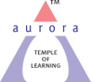
Aurora’s Degree & PG College
(ACCREDITED BY NAAC WITH 'B++' GRADE)
Chikkadpally, Hyderabad 500020

NAME OF THE EVENT | WORLD LAUGHTER DAY
TYPE OF EVENT | WORLD EVENT
FACULTY INCHARGE | M.MAMATHA
DEPARTMENT | MANAGEMENT
DATE | 09.01.2019
VENUE | AURORA’S DEGREE & PG COLLEGE
TARGET AUDIENCE | FACULTY & STUDENTS

OBJECTIVE:
The main objective of conducting the event is to spread awareness in promoting peace, brotherhood, and friendship among all. The Day reminds the society that laughter is the best medicine to ward off dangers of modern day monotonous and mechanized lifestyles.
BRIEF ABOUT THE EVENT:
It has been observed that the event started with Introduction to World laughter day was given by the coordinator, and then it was continued with the Welcome speech by a student, who entertained both the faculty and students with his funny acts.
There was a PPT presentation on the history, benefits of the ‘WORLD LAUGHTER DAY’. In PPT we had showed types of smiles, few great people’s biography like Charlie Chaplin, Mr. Bean & Brahmanandam etc.,
Later a game was planned with the audience, Smiley batches were given to the winners.
Next we had a skit on the title “EXAM” where the viewers enjoyed it, then everyone were given placards of Emojis and enacted on it. At the end Vote of thanks was given by the coordinator.
OUTCOME:
The audience enjoyed the event a lot. They have learned a few health tips about the importance of laughing in their daily lives.

PHOTOGRAPH:
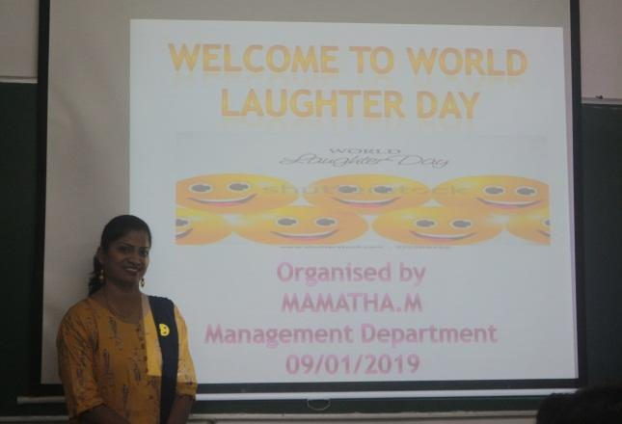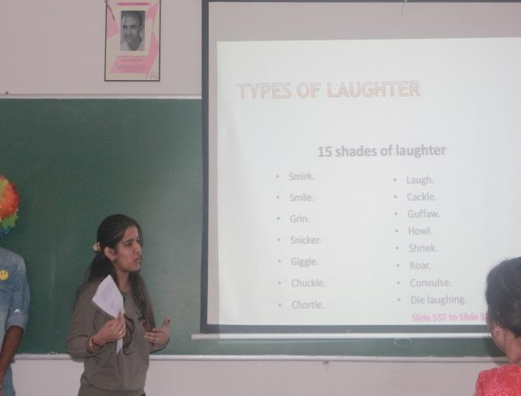
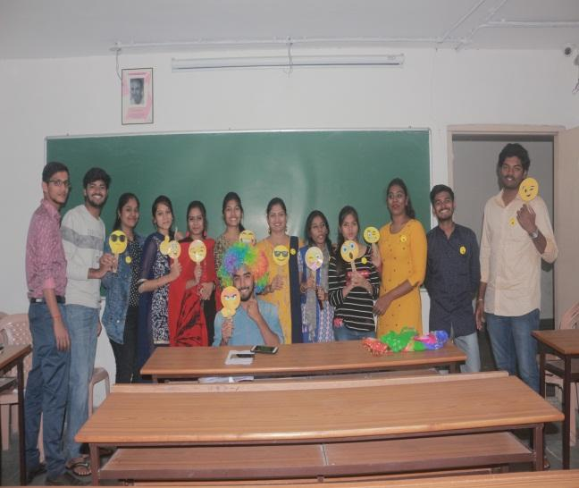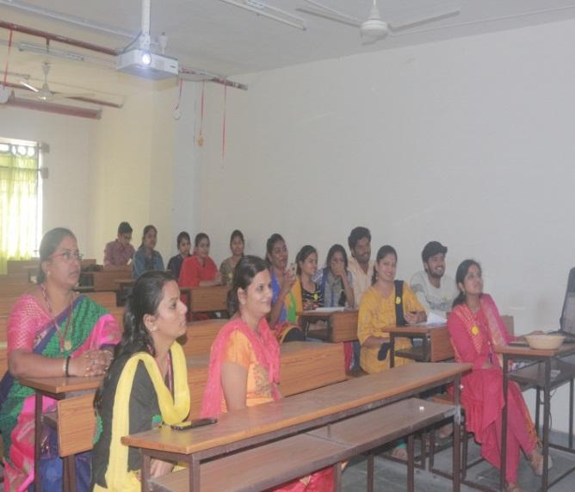

LIST OF THE STUDENT COORDINATORS:
- Bhargavi – B.Com Comp – 3 B – 1051-16-402-152
- Srihitha - B.Com Comp – 3 C – 1051-16-402-181
- Mahesh Babu – B.Com Comp – 3 C – 1051-16-402-217
LIST OF THE PARTICIPANTS
- Avinash Bani – B.Com - Comp – 3 A – 1051-16-402-023
- Apoorva – B.Com Comp – 3 A – 1051-16-402-017
- Rachana - B.Com Comp – 3 C – 1051-16-402-175
- Vishal – B.Com Comp – 3 C – 1051-16-402-191
- Kajal Agarwal – BBA – 3 – 1051-16-684-022

