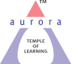
Aurora’s Degree & PG College
(ACCREDITED BY NAAC WITH 'B++' GRADE)
Chikkadpally, Hyderabad 500020

NAME OF THE EVENT | National Girl Child Day
TYPE OF EVENT | Faculty/Students Event
FACULTY INCHARGE | Sandhya Rani G
DEPARTMENT | Department of Commerce
DATE | 24th Jan 2019
VENUE | Block VI, Room no.308
TARGET AUDIENCE | Students

OBJECTIVE:
- It is celebrated as a national observance to increase the consciousness of the people and offer new opportunities to the girl child in the society.
- An initiative towards removal of certain inequalities faced by the girl children of the Indian society.
- To work against diminishing the child sex ratio in the India and change the people mind about the girl child.
- To address the girl children issues associated to their health, respect, education, nutrition and etc.
- To conduct an essay writing competition on “Importance of Educating a girl child” and Documentary making on “Aspiration of a Girl child”.

BRIEF ABOUT THE EVENT:
This event was conducted in Block VI, Room no 308 on 23rd Jan 2019. Students from different steams have participated in essay writing competition and Documentary making. Prizes were given for the best essay writing and Participation certificate for Documentary making on 26th Jan 2019 on occasion of Republic Day.
OUTCOME:
Students have taken part with great enthusiasm on essay writing competition and documentary making. An awareness was given to target audience and It was an initiative for a social cause.

PHOTOGRAPH:

Picture 1
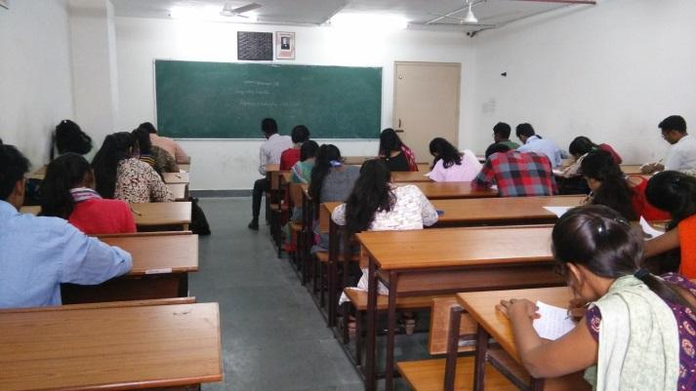
Picture 2
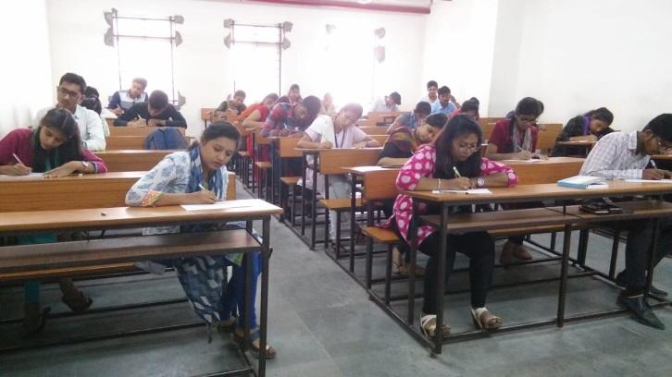

List of Prize Winners for Essay writing competition-In English
S.no | Roll no | Name of the Student | Stream | Class & Section | Prize
1 | 1051-18-488-094 | Vidya | BTBIC | 1B | 1st
2 | 1051-17-391-001 | Arpit S | BA | 2 | 2nd
List of Participation Certificates Issued
3 | 1051-16-467-091 | M.Giri Babu | MSCs | 3B | Telugu Participation
4 | 1051-17-402-166 | Anirudh Sharma | BcomCom | IC | Hindi Participation
List of Participation certificate issued in Documentary making
1 | 1051-18-391-005 | Prathyush Nallela | BA 1 | 1 | Participation Certificate
2 | 1051-18-391-020 | Prasad reddy | BA 1 | 1
3 | 1051-17-684-038 | P.S.L Vishwitha | BBA | 2A

List of the participants in Documentary making competition
“Aspiration of a Girl Child”
S.no | Roll no | Name of the student |  |  | Stream | Class& section
1 | 1051-18-391-005 | Prathyush Nallela |  |  | BA 1 | 1
2 | 1051-18-391-020 | Prasad Reddy |  |  | BA 1 | 1
3 | 1051-17-684-038 | P.S.L Vishwitha |  |  | BBA | 2A
NATIONAL GIRL CHILG DAY EVENT -24TH JANUARY 2019
List of the participants in Essay writing competition
“Importance of Educating Girl Child”
S.no | Name of the student |  | Stream | Class& section
1 | Moumita |  | B.com App | 3
2 | Vaishnavi |  | B.com App | 3
3 | Sahiti |  | Bcom Gen | 3A
4 | Pratibha |  | BBA | 3
5 | Piyush Sharma |  | BBA | 3
6 | Hemanth |  | BA | 3
7 | Pavan |  | BA | 3
8 | M.Giri Babu |  | MSCs | 3B
9 | Jai Rajeshwar |  | Bsc MECs | 3A
10 | K.Shiva Krishna |  | Bsc MECs | 3A
11 | G.Apoorvaa |  | B.com com | 3A
12 | Rohini |  | Bcom com | 3C
13 | Shardha |  | BA | 2
14 | Arpit |  | BA | 2
15 | Mrudula |  | BTBIC | 2A
16 | Nagalakshmi |  | BTBIC | 2A
17 | Meena |  | BTBIC | 2A
18 | Shalini |  | BTBIC | 2A
19 | Kanchana |  | Bcom Gen | 2A
20 | Varsha |  | Bcom Gen | 2A
21 | Aarthi |  | Bcom Gen | 2A
22 | Y.V ShivaRam |  | B.com com | 2D
23 | Kalyan |  | B.com com | 2D
24 | Nisha fathima |  | Bcom Hon | 2B
25 | Anirudh |  | Bcom com | 1C
26 | Amarnath |  | Bcom com | 1C
27 | Vidya |  | BTBIC | 1B
28 | Sirisha |  | Bcom com | 1C
29 | Bhavyasree |  | Bcom com | 1C
30 | Shivani |  | Bcom com App | 1
31 | Sofia |  | Bcom com App | 1
32 | Varsha Reddy |  | MSCs | 1C
33 | Deepak |  | BA | 1
34 | Kavyasree |  | MSCs | 1C
35 | Rishita |  | Mscs | 1B
36 | Md.Waleed |  | BA | 1
37 | K.Sairam |  | BA | 1
38 | Priyanka |  | Bcom Hon | 1B

