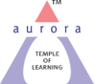
Aurora’s Degree & PG College
(ACCREDITED BY NAAC WITH 'B++' GRADE)
Chikkadpally, Hyderabad 500020

NAME OF THE EVENT | Social Event
TYPE OF EVENT | Birth anniversary of Smt. Sarojini Naidu (National Women’s Day)
FACULTY INCHARGE | Ms. Sonia Raju
DEPARTMENT | Humanities
DATE | 13/02/2019
VENUE | Room no. 406 & 407, Block VI
TARGET AUDIENCE | Students

OBJECTIVE:
- To enlighten the students on the life and achievements of the 'Nightingale of India' Smt. Sarojini Naidu
- To enlighten the students about her contribution as a freedom fighter, political figure and poet of modern India
- Activities proposed to be conducted will help the students to have an insight of her life and work
BRIEF ABOUT THE EVENT:
On the account of Smt. Sarojini Naidu’s Birth anniversary (National Women’s Day) the Department of Humanities in collaboration with Women Empowerment Cell celebrated the event by conducting several competitions on 13th February, 2019 at Block VI ADC. The event started with a brief introduction of the Veteran, her life and her contributions to the society at large, followed by the competitions i.e. Poetry recitation, Role play/ Narration, and Collage making. A total no. of 20 students enthusiastically participated in various competitions both individually and in teams from B. Com (Hons.), B. Com (Comp.), BBA and BA.
OUTCOME:
The objective of the event was fulfilled as the students learnt about the dynamic personality of Smt. Sarojini Naidu, the various competitions conducted gave an insight to the students about her contribution to Indian Literature, freedom struggle and to know her as an empowered woman who combines in the most remarkable way great intellectual power with charm, sweetness with courageous energy, a wide culture with originality, and earnestness with humor.

PHOTOGRAPH:
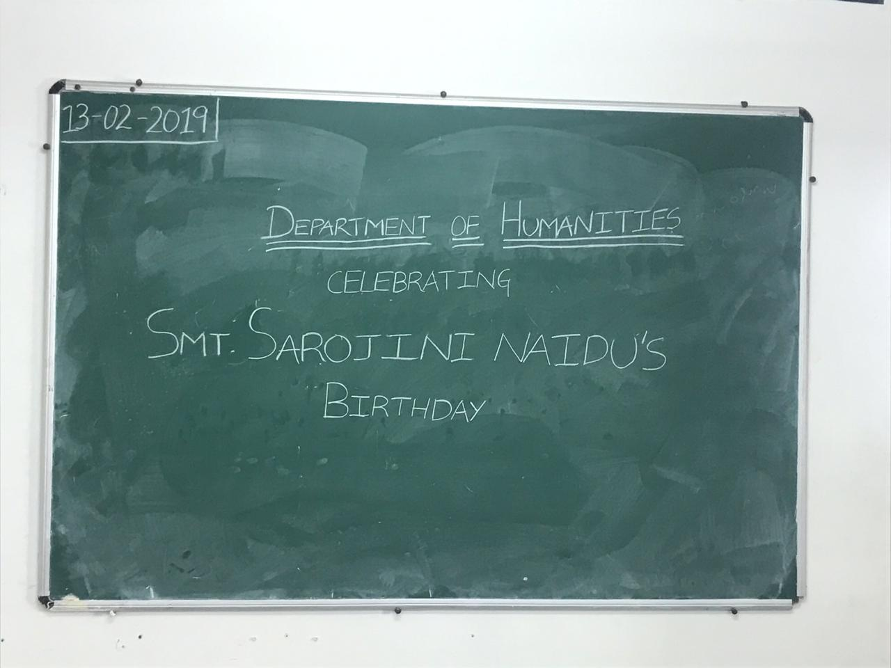
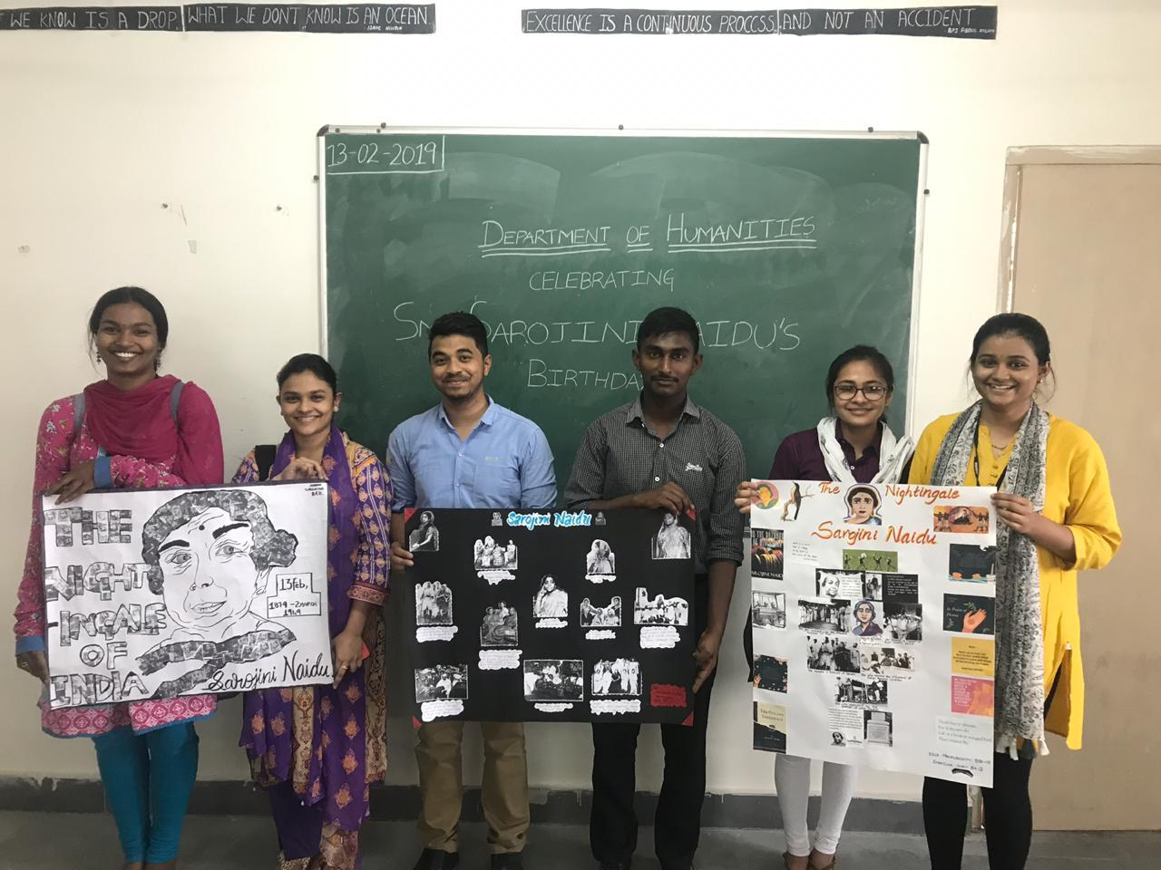

DETAILED REPORT:
On the account of Smt. Sarojini Naidu’s Birth anniversary (National Women’s Day) the Department of Humanities in collaboration with Women Empowerment Cell of Aurora’s Degree & PG College celebrated the occasion with great enthusiasm. The Students had participated in the following competitions, from 10:30-11:30 am Poetry recitation on the works of Smt. Sarojini Naidu; from 12:30-1:30 pm Role play/ Narration and from 1:30-2:30 pm Collage making.
Simran Singh of B. Com (Hons.) 2 A won in Poetry recitation; P. Abhinav of BA III (MCPSLi.) won in Role play/Narration and the team of Simroz and K. Harshitha of BA II won in Collage making. The competitions conducted gave an insight to the students regarding the dynamic and evergreen personality and work of Smt. Sarojini Naidu ‘the Nightingale of India’.

- LIST OF THE STUDENT COORDINATORS (NAME , ROLL NO, CLASS & SECTION)
S No. | NAME | ROLL NO. | CLASS & SECTION
1. | Ch. Bharath | 1051-16-274-005 | BA III (MCHG)
2. | Pavan Kalyan | 1051-16-274-013 | BA III (MCHG)
3. | E. Pranav | 1051-17-391-032 | BA II (MCPSLi.)
4. | B. Deepak | 1051-18-391-019 | BA I (MCPSLi.)
5. | Laxmi Prathyush | 1051-18-391-005 | BA I (MCPSLi.)

- LIST OF THE PARTICIPANTS (NAME , ROLL NO, CLASS & SECTION)
S NO. | NAME | ROLL NO. | CLASS & SECTION
POETRY RECITATION
1. | Simran Singh | 1051-17-407-003 | B. Com (Hon.) 2 A
2. | Amarnath | 1051-18-402-163 | B. Com (Comp.) 1 C
3. | V. Sai Charan | 1051-17-391-014 | BA II
4. | B. Naga Sai Deepak | 1051-18-391-019 | BA I
5. | Ujwala Potharazu | 1051-17-391-013 | BA II
6. | Krishna Priya. V | 1051-17-391-023 | BA II
ROLE PLAY/ NARRATION
7. | K. Sai Ram | 1051-18-391-028 | BA I
8. | Md. Waleed Uddin | 1051-18-391-008 | BA I
9. | P. Abhinav | 1051-16-391-008 | BA III (MCPSLi.)
10. | Sameera | 1051-16-391-012 | BA III (MCPSLi.)
11. | M A Nayab | 1051-16-391-005 | BA III (MCPSLi.)
12. | K. Suraj | 1051-16-274-011 | Ba III (MCHG)
COLLAGE MAKING
13. | Nikhil Dolia  &  Hemanth Kumar | 1051-17-391-006 &  1051-17-391-003 | BA II
14. | Simrooz  &  K. Harshitha | 1051-17-391-029  &  1051-17-391-027 | BA II
15. | T. Vamsi  &  G.V. Prasad | 1051-18-391-014  & | BA I
16. | Maha Lakshmi  &  Shradha Shah | 1051-18-684-064  &  1051-17-391-018 | BBA I B  BA II

- EVENT PHOTOS

