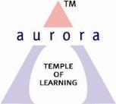
Aurora’s Degree & PG College
(ACCREDITED BY NAAC WITH 'B++' GRADE)
Chikkadpally, Hyderabad 500020

NAME OF THE EVENT : | Karl Pearson Birthday celebrations
FACULTY INCHARGE | P.Kiranmayi
DEPARTMENT | Department of Statistics
TYPE OF EVENT | Karl Pearson Birthday celebration’s (Departmental Event)
DATE | 27th March 2019
VENUE | Aurora’s Degree & PG College, Chikkadpally, Hyderabad.
TARGET AUDIENCE | Faculty,ug and post graduate student

Objective:

Recalling the contributions of Karl Pearson’s about statistics.
Founder of biometrics, Karl Pearson was one of the principal architects of the modern theory of mathematical statistics. He was a polymath whose interests ranged from astronomy, mechanics, meteorology and physics to the biological sciences in particular (including anthropology, eugenics, evolutionary biology, heredity and medicine).

OUTCOME

Students came to know Pearson's inventions in Geo –statistics; Karl Pearson was Founder of the Biometric School. He made prolific contributions to statistics, eugenics and to the scientific method. Stimulated by the applications of W.F.R. Weldon and F. Galton he laid the foundations of much of modern mathematical statistics.

Objective:

Recalling the contributions of Karl Pearson’s about statistics.
Founder of biometrics, Karl Pearson was one of the principal architects of the modern theory of mathematical statistics. He was a polymath whose interests ranged from astronomy, mechanics, meteorology and physics to the biological sciences in particular (including anthropology, eugenics, evolutionary biology, heredity and medicine).
OUTCOME

Students came to know the Pearson’s inventions in Geo –statistics; Karl Pearson was Founder of the Biometric School. He made prolific contributions to statistics, eugenics and to the scientific method. Stimulated by the applications of W.F.R. Weldon and F. Galton he laid the foundations of much of modern mathematical statistics.

Photographs:

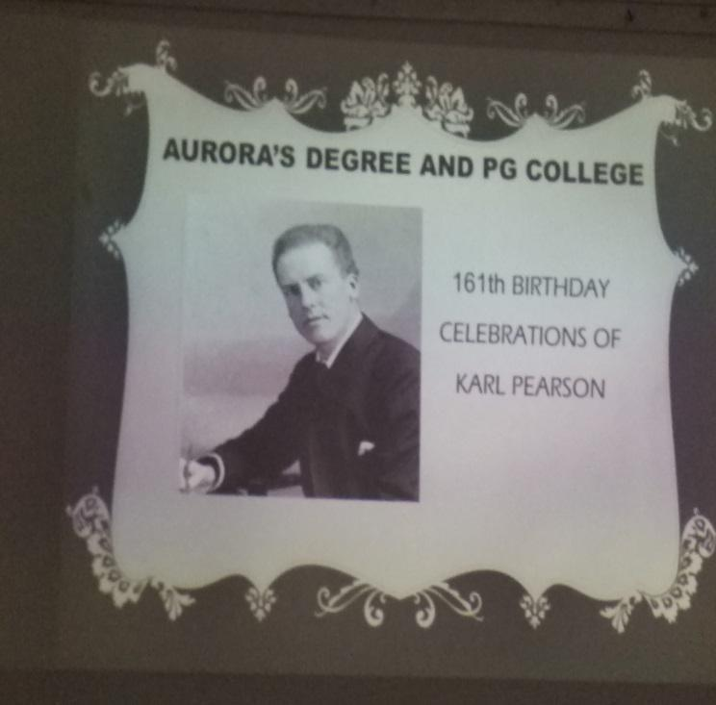
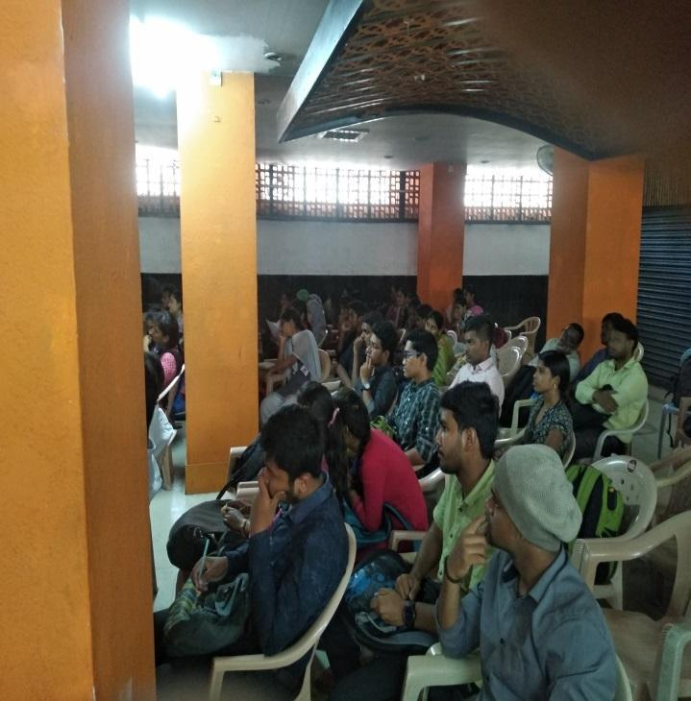

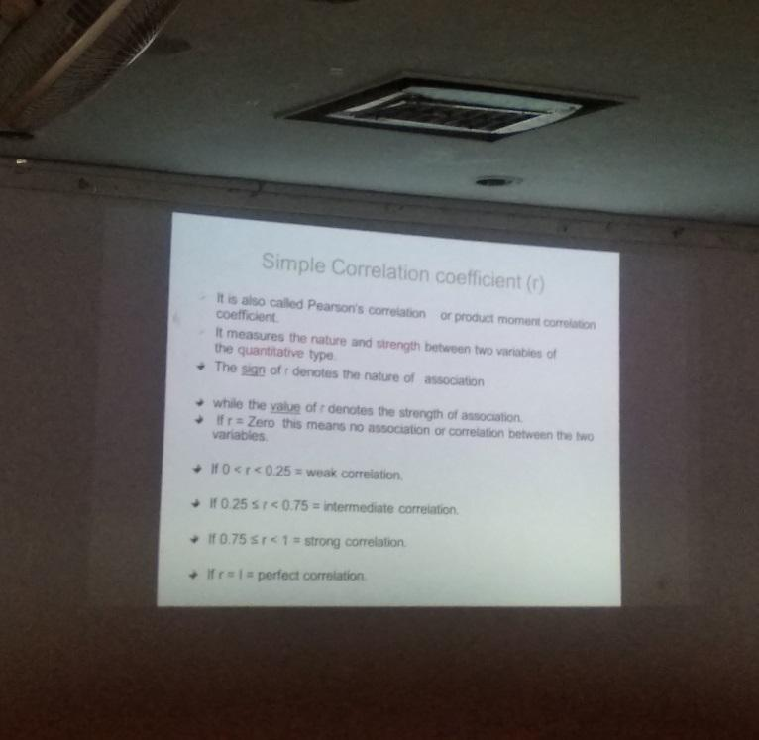
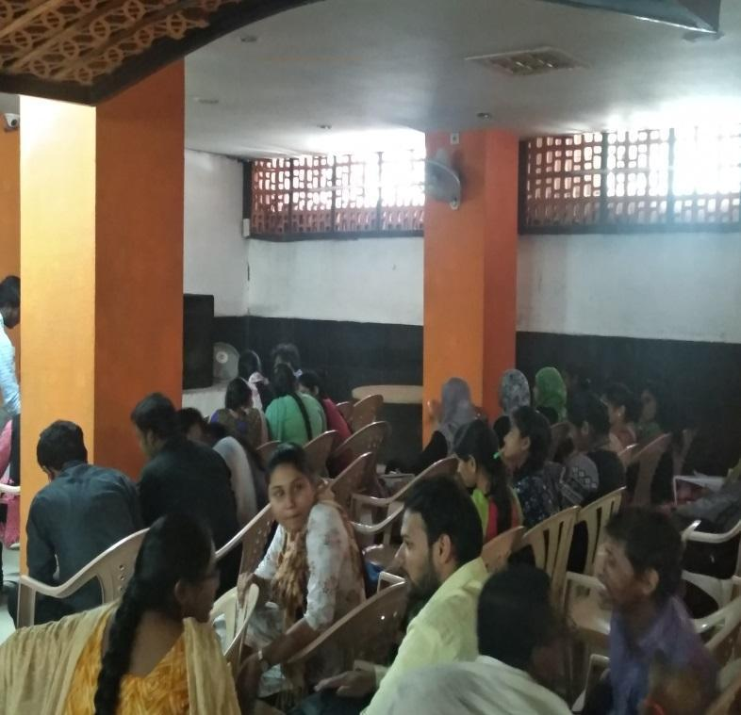

Detailed Report on Karl Pearson Birthday Mar-27’ 2019
OBJECTIVE:
In recognition of the notable contributions made by Late Prof Karl Pearson in the field of Statistics .He was an influential mathematician and Biostatistician.
He has been credited with establishing the discipline of mathematical statistics .He founded the world's first university statistics department at University College London in 1911, and contributed significantly to the field of biometrics, meteorology, theories of social Darwinism and eugenics. Pearson was also a protégé and biographer of Sir Francis Galton.
Brief report on Karl Pearson Birthday Mar 27 -2019

On Account of Karl Pearson 160th Birthday Statistics Department celebrated his birthday. He was a mathematician and a biostatistician. Many Posters were prepared by the PG students and UG student’s .we conducted Essay writing (topic-role of statistics in Business, Govt. sectors & pharmacy) & Quiz, about his contributions and achievements are displayed on the notice board as well as in classes. Students presented Seminars on his contributions in the field of Statistics.

P.kiranmayi
Dept. of Statistics

Aurora’s Degree & PG College
(ACCREDITED BY NAAC WITH 'B++' GRADE)
Chikkadpally, Hyderabad 500020

NAME OF THE EVENT : | C. Radhakrishna Rao’s Birthday Celebrations- A Living Legend.
FACULTY INCHARGE | Rajyalakshmi
DEPARTMENT | Department of Statistics
DATE | 15th Sep 2018
VENUE | Aurora’s Degree & PG College, seminar hall
TARGET AUDIENCE | faculty ,Degree& Post graduate student
SPEAKER | Dr. Raghavendra, ADRIN.

Objective:
To inspire all the students & faculty. This programme is conducted to inculcate the analysis based on “Big Data & Cloud Computing”

OUTCOME:
Big Data represents content, whereas cloud computing is infrastructure; the combination of both the technologies can yield excellent results.

Photographs
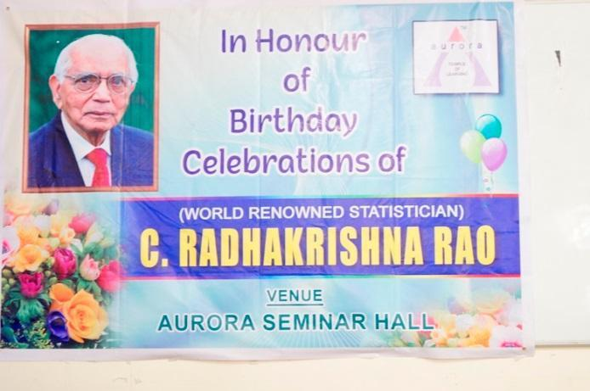 | 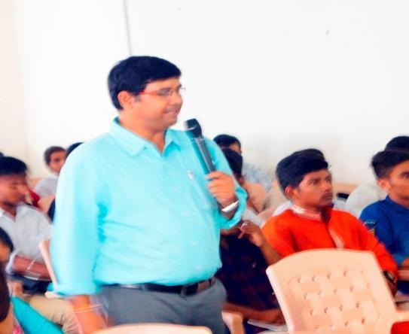

Report on Dr. C.R Rao’s Birthday celebrations
Dr. Calyampudi Radhakrishna Rao’s birthday celebrations held on 15-9-18 , a living legend & Doyen of Statistics. C R Rao was born into a Kannada speaking Telugu family in Hadagali, Bellary, Karnataka, India. He received an M.Sc. in mathematics from Andhra University and an M.A. in statistics from Calcutta University in 1943. He was among the first few people in the world to hold a master's degree in Statistics.
Dr. Rao worked at the Indian Statistical Institute and the Anthropological Museum in Cambridge before acquiring a Ph.D. degree at King's College in Cambridge University under R. A. Fisher in 1948. He held several important positions, as the Director of the Indian Statistical Institute, Jawaharlal Nehru Professor and National Professor in India, University Professor at the University of Pittsburgh and Eberly Professor and Chair of Statistics and Director of the Center for Multivariate Analysis at the Pennsylvania State University. As Head and later Director of the Research and Training School at the Indian Statistical Institute for a period of over 40 years, Dr. Rao developed research and training programs and produced several leaders in the field of Mathematics. He received many awards and honors from various universities
To understand his life and achievements in the field of statistics and also enlightening the students by connecting the need of statistics in modern science,The following activities has been conducted prior to this event
- PPT presentations on “Applications of Statistics on Various fields”
- Poster presentations on ”Life & Achievements of Dr C.R.Rao .”
The charts were displayed on the notice board of Block VI.
U.K.S Harshini of PG final year student invited all the guest on to the Dias. The program started with welcome song by PG students, welcome address by Vice Principal, Mr.Satyanarayana. Samanvit ha of PG first year gave a speech on living legend Dr.C.R Rao .
Sri Lalana of PG final year student introduce Dr Raghevendra ,Scientist at (Advanced Data Processing Research Institute Recruitment,ADRIN) to the gathering. Harshini invited the guest to give a lecture on “Big Data & Cloud Computing”. He delivered a lecture on “Big Data & Cloud Computing “, useful for statistics students. The lecture scheduled for one and half hour.He gave the information on the importance of Statistics in understanding Big Data & its applications which is useful in Various fields. The lecture was very inspiring to the students. Dr Raghevendra, has come forward to guide the students for projects. He presented certificates to all the winners who participated in PPT presentation and Poster presentation. The program closed with vote of thanks by K. Parimala Sudhir (HOD,Department Of Statistics).
Expenditure : Guest Honorarium & Refreshments : 2000/- ` Event coordinator
( Rajya Lakshmi)

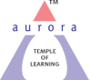
Aurora’s Degree & PG College
(ACCREDITED BY NAAC WITH 'B++' GRADE)
Chikkadpally, Hyderabad 500020

NAME OF THE EVENT | R.A. FISHER’S BIRTHDAY CELEBRATIONS
TYPE OF EVENT | R.A. FISHER BIRTHDAY(Departmental Event)
FACULTY INCHARGE | G.Priyanka
DEPARTMENT | Department of Statistics
DATE | February 17th 2018
VENUE | Aurora’s Degree and PG college, Chikkadpally, Hyderabad.
TARGET AUDIENCE | Students of UG-BSc(MSCs),PG-MSc(Statistics)

Objective:
To aware the students about the contributions of Prof. R.A. Fisher in the field of Statistics . Motivating and inspiring the students regarding his studies.
OUTCOME:
This event has made student centric, students actively participated in different power point presentations, Quiz, Descriptive Analysis enthusiastically. Students came to know about the various contributions and works done by Sir Fisher in the field of Statistics.

.

PHOTOGRAPH:

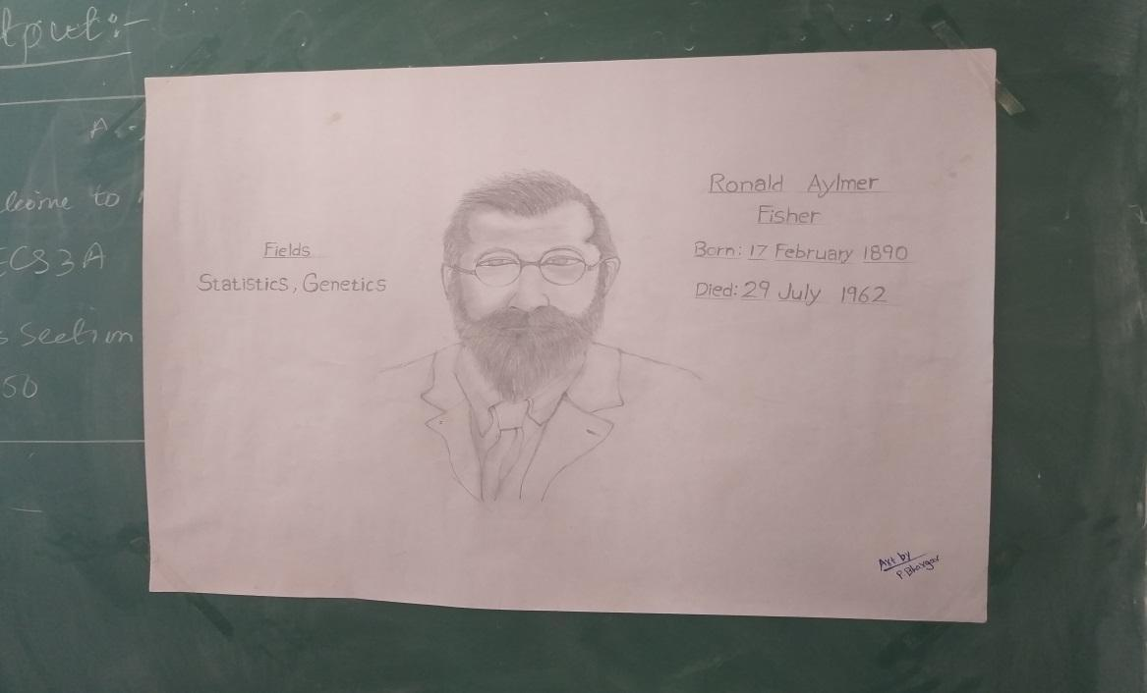
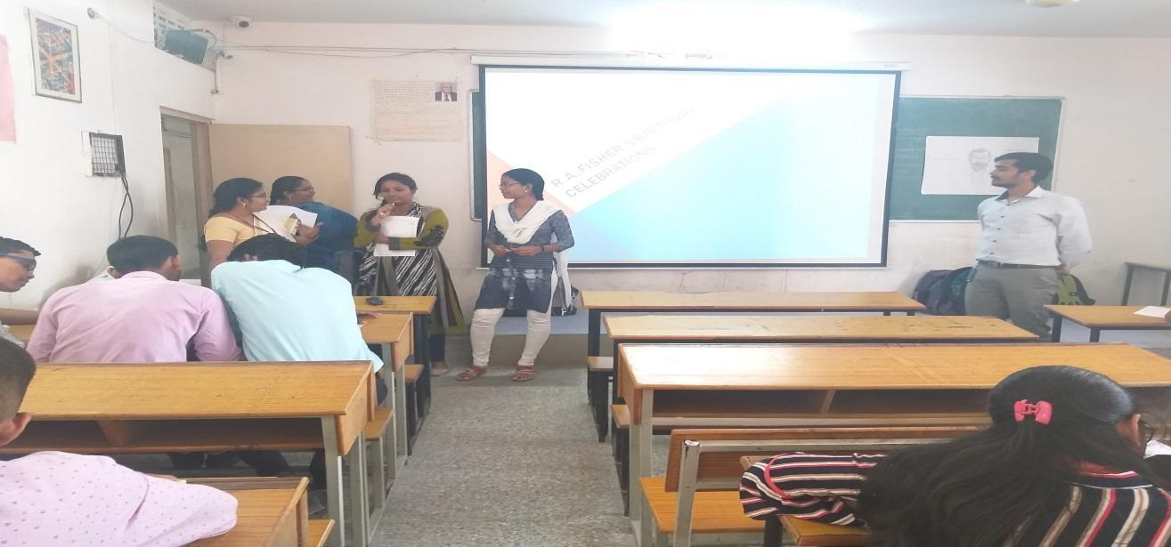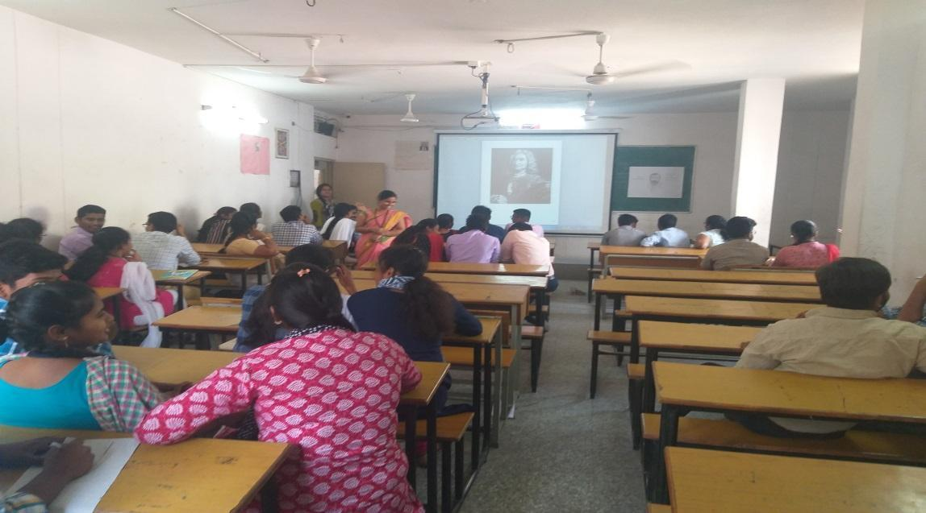
Report on Prof. R.A. Fisher celebrations
OBJECTIVE: To aware the students about the contributions of Prof. R.A. Fisher in the field of Statistics. Motivating and inspiring the students regarding his studies.

BRIEF ABOUT THE EVENT: The event was conducted on occasion of the birthday of Prof. R.A. Fisher on 17th February. The event was conducted to inspire the students about the life achievements of Prof .R.A.Fisher.
In the event we have conducted competitions such as PPT, Quiz, Image Recognition, Descriptive Analysis. The students from B. Sc (Statistics) I, II, III years and M.Sc. (Statistics) I,II years have participated more actively in all the sessions and the winners were awarded with a certificate.
The awarded students are:
- Quiz: Mahindra (MSCs 3B),Sahithi (MSCs 2C)
- PPT: K.Sudershini (MSCs 1C)
- Descriptive Analysis: Vishal,Santhosh,Apoorva(MSc I year)

OUTCOME: This event has made student centric, students actively participated in different power point presentations, Quiz, Descriptive Analysis enthusiastically. Students came to know about the various contributions and works done by Sir Fisher in the field of Statistics

Aurora’s Degree & PG College
(ACCREDITED BY NAAC WITH 'B++' GRADE)
Chikkadpally, Hyderabad 500020

NAME OF THE EVENT : | Emerging Trends in Statistics
FACULTY INCHARGE | K.ParimalaSudhir,Dr.RaghunadhaAcharya&Prof.Lakshmi Manga
DEPARTMENT | Statistics
DATE | 29th& 30th march2019
VENUE | Aurora’ Seminar Hall
TARGET AUDIENCE | UG&PG Statistics students
SPEAKER | Prof.Anjireddy ,Director DRD ,JNTUH; Dr. Kirthi, Srivatsav Scientist,NGRI, Dr.Bhattacharyulu; Assistant Professor; Dr.Gopinath,vicePresident,TCS; DrMr.Ravikumat,DataScientist,ReddyLABs; Dr.RaghunathaAcharya,Associate Professor ADC.

Objective:

To address Emerging problems and challenges in analyzing data sets observed in diversified fields.

OUTCOME:
Students identified various opportunities available in Statistics field, ie higher studies, job opportunities internship’s& various research projects.

Photographs
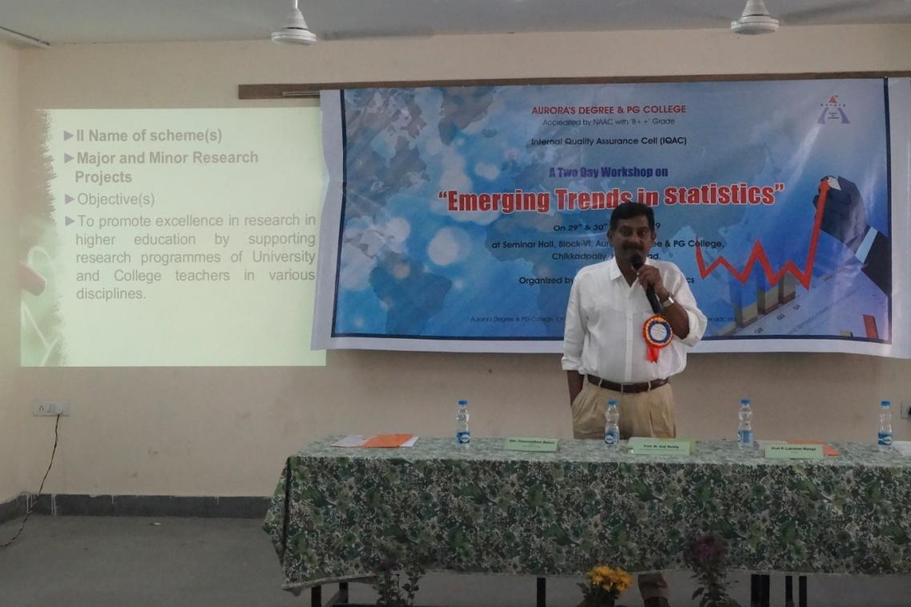
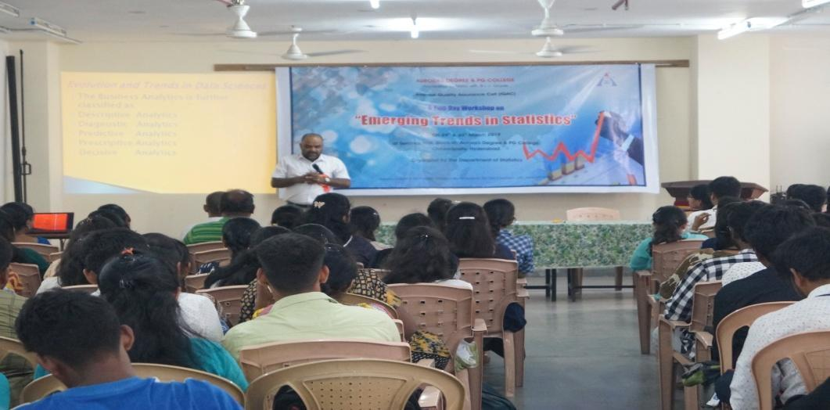
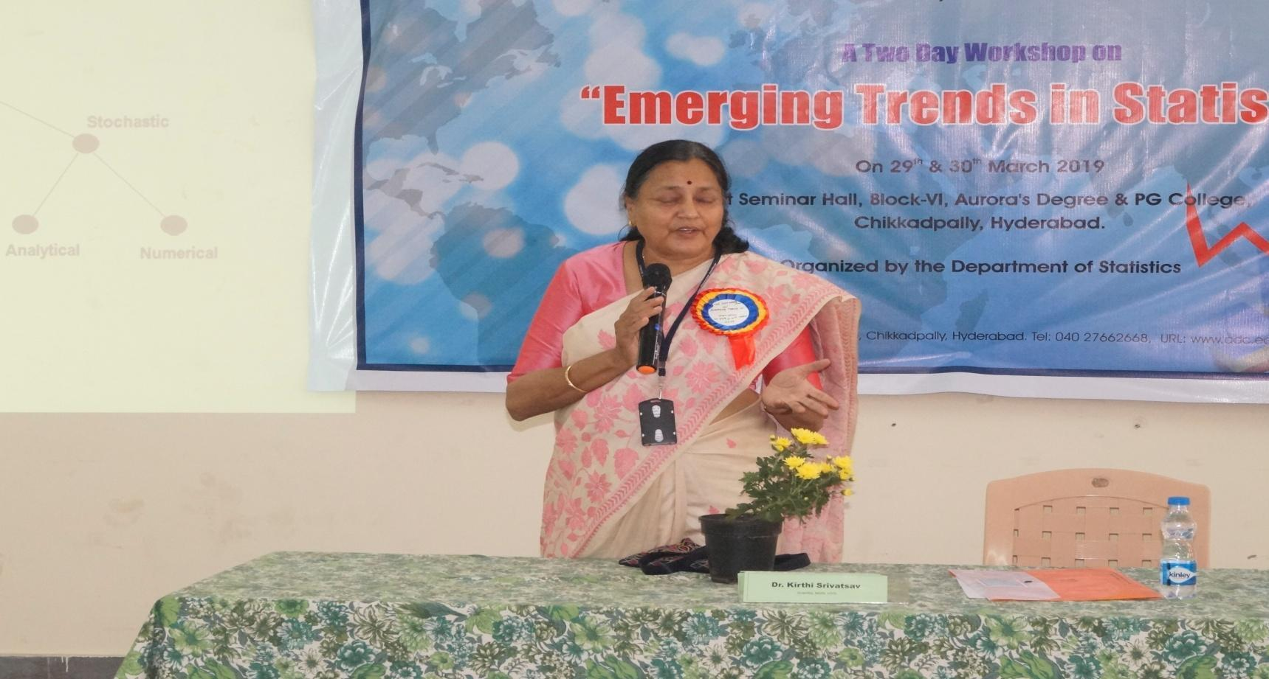
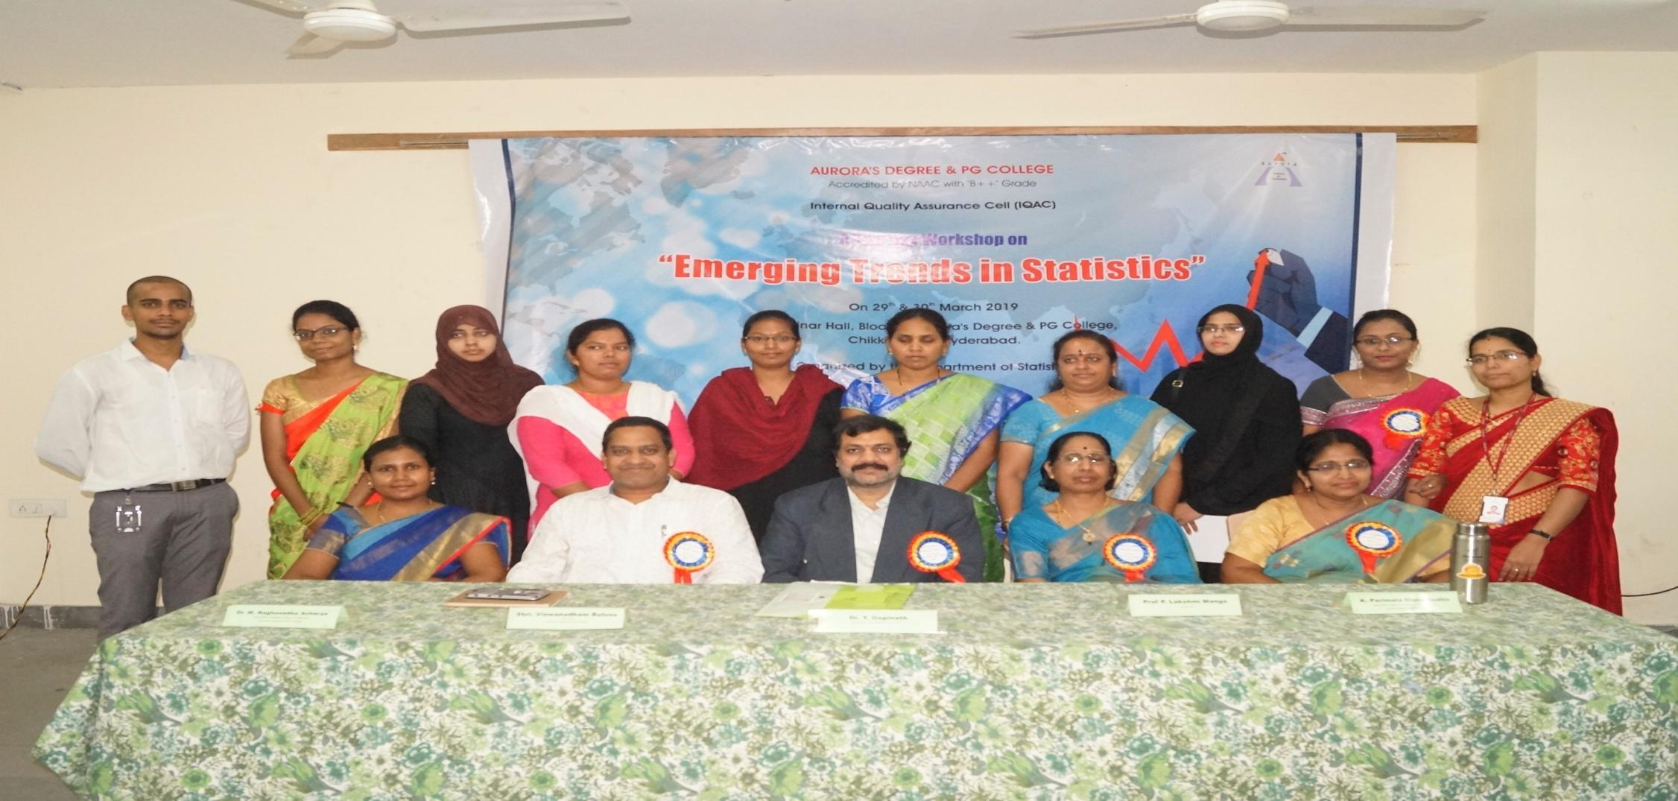

A two-Day Workshop on ‘Emerging Trends in Statistics

Date : 29th & 30th March 2019
Time : 10.00 am onwards
Co-coordinators : Parimala Sudhir.K, Dr.Raghunadh Acharya & Prof.P.Lakshmi Manga
Student Co-coordinators: Rishika PG Statistics 2nd yr. (Captain) & Bhavani PG Statistics 1st yr. (Captain)
Venue : Seminar Hall

Report on Emerging Trends in Statistics

A two day workshop on Emerging Trends in statistics was organized on 29th & 30th March 2019 at seminar hall of Aurora’s Degree & PG College.

Objective:
To address emerging problems and challenges in analyzing datasets observed in diversified fields.
Proceedings:
Lightening of the Lamp: Prof.Anji Reddy Director, Directorate of Research &Development, JNTU, Hyderabad the chief guest, Sri.Vishwanadham Bulusu, Principal, Prof. Lakshmi Manga, Dr.Raghunadha Acharya & Ms K.Parimala Diana Sudhir, Convenors started the session formally with lighting of the lamp with the support of staff Ms. Rajyalakshmi & Ms. Kiranmayi .

Ms. Parimala Diana Sudhir, Head department of statistics presented the welcome address with brief about the workshop, and its need and relevance in today’s growing technological world, also presented the strengths of the department. This was followed by the brief encouraging note by the Principal. The participants were suggested to utilize this opportunity to enhance their knowledge and make the best use of it for their future career.

Day-1

Session-1
Topic: Research & Development in Indian Scenario

Prof.Anji Reddy Director R&D, JNTU, Hyderabad in his speech touched on the following topics

- Motivation of Research:
- Desire to get a research degree along with consequential benefits.
- Desire to service society
- Grouping of Research Objectives:
- Exploratory or Formative
- Descriptive Research
- Diagnostic Research
- Hypothesis testing
- Types of Research:

Also emphasized & enlightened on the direction to approach research institutions in India like UGC, AICTE, CSIR, &DSIR etc.
The audience found the topics to great use in planning their research.

Tea break:

Session-2

Topic: Statistics in Geo-Physics
Dr. Kirthi Srivatsav Scientist, NGRI, Hyderabad, delivered a lecture on ‘Modeling of Earth processes’ touched on the following topics
- Modeling
- Deterministic & Stochastic Models
- Analytical & Numerical Methods

Madam briefed about Probability model used for Tsunami data.
The audience found the topics to be of great use and the information was very broad and highly intellectual.

Lunch:

Session-3
Topic: Machine Learning Classification Technique

Dr. N Bhatracharyulu, Assistant Professor, Department of Statistics ,OU briefed on the basic terminology used in Machine Learning Classification Technique. The following topics were covered.
- Learning
- Feature
- Feature space
- Feature Vector
- Computational Procedures
- Linear classification using linear discriminant function for binary output with minimum mean squared error
- Bayesian probabilities for classifications under normality with common covariance matrix
- K-nearest neighbor classification
- Perceptron learning linear classifier
- Support vector machine.

The audience found the information to be very useful and was updated on their learning in the area of Machine Learning Classification Technique.

Day-2
Session-1

Topic: Evolution and Trends in Data Sciences

Dr.M.Raghunadha Acharya, Associate Professor, Department of Statistics, Aurora’s Degree & PG College spoke on the latest trends in data sciences by covering the 5 areas in Analytics
- Descriptive analytics
- Diagnostic analytics
- Predictive analytics
- Prescriptive analytics
- Decisive analytics
Sir explained all the detailed concepts related to big data, which depends on 5 v's i.e Volume, Velocity, Variety, Verosity, &Value. Also networks & examples on data analysis.

The audience were very appreciative of the information they have received from the esteemed speaker.

Tea break:

Session-2

Topic: Design of experiments and its applications in Pharma industry

Shri Ravi Dasari, Data Scientist, Dr. Reddy Lab, Hyderabad emphasized on the role of DOE in the pharmaceutical industry, which discovers, develops, produces, and markets drugs for medications to be administered to patients. Ravi focused on
Pharmaceutical QBD, a systematic approach to develop, that begins with predefined objectives and emphasized on product and process understanding, process control based on sound science and quality risk management methods.

Explained about the advantages of DOE methods in saving money and time by using design of experiments.
(Note: Proud to have Mr. Ravi as one of the resource person, an Alumni of Aurora, the first batch of MSc Statistics)

Lunch:

Session-3

Topic: Influence of Analytics in Telecom Industry

Dr.Y.Gopinath, Vice President, TCS, Hyderabad highlighted the influence of analytics in telecom industry. Encouraged the student to enhance their statistical technical skills in analytics field.

The talk was of great benefit to all the audience which kept the audience engaged.

Vote of Thanks:
The valedictory was conducted at the end of the program with Dr.Y.Gopinath being the Chief Guest, the Principal also spoke on this occasion, and certificates were distributed to the participants. Many students and faculty from different colleges expressed their views and thanked the college for the encouragement and motivation towards their career plans. Ms. Parimala Diana Sudhir, Convener of the workshop presented the vote of thanks. The event concluded with national anthem.

Conclusion: The total number of participants is 154 of which in house participants are 89 & outsiders were 65 including some faculty members from other colleges. Around 50 volunteers coordinated the whole programme successfully from the statistics stream of UG and PG. It’s a collective effort of all the department faculty & statistics student community.

