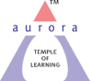
Aurora’s Degree & PG College
(ACCREDITED BY NAAC WITH 'B++' GRADE)
Chikkadpally, Hyderabad 500020

NAME OF THE EVENT | World Earth Hour
TYPE OF EVENT | College Level
FACULTY INCHARGE | Raga Sudha J
DEPARTMENT | Mathematics
DATE | 30th April 2019
VENUE | Aurora’s Degree College
TARGET AUDIENCE | B.Sc (All 1st,2nd & 3rd Years)

OBJECTIVE:
To Bring awareness to the students and Faculties and staff about earth hour and its importance
BRIEF ABOUT THE EVENT:
Individuals, businesses and cities in 188 countries and territories worldwide joined Earth Hour 2019 to speak up for nature and inspire urgent action for the environment. As Earth Hour rolled around the globe, thousands of landmarks switched off their lights in solidarity for our planet. Through the global appeal of the world’s largest grassroots movement for the environment, #EarthHour, #Connect2Earth and related hashtags trended in 26 countries as people across the globe generated over 2 billion impressions to show their concern for nature. Individuals pledged their support for the planet, challenging world leaders to push the preservation of nature up the global agenda.
We had a scheduled power cut between 8:30AM to 9:30 AM in Main Block, Aurora’s Degree & PG college. We had fans, lights off by power cut. Sent emails to all the students of the college about the earth hour program in our college and mentioned the link https://www.earthhour.org/ to go through and participate if they wish to.

OUTCOME:
Brought awareness to the students about the Earth Hour and Saving the energy by switching off lights etc for an hour. The scheduled power cut and charts display has enlightened the students about the planet and saving energy.

PHOTOGRAPH:

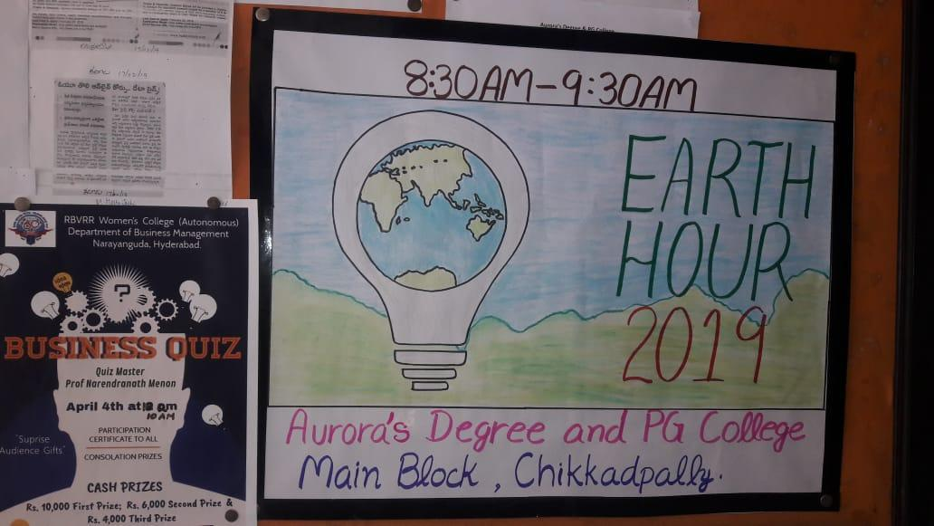

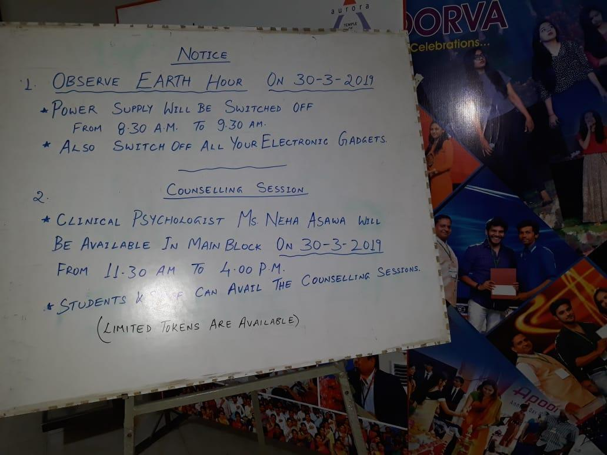
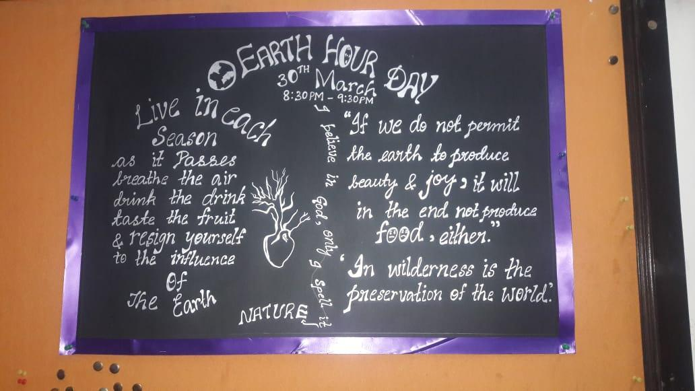
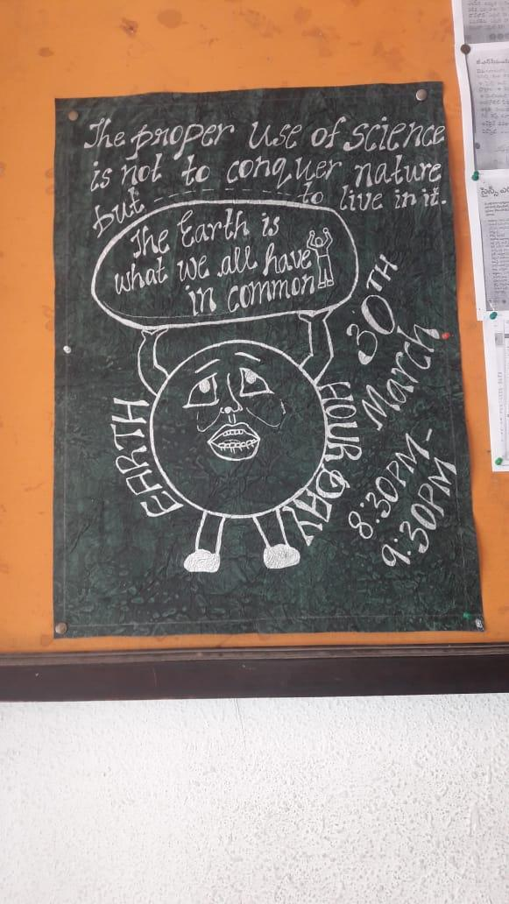
DETAILED REPORT : ( Give complete information about the event, including the following)
- LIST OF THE STUDENT COORDINATORS (NAME , ROLL NO, CLASS & SECTION)
AmanPreet Kaur, MPCS2B, 1051-17-468-077, Rubina, MPCS2A

- LIST OF THE PARTICIPANTS (NAME , ROLL NO, CLASS & SECTION): B.SC (Ist,IInd and IIIrd years)
- EVENT PHOTOS ( MIN 2 MAX 4)

