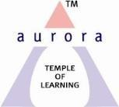
Aurora’s Degree & PG College
Chikkadpally, Hyderabad 500020
NAME OF THE EVENT : | ROSE DAY FOR CANCER PATIENTS
FACULTY INCHARGE | Kavitha. Ch
DEPARTMENT | Department of COMMERCE
DATE | 22nd SEPTEMBER 2018
VENUE | Auroras Auditorium
TARGET AUDIENCE | UG - B Com Hons Students

Rose is a symbol of love, care and concern. September 22nd of each year is observed as Rose Day, for supporting all those people around the world who are fighting with cancer. Rose day is observed to let all cancer patients be aware that they can face the disease with strong willpower and spirit.
It is observed in the memory of 12 year old Melinda Rose from Canada, who was diagnosed with Askin’s Tumour, a rare form of Blood Cancer. Doctors predicted that she will not survive more than a couple of weeks, but she lived six months more. Within that period, she successfully cheered up other cancer patients and their caregivers with her letters, poems, and emails.

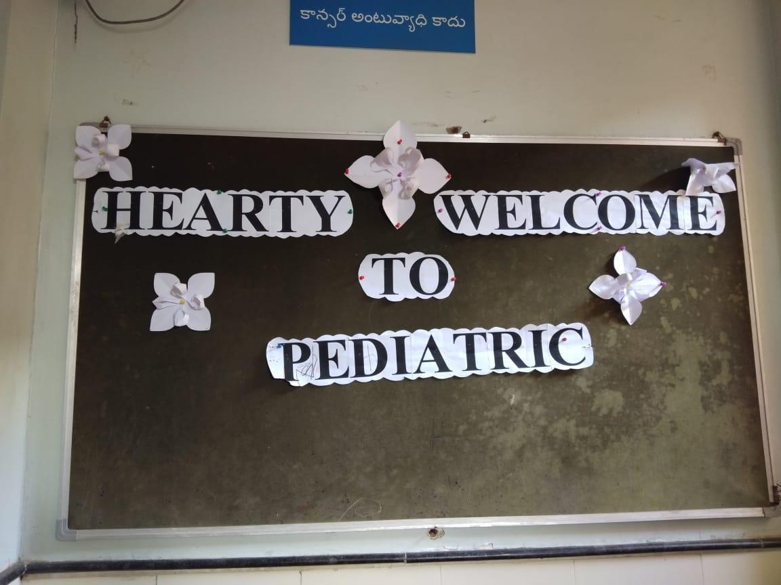
The students of B.Com 1HA have taken part in this event. On this special day, Aurorian’s visited the Paediatric ward at the MNJ Cancer Hospital, Hyderabad and mingled with the kids who were in the midst of cancer treatment. The students sweetened the pot with Colouring books and crayons, Balloons, Bubble blowers and biscuits.

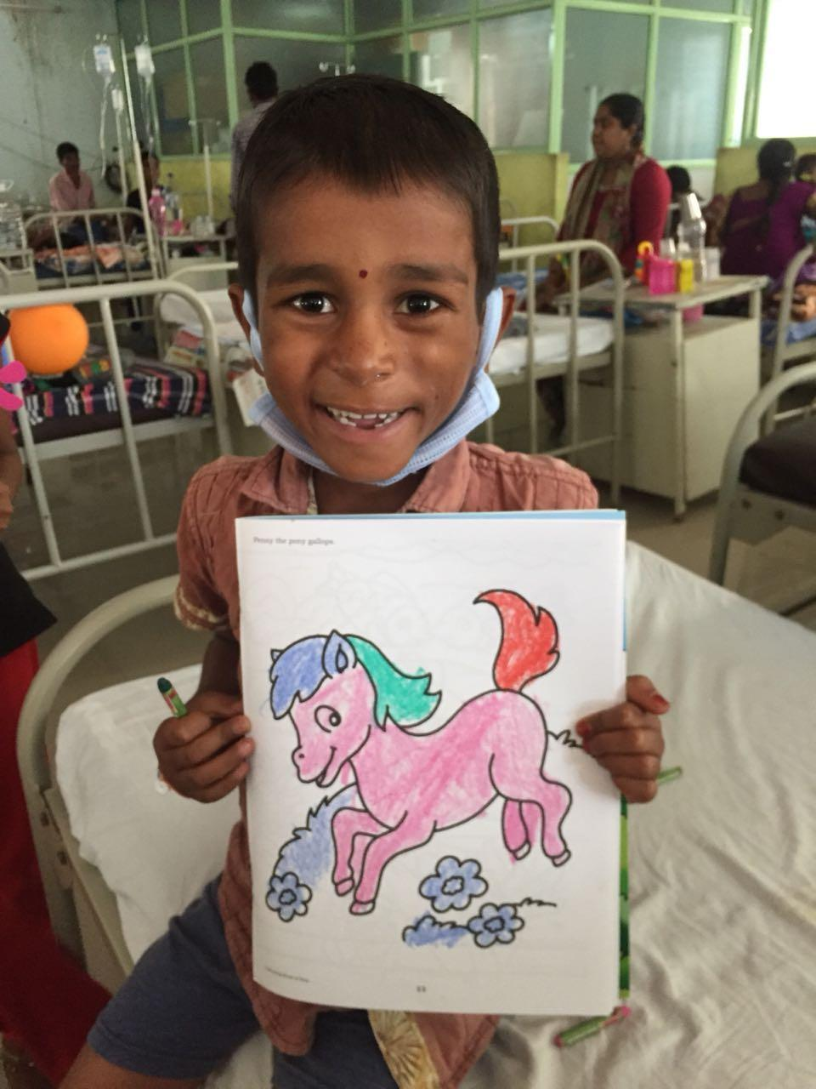
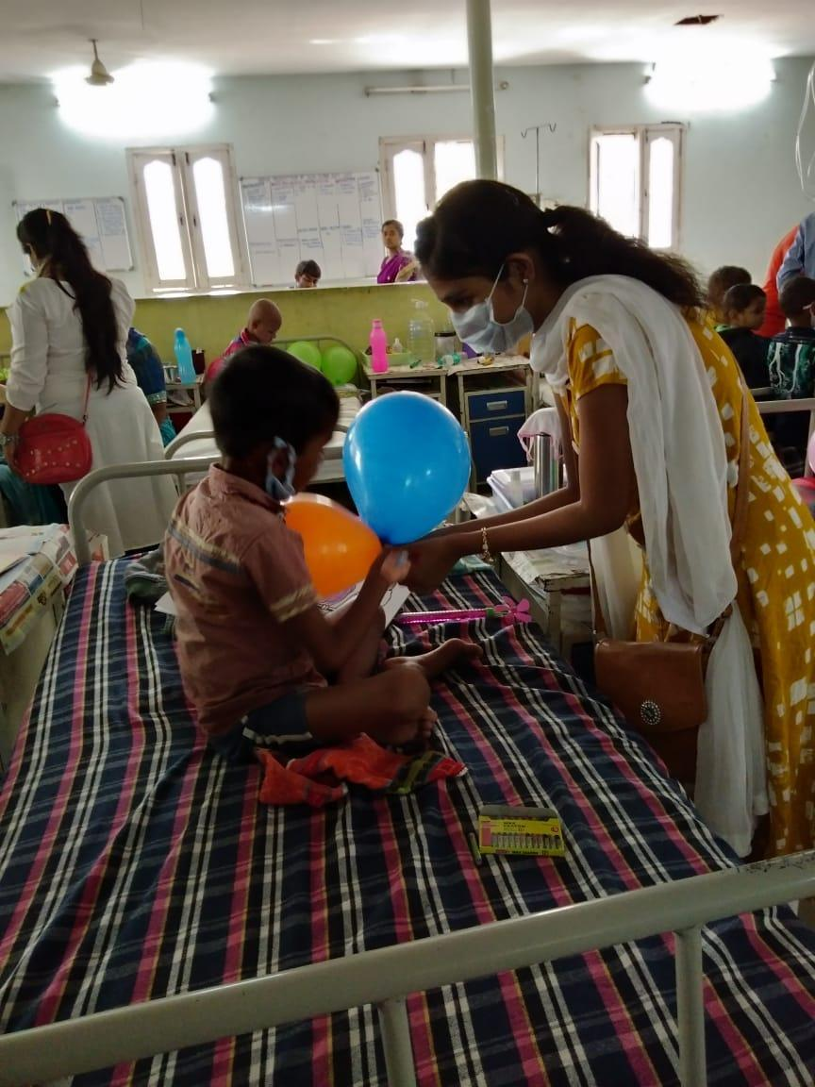
There were around 70 kids in the ward with their guardians. Every one of us made up each kid present there and interacted with them. While touching base with them, we bumped into a woman whose daughter was going through blood cancer and she said “It feels good when someone fills them with hope. Everyone has to die one day or the other. But when such people come and give them encouragement, it makes us as well as them feel better. Many patients at the Hospital had travelled from various parts of the country because they did not have proper treatment at their domestic place. Also, they were happy with the treatment being provided to their children at the hospital.

" 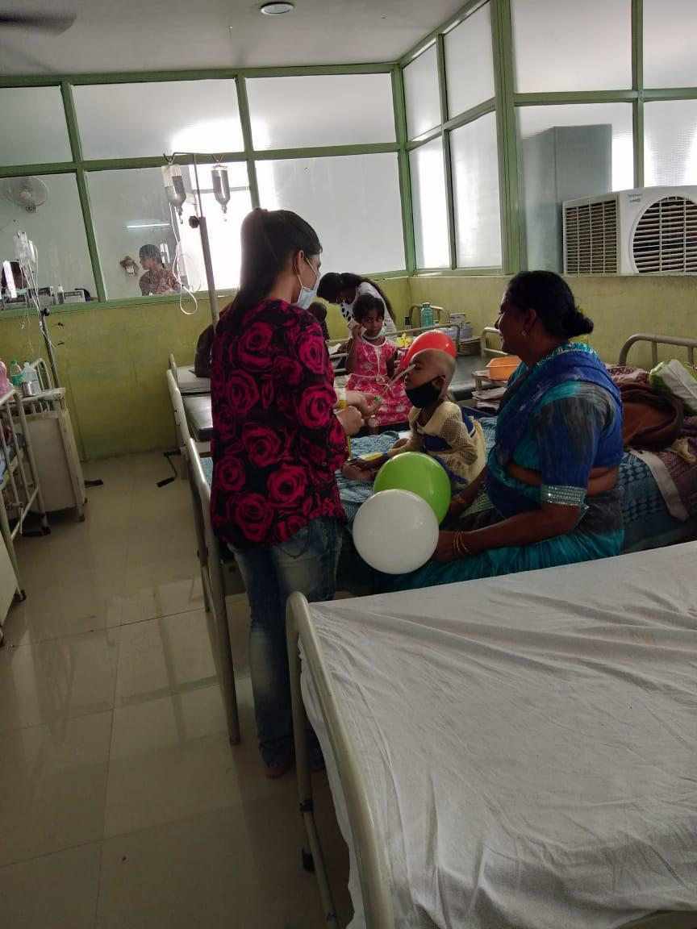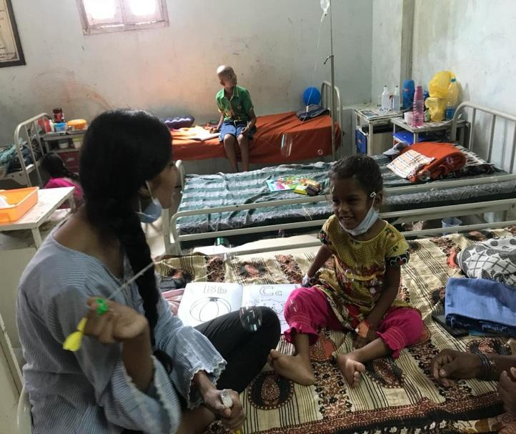
The event was made good with the help of class in-charge of B.Com 1HA and the funds raised by the students of the respective class were utilised for purchasing the gifts for the kids.

