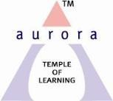
Aurora’s Degree & PG College
Chikkadpally, Hyderabad 500020
NAME OF THE EVENT : | Karl Weierstrass Birthday
FACULTY INCHARGE | B.MANASA
DEPARTMENT | MATHEMATICS
DATE | 31/10/2018
VENUE | RTC X Road , VI block.
TARGET AUDIENCE | MSCs 1A Students
SPEAKER | -

Objective:

- To know about Karl Weierstrass , the Genius Who Continues to Amaze the World.
- To motivate students towards research
- To create a platform to the students to explore their talent in mathematics
Brief about the event:
Every year Department of Mathematics celebrates Karl Weierstrass Birthday on 31st October. Students have done charts on Weierstrass life history and achievements. Students presented a PPT on Weierstrass Life, his works in various areas.
OUTCOME:
All the students got inspired with his contributions and his theories in calculus. Students got to know his significant achievements in calculus of variants.

Photographs
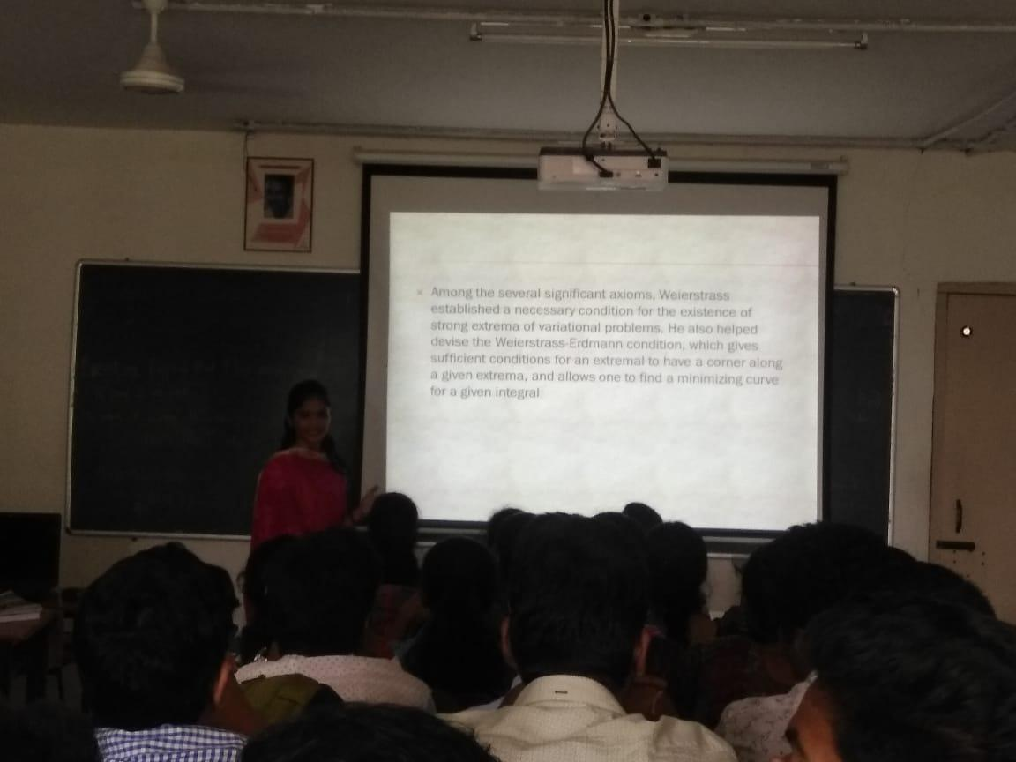 | 