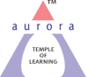
Aurora’s Degree & PG College

(Accredited by NAAC with 'B++' grade)
Chikkadpally, Hyderabad 500020
Department of Biochemistry

EVENT REPORT

NAME OF THE EVENT | National Doctor’s Day
TYPE OF EVENT | Webinar on “Resident wellness and Resilience”
FACULTY INCHARGE | P.Suvarna
DEPARTMENT | Department of Biochemistry
DATE | 1st July 2020
VENUE | Online
TARGET AUDIENCE | Faculty, research scholars, UG Students and others

OBJECTIVE:
Webinar on “Resident wellness and Resilience” is to create awareness among people about the importance of homely food in maintain health.
- To focus on the life style disorders and measures for the prevention.
- To motivate the students towards a healthy life style.

BRIEF ABOUT THE EVENT:
“Resident wellness and Resilience” webinar on account of National Doctor’s Day was organized on 1st July 2020 from 03:30p.m to 4:30pm through online mode using zoom application.
- PPT presentation on “Resident wellness and Resilience”.

OUTCOMES:
Speaker Dr. Rajeev Garg has presented the session which included basic information on Healthy life style. He also gave a detailed note on life style disorders like Diabetes, types of Diabetes and its prevention. Webinar ended with a good question and answer session followed by the feedback response by participants.

PHOTOGRAPHS:

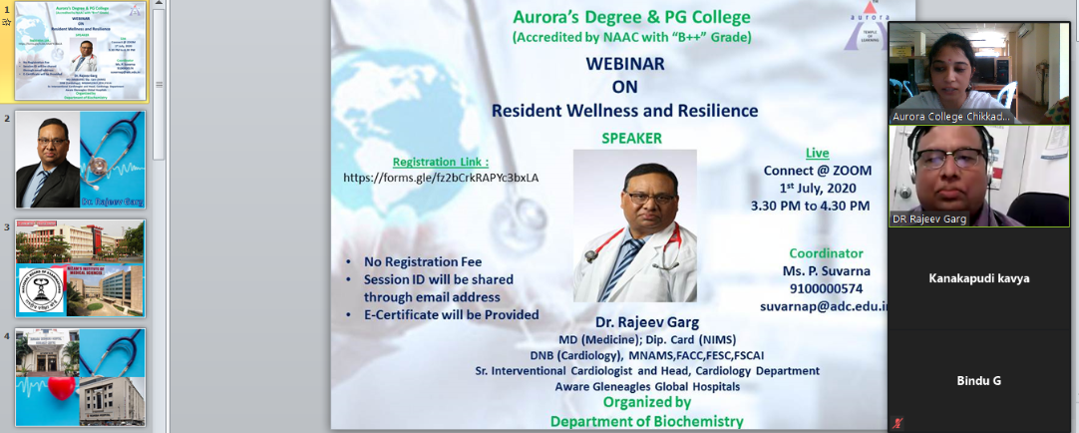

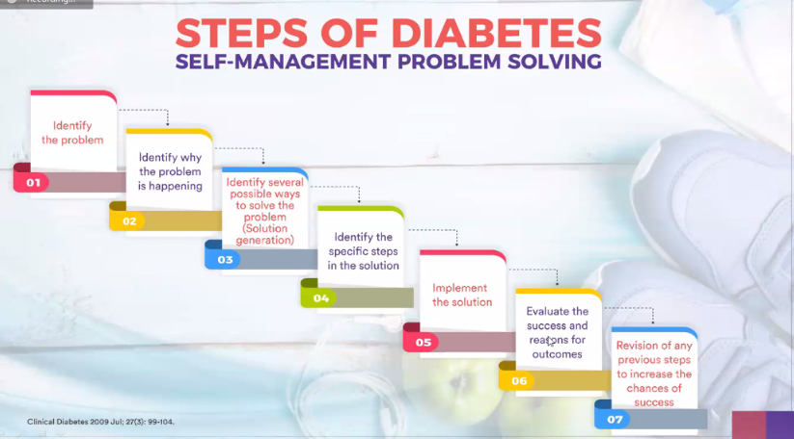

Aurora’s Degree & PG College

(Accredited by NAAC with 'B++' grade)
Chikkadpally, Hyderabad 500020
Department of Biochemistry

EVENT REPORT

NAME OF THE EVENT | National Doctor’s Day
TYPE OF EVENT | Webinar on “Resident wellness and Resilience”
FACULTY INCHARGE | P.Suvarna
DEPARTMENT | Department of Biochemistry
DATE | 1st July 2020
VENUE | Online
TARGET AUDIENCE | Faculty, research scholars, UG Students and others

OBJECTIVE:
Webinar on “Resident wellness and Resilience” is to create awareness among people about the importance of homely food in maintain health.
- To focus on the life style disorders and measures for the prevention.
- To motivate the students towards a healthy life style.

BRIEF ABOUT THE EVENT:
“Resident wellness and Resilience” webinar on account of National Doctor’s Day was organized on 1st July 2020 from 03:30p.m to 4:30pm through online mode using zoom application.
- PPT presentation on “Resident wellness and Resilience”.

OUTCOMES:
Speaker Dr. Rajeev Garg has presented the session which included basic information on Healthy life style. He also gave a detailed note on life style disorders like Diabetes, types of Diabetes and its prevention. Webinar ended with a good question and answer session followed by the feedback response by participants.

PHOTOGRAPHS:

DETAILED REPORT:
National Doctor’s Day is celebrated every year on 1st of July. No doubt the doctors play an important role in our life. The day raises awareness about the roles, importance, and responsibilities of doctors and to promote the medical profession.
It is truly said that we can’t see God but on Earth Doctor is like a God who cures us and gives us life to live in a better way.
This day provides us an opportunity to thank physicians, doctors that they do for the patients, the communities they work in, and for the society as a whole. No doubt it is their hard work that keeps us all healthy.
In order to create awareness among people on Healthy life style, Disorders and importance of homely food to address all these things Webinar on “Resident Wellness and Resilience” was conducted by Department of Biochemistry on 1st of July 2020 from 3:30p.m to 4:30pm through video conferencing application zoom. This session was presented by an esteemed speaker Dr. Rajeev Garg. Webinar involved information regarding insights of Self-management problem solving and how to encounter life style disorders.
Webinar started with the welcome speech and addressing guest profile followed by presentation and later it came to an end with a question and answer session followed by participant’s feedback.

SPEAKER’S PROFILE:
DR RAJEEV GARG,
Sr.Interventional Cardiologist
HOD- Cardiology Dept,
Aware Gleneagles Global Hospitals.
Qualification: MD (Medicine); Dip. Card (NIMS)
DNB (Cardiology), MNAMS,FACC,FESC,FSCAI.

Life Membership: 1) Association of Physicians of India.
2) Peadiatric Cardiology Society of India.
3) Cardiology Society of India
4) Indian College of Intervention Cardiology
5) Indian Society of Echocardiography
6) Asia Pacific Society of Intervention Cardiology
7) Indian Society of Hypertension

Year and University of Qualification:

Degree | Year | Name of College | Name of University
MBBS  MD (Medicine)  DNB (Cardiology)  Dip Cardiology | 1989  1992  2001  2002 | Pt JNM  Medical College, Raipur.  Pt JNM  Medical College, Raipur.  National Board of Examination, New Delhi.  Nizam Institute of Medical Sciences, Hyderabad. | Ravishanker University, Raipur.  Ravishanker University, Raipur .  National Board of Examination, New Delhi.  Nizam Institute of Medical Sciences, Hyderabad.

Experience: Post MD
Designation | Hospital | Year
Sr. Resident Cardiology  DNB Resident Cardiology  Registrar Cardiology  Resident Dip Card  Consultant Cardiologist | NIMS  AMS, DDH, Hyd.  AMS, DDH, Hyd  NIMS  Yashoda Super speciality  Hospital, Malakpet | Feb 1993-Oct 1994  Nov 1994-Oct 1996  Nov 1996-Dec 1999  Jan2000-2002  Feb 2002 – Jan 2017
Presented six papers in National Conferences
Associated with following trials
- FAMI (Fragmin in Acute Myocardial Infarction) a double blind placebo trial under guidance of Professor VV Kakkar of Thrombosis Reasearch Institute London.
- RIVERA (Registry on IntraVenous Anticoagulation In the Elective and Primary Real World of Angioplasty) (Enoxparin in PCI) on going trial
- Principle investigator in Nicorandil OD preparation phase III trial
- Principle investigator for indian experience of Rimonabant a double
Blind placebo trial in Indian subjects.
5) Co investigator in SEEPIA & SHINE study: study of Automixoban (DTI) in NSTEMI.
6) Analysis of 12 Months Clinical Outcomes Associated with Implantation of Ultrathin
(60microm) Bare Metal Stent in an Unselected Real-world Population with Coronary
Artery Disease: Results from a Multi-centre Experience – JCDR
7) Performed about 3000 Angioplasties including Carotid, Renal and Peripheral
Angioplasties, 400 PBMV, about 200Pacemakers, ASD, PDA, RSOV device closure.
8) Associated with Heart Failure Clinics at the hospital and Performed LVAD(Left
ventricular Assist Device) and associated with Cardiac transplant program. Global team
has performed about 14 successful Cardiac transplants last year.
9) Visiting Faculty to TCTAP Seol South Korea.

