Aurora’s Degree & PG College
(ACCREDITED BY NAAC WITH 'B++' GRADE)
Chikkadpally,Hyderabad 500020

EVENT / ACTIVITY DETAILED REPORT

NAME OF THE EVENT / ACTIVITY | Prof. C. R. Rao’s Birth Centenary Celebrations
TYPE OR TITLE OF EVENT / ACTIVITY | Webinar
FACULTY INCHARGE | Convener: K.Parimala Diana Sudhir  Coordinator: D.Rajyalakshmi
DEPARTMENT/CELL/COMMITTEE/CLUB | Statistics
DATE | 10-09-2020
VENUE | Google Meet platform
TARGET AUDIENCE | Faculty, Research Scholars & Students

- PROGRAM SCHEDULE:
- Introduction : K.Parimala Diana Sudhir (Convener)
- Principal’s Address:Dr.VishwanadhamBulusu
- Welcoming the Speaker : K.Parimala Diana Sudhir
- Address by the Speaker : Prof.JammalamadakaSrinivasaRao(Distinguished
Professor, University of California, USA)
- Video presentation : D.Rajyalakshmi (Coordinator)
- Announcement of winners :K.Parimala Diana Sudhir
of the competitions
- Vote of thanks: :K.Parimala Diana Sudhir (Convener)
- LIST OF FACULTY COORDINATORS (DEPARTMENT):
- K.Parimala Diana Sudhir(HOD)-Convener
- D.Rajyalakshmi

- LIST OF THE STUDENT COORDINATORS (NAME , ROLL NO, CLASS & SECTION)
- Ms.Metilda (PGcaptain) - 1051-19-507-037
- Mr.Ashish (MSCS3A captain) - 1051-18-467-042
- MrRoopesh (MSCS3B captain) - 1051-18-467-051
- Mr.Krishna (MSCS3C captain) - 1051-18-467-102

- LIST OF THE PARTICIPANTS (NAME , ROLL NO, CLASS & SECTION, NO OF GIRLS, BOYS, CASTE )
Full Name of the Person | College Name | EMAILID | What is your level of satisfaction for the webinar | The subject matter was presented effectively | The webinar was informative | Suggest Topics for Future Webinars
Kiranmayi | Aurora degree and PG College | kiranmayip@adc.edu.in | 4 | 4 | 4
P.Nagadurga | Loyola Academy | pnagadurga76@gmail.com | 4 | 4 | 4 | Good
Yuthika | Rbvrr women's college | yuthika1911@gmail.com | 3 | 3 | 3
P. LaxmiPrasanna | RBVRR Women's college | laxmi.prasanna877@gmail.com | 4 | 4 | 4
RanjithaChul | University College of Science, OU | chulranjitha7386@gmail.com | 4 | 4 | 4
Dr. Sridhar Akiri | GIS, GITAM ( Deemed to be University ) | akirisridhar@gmail.com | 5 | 5 | 5 | R Software
NEMALI BHANU TEJA | Royal | bhanuteja.nemali@gmail.com | 5 | 5 | 5 | Stochastic processes
DR. SANJAY AGARWAL | J. N. K. Post Graduate College, Barabanki | dr.sanjayagarwal15@gmail.com | 5 | 5 | 5 | Statistics and Mathematics
T.V.Ramana | JawabanBharati Degree College | tvramanas@gmail.com | 5 | 5 | 5 | Conduct more seminars
G Mounika | Aurora's degree and Pg college | mounikagundala42@gmail.com | 5 | 5 | 5
Katheeja Mary G | MarudharKesari Jain College for Women | katheejamary15@gmail.com | 5 | 5 | 5 | Applications of advanced statistics
VailalaGnyanvarun | Bhavansvivekananda college | gnyanvarun8634@gmail.com | 4 | 5 | 5 | Internships
Dr. G. Mahesh | Geethanjali College of Engineering and Technology | gattumahesh790@gmail.com | 5 | 5 | 5 | Applications of Mathematics and statistics
DR. GOPATHI. DILEEP KUMAR | SRI SAI DEGREE AND PG COLLEGE | gopathi.dileepkumar@gmail.com | 5 | 5 | 5 | Excellent session
PerikaPallavi | TSWRDC(W)College.Nalgonda.mahatma Gandhi University | sunnyperika318@gmail.com | 5 | 5 | 5 | Yes
ManikantaBhoi | Central University of Odisha | manikantabhoi.sp@gmail.com | 5 | 5 | 5 | Design and analysis of experiments
ARUN KUMAR SARIPALLI | GayatriVidyaParishad college for Degree and p.g.courses(A) | arunkumarsaripalli9788@gmail.com | 5 | 5 | 5 | Nothing
V Mounika | St Ann's college for women's Mehdipatnam | mounikamona0919@gmail.com | 5 | 5 | 5
SRIPADH DESHPANDE | KESHAV MEMORIAL INSTITUTE OF COMMERCE AND SCIENCES | sripadhdeshpande@gmail.com | 5 | 5 | 5
JAYANTHY S | Periyar Arts college | jayanthykarthik0@gmail.com | 5 | 5 | 5
Dr. A. Mohan Babu | Dravidian University | mohanbabu.annam@gmail.com | 5 | 5 | 5 | Nice
Badavathkalpana | TSWRDC(W),kothagudem | kalpanachinni314@gmail.com | 5 | 5 | 5 | How to develop research skills by using statistical tools
Y Sri Krishna Mohan | Aurora's Degree and PG College | srikrishnamohany@adc.edu.in | 5 | 5 | 5 | Data analytics
MATAPATHI MAITREYI | BankatalBadruka College For Information Technology | maitreyimatapathi53@gmail.com | 5 | 5 | 5 | None
Dr.C.S.S.R.L. HanumanthaRao | M.R.(A). College Vizianagaram Andhra Pradesh | chraomr@gmail.com | 4 | 5 | 5 | Any Application Oriented Program In Statistics.
KabirPatil | AnandNiketan | kabirspatil@gmail.com | 5 | 5 | 5 | probablity
Indira Tiruveedhula | Maris Stella College | indu02112000@gmail.com | 4 | 4 | 5 | any career options in statistics
ASHIKA | Jss academy of higher education and research Mysore | ashikanayak79@gmail.com | 5 | 5 | 5 | Carrier opportunities for Statistics
Bandi.yamuna | tswrdckhothagudem | yamunagoud7@gmail.com | 5 | 5 | 5
Dr. RAJU SAKE | Department of Statistics, Sri Krishnadevaraya University, Anantapur. | raju.hcu2007@gmail.com | 4 | 4 | 4 | Satisfaction
BOGA MADHAVI | Sreedattha Institute of Engineering and Science | bogamadhavi286@gmail.com | 5 | 5 | 4 | Applications of Decision making process in management
Bandi.keerthi | TSWRDCWatKHAMMAM | bandikeerthi53@gmail.com | 5 | 4 | 5 | Yes
Yedlapallijagannadhapuri | AchrayaNagarjuna university | jagannadh_puri@rediffmail.com | 5 | 5 | 5 | Software related jobs for Statistics
DR. GOPATHI. DILEEP KUMAR | SRI SAI DEGREE AND PG COLLEGE | gopathi.dileepkumar@gmail.com | 5 | 5 | 5 | Excellent presentation
matetiprathyusha | aurora degree and pg college | matetiusha1996@gmail.com | 5 | 5 | 5
Sabbavarapusuribabu | M.R.College (A) | himababu72@gmail.com | 5 | 5 | 5 | Everything good organisation
NanagiriAkhila | University College of Science, OU | nanagiriakhila@gmail.com | 5 | 5 | 5 | Operational Research.  Quality Control.  Design of Experiment.
D.Suharsha | St.Anns college for women | suharshagoud123@gmail.com | 4 | 4 | 4
SandipGhanta | Seacom Skills University | sandipghanta11@gmail.com | 5 | 5 | 5 | Organize similar webinar.
GuthalaDivya | Telangana social welfare residential degree college for women | divyarao.feb14@gmail.com | 5 | 5 | 5 | Our request is to please conduct work shops on our subject statistics I think it will possible by you people only thank you.
Mr. V L N SRIHARI GADDAM | SPHOORTHY ENGINEERING COLLEGE | sriharivln@yahoo.co.in | 5 | 5 | 5 | directional data analysis
Sowmyavalli | Jss academy of higher education and research | sowmyavallirachaputi@gmail.com | 4 | 4 | 4 | How Statistics are used in clinical trials
KanaadPatil | AnandNiketan | kannsp123@gmail.com | 5 | 5 | 5 | game theory
Katheeja Mary G | MarudharKesari Jain College for Women | katheejamary15@gmail.com | 5 | 5 | 5 | Applications of advanced statistics
NITYANANDA GHOSH. | LOYOLA ACADEMY DEGREE & PG COLLEGE | nitya_loyola@yahoo.com | 5 | 5 | 5 | Mathematical Tools for understanding Sciences.
SwathiTheegalapally | Aurora's degree &pg college | tswathi2340@gmail.com | 5 | 5 | 5
Aliminetisushma | Aurora degree and pg college | sushmareddy875@gmail.com | 5 | 5 | 4
Harichandana.Ch | Mahatma jyothibaphule residential degree college for women | 7011Harichandana.Ch@gmail.com | 4 | 5 | 5 | Regression, time series
S Jayashree | R.B.V.R.R.Women's College | shree.eniganti.jaya@gmail.com | 5 | 5 | 5 | Testing of Hypothesis and Estimations with Application
PasalaHimagayatri | Govt junior college | himagayatri.pasala@gmail.com | 5 | 5 | 5 | Awesome
Syed AnaitullahBukharie | S p college ma road srinagarjammu and Kashmir | syedanaiyatbukharie@gmail.com | 2 | 1 | 1 | Design of experiment
VadapalliMounika | TSWRDCW Khammam | mounika.vadapalli38@gmail.com | 5 | 5 | 1 | Yes
AnithaMudhireddy | St.Pious X Degree & PG College for Women | reddyanitha1985@gmail.com | 4 | 5 | 5 | Data analysis using SPSS
Kishormahendrakar | Veda degree college | kishormahendrakar@gmail.com | 5 | 5 | 5 | Very nice topic
VARANASI PARDHA SARADHI SEKHAR | NALANDA DEGEREE COLLEGE | saradhisekhar@gmail.com | 5 | 5 | 5 | i want more webinars on the topics such regressions, correlation and topics whihc we use in daily life unknowingly
SOUMYA PANDIRI | Kasturba Gandhi Degree and PG College for women | soumyapandiricharu@gmail.com | 5 | 5 | 5
PanjalaMounika | University College of Science, OU. | mounikapanjala123@gmail.com | 5 | 4 | 5
Mohammed Quddus | Telangana University | mohdquddus.k143@gmail.com | 5 | 5 | 4 | Operation Research
KuntalaAmulya | Aurora Degree and Pg College | amulyakuntala98@gmail.com | 4 | 5 | 5
VailalaGnyanvarun | Bhavansvivekananda college | gnyanvarun8634@gmail.com | 5 | 4 | 5 | Internships
N VASANTHA KUMAR | Dravidian University | vasanthakumaran4@gmail.com | 5 | 5 | 5 | No
SabbavarapuMohanalasya | R.B.School | himagayatri.pasala@gmail.com | 5 | 5 | 5 | Good
VailalaGnyanvarun | Bhavansvivekananda college | gnyanvarun8634@gmail.com | 5 | 4 | 5 | Internships
Dr.RajuNellutla | Guru Nanak Institutions Technical Campus(A) | rajunellutla@gmail.com | 5 | 5 | 5 | Applications of statistics in data science
DebapriyoSengupta | Visva-Bharati university | senguptadebapriyo11@gmail.com | 4 | 5 | 5 | Python using in statistics and job aspects of statistics
BHARAT KUMAR | PGGC-11, PANJAB UNIVERSITY, CHANDIGARH | bhrt12.07.2001@gmail.com | 5 | 5 | 5
PuttaAnjaneyulu | Aurora'S Degree and PG College | anjaneyulup@adc.edu.in | 5 | 5 | 5
VelampudiSrinivasarao | Raghu institute of technology | vsr.rit@gmail.com | 4 | 4 | 4 | Nothing
JyotirmayeeNaik | Central University Of Odisha | jyotirmayeenaik45@gmail.com | 4 | 4 | 5
Pudivijayalakshmi | S.K.Degree College | rongaliindraneela@gmail.com | 5 | 5 | 5 | Everything good
TEJASWINEE SAHU | Central University of Odisha, Koraput | tejaswinee362@gmail.com | 5 | 4 | 4
KesaboinaSujatha | TSWRDCW Kothagudem | jassubolla@gmail.com | 5 | 5 | 5 | Relative to pandamic calculation
Malothukalyani | Tswrdcwkmm | kalyanimalothu6@gmail.com | 4 | 5 | 4
SARNALINA DATTA | VISVA-BHARATI UNIVERSITY | sarnalinadatta@gmail.com | 5 | 5 | 5
NITYANANDA GHOSH | LOYOLA ACADEMY DEGREE & PG COLLEGE | nitya_loyola@yahoo.com | 5 | 5 | 5 | Nanotechnology .
Kadapallapooja | Aurora degree and pg college | kadapallapooja.8639@gmail.com | 5 | 5 | 5
M V R Kameswari | GITAM University, Visakhapatnsm | mvrkameswari@gmail.com | 5 | 5 | 5
V SaiPrasanth | BankatlalBadruka College for information technology | vempatisaiprasanth98@gmail.com | 5 | 5 | 5 | My Suggestion is that the topics in Statistics are Theory of Estimation, Operations research,non parametric inference and Testing of Hypothesis this topics are very useful for Future webinars
SabbavarapuPydinaidu | Miracle engineering college | 2013rcraju@gmail.com | 5 | 5 | 5 | Super
Adithya Krishnan P | Indian Association for the Cultivation of Science, Kolkata | adithyakrishnanp@gmail.com | 4 | 5 | 5 | Statistics and stock market prediction
V Soumya | Gandhi Institute of Technology and Management | soumya.vishwas2811@gmail.com | 5 | 5 | 5
K.Sasikala | GITAM (Deemed to be University) | kondesasi@gmail.com | 5 | 5 | 5 | Good
K Nagaraju | Geethanjali College of Engineering and Technology | kastoori.nagaraju@gmail.com | 4 | 4 | 4
KeerthanaRamkumar | St. Francis College for women | keerthanaram018@gmail.com | 4 | 4 | 5 | Data science
Shivani | Aurora degree college | shivani.shivani70@gmail.com | 5 | 5 | 5
Mr. V L N SRIHARI GADDAM | SPHOORTHY ENGINEERING COLLEGE | sriharivln@yahoo.co.in | 5 | 5 | 5 | Directional data analysis
Dr.K.ArumaKumari | Gitam (Deemed to be)University | akatraga@gitam.edu | 5 | 5 | 5 | Good
Dr. A. Mohan Babu | Dravidian University | mohanbabu.annam@gmail.com | 5 | 4 | 5 | Nice
Dr S GOVINDA RAO | ANGRAU, Agricultural College, Naira | govinda.seepana@gmail.com | 3 | 4 | 4 | Role of Statistics in Agriculture
Malothukalyani | Tswrdcwkmm | kalyanimalothu6@gmail.com | 5 | 4 | 5
Badavathkalpana | TSWRDC(W), kothagudem | kalpanachinni314@gmail.com | 5 | 5 | 5 | No
ManimangalamHemalatha | Krishna chaytanya degree clg | hemalathamanimangalam@gmail.com | 5 | 5 | 5
Magantisivaparvathi | P. B Siddhartha college of arts and science | msivaparvathi0705@gmail.com | 5 | 5 | 5
K.Sigmateena | TSWRDC(W), Kothagudem | sigmateena3@gmail.com | 5 | 5 | 5 | Number series
GangadharKishanraoPatil | ACS College ShankarnagarTq.BiloliDistNanded,Maharashtra | gkpatil2012@gmail.com | 5 | 5 | 5 | How to teach Mathematics online?
DandibhotlaSwetha | Maris Stella College | dandibhotlaswetha@gmail.com | 5 | 5 | 5 | Directional analysis
B.veda | St.ann's college for women | bellaryveda2000@gmail.com | 5 | 4 | 5 | More on statistics
B.veda | St.ann's college for women | bellaryveda2000@gmail.com | 5 | 4 | 5 | More on statistics
JWALITHA UBBANA | TSWRDC-W Kothagudem | p.jwalitha@gmail.com | 4 | 5 | 5
T. Mani | TSWRDC kothagudem | thudummani2012@gmail.com | 4 | 4 | 4
DivyaSindhuraKetha | Maris Stella College | divyasindhura28@gmail.com | 5 | 5 | 5 | ANOVA
Malothukalyani | Tswrdcwkmm | kalyanimalothu6@gmail.com | 5 | 4 | 5
P. Clarissa Mercy Jael Raj | At. Ann's High School | clarissajael28@gmail.com | 5 | 5 | 5
Dr S GOVINDA RAO | ANGRAU, Agricultural College, Naira | govinda.seepana@gmail.com | 4 | 3 | 4 | Recent Advances in Agricultural Statistics
DR.S.PAVAN KUMAR | GITAM DEEMED TO BE UNIVERSITY, BENGALURU | psubbar@gitam.edu | 5 | 5 | 5 | No suggestions
ALMUHAMED ZUFAIR N | Presidency College, Chennai | muhzuf@gmail.com | 2 | 3 | 3 | Data Science and it's uses
Mr. POLISETTI RAVI KISHORE | SRINIVASA INSTITUTE OF ENGINEERING AND TECHNOLOGY, Cheyyeru | ravi.polisetti@gmail.com | 5 | 5 | 5 | Nice
ThangaveluNithya | Krishna Chaithanya | nithyathangavelu332@gmail.com | 5 | 5 | 5
VARANASI PARDHA SARADHI SEKHAR | NALANDA DEGREE COLLEGE | saradhisekhar@gmail.com | 5 | 5 | 5 | on the topics such as regression ,correlation
P. Clarissa Mercy Jael Raj | At. Ann's High School | clarissajael28@gmail.com | 5 | 5 | 5
MuddasuMounika | Aurora's Degree and PG College | muddasumounika546@gmail.com | 4 | 4 | 4 | Python and also job suggestion in the field of statistics in govt sector
Dr R SubbaRao | Sagi Rama KrishnamRaju Engineering College Bhimavaram | rsubbarao9@gmail.com | 5 | 5 | 5 | Application of sqc in directional data
Dr. P. Vijaya Kumar | GIS, GITAM(Deemed to be University), Visakhapatnam | vk.gitam@gmail.com | 5 | 5 | 5 | Data science
MD. BUSHRA AFREEN | TSWRDC ( W ) BHADRADRI KOTHAGUDEM | bushraafreen555@gmail.com | 5 | 4 | 5 | Please Conduct the another Webinor Taxation
RamanandBalivada | Master Minds | ramanandbalivada@gmail.com | 4 | 5 | 5 | Drawing conclusions using Statistical Inference to overcome post-covid problems. (Happy if the program is technically improved next time.)
tspavani865@gmail.com | Dravidian university | tspavani865@gmail.com | 5 | 5 | 5 | statistical inference
AkulaShailaja | Aurora's degree and pg college | shailajaakula86@gmail.com | 5 | 5 | 5 | What kind of carreropportunities of statistics in our India?
PerikaPallavi | TSWRDC(W)College,Nalgonda.Mahatma Gandhi University | sunnyperika318@gmail.com | 5 | 5 | 5 | We want many web meeting
S PAVANI | Dravidian university | tspavani865@gmail.com | 5 | 5 | 5 | Statistical inference
MD. BUSHRA AFREEN | TSWRDC (W) BHADRADRI KOTHAGUDEM | bushraafreen555@gmail.com | 5 | 4 | 5 | Please Conduct the another Webinor Taxation
Ramesh kale | Anurag college of engineering | ramesh.kale2009@gmail.com | 5 | 1 | 5 | Nothing sir
Rajya Lakshmi | Aurora's Degree PG College | rajyalakshmid@adc.edu.in | 5 | 5 | 5
Lipsa Rani Bhoi | Central University of odisha, Koraput | lipsharanibhoi13@gmail.com | 4 | 5 | 5 | Arima model timeseries real life examples
Prasuna | Krishna Teja | drprasuna9@gmail.com | 5 | 5 | 5 | Operations Research
raghuthanda@gmail.com | CMR ENGINEERING COLLEGE | raghuthanda@gmail.com | 5 | 5 | 5 | Very good session
ALLUGUVELLI RAMESH | Geethanjali college of Engineering and Technology | alluramesh1@gmail.com | 5 | 5 | 5
ALLUGUVELLI RAMESH | Geethanjali college of Engineering and Technology | alluramesh1@gmail.com | 5 | 5 | 5 | Nothing
Dr.A.Swetha | Dravidian University | swetha.ammiti@gmail.com | 5 | 5 | 5 | Good
Dr K Venkatesbwarlu | Geethanjali College of Engineering and Technology | venkat1812@gmail.com | 5 | 5 | 5 | No
Dr K Venkateshwarlu | Geethanjali College of Engineering and Technology | venkat1812@gmail.com | 5 | 5 | 5
S PAVANI | Dravidian university | tspavani865@gmail.com | 5 | 5 | 5 | Statistical inference
Sabbavarapu Lakshmi | M.R.High school | 2013rcraju@gmail.com | 5 | 5 | 5 | Good
RongaliIndraneela | Quadrant | rongaliindraneela@gmail.com | 5 | 5 | 5 | Awesome
RongaliRajpreetham | Avanthi engineering college | 2013rcraju@gmail.com | 5 | 5 | 5 | Awesome
Karri Mohanrao | Miracle engineering college | 2013rcraju@gmail.com | 5 | 5 | 5 | Good
Karri Arunakumari | Andhra University | rongaliindraneela@gmail.com | 5 | 5 | 5 | Awesome
SirimillaPravalika | Aurora degree and pg college | napravalika2114@gmail.com | 5 | 5 | 5 | Artificial intelligence
SireeshaVeeramachaneni | GITAM (Deemed to be University) | vsirisha80@gmail.com | 4 | 5 | 5
JAMALAPURAM SRAVANTHI | TSWRDCC(W)SANGAREDDY | sravanthijamalapuram@gmail.com | 5 | 5 | 5 | Probability problems..
kadariSrinivasaRao | BJR GDC Narayanaguda Hyderabad | kadarisrinu@gmail.com | 5 | 5 | 5 | Good
SandipGhanta | Seacom Skills University | sandipghanta11@gmail.com | 5 | 5 | 5 | Organize similar webinar
Anithakunduru | T. S. W. R. D. C(w) Nalgonda | kunduruanitha2000@gmail.com | 5 | 4 | 4 | No
BhandaviBommishetti | TSWRDC (w), Nalgonda | bommishettib10@gmail.com | 5 | 4 | 4 | No
Dr.SreedharNamburi | GITAM (Deemed to be University) | sreedharnamburi13@gmail.com | 5 | 5 | 5 | No
Dr. Mahesh Kumar Panda | Central University of Odisha | mahesh2123ster@gmail.com | 4 | 5 | 5
Dr SATHISH JANJETI | GayatriVidyaParishad College of Engineering (Autonomous) | jsathish@gvpce.ac.in | 5 | 5 | 5 | Statistics
R. Srilakshmi | BJR Govt degree college | r.srilakshmi8@gmail.com | 4 | 4 | 5
MD.AZRA SHAREEN | TSWRDC W VIKARABAD | azrashareen666@gmail.com | 4 | 4 | 4 | Thank you sir
GouthamSwapna | Geethanjali College of Pharmacy | swapna4984@gmail.com | 5 | 5 | 5 | No
S lakshmi | MRH School | rongalilakshm1976@gmli.com | 5 | 4 | 5 | No
M.VARALAKSHMI | Vishwaviswani business school | parepallivaralakshmi@gmail.com | 5 | 5 | 4 | Conduct SPSS program
Vinita Jaichander | Aurora Degree and PG College | jvinita18@gmail.com | 5 | 5 | 5
SATHISH JANJETI | GayatriVidyaParishad College of Engineering (Autonomous) | jsathish@gvpce.ac | 5 | 5 | 5
D.Suharsha | St.Anns college for women | suharshagoud123@gmail.com | 4 | 4 | 4
Dr.SreedharNamburi | GITAM (Deemed to be University) | sreedharnamburi13@gmail.com | 5 | 5 | 5 | No
Dr.SreedharNamburi | GITAM (Deemed to be University) | sreedharnamburi13@gmail.com | 5 | 5 | 5 | No
Dr.SreedharNamburi | GITAM (Deemed to be University) | sreedharnamburi13@gmail.com | 5 | 5 | 5 | No
Dr SATHISH JANJETI | GayatriVidyaParishad College of Engineering (Autonomous) | jsathish@gvpce.ac | 5 | 5 | 5 | Multiple regression
SANDHYA JELDI | MARIS STELLA COLLEGE VIJAYAWADA | sandhyajeldi@gmail.com | 5 | 5 | 5 | Nothing
VenkataSumanjaliMeka | Maris Stella College | sumanjalimeka@gmail.com | 5 | 4 | 4 | Uses of statistics...

- PARAGRAPH ABOUT THE PROCEEDINGS (TILL THE END OF THE EVENT)
A webinar on “Statistics and Chance” on the occasion of Birth Centenary Celebration’ s of Prof.C.R.Rao was organized by department of Statistics, Aurora’s Degree & PG College. It was organized on 10th September 2020 on Google meet platform for about 2 and ½ hrs.
Around 170 participants participated across India, which includes Professors, lecturers, teachers, research scholars, & students from 8th class to PG. Ms.K.Parimala Diana Sudhir convened the event.
The session started at the schedule time at 10:00am. The inaugural session was started by the convener, Ms.ParimalaSudhirwith welcome note followed by a briefing about the LIVING LEGEND, Prof.C.RadhakrishnaRao, world renowned Statistician on the occasion of his 100th birthday. She welcomed the speaker Prof. JammalamadakaSrinivasRao, who is a student of Prof.Rao.Principal Dr.VishwanadhamBulusu, gave a great and inspiring speech. He spoke crisply about the importance of the event. Principal suggested to utilize this opportunity to enhance their knowledge and make best use of this lecture by great personalities for their future career.
The session started with a brief introduction of the speaker Prof. JammalamadakaSrinivasaRao, a leading researcher in statistical science and distinguished professor from university of California, Santa Barbara, USA. He received Dr.C.R.Rao’s life time achievement award in December 2019.His lecture covered the major break-through and turning points in the journey of Statistics and he shared his experiences and achievementsas a student of Prof.C.RadhakrishnaRao.
His lecture covered various examples related to the following:
- Role of probability in inventory modeling, reliability systems.
- Stochastic modeling in the study of COVID data determining the chance of spreading from one person to another.
- Example related to optimal designs, randomized response surface designs & few examples related on probability concepts in developing statistical thinking.
The lecture went on for more than one 1hr. The convener thanked the speaker for such a useful, informative, knowledgeable lecture with elaborative examples on Chance Factor. A video presentation of Aurora’s students activity on promotion of C.R.Rao’s institute competitions (around 65 institutions in Hyderabad) was done. Ms.ParimalaSudhir thanked the speaker, Principal, Vice principal, all the participants across India, department members & student coordinators. Feedback form was provided at the end of the session. Participation certificate was provided to all the registered participants.Mr.ArjunRao,&Ms.Lakshmi from Computer Science department extended technical support throughout the webinar.
Organizing the event:
Prior to this event, the department members shared their thoughts on organizing this event. Principal & Vice Principal Mr.HariPrasadgave suggestions& provided technical support in organizing.
Two competitions conducted prior to the event.
- Poster presentation on “Explore Statistics “separately for High School, Intermediate and UG,PG students.
- E-quiz for UG, PG Statistics students on 8th September.
Ms.Rajyalakshmi coordinated to conduct the competitions with the help of student coordinators, Ms.metilda (PGcaptain). Mr.Ashish(MSCS3A captain), MrRoopesh(MSCS3B captain), &Mr.Krishna (MSCS3C captain).
The posterpreparation was done by Mr.Vishnu, and theorganising team sent mails to students, faculty regarding the event, & progress of the work is monitored by the convener. The participants for the competitions are from India, UK, &Dubia. Evaluation is done by the department faculty (internal) and external evaluation also was done for Poster presentation.
The external Evaluators are:
- Dr.Murthy, Professor, Department of Statistics ICFAI University, Hyderabad.
- Dr.Lalitha, Associate Professor, Department of Statistics, Kasturba Gandhi Degree College for Women.
- Ms.Srikala,Associate Professor, Department of Statistics, St.Ann’s Degree College for Women
Around 350 students participated for E-quiz & 20 students for poster presentation on “Explore Statistics”.

The winners for Poster presentation on “ Explore Statistics”:
POSTER PRESENTATION WINNERS
Name of the Student | Gpay/Ac no | IFSC Code | Prize | Cash Award | level | College Name
Nazmeen Sultana | 9000171786 |  | II | 500/- | Junior | St Anns Junior College(HYDERABAD)
Sidharth | 9894020673 |  | II | 500/- | Junior | AdityaVidyashramschoo(HYDERABAD)
AnushaShery | 9515371733 |  | II | 500/- | UG&PG | St Pious Degree College(HYDERABAD)
SusmitaLenka | AC 34259986562 | SBIN0002185 | I | 1000/- | UG&PG | Presidency College (CHENNAI)
SibanAshi | 9488829978 |  | II | 500/- | School | BharatiyaVidyaBhavan(HYDERABAD)
ManuelaVutukuri | AC007501024884 | ICIC0001111 | I | 1000/- | School | King Edward School (UK)
LalithaKumari |  |  | I | 1000/- | School | (HYDERABAD)

The cash prize was given to Poster Presentation winners from the department fund ( from previous event balance amount).Our department member Mr.MadhusudhanaRao also contribute 1000/ for prize.
Around 150 students got 100%in E-quiz competitions. Excellency certificates will be provided after screening in final roundson the Event “ International Statistics Day” to be scheduled on October 20th2020.
- INCOME AND EXPENDITURE
Expenditure for the Poster Presentation :Rs 5000/- ( 4000/- from the department previous event amount+ contribution of 1000/- from Mr.MadhusudhanaRao)

- EVENT PHOTOS ( MIN 2 MAX 4)

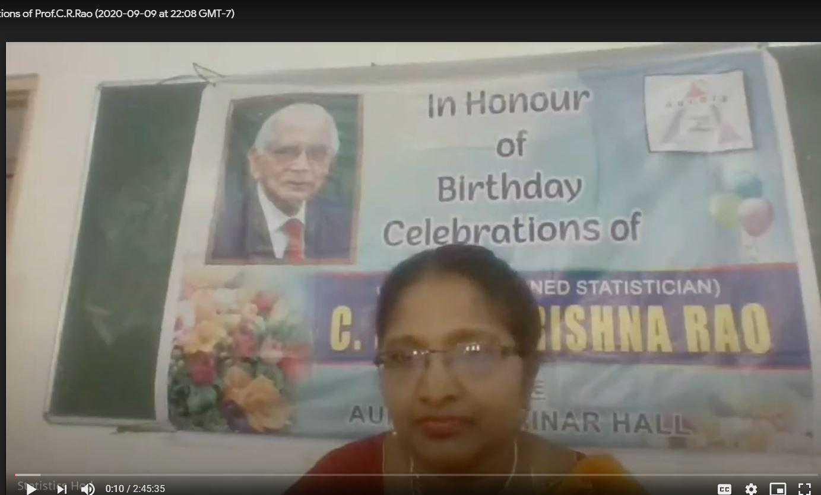

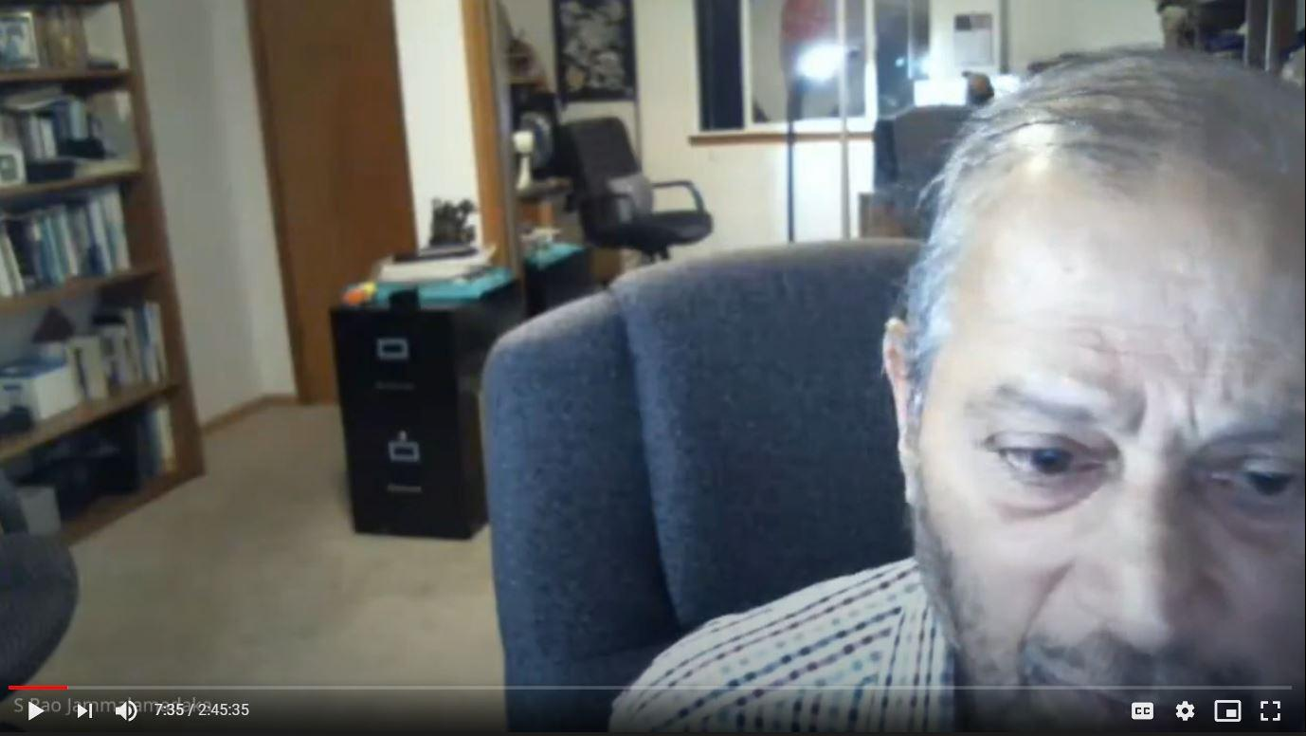
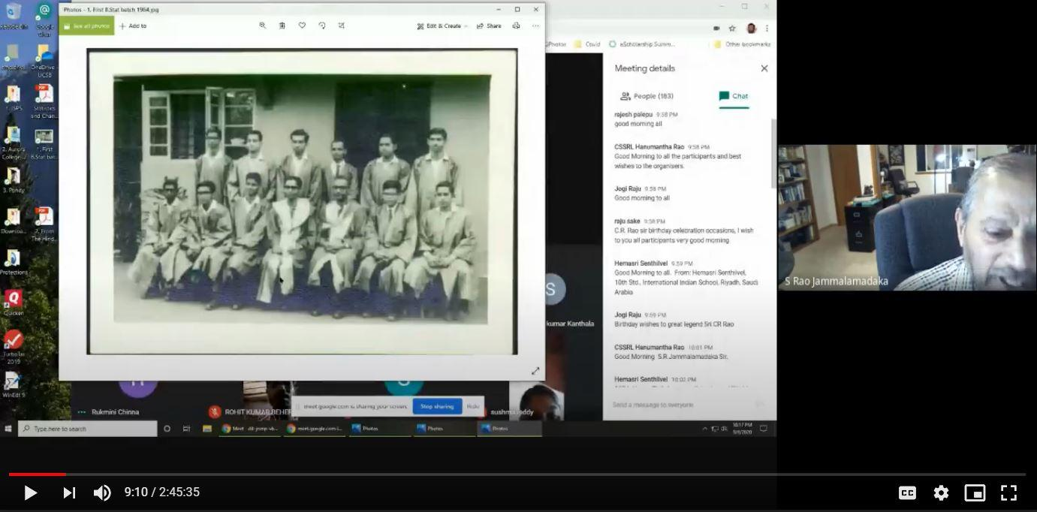
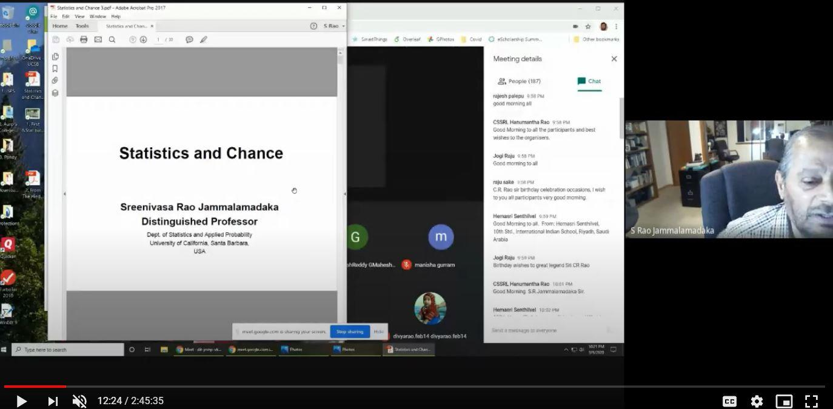
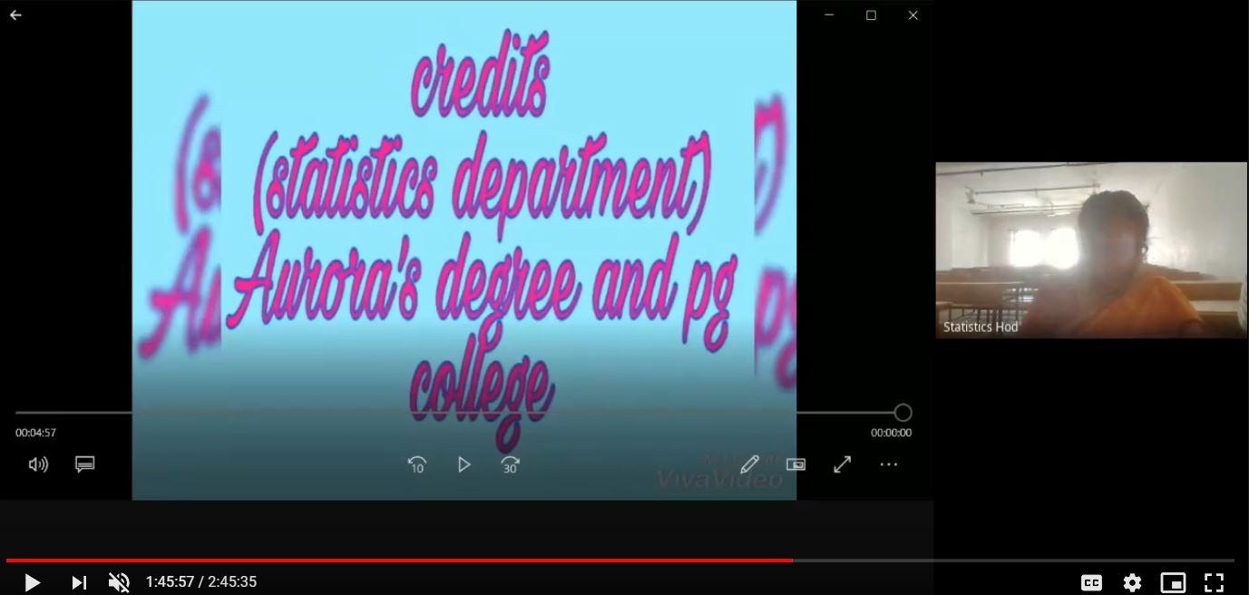

- GUEST PROFILE (IF ANY)
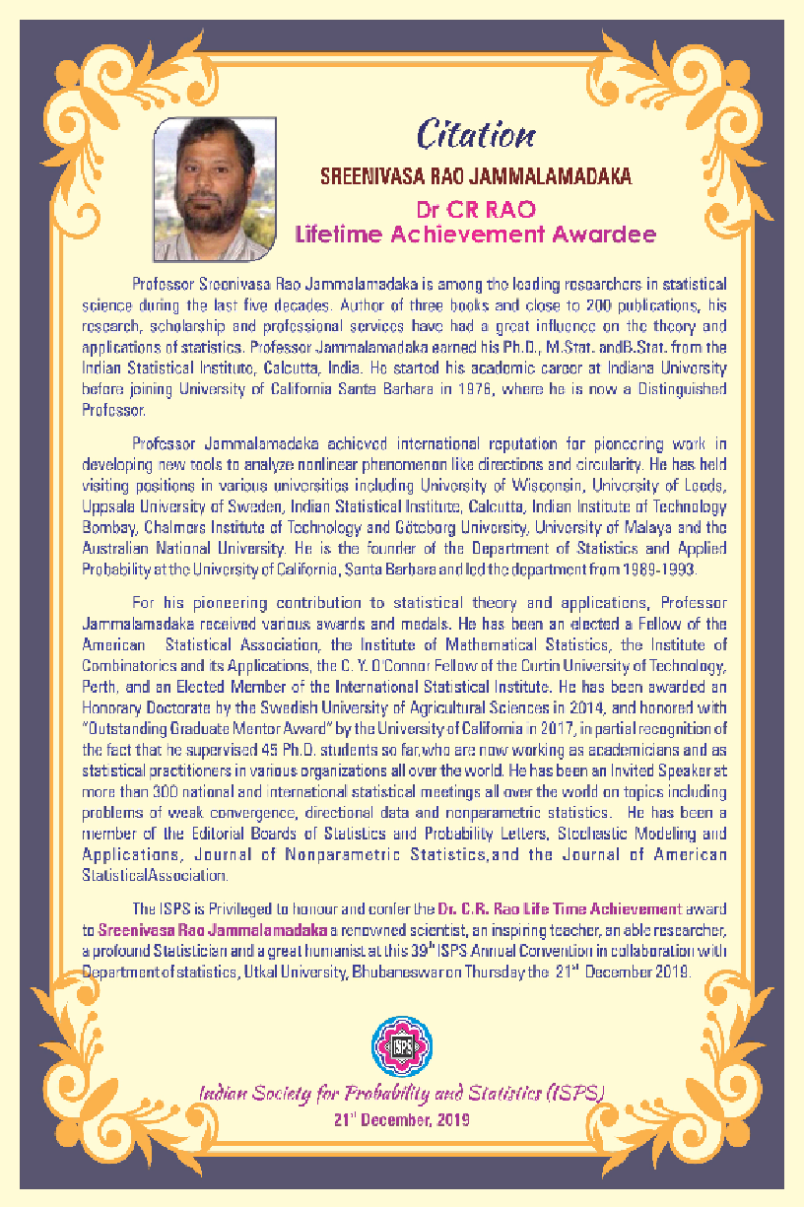
- FEED BACK IF ANY
Full Name of the Person | College Name | EMAILID | What is your level of satisfaction for the webinar | The subject matter was presented effectively | The webinar was informative | Suggest Topics for Future Webinars
Kiranmayi | Aurora degree and PG College | kiranmayip@adc.edu.in | 4 | 4 | 4
P.Nagadurga | Loyola Academy | pnagadurga76@gmail.com | 4 | 4 | 4 | Good
Yuthika | Rbvrr women's college | yuthika1911@gmail.com | 3 | 3 | 3
P. LaxmiPrasanna | RBVRR Women's college | laxmi.prasanna877@gmail.com | 4 | 4 | 4
RanjithaChul | University College of Science, OU | chulranjitha7386@gmail.com | 4 | 4 | 4
Dr. Sridhar Akiri | GIS, GITAM ( Deemed to be University ) | akirisridhar@gmail.com | 5 | 5 | 5 | R Software
NEMALI BHANU TEJA | Royal | bhanuteja.nemali@gmail.com | 5 | 5 | 5 | Stochastic processes
DR. SANJAY AGARWAL | J. N. K. Post Graduate College, Barabanki | dr.sanjayagarwal15@gmail.com | 5 | 5 | 5 | Statistics and Mathematics
T.V.Ramana | JawabanBharati Degree College | tvramanas@gmail.com | 5 | 5 | 5 | Conduct more seminars
G Mounika | Aurora's degree and Pg college | mounikagundala42@gmail.com | 5 | 5 | 5
Katheeja Mary G | MarudharKesari Jain College for Women | katheejamary15@gmail.com | 5 | 5 | 5 | Applications of advanced statistics
VailalaGnyanvarun | Bhavansvivekananda college | gnyanvarun8634@gmail.com | 4 | 5 | 5 | Internships
Dr. G. Mahesh | Geethanjali College of Engineering and Technology | gattumahesh790@gmail.com | 5 | 5 | 5 | Applications of Mathematics and statistics
DR. GOPATHI. DILEEP KUMAR | SRI SAI DEGREE AND PG COLLEGE | gopathi.dileepkumar@gmail.com | 5 | 5 | 5 | Excellent session
PerikaPallavi | TSWRDC(W)College.Nalgonda.mahatma Gandhi University | sunnyperika318@gmail.com | 5 | 5 | 5 | Yes
ManikantaBhoi | Central University of Odisha | manikantabhoi.sp@gmail.com | 5 | 5 | 5 | Design and analysis of experiments
ARUN KUMAR SARIPALLI | GayatriVidyaParishad college for Degree and p.g.courses(A) | arunkumarsaripalli9788@gmail.com | 5 | 5 | 5 | Nothing
V Mounika | St Ann's college for women's Mehdipatnam | mounikamona0919@gmail.com | 5 | 5 | 5
SRIPADH DESHPANDE | KESHAV MEMORIAL INSTITUTE OF COMMERCE AND SCIENCES | sripadhdeshpande@gmail.com | 5 | 5 | 5
JAYANTHY S | Periyar Arts college | jayanthykarthik0@gmail.com | 5 | 5 | 5
Dr. A. Mohan Babu | Dravidian University | mohanbabu.annam@gmail.com | 5 | 5 | 5 | Nice
Badavathkalpana | TSWRDC(W),kothagudem | kalpanachinni314@gmail.com | 5 | 5 | 5 | How to develop research skills by using statistical tools
Y Sri Krishna Mohan | Aurora's Degree and PG College | srikrishnamohany@adc.edu.in | 5 | 5 | 5 | Data analytics
MATAPATHI MAITREYI | BankatalBadruka College For Information Technology | maitreyimatapathi53@gmail.com | 5 | 5 | 5 | None
Dr.C.S.S.R.L. HanumanthaRao | M.R.(A). College Vizianagaram Andhra Pradesh | chraomr@gmail.com | 4 | 5 | 5 | Any Application Oriented Program In Statistics.
KabirPatil | AnandNiketan | kabirspatil@gmail.com | 5 | 5 | 5 | probablity
Indira Tiruveedhula | Maris Stella College | indu02112000@gmail.com | 4 | 4 | 5 | any career options in statistics
ASHIKA | Jss academy of higher education and research Mysore | ashikanayak79@gmail.com | 5 | 5 | 5 | Carrier opportunities for Statistics
Bandi.yamuna | tswrdckhothagudem | yamunagoud7@gmail.com | 5 | 5 | 5
Dr. RAJU SAKE | Department of Statistics, Sri Krishnadevaraya University, Anantapur. | raju.hcu2007@gmail.com | 4 | 4 | 4 | Satisfaction
BOGA MADHAVI | Sreedattha Institute of Engineering and Science | bogamadhavi286@gmail.com | 5 | 5 | 4 | Applications of Decision making process in management
Bandi.keerthi | TSWRDCWatKHAMMAM | bandikeerthi53@gmail.com | 5 | 4 | 5 | Yes
Yedlapallijagannadhapuri | AchrayaNagarjuna university | jagannadh_puri@rediffmail.com | 5 | 5 | 5 | Software related jobs for Statistics
DR. GOPATHI. DILEEP KUMAR | SRI SAI DEGREE AND PG COLLEGE | gopathi.dileepkumar@gmail.com | 5 | 5 | 5 | Excellent presentation
matetiprathyusha | aurora degree and pg college | matetiusha1996@gmail.com | 5 | 5 | 5
Sabbavarapusuribabu | M.R.College (A) | himababu72@gmail.com | 5 | 5 | 5 | Everything good organisation
NanagiriAkhila | University College of Science, OU | nanagiriakhila@gmail.com | 5 | 5 | 5 | Operational Research.  Quality Control.  Design of Experiment.
D.Suharsha | St.Anns college for women | suharshagoud123@gmail.com | 4 | 4 | 4
SandipGhanta | Seacom Skills University | sandipghanta11@gmail.com | 5 | 5 | 5 | Organize similar webinar.
GuthalaDivya | Telangana social welfare residential degree college for women | divyarao.feb14@gmail.com | 5 | 5 | 5 | Our request is to please conduct work shops on our subject statistics I think it will possible by you people only thank you.
Mr. V L N SRIHARI GADDAM | SPHOORTHY ENGINEERING COLLEGE | sriharivln@yahoo.co.in | 5 | 5 | 5 | directional data analysis
Sowmyavalli | Jss academy of higher education and research | sowmyavallirachaputi@gmail.com | 4 | 4 | 4 | How Statistics are used in clinical trials
KanaadPatil | AnandNiketan | kannsp123@gmail.com | 5 | 5 | 5 | game theory
Katheeja Mary G | MarudharKesari Jain College for Women | katheejamary15@gmail.com | 5 | 5 | 5 | Applications of advanced statistics
NITYANANDA GHOSH. | LOYOLA ACADEMY DEGREE & PG COLLEGE | nitya_loyola@yahoo.com | 5 | 5 | 5 | Mathematical Tools for understanding Sciences.
SwathiTheegalapally | Aurora's degree &pg college | tswathi2340@gmail.com | 5 | 5 | 5
Aliminetisushma | Aurora degree and pg college | sushmareddy875@gmail.com | 5 | 5 | 4
Harichandana.Ch | Mahatma jyothibaphule residential degree college for women | 7011Harichandana.Ch@gmail.com | 4 | 5 | 5 | Regression, time series
S Jayashree | R.B.V.R.R.Women's College | shree.eniganti.jaya@gmail.com | 5 | 5 | 5 | Testing of Hypothesis and Estimations with Application
PasalaHimagayatri | Govt junior college | himagayatri.pasala@gmail.com | 5 | 5 | 5 | Awesome
Syed AnaitullahBukharie | S p college ma road srinagarjammu and Kashmir | syedanaiyatbukharie@gmail.com | 2 | 1 | 1 | Design of experiment
VadapalliMounika | TSWRDCW Khammam | mounika.vadapalli38@gmail.com | 5 | 5 | 1 | Yes
AnithaMudhireddy | St.Pious X Degree & PG College for Women | reddyanitha1985@gmail.com | 4 | 5 | 5 | Data analysis using SPSS
Kishormahendrakar | Veda degree college | kishormahendrakar@gmail.com | 5 | 5 | 5 | Very nice topic
VARANASI PARDHA SARADHI SEKHAR | NALANDA DEGEREE COLLEGE | saradhisekhar@gmail.com | 5 | 5 | 5 | i want more webinars on the topics such regressions, correlation and topics whihc we use in daily life unknowingly
SOUMYA PANDIRI | Kasturba Gandhi Degree and PG College for women | soumyapandiricharu@gmail.com | 5 | 5 | 5
PanjalaMounika | University College of Science, OU. | mounikapanjala123@gmail.com | 5 | 4 | 5
Mohammed Quddus | Telangana University | mohdquddus.k143@gmail.com | 5 | 5 | 4 | Operation Research
KuntalaAmulya | Aurora Degree and Pg College | amulyakuntala98@gmail.com | 4 | 5 | 5
VailalaGnyanvarun | Bhavansvivekananda college | gnyanvarun8634@gmail.com | 5 | 4 | 5 | Internships
N VASANTHA KUMAR | Dravidian University | vasanthakumaran4@gmail.com | 5 | 5 | 5 | No
SabbavarapuMohanalasya | R.B.School | himagayatri.pasala@gmail.com | 5 | 5 | 5 | Good
VailalaGnyanvarun | Bhavansvivekananda college | gnyanvarun8634@gmail.com | 5 | 4 | 5 | Internships
Dr.RajuNellutla | Guru Nanak Institutions Technical Campus(A) | rajunellutla@gmail.com | 5 | 5 | 5 | Applications of statistics in data science
DebapriyoSengupta | Visva-Bharati university | senguptadebapriyo11@gmail.com | 4 | 5 | 5 | Python using in statistics and job aspects of statistics
BHARAT KUMAR | PGGC-11, PANJAB UNIVERSITY, CHANDIGARH | bhrt12.07.2001@gmail.com | 5 | 5 | 5
PuttaAnjaneyulu | Aurora'S Degree and PG College | anjaneyulup@adc.edu.in | 5 | 5 | 5
VelampudiSrinivasarao | Raghu institute of technology | vsr.rit@gmail.com | 4 | 4 | 4 | Nothing
JyotirmayeeNaik | Central University Of Odisha | jyotirmayeenaik45@gmail.com | 4 | 4 | 5
Pudivijayalakshmi | S.K.Degree College | rongaliindraneela@gmail.com | 5 | 5 | 5 | Everything good
TEJASWINEE SAHU | Central University of Odisha, Koraput | tejaswinee362@gmail.com | 5 | 4 | 4
KesaboinaSujatha | TSWRDCW Kothagudem | jassubolla@gmail.com | 5 | 5 | 5 | Relative to pandamic calculation
Malothukalyani | Tswrdcwkmm | kalyanimalothu6@gmail.com | 4 | 5 | 4
SARNALINA DATTA | VISVA-BHARATI UNIVERSITY | sarnalinadatta@gmail.com | 5 | 5 | 5
NITYANANDA GHOSH | LOYOLA ACADEMY DEGREE & PG COLLEGE | nitya_loyola@yahoo.com | 5 | 5 | 5 | Nanotechnology .
Kadapallapooja | Aurora degree and pg college | kadapallapooja.8639@gmail.com | 5 | 5 | 5
M V R Kameswari | GITAM University, Visakhapatnsm | mvrkameswari@gmail.com | 5 | 5 | 5
V SaiPrasanth | BankatlalBadruka College for information technology | vempatisaiprasanth98@gmail.com | 5 | 5 | 5 | My Suggestion is that the topics in Statistics are Theory of Estimation, Operations research,non parametric inference and Testing of Hypothesis this topics are very useful for Future webinars
SabbavarapuPydinaidu | Miracle engineering college | 2013rcraju@gmail.com | 5 | 5 | 5 | Super
Adithya Krishnan P | Indian Association for the Cultivation of Science, Kolkata | adithyakrishnanp@gmail.com | 4 | 5 | 5 | Statistics and stock market prediction
V Soumya | Gandhi Institute of Technology and Management | soumya.vishwas2811@gmail.com | 5 | 5 | 5
K.Sasikala | GITAM (Deemed to be University) | kondesasi@gmail.com | 5 | 5 | 5 | Good
K Nagaraju | Geethanjali College of Engineering and Technology | kastoori.nagaraju@gmail.com | 4 | 4 | 4
KeerthanaRamkumar | St. Francis College for women | keerthanaram018@gmail.com | 4 | 4 | 5 | Data science
Shivani | Aurora degree college | shivani.shivani70@gmail.com | 5 | 5 | 5
Mr. V L N SRIHARI GADDAM | SPHOORTHY ENGINEERING COLLEGE | sriharivln@yahoo.co.in | 5 | 5 | 5 | Directional data analysis
Dr.K.ArumaKumari | Gitam (Deemed to be)University | akatraga@gitam.edu | 5 | 5 | 5 | Good
Dr. A. Mohan Babu | Dravidian University | mohanbabu.annam@gmail.com | 5 | 4 | 5 | Nice
Dr S GOVINDA RAO | ANGRAU, Agricultural College, Naira | govinda.seepana@gmail.com | 3 | 4 | 4 | Role of Statistics in Agriculture
Malothukalyani | Tswrdcwkmm | kalyanimalothu6@gmail.com | 5 | 4 | 5
Badavathkalpana | TSWRDC(W), kothagudem | kalpanachinni314@gmail.com | 5 | 5 | 5 | No
ManimangalamHemalatha | Krishna chaytanya degree clg | hemalathamanimangalam@gmail.com | 5 | 5 | 5
Magantisivaparvathi | P. B Siddhartha college of arts and science | msivaparvathi0705@gmail.com | 5 | 5 | 5
K.Sigmateena | TSWRDC(W), Kothagudem | sigmateena3@gmail.com | 5 | 5 | 5 | Number series
GangadharKishanraoPatil | ACS College ShankarnagarTq.BiloliDistNanded,Maharashtra | gkpatil2012@gmail.com | 5 | 5 | 5 | How to teach Mathematics online?
DandibhotlaSwetha | Maris Stella College | dandibhotlaswetha@gmail.com | 5 | 5 | 5 | Directional analysis
B.veda | St.ann's college for women | bellaryveda2000@gmail.com | 5 | 4 | 5 | More on statistics
B.veda | St.ann's college for women | bellaryveda2000@gmail.com | 5 | 4 | 5 | More on statistics
JWALITHA UBBANA | TSWRDC-W Kothagudem | p.jwalitha@gmail.com | 4 | 5 | 5
T. Mani | TSWRDC kothagudem | thudummani2012@gmail.com | 4 | 4 | 4
DivyaSindhuraKetha | Maris Stella College | divyasindhura28@gmail.com | 5 | 5 | 5 | ANOVA
Malothukalyani | Tswrdcwkmm | kalyanimalothu6@gmail.com | 5 | 4 | 5
P. Clarissa Mercy Jael Raj | At. Ann's High School | clarissajael28@gmail.com | 5 | 5 | 5
Dr S GOVINDA RAO | ANGRAU, Agricultural College, Naira | govinda.seepana@gmail.com | 4 | 3 | 4 | Recent Advances in Agricultural Statistics
DR.S.PAVAN KUMAR | GITAM DEEMED TO BE UNIVERSITY, BENGALURU | psubbar@gitam.edu | 5 | 5 | 5 | No suggestions
ALMUHAMED ZUFAIR N | Presidency College, Chennai | muhzuf@gmail.com | 2 | 3 | 3 | Data Science and it's uses
Mr. POLISETTI RAVI KISHORE | SRINIVASA INSTITUTE OF ENGINEERING AND TECHNOLOGY, Cheyyeru | ravi.polisetti@gmail.com | 5 | 5 | 5 | Nice
ThangaveluNithya | Krishna Chaithanya | nithyathangavelu332@gmail.com | 5 | 5 | 5
VARANASI PARDHA SARADHI SEKHAR | NALANDA DEGREE COLLEGE | saradhisekhar@gmail.com | 5 | 5 | 5 | on the topics such as regression ,correlation
P. Clarissa Mercy Jael Raj | At. Ann's High School | clarissajael28@gmail.com | 5 | 5 | 5
MuddasuMounika | Aurora's Degree and PG College | muddasumounika546@gmail.com | 4 | 4 | 4 | Python and also job suggestion in the field of statistics in govt sector
Dr R SubbaRao | Sagi Rama KrishnamRaju Engineering College Bhimavaram | rsubbarao9@gmail.com | 5 | 5 | 5 | Application of sqc in directional data
Dr. P. Vijaya Kumar | GIS, GITAM(Deemed to be University), Visakhapatnam | vk.gitam@gmail.com | 5 | 5 | 5 | Data science
MD. BUSHRA AFREEN | TSWRDC ( W ) BHADRADRI KOTHAGUDEM | bushraafreen555@gmail.com | 5 | 4 | 5 | Please Conduct the another Webinor Taxation
RamanandBalivada | Master Minds | ramanandbalivada@gmail.com | 4 | 5 | 5 | Drawing conclusions using Statistical Inference to overcome post-covid problems. (Happy if the program is technically improved next time.)
tspavani865@gmail.com | Dravidian university | tspavani865@gmail.com | 5 | 5 | 5 | statistical inference
AkulaShailaja | Aurora's degree and pg college | shailajaakula86@gmail.com | 5 | 5 | 5 | What kind of carreropportunities of statistics in our India?
PerikaPallavi | TSWRDC(W)College,Nalgonda.Mahatma Gandhi University | sunnyperika318@gmail.com | 5 | 5 | 5 | We want many web meeting
S PAVANI | Dravidian university | tspavani865@gmail.com | 5 | 5 | 5 | Statistical inference
MD. BUSHRA AFREEN | TSWRDC (W) BHADRADRI KOTHAGUDEM | bushraafreen555@gmail.com | 5 | 4 | 5 | Please Conduct the another Webinor Taxation
Ramesh kale | Anurag college of engineering | ramesh.kale2009@gmail.com | 5 | 1 | 5 | Nothing sir
Rajya Lakshmi | Aurora's Degree PG College | rajyalakshmid@adc.edu.in | 5 | 5 | 5
Lipsa Rani Bhoi | Central University of odisha, Koraput | lipsharanibhoi13@gmail.com | 4 | 5 | 5 | Arima model timeseries real life examples
Prasuna | Krishna Teja | drprasuna9@gmail.com | 5 | 5 | 5 | Operations Research
raghuthanda@gmail.com | CMR ENGINEERING COLLEGE | raghuthanda@gmail.com | 5 | 5 | 5 | Very good session
ALLUGUVELLI RAMESH | Geethanjali college of Engineering and Technology | alluramesh1@gmail.com | 5 | 5 | 5
ALLUGUVELLI RAMESH | Geethanjali college of Engineering and Technology | alluramesh1@gmail.com | 5 | 5 | 5 | Nothing
Dr.A.Swetha | Dravidian University | swetha.ammiti@gmail.com | 5 | 5 | 5 | Good
Dr K Venkatesbwarlu | Geethanjali College of Engineering and Technology | venkat1812@gmail.com | 5 | 5 | 5 | No
Dr K Venkateshwarlu | Geethanjali College of Engineering and Technology | venkat1812@gmail.com | 5 | 5 | 5
S PAVANI | Dravidian university | tspavani865@gmail.com | 5 | 5 | 5 | Statistical inference
Sabbavarapu Lakshmi | M.R.High school | 2013rcraju@gmail.com | 5 | 5 | 5 | Good
RongaliIndraneela | Quadrant | rongaliindraneela@gmail.com | 5 | 5 | 5 | Awesome
RongaliRajpreetham | Avanthi engineering college | 2013rcraju@gmail.com | 5 | 5 | 5 | Awesome
Karri Mohanrao | Miracle engineering college | 2013rcraju@gmail.com | 5 | 5 | 5 | Good
Karri Arunakumari | Andhra University | rongaliindraneela@gmail.com | 5 | 5 | 5 | Awesome
SirimillaPravalika | Aurora degree and pg college | napravalika2114@gmail.com | 5 | 5 | 5 | Artificial intelligence
SireeshaVeeramachaneni | GITAM (Deemed to be University) | vsirisha80@gmail.com | 4 | 5 | 5
JAMALAPURAM SRAVANTHI | TSWRDCC(W)SANGAREDDY | sravanthijamalapuram@gmail.com | 5 | 5 | 5 | Probability problems..
kadariSrinivasaRao | BJR GDC Narayanaguda Hyderabad | kadarisrinu@gmail.com | 5 | 5 | 5 | Good
SandipGhanta | Seacom Skills University | sandipghanta11@gmail.com | 5 | 5 | 5 | Organize similar webinar
Anithakunduru | T. S. W. R. D. C(w) Nalgonda | kunduruanitha2000@gmail.com | 5 | 4 | 4 | No
BhandaviBommishetti | TSWRDC (w), Nalgonda | bommishettib10@gmail.com | 5 | 4 | 4 | No
Dr.SreedharNamburi | GITAM (Deemed to be University) | sreedharnamburi13@gmail.com | 5 | 5 | 5 | No
Dr. Mahesh Kumar Panda | Central University of Odisha | mahesh2123ster@gmail.com | 4 | 5 | 5
Dr SATHISH JANJETI | GayatriVidyaParishad College of Engineering (Autonomous) | jsathish@gvpce.ac.in | 5 | 5 | 5 | Statistics
R. Srilakshmi | BJR Govt degree college | r.srilakshmi8@gmail.com | 4 | 4 | 5
MD.AZRA SHAREEN | TSWRDC W VIKARABAD | azrashareen666@gmail.com | 4 | 4 | 4 | Thank you sir
GouthamSwapna | Geethanjali College of Pharmacy | swapna4984@gmail.com | 5 | 5 | 5 | No
S lakshmi | MRH School | rongalilakshm1976@gmli.com | 5 | 4 | 5 | No
M.VARALAKSHMI | Vishwaviswani business school | parepallivaralakshmi@gmail.com | 5 | 5 | 4 | Conduct SPSS program
Vinita Jaichander | Aurora Degree and PG College | jvinita18@gmail.com | 5 | 5 | 5
SATHISH JANJETI | GayatriVidyaParishad College of Engineering (Autonomous) | jsathish@gvpce.ac | 5 | 5 | 5
D.Suharsha | St.Anns college for women | suharshagoud123@gmail.com | 4 | 4 | 4
Dr.SreedharNamburi | GITAM (Deemed to be University) | sreedharnamburi13@gmail.com | 5 | 5 | 5 | No
Dr.SreedharNamburi | GITAM (Deemed to be University) | sreedharnamburi13@gmail.com | 5 | 5 | 5 | No
Dr.SreedharNamburi | GITAM (Deemed to be University) | sreedharnamburi13@gmail.com | 5 | 5 | 5 | No
Dr SATHISH JANJETI | GayatriVidyaParishad College of Engineering (Autonomous) | jsathish@gvpce.ac | 5 | 5 | 5 | Multiple regression
SANDHYA JELDI | MARIS STELLA COLLEGE VIJAYAWADA | sandhyajeldi@gmail.com | 5 | 5 | 5 | Nothing
VenkataSumanjaliMeka | Maris Stella College | sumanjalimeka@gmail.com | 5 | 4 | 4 | Uses of statistics...

- ATTACHMENTS:
- EVENT/ACTIVITY PROPOSAL
Aurora’s Degree & PG College
(Accredited by NAAC with 'B++' grade)
Chikkadpally,Hyderabad- 500020
Department of Statistics

EVENT PROPOSAL

Type of Event: Departmental
Event Title: Centenary Birth Celebrations of Prof.C.R.Rao (Living Legend)
Cell Convener: Sujatha K
Faculty in charge: K.Parimala Diana Sudhir, Rajyalakshmi
Date& Venue:10-09-2020
Target audience: Faculty/Students, Research Scholar
Level: International
Budget:
Student volunteer’s: Metilda (PG-Statistics), Ashish(MSCs3A), Roopesh(MSCs3B)
& Krishna (MSCs3C)
Objective: Celebrating Living Legend’s Birthday& enlightening the achievement s of the Prof.C.R.Rao& to draw inspiration from him.
Proposed activities: International Webinar
- Lecture by speaker on ‘Statistics & Chance”

- Poster presentation Competitions are conducting for high school 10+2, UG & PG students on the topic” Explore Statistics”,
- Quiz competitions for UG & PG statistics students.
Speaker: SreenivasaRaoJammalamadaka, Distinguished Professor, University of California, Santa Barbara, USA
- EVENT / ACTIVITY NOTICE
Notice1:

Statistics Hod <hod_statistics@adc.edu.in> | Thu, Aug 27, 11:57 AM
to faculty

Greetings!

Aurora's Degree & PG College, Chikkadpally, invites faculty, research scholars students to participate in 'Centenary Birth Celebrations of Prof.C.R.Rao' on 10th September 2020, organized by the Department of Statistics.
Request to share for highschool, 10+2, UG & PG students (with mathematics background) to participate in competitions.
Please find the brochure attached.

Link for registration:

.https://forms.gle/brgBkrn6EBHbAuko9

Thank you.

Regards,
K.Parimala Diana Sudhir,
Head, Department of Statistics
Aurora's Degree &PGCollege,
Hyderabad.
Ph.no 9100000578/9885128667

Notice2:

Statistics Hod | Thu, Sep 10, 10:06 AM
to viceprincipal, faculty

Greetings!
Aurora's Degree & PG College, Chikkadpally, invites faculty, research scholars students to participate in 'Birth Centenary Celebrations of Prof.C.R.Rao' on 10th September 2020, organized by the Department of Statistics. First please join the link by Google meet at 10.15 am
Join with Google Meet
meet.google.com/dit-jnmp-vka
Those who are unable to join in Google Meet then use the stream link
https://stream.meet.google.com/stream/132e970f-fa2b-47c9-8a21-2c3d8b3cb44e

Thank you.
Regards,
K.Parimala Diana Sudhir,
Head, Department of Statistics
Aurora's Degree &PGCollege,
Hyderabad.
Ph.no 9100000578/9885128667

- RECEIPTS (IF ANY)
SibanAashi | Wed, Sep 23, 4:32 PM (7 days ago)
to me

Respected ma'am

Thank you for your sending the prize.
I have received it and herewith attached the transaction details.

Thanking you

With regards
M.SibanAashi, IX -A, BharathiyaVidyaBhavan, Ajjanur, Coimbatore

On Wed, 23 Sep 2020, 16:19 Statistics Hod, <hod_statistics@adc.edu.in> wrote:
Good Afternoon Students,

Thank you for active participation.We have deposited the prize amount as per the account numbers mentioned by you. Kindly respond with your proofs. Due to technical issues the certificates are not ready. We will send them shortly.

Thank you,

Parimala Diana Sudhir.K,
Associate Professor &Head,Department of Statistics,
Aurora's Degree & PG College.
Hyderabad.

d)CERTIFICATES (IF ANY)
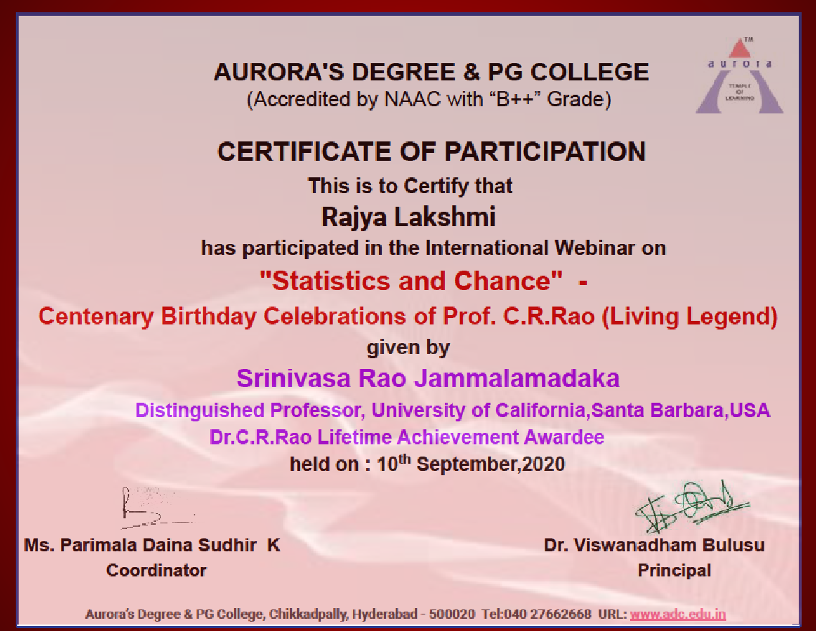
e) LETTERS OF COMMUNICATION (IF ANY)

Statistics Hod <hod_statistics@adc.edu.in> | Thu, Aug 13, 2:42 PM
to rao

Good Afternoon sir,

Greeting from Aurora,

Aurora's Degree & PG College from Hyderabad,Telangana, one of the top institutions, conducts various initiatives for strengthening statistical knowledge both for students & faculty. I, Parimala Diana Sudhir Head, Department of Statistics invite you for the Webinar on the occasion of C.R.Rao's Birth centenary celebrations on september 10th 2020. This webinar is conducted to inspire young students & faculty. I was inspired by your lecture sir at the statistics department, OU a few years back. We would like to hear your talk on this special occasion once again.Request to consider our invitation.Kindly note that the college will not pay any honorarium for this webinar due to the present conditions.We are thankful for your kind cooperation in this regard.

Thank you,
Regards,

Parimala Diana Sudhir.K
Head,Department of Statistics
Aurora's Degree & PG College
Hyderabad.
Ph.no 9885128667/9100000578

S RaoJammalamadaka <rao@pstat.ucsb.edu> | Aug 15, 2020, 4:49 AM
to Rajasekhara, Kraleti, me

Hi Parimala
I understand that you have a different goal and different audience. If I can get finished with my ISPS commitment (which is supposed to be from 930-1000 am on 10th, then I can talk to your audience from 1030-1130 IST on a general intro to stats titled "Statistics and Chance" -- hopefully you can open it upto a wider audience than your college. I will send you a short abstract and an intro to myself, if we agree on timings and other coordinates. Best
Sreenivas
PS. I may not have much sleep the nite before (Sept 9 for me) , but it is all for a good purpose!!

On Fri, Aug 14, 2020 at 2:55 AM Statistics Hod<hod_statistics@adc.edu.in> wrote:
Good Afternoon Sir,
Thank You for responding to our mail.We from the department of Statistics from Aurora's college are conducting this webinar for students of high school,intermediate& undergraduates at our city level to explore the opportunities in the statistics field.Also to make them understand the life & achievements of Prof.C.R.Raogaru, his contributions in Statistics. We are thankful & grateful if you can address this particular group about half an hour any time (9am to 7pm)of IST, so that we are flexible to arrange our program accordingly.Sir,your lecture will definitely inspire this young generation to choose a career in Statistics as many of them are not aware about this field.

We humbly request you to accept our invitation.

Thank you.
Regards ,
Parimala Diana Sudhir.K

