Aurora’s Degree and PG College 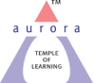
(ACCREDITED BY NAAC WITH ‘B++’ GRADE)
Chikkadpally, Hyderabad 500020
Cultural Committee
EVENT PROPOSAL
for

Smt . M. S. Subbulakshmi Birthday Celebration

Event/Activity Name: Smt. M. S. Subbulakshmi Birthday Celebration

Event/Activity Title: Smt. M. S. Subbulakshmi Birthday Celebration
Cell / Committee/Club Convener/facilitator: Mr Aslam Shareef
Faculty coordinators: Mr Aslam Shareef & Mr. K Madhusudhan Rao
Date: 16-09-2020
Venue: Aurora’s Degree and Pg College
Target audience: Faculty & Students
Platform: Online- Google Meet
Level: National
Student Volunteer’s: Sudhanshu Vyas (Stream), Ravi Varma(Stream)
Objective: To pay tribute to the Great Indian Classical Singer.
Proposed activities:
- Poster & PPT presentation
- Inviting students and Alumni to render composition of Smt. M.S Subbulakshmi
Guest/Speaker details:
Budget:
Cultural Convener IQAC Coordinator Principal
(Name) Dr. Ravi kiran Dr. Viswanadham Bulusu

Aurora’s Degree & PG College
(ACCREDITED BY NAAC WITH 'B++' GRADE)
Chikkadpally, Hyderabad 500020

EVENT / ACTIVITY SHORT REPORT

NAME OF THE EVENT / ACTIVITY | Late Smt. M.S. Subbulakshmi Birthday Celebration
TYPE OR TITLE OF EVENT / ACTIVITY | Late Smt. M.S. Subbulakshmi Birthday Celebration
FACULTY INCHARGE | Mr. Aslam Shareef & Mr. H.K Madhusudan Rao
DEPARTMENT/CELL/COMMITTEE/CLUB | Cultural Committee
DATE | 16-09-2020
VENUE | Online –Google Meet
TARGET AUDIENCE | National Level – Faculty and Students

OBJECTIVE:
To pay tribute to the legendary carnatic singer

BRIEF ABOUT THE EVENT:
Cultural Committee celebrated Late Smt. M.S Subbulakshmi birthday on 16th September 2020, in which Students from Second and Final years have taken part in classical singing, Poster presentation and power Point presentation. Posters were displayed all over all the college, and Power point presentation done during the live session on E-platform, Dance performance by final year students presented on e-platform. Alumni shown interest to be part of celebration and shared recorded rendition of late Smt. M.S Subbulakshmi, which was played during celebration on E-Platform(Google Meet). Total 84 certificates issued to the people who joined the celebration.
OUTCOME:
Audiences of various age groups gather in one e-platform and enjoyed the legendary carnatic singer renditions.

PHOTOGRAPH:
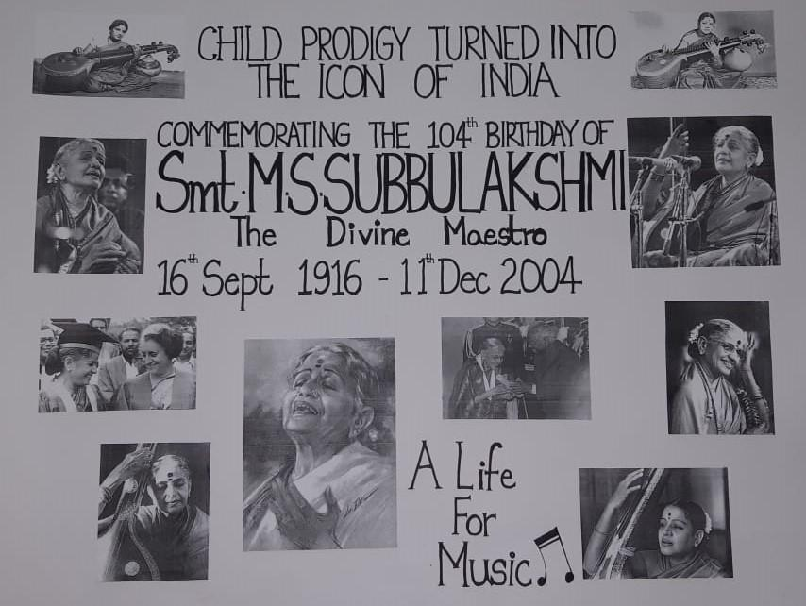
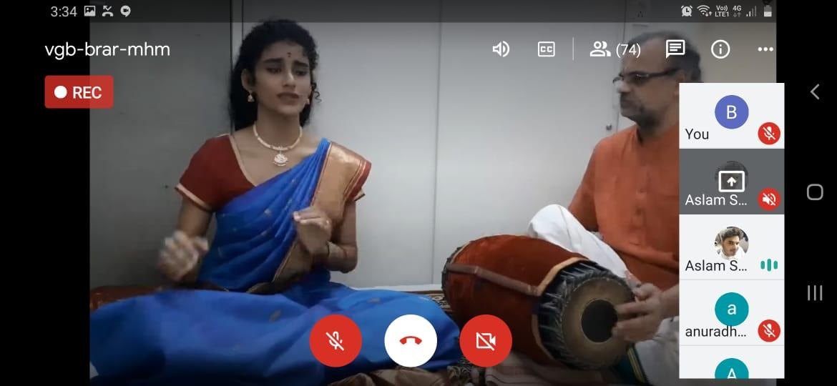
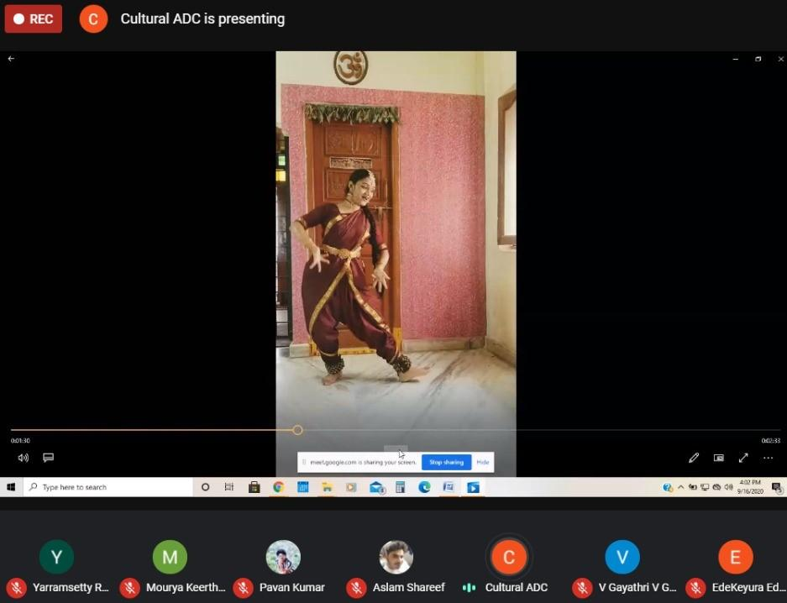

Aurora’s Degree & PG College
(ACCREDITED BY NAAC WITH 'B++' GRADE)
Chikkadpally, Hyderabad 500020

EVENT / ACTIVITY DETAILED REPORT

NAME OF THE EVENT / ACTIVITY | Late Smt. M.S. Subbulakshmi Birthday Celebration
TYPE OR TITLE OF EVENT / ACTIVITY | Late Smt. M.S. Subbulakshmi Birthday Celebration
FACULTY INCHARGE | Mr. Aslam Shareef & Mr. K. Madhusudhan Rao.
DEPARTMENT/CELL/COMMITTEE/CLUB | Cultural Committee
DATE | 16-09-2020
VENUE | Online – Google Meet
TARGET AUDIENCE | National Level – Faculty and Students

- PROGRAM SCHEDULE
Late Smt MS Subbulakshmi 104th Birthday Celebration - Program Schedule

SL.NO | Activity | Timing
1 | Introduction By Aslam Shareef sir | 3:00 – 3:02
2 | Prayer song by Madhusudhan sir | 3:02 – 3:03
3 | Inaugural in Original Voice of Late. Smt M.S Subbulakshmi | 3:03 – 3:11
4 | Classical rendition By our Alumni Miss. Harini | 3:11 – 3:17
5 | Classical dance by Naga Durga of final year BA | 3:18 – 3:25
6 | Classical Rendition by Bharat raj of final year MSCs | 3:25 – 3:30
7 | Speech by keyura of final year BBA | 3:30 – 3:32
8 | Classical Rendition By our Alumni Miss. Urma | 3:32 – 3:35
9 | PPT BY Sudhanshu Vyas of Final B.com Computers | 3:35 – 3:40
10 | Flute and song by Raghava of final year MECs | 3:40 – 3:48
11 | Classical Rendition By our Alumni Mr. Vijay | 3:48 – 3:50
12 | Classical Dance by Shivani of final year B.com Honours | 3:50 – 3:55
13 | PPT by keerthi of 2nd year Bt.Bi.C | 3:55 – 3:56
14 | Classical song by Sweya laksmi | 3:56 – 3:58
15 | Vote of thanks by Convener | 3:58 – 4:00

- LIST OF FACULTY COORDINATORS (DEPARTMENT)
- Mr. Aslam Shareef ( Physics & Electronics Department)
- Mr. H.K. Madhusudhan Rao ( Statistics)

- LIST OF THE STUDENT COORDINATORS (NAME , ROLL NO, CLASS & SECTION)
S.No | Name | Roll No | Class | Section | Phone No
1 | Sudhanshu Vyas | 1051-17-402-154 | B.Com(Computer) | 3C | 7416367060
2 | Y.Ravi Varma | 1051-19-468-041 | B.SC(MPCS) | 2A | 9398417598
3 | P Venkata Ratna Krishna Bharathi | 1051-18-468-054 | B.Sc(MPCS) | 3B | 9110759592

- LIST OF THE PARTICIPANTS

S.No | Name | S.No | Name
1 | Srinivas U | 17 | Sudhanshu Vyas
2 | Bathoji Architha | 18 | Ayushmodi
3 | T. Syamala Devi | 19 | PALLENI SRUTHI
4 | V.Gayathri | 20 | Sunny Paul
5 | VENNA SAI AMRUTH REDDY | 21 | Hari shankar.gogula
6 | B.Nikhil | 22 | Hema Rao
7 | Budagolla Jashwanth | 23 | Lakshmi Waghmare
8 | Erugadindla Raja Shèkhàr | 24 | Mourya.keerthi
9 | Kottakapu varsha reddy | 25 | PALLENI SRUTHI
10 | Rubina | 26 | KUMAR NAGA NEEYATHI
11 | SANDHYA RANI G | 27 | A Sandhya Rani
12 | Mahitha M | 28 | P. Nikitha
13 | E.shivani | 29 | Suvarna P
14 | P. Nikitha | 30 | Bathojiswetha
15 | Bathojiswetha | 31 | Kandera Divya
16 | KALERU SUDERSHANI | 32 | Dr.B.Leelamani
33 | Sandra Snehalatha | 59 | Hruthvika Babburi
34 | P.Archana | 60 | KOTA NAGALAXMI
35 | B.Udaya Sree | 61 | pragati oza
36 | Mahek gupta | 62 | S Naveen Chakravarthy
37 | R. SRAVAN KUMAR | 63 | VASIREDDI.ANURADHA
38 | Aslam Shareef | 64 | Madhavi Bulusu
39 | Seelam varsha | 65 | Dr Radhika Rani
40 | Keyura | 66 | Navneetha
41 | Raga Sudha Jonnada | 67 | Navneetha
42 | Y. Ravi varma | 68 | Madhupriya A
43 | shivani vani | 69 | Saparay Hemanth Kishore
44 | NEHA TINGLIKAR | 70 | Kondakalla Kumar
45 | VASIREDDI.ANURADHA | 71 | Kumari shalini
46 | s s sai nitish | 72 | S. Lakshmi
47 | Amarnath | 73 | B MANASA
48 | govind sunanda | 74 | Prathibha G
49 | MOKTALA KAVYASREE | 75 | Dr. Meera Joshi
50 | Dr. VIRIVADA VENKATA RAGHAVA RAMAN | 76 | Munnangi Latha Salome
51 | Dr. Om Prakash Yadav | 77 | A. Anagha
52 | Mr. CHANDRA PRAVEEN N | 78 | K. Anurag Reddy
53 | Sourabchintu | 79 | S Naveen Chakravarthy
54 | G Rahul | 80 | P POORNACHANDER
55 | G. Geetha | 81 | R.SRAVAN KUMAR
56 | VASIREDDI.ANURADHA | 82 | Budagolla Jashwanth
57 | BITLA.SARITHA | 83 | Injeti Madhavi
58 | VASIREDDI.ANURADHA | 84 | BITLA.SARITHA

- PARAGRAPH ABOUT THE PROCEEDINGS
Madhurai Shanmukhavadivu Subbulakshmi (also known as M.S. Subbulakshmi; September 16,1916-December 11,2004) was an Indian Carnatic Singer from Madurai, Tamil Nadu. She was the first Musician ever to be awarded the Bharat Ratna, India’s highest Civilian honor. She is the first Indian musician to receive the Ramon Mangsaysay Award, often considered Asia’s Noble Prize, in 1974 with the citation reading “Exacting Purists acknowledge Srimati M.S. Subbulakshmi as the leading exponent of classical and semi classical songs in the carnatic tradition of south India. Since most of the people of this generation don’t know who she really is, besides from her being famous, we are celebrating this day to know about her life and achievements.
Cultural Committee celebrated Late Smt. M.S Subbulakshmi birthday on 16th September 2020, In which Students from Second and Final years have taken part in classical singing, Poster presentation and power Point presentation. Posters were displayed all over all the college, and Power point presentation done during the live session on E-platform, Dance performance by final year students presented on e-platform. Alumni shown interest to be part of celebration and shared recorded rendition of late Smt. M.S Subbulakshmi, which was played during celebration on E-Platform(Google Meet). Total 84 certificates issued to the people who joined the celebration.

- INCOME AND EXPENDITURE : N/A
- EVENT PHOTOS
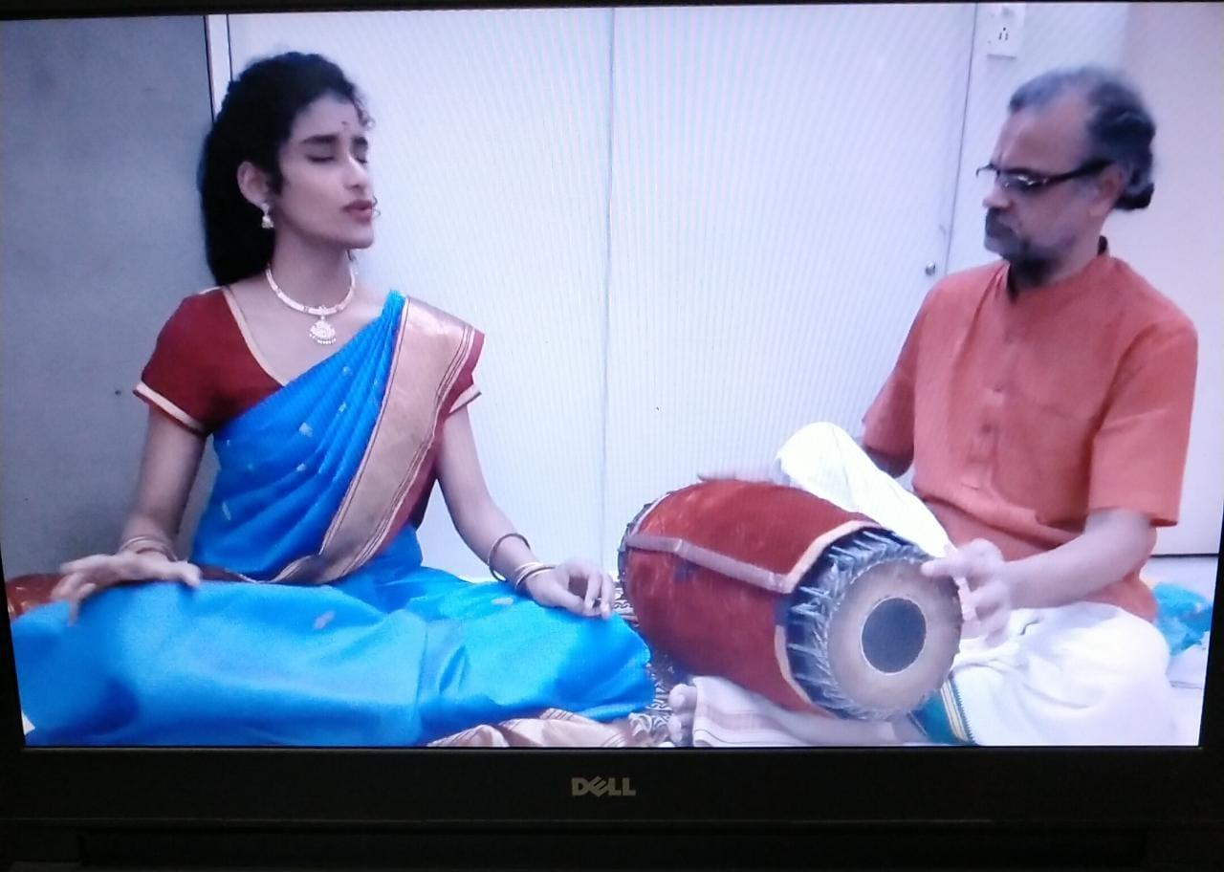
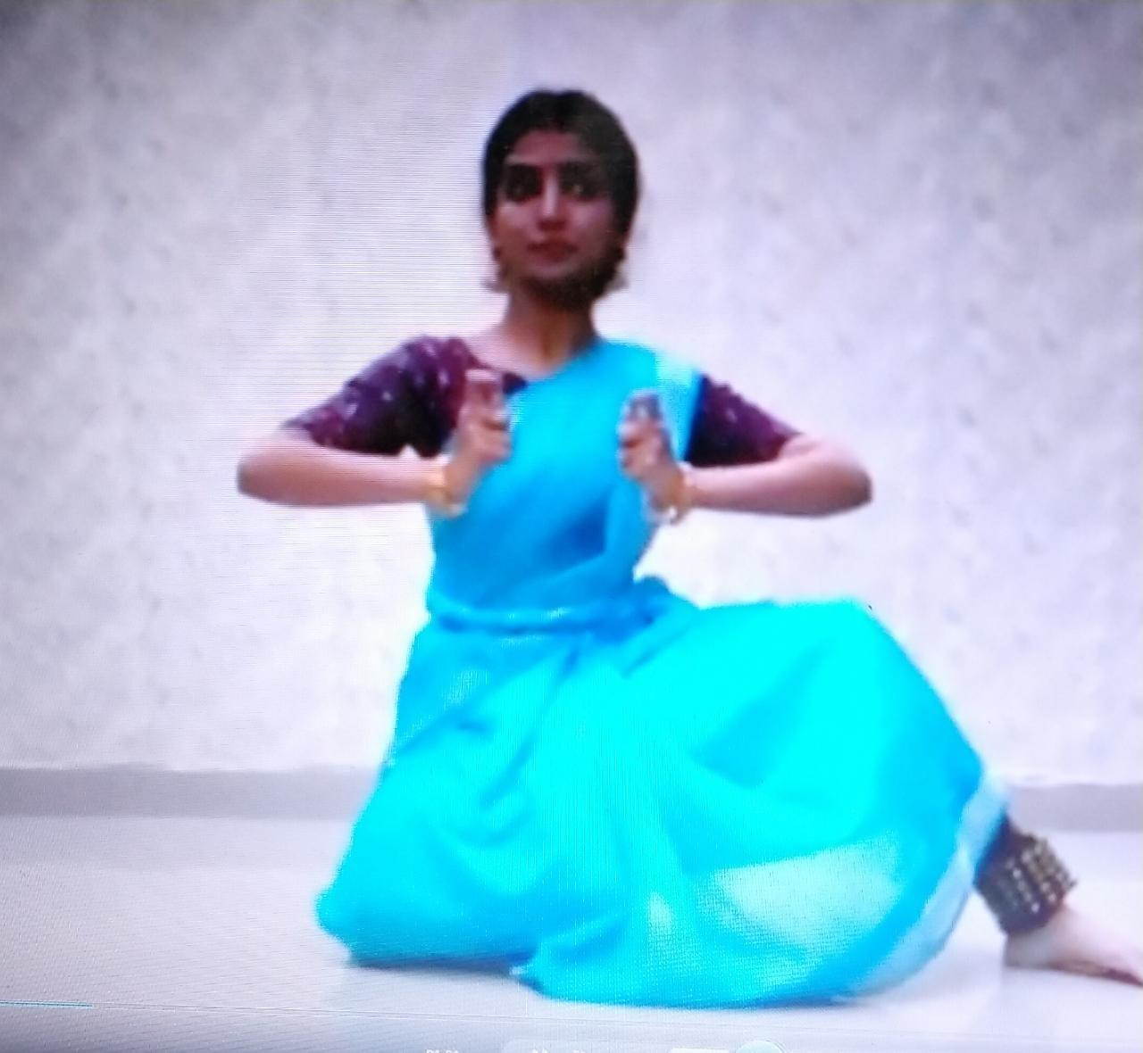
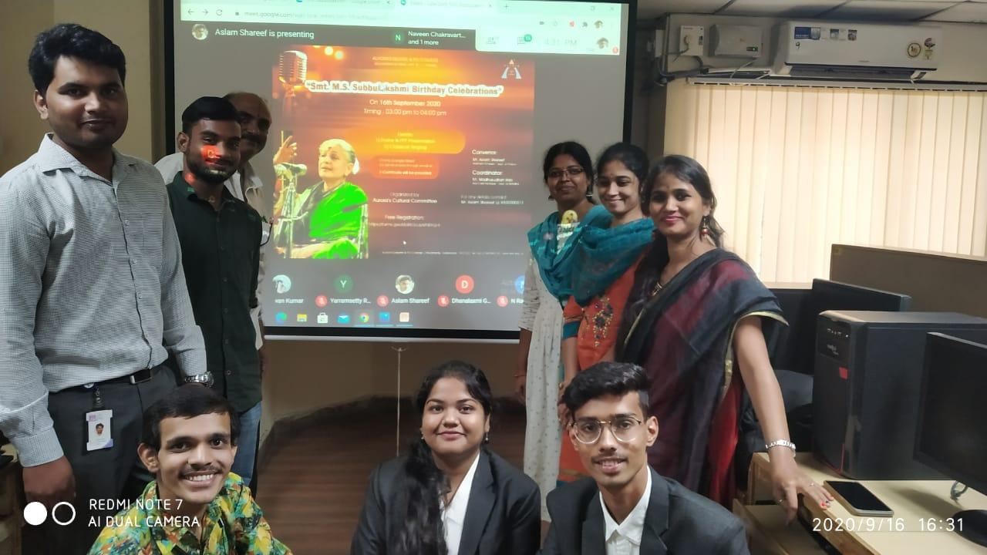
- GUEST PROFILE : N/A
- FEED BACK :N/A

- ATTACHMENTS:
EVENT/ACTIVITY PROPOSAL
Event Name: Late. Smt. M. S. Subbulakshmi Birthday Celebration

Event Title: Late. Smt. M. S. Subbulakshmi Birthday Celebration
Cell / Committee Convener: Mr Aslam Shareef
Faculty coordinator: Mr Aslam Shareef & Mr. K Madhusudhan Rao
Date& Venue: 16-09-2020
Target audience: Faculty & Students
Platform: Online- Google Meet
Level: National
Student Volunteer’s: Sudhanshu Vyas, Ravi Varma, Krishna Bharathi
Objective: To pay tribute to the Great Indian Classical Singer.
Proposed activities:
- Poster & PPT presentation
- Inviting students and Alumni to render composition of Smt. M.S Subbulakshmi

EVENT / ACTIVITY NOTICE:
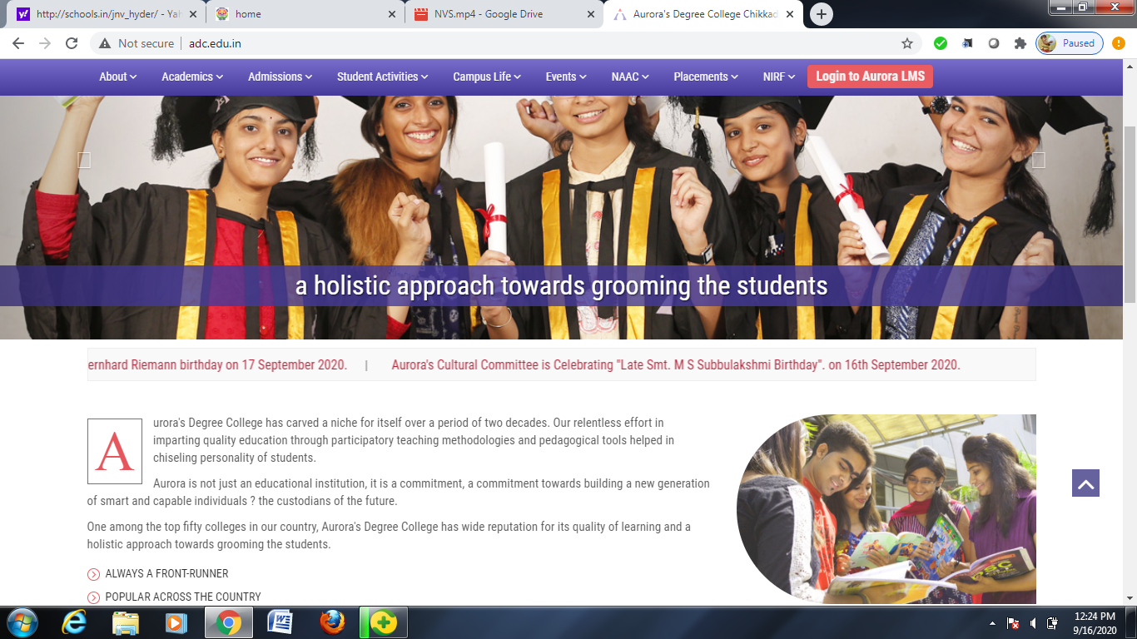
RECEIPTS : N/A
CERTIFICATES :
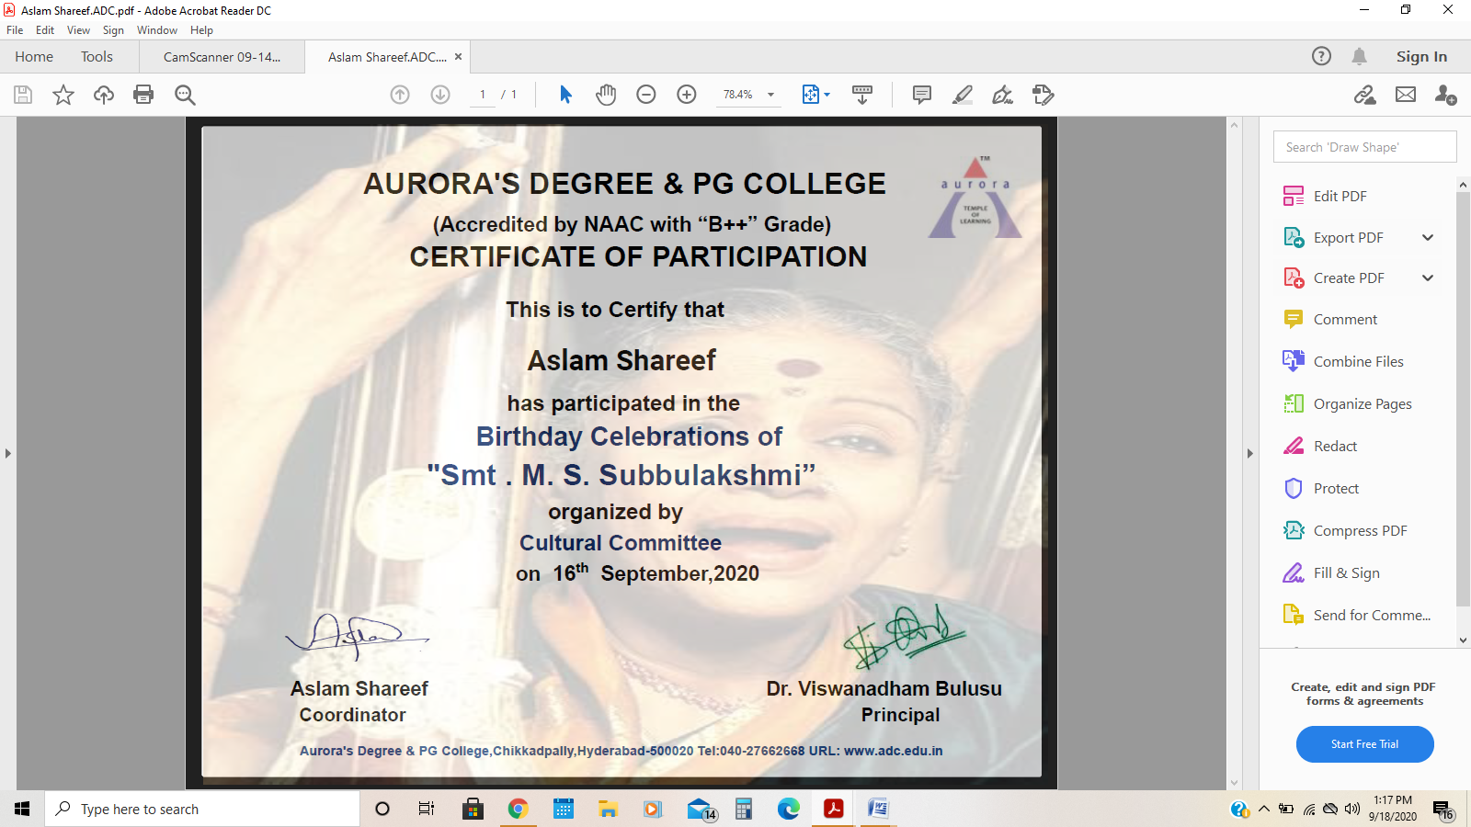

LETTERS OF COMMUNICATION :
