Aurora’s Degree & PG College
(ACCREDITED BY NAAC WITH 'B++' GRADE)
Chikkadpally, Hyderabad 500020
EVENT PROPOSAL

Event Name: Durgabai Deshmukh’s Birthday
Event Title: Durgabai Deshmukh’s Birthday
Faculty coordinator: Archana. G
Date& Venue: February 13th, 2020; Zoom App
Target audience: B.Com 3 Honours A
Level: College Level
Budget: Nil
Student volunteer’s: Shreyansh Jain, Faizan and all Group Leaders.
Objective: In memory of date of birth of Durgabai Deshmukh’s Birthday is celebrated as class event. The birthday of India’s freedom fighter, the member of the Constituent Assembly, a Lawyer, politician and was also a member of the Planning Commission of India marks an important celebration in the country, on July 15th every year. Durgabai Deshmuk was also known as the IRON LADY of India and a recipient of the PADMA VIBHUSHAN. Objective of celebrating Durgabai Deshmukh’s Birthday is to express love and gratitude towards Women’s contribution to our lives and society.

Proposed activities: PPT-Biography of Durgabai Deshmukh
Poster Presentation

\

Aurora’s Degree & PG College
(ACCREDITED BY NAAC WITH 'B++' GRADE)
Chikkadpally, Hyderabad 500020

NAME OF THE EVENT | Durgabai Deshmukh’s BirthDay
TYPE OF EVENT | Class Event
FACULTY INCHARGE | Archana.G
DEPARTMENT | Department of Commerce
DATE | 15-07-2020
VENUE | Block VI, Aurora’s Degree and PG College; Zoom App
TARGET AUDIENCE | B.Com 3Honours A Students

OBJECTIVE:
In memory of date of birth of Durgabai Deshmukh’s Birthday is celebrated as class event. The birthday of India’s freedom fighter, the member of the Constituent Assembly, a Lawyer, politician and was also a member of the Planning Commission of India marks an important celebration in the country, on July 15th every year. Durgabai Deshmuk was also known as the IRON LADY of India and a recipient of the PADMA VIBHUSHAN. Objective of celebrating Durgabai Deshmukh’s Birthday is to express love and gratitude towards Women’s contribution to our lives and society.
BRIEF ABOUT THE EVENT:
On the day of the event Coordinator in the class Shreyansh Jain given introductory speech about Durgabai Deshmukh.
HOD department of Honors and Faculty of the class were invited as Guests on the occasion.
PPT was given by the students on the Biography of Durgabai Deshmukh.
Poster Making done by students.

OUTCOME:
- Students got to know about Durgabai Deshmukh’s Biography.
- Students understood the power and strength of a woman in the society.
PHOTOGRAPH:

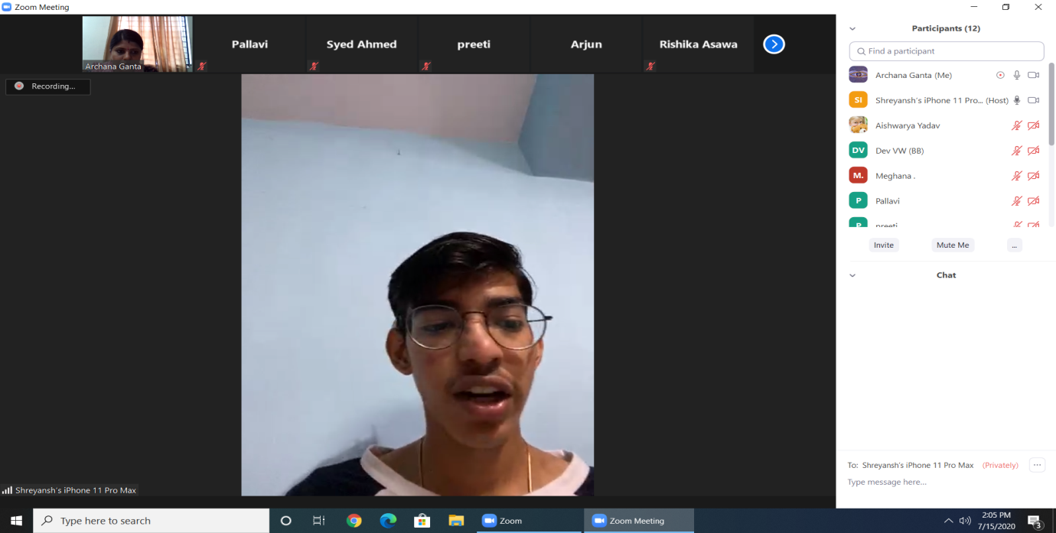

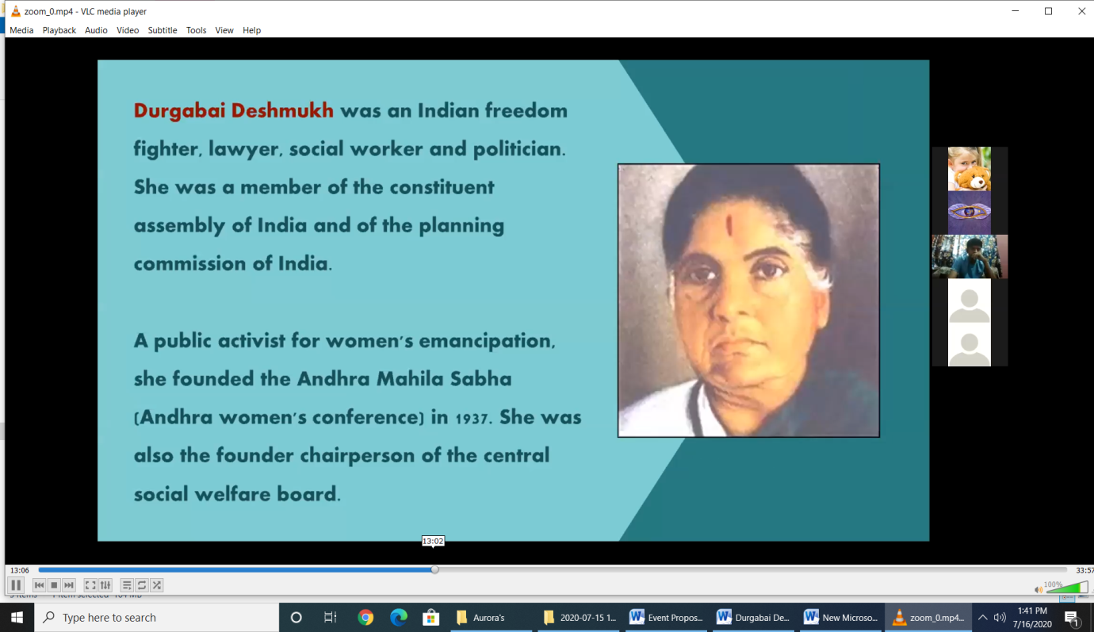

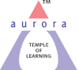
Aurora’s Degree & PG College
(ACCREDITED BY NAAC WITH 'B++' GRADE)
Chikkadpally, Hyderabad 500020

NAME OF THE EVENT | Durgabai Deshmukh’s Birth Day
TYPE OF EVENT | Class Event
FACULTY INCHARGE | Archana.G
DEPARTMENT | Department of Commerce
DATE | 15-07-2020
VENUE | Block VI, Aurora’s Degree and PG College; Zoom App
TARGET AUDIENCE | B.Com 3Honours A Students

OBJECTIVE:
In memory of date of birth of Durgabai Deshmukh’s Birthday is celebrated as class event. The birthday of India’s freedom fighter, the member of the Constituent Assembly, a Lawyer, politician and was also a member of the Planning Commission of India marks an important celebration in the country, on July 15th every year. Durgabai Deshmuk was also known as the IRON LADY of India and a recipient of the PADMA VIBHUSHAN. Objective of celebrating Durgabai Deshmukh’s Birthday is to express love and gratitude towards Women’s contribution to our lives and society.
BRIEF ABOUT THE EVENT:
On the day of the event Coordinator in the class Shreyansh Jain given introductory speech about Durgabai Deshmukh.
HOD department of Honors and Faculty of the class were invited as Guests on the occasion.
PPT was given by the students on the Biography of Durgabai Deshmukh.
Poster Making done by students.

OUTCOME:
- Students got to know about Durgabai Deshmukh’s Biography.
- Students understood the power and strength of a woman in the society.

PHOTOGRAPH:

DETAILED REPORT: The event was started sharp 2:00 pm on 15th July, 2020 with the help of Zoom App.
It was completely an online event due to pandemic situation covid-19.
Guests were invited by Shreyansh Jain.
Veena Malked Madam and Padmini Madam delivered a Motivational speech on the occasion of Durgabai Deshmukh’s Birth Anniversary.
Aishwarya, Rishika Asawa, Ahihsek Chakrawarthy and Samarth Marda were given PPT on Biography of Durgabai Deshmukh.
Rithika was made Poster and displayed during the session.
Vote of Thanks given by Faizan.

- LIST OF THE STUDENT COORDINATORS
Shreyansh Jain 1051-18-407-038 2Hon A
Arvind Ravada 1051-18-407-006 2Hon A
Rithika 1051-18-407-027 2Hon A
Syed Faizan 1051-18-407-037 2Hon A
Shruthi Choraria 1051-18-407-034 2Hon A
Anushka 1051-18-407-042 2Hon A

- LIST OF THE PARTICIPANTS
Students of B.Com Honours A

