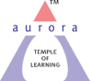
Aurora’s Degree & PG College
(ACCREDITED BY NAAC WITH 'B++' GRADE)
Chikkadpally, Hyderabad- 500020
Department of Computer Science

EVENT REPORT

EVENT TITLE | International internet day
TYPE OF EVENT | Class
FACULTY INCHARGE | S.Lakshmi
DEPARTMENT | Computer Science
DATE | 29/10/2020
VENUE | Online(Google Meet)
TARGET AUDIENCE | Students

OBJECTIVE: The objective is to raise awareness on importance of internet in our daily life to perform various transactions, communications and so on.

BRIEF ABOUT THE EVENT: Event started at 1:30,Total 92 students have attended and 5 students gave Power Point presentations on basics of internet, Advantages & Disadvantages of Internet, facts of Internet, who invented the Internet and how it is introduced.

OUTCOME: Students got the awareness of internet when and how it was introduced.

PHOTOGRAPH: (maximum 2)

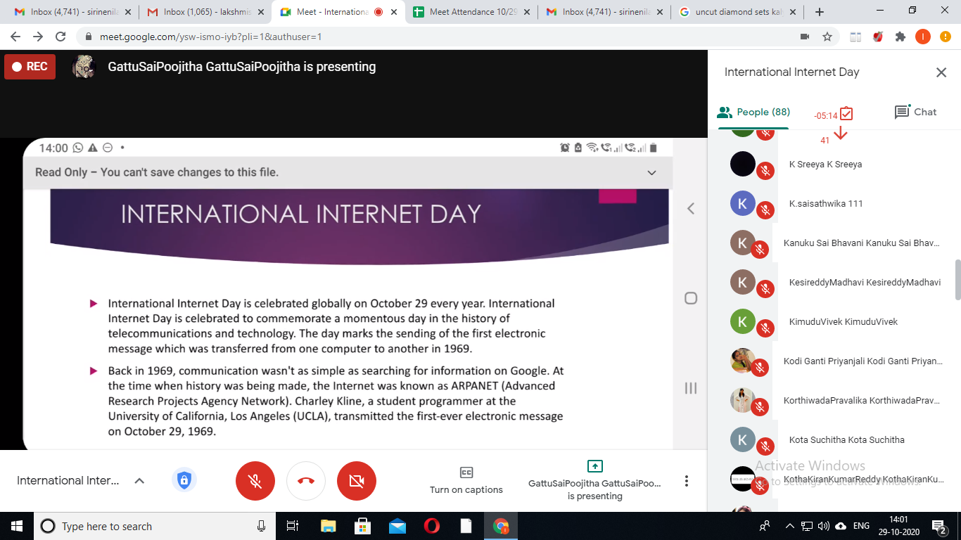

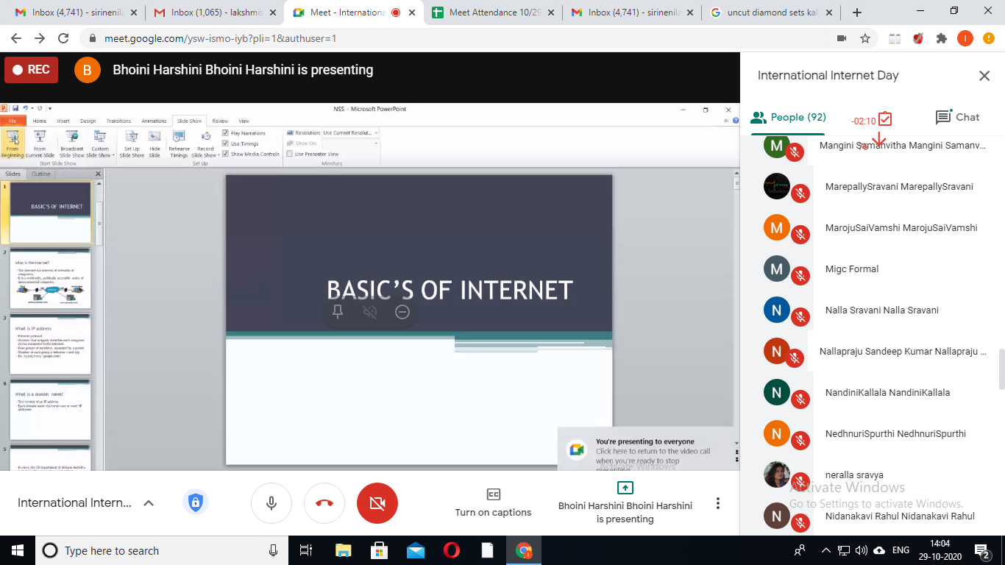

Detailed Report: International Internet day is Conducted to get the awareness on importance of Internet, various transactions ,communications etc. On this occasion Power Point presentations are conducted in online through Google Meet.
Session started at 1:30 PM. Total 92 Students have participated .Few students K. Pravalika from Bt.Bi.C 3B,G.Sai Poojitha from Mi.G.C 3B , S. Akshitha from B.Com honor’s 2B, B. Harshini from B.Com honor’s 2A and J.Surekha from MPCS3A have given power point presentation on various topics like Basics of Internet ,Advantages & Disadvantages of Internet, facts, etc.

