Aurora’s Degree & PG College
(ACCREDITED BY NAAC WITH 'B++' GRADE)
Chikkadpally, Hyderabad 500020

World Computer Literacy Day Short Report
NAME OF THE EVENT | World Computer Literacy Day
TYPE OR TITLE OF EVENT | World Computer Literacy Day
FACULTY INCHARGE | Srinivas U
DEPARTMENT | Computer Science
DATE | 02-12-2020
VENUE | Main Block, Aurora’s Degree & PG College,Chikkadpally
TARGET AUDIENCE | Non-Teaching Staff
Objective:
It is intended to encourage the development of technological skills, create awareness and drive digital literacy in underserved communities
Brief about the event
On 2nd 2020 event was conducted for the Non-Teaching staff on Ms-word and MS-Excel.In this connection explained Advantages and creation of document using formatting features, editing documents ,inserting tables take a print of document using page layout such as page setting, orientation and margins. excel features, creation of worksheet, calculation of data ,inserting charts and taking printouts of a worksheet with proper settings were explained
Outcome:
The Non-Teaching staff is aware about creation of document and formatting features in MS-word, creation of worksheet ,page setting in MS-Excel and Basic internet concepts.
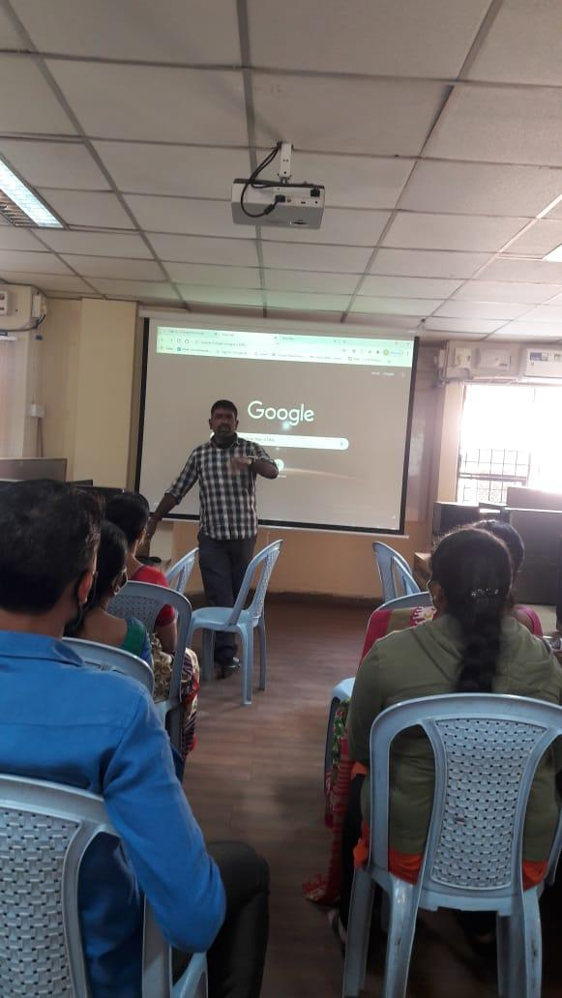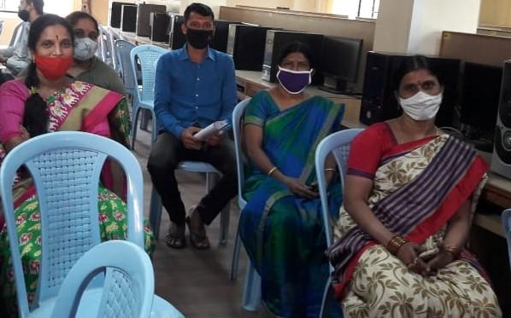

Aurora’s Degree & PG College
(ACCREDITED BY NAAC WITH 'B++' GRADE)
Chikkadpally, Hyderabad 500020

World Computer Literacy Day Detailed Report
NAME OF THE EVENT | World Computer Literacy Day
TYPE OR TITLE OF EVENT | World Computer Literacy Day
FACULTY INCHARGE | Srinivas U
DEPARTMENT | Computer Science
DATE | 02-12-2020
VENUE | Main Block, Aurora’s Degree & PG College,Chikkadpally
TARGET AUDIENCE | Non-Teaching Staff

Brief about the event
On 2nd 2020 event was conducted for the Non-Teaching staff on MS-word and MS-Excel. In this connection explained Advantages and creation of document using formatting features, editing documents, inserting tables take a print of document using page layout such as page setting, orientation and margins. excel features, creation of worksheet, calculation of data, inserting charts and taking printouts of a worksheet with proper settings were explained.
The following few important topics covered
- Change capitalizations the easy way
- Protect your document
- Basic formulas and calculations in Excel
- Scale spread sheet to fit on one page when printing from excel
- Freeze or lock rows and columns in an Excel worksheet
- Basics of Internet

