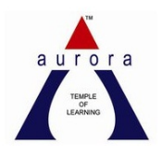
AURORA'S DEGREE AND PG COLLEGE
(ACCREDITED BY NAAC WITH B++ GRADE)
DEPARTMENT OF COMMERCE & MANAGEMENT
EVENT PROPOSAL
for
International Anti-Corruption Day

Event/Activity Name: World Event
Event/Activity Title: International Anti-Corruption Day
Faculty coordinators: Mr. Shiva Shanker G
Date: 9th of December, 2020
Venue: Aurora’s Degree and PG College
Target audience: Students of 2 Computer Applications – C
Level: College
Student Volunteers: Shifa Khan & Abdur Rehman Khan from 2 Comp Appl – C
Objective: The UN General Assembly declared 9th December as International Anti-Corruption Day, to be observed annually. The objective of this Day is to create awareness about the negative effects of corruption and the need to prevent and fight it.

Co-Ordinator IQAC Coordinator Principal
G Shiva Shanker Dr. Ravi kiran Dr. Viswanadham Bulusu

Aurora’s Degree & PG College
(ACCREDITED BY NAAC WITH 'B++' GRADE)
Chikkadpally, Hyderabad 500020

EVENT SHORT REPORT

NAME OF THE EVENT / ACTIVITY | International Anti-Corruption Day
TYPE OR TITLE OF EVENT / ACTIVITY | World Event
FACULTY INCHARGE | G Shiva Shanker
DEPARTMENT/CELL/COMMITTEE/CLUB | Commerce – Computer Applications
DATE | 9th of December, 2020
VENUE | Aurora’s Degree and PG College
TARGET AUDIENCE | Students of 2 Computer Applications – “C” section

OBJECTIVE:
The UN General Assembly declared 9th December as International Anti-Corruption Day, to be observed annually. The objective of this Day is to create awareness about the negative effects of corruption and the need to prevent and fight it.

BRIEF ABOUT THE EVENT:
The event was held in our college. On the day of the event, the students have prepared a documentary and it was mailed to all the students to share the knowledge about Anti - Corruption Day.

OUTCOME:
The day emphasizes the need for the eradication of corruption and intends to create awareness on the ways through which it can be reduced.

PHOTOGRAPH:

Detailed Report :
International Anticorruption Day marks the adoption in 2003 of the United Nations Convention Against Corruption. Almost all countries in Asia and the Pacific have ratified the Convention. By doing so, they have obligated themselves to adopt and implement policies that prevent and penalize corruption.
The event was held in our college. On the day of the event, the students have prepared a documentary and it was mailed to all the students to share the knowledge about Anti - Corruption Day. The day emphasizes the need for the eradication of corruption and intends to create awareness on the ways through which it can be reduced.

Corruption, the human attitude, a very dangerous factor than the terrorism which is destroying the world's economies financially, ethically and physically. Let us promise ourselves that we will not commit ourselves to corruption on this INTERNATIONAL DAY OF ANTI CORRUPTION.

- LIST OF THE STUDENT COORDINATORS
Shifa Khan (1051-19-405-153)
Abdur Rehman Khan (1051-19-405-150)
Swaraj Sanghi (1051-19-405-197)
- LIST OF THE PARTICIPANTS
S.No | Roll No. | Name | College Email ID
1 | 1051-19-405-141 | Katika Naga Pavan | katikanagapavan19@adc.edu.in
2 | 1051-19-405-142 | Anne Vaishnavi | annevaishnavi19@adc.edu.in
3 | 1051-19-405-143 | G Dharma Vardhan | gdharmavardhan19@adc.edu.in
4 | 1051-19-405-144 | Mula Varun Kumar | mulavarunkumar19@adc.edu.in
5 | 1051-19-405-145 | Muzammil Masood Al Behlooli | muzammilmasoodalbehlooli19@adc.edu.in
6 | 1051-19-405-146 | Konda Akshay | kondaakshay19@adc.edu.in
7 | 1051-19-405-147 | Mohammed Shoaib Amir | mohammedshoaibamir19@adc.edu.in
8 | 1051-19-405-148 | Mana Uday Kumar | manaudaykumar19@adc.edu.in
9 | 1051-19-405-149 | Mohd Waseem Ahmed | mohdwaseemahmed19@adc.edu.in
10 | 1051-19-405-150 | Abdur Rehman Khan | abdurrehmankhan19@adc.edu.in
11 | 1051-19-405-151 | Vineet Joshi | vineetjoshi19@adc.edu.in
12 | 1051-19-405-152 | Md Fazal Ulla Choudri | mdfazalullachoudri19@adc.edu.in
13 | 1051-19-405-153 | Shifa Khan | shifakhan19@adc.edu.in
14 | 1051-19-405-154 | Monani Shyam K | monanishyamk19@adc.edu.in
15 | 1051-19-405-155 | Sandha Manoj | sandhamanoj19@adc.edu.in
16 | 1051-19-405-156 | Gudiniya Ruchika | gudiniyaruchika19@adc.edu.in
17 | 1051-19-405-157 | Kusum Santra | kusumsantra19@adc.edu.in
18 | 1051-19-405-158 | Pandey Mrityunjay | pandeymrityunjay19@adc.edu.in
19 | 1051-19-405-159 | S Lokesh Raj Agarwal | slokeshrajagarwal19@adc.edu.in
20 | 1051-19-405-160 | Vikas Biswal | vikasbiswal19@adc.edu.in
21 | 1051-19-405-161 | Roshan Singh | roshansingh19@adc.edu.in
22 | 1051-19-405-162 | Mousumi Samanta | mousumisamanta19@adc.edu.in
23 | 1051-19-405-163 | Sunka Soniya Anil | sunkasoniyaanil19@adc.edu.in
24 | 1051-19-405-164 | Abhishek | abhishek19@adc.edu.in
25 | 1051-19-405-165 | Ravani Riyaz | ravaniriyaz19@adc.edu.in
26 | 1051-19-405-166 | Sourav Agarwal | souravagarwal19@adc.edu.in
27 | 1051-19-405-167 | Varindani N Bhupesh | varindaninbhupesh19@adc.edu.in
28 | 1051-19-405-168 | Kashif Khan | kashifkhan19@adc.edu.in
29 | 1051-19-405-169 | Ramavatar Khandelwal | ramavatarkhandelwal19@adc.edu.in
30 | 1051-19-405-170 | Mohammed Aqeem Uddin | mohammedaqeemuddin19@adc.edu.in
31 | 1051-19-405-171 | Harsh Verma | harshverma19@adc.edu.in
32 | 1051-19-405-172 | Dhannawat Rusheel | dhannawatrusheel19@adc.edu.in
33 | 1051-19-405-173 | Abhishek Kongle | abhishekkongle19@adc.edu.in
34 | 1051-19-405-174 | B Yash Kumar | byashkumar19@adc.edu.in
35 | 1051-19-405-175 | Sandeep Kumar Yadav | sandeepkumaryadav19@adc.edu.in
36 | 1051-19-405-176 | C S Rithvik | csrithvik19@adc.edu.in
37 | 1051-19-405-177 | Rajnish Kumar Jha | rajnishkumarjha19@adc.edu.in
38 | 1051-19-405-178 | Daulat Dhani | daulatdhani19@adc.edu.in
39 | 1051-19-405-179 | Suraj Lal Varma | surajlalvarma19@adc.edu.in
40 | 1051-19-405-180 | Ravula Rohan Kumar | ravularohankumar19@adc.edu.in
41 | 1051-19-405-181 | Krishi Singh | krishisingh19@adc.edu.in
42 | 1051-19-405-182 | Mir Zulfequar Ali | mirzulfequarali19@adc.edu.in
43 | 1051-19-405-183 | Ranjit Singh Solanki | ranjitsinghsolanki19@adc.edu.in
44 | 1051-19-405-184 | Faiz Dhanani | faizdhanani19@adc.edu.in
45 | 1051-19-405-185 | Devarshi Aaditya | devarshiaaditya19@adc.edu.in
46 | 1051-19-405-186 | Aryan | aryan19@adc.edu.in
47 | 1051-19-405-187 | Aiman Ahmed Farooqi | aimanahmedfarooqi19@adc.edu.in
48 | 1051-19-405-188 | Priyansh Kumar Surana | priyanshkumarsurana19@adc.edu.in
49 | 1051-19-405-189 | Mohd Sohail Khan | mohdsohailkhan19@adc.edu.in
50 | 1051-19-405-190 | Arni Sham Seema | arnishamseema19@adc.edu.in
51 | 1051-19-405-191 | Shravan Kumar Singh | shravankumarsingh19@adc.edu.in
52 | 1051-19-405-192 | Amit Agarwal | amitagarwal19@adc.edu.in
53 | 1051-19-405-193 | Shashank Tiwari | shashanktiwari19@adc.edu.in
54 | 1051-19-405-194 | Haiyawala Yesh Singh | haiyawalayeshsingh19@adc.edu.in
55 | 1051-19-405-195 | Mirza Mehmood Ali Baig | mirzamehmoodalibaig19@adc.edu.in
56 | 1051-19-405-196 | Harsh Karnani | harshkarnani19@adc.edu.in
57 | 1051-19-405-197 | Swaraj Sanghi | swarajsanghi19@adc.edu.in
58 | 1051-19-405-198 | R Sirisha | rsirisha19@adc.edu.in
59 | 1051-19-405-199 | Mohammed Faiyaz Khan | mohammedfaiyazkhan19@adc.edu.in
60 | 1051-19-405-200 | Mohd Irfan | mohdirfan19@adc.edu.in
61 | 1051-19-405-201 | Kasanaboina Nikitha | kasanaboinanikitha19@adc.edu.in
62 | 1051-19-405-202 | Pooja Kishan Motwani | poojakishanmotwani19@adc.edu.in
63 | 1051-19-405-203 | Kadaji Datta | kadajidatta19@adc.edu.in
64 | 1051-19-405-204 | Naveen Kumar Mishra | naveenkumarmishra19@adc.edu.in
65 | 1051-19-405-205 | Laxman Dass Koushal Raj | laxmandasskoushalraj19@adc.edu.in
66 | 1051-19-405-206 | Shaik Mohammed Iftekhar | shaikmohammediftekhar19@adc.edu.in
67 | 1051-19-405-207 | Deepak Shinde | deepakshinde19@adc.edu.in
68 | 1051-19-405-208 | K Dinesh Kumar | kdineshkumar19@adc.edu.in
69 | 1051-19-405-209 | Chetan Lahoti | chetanlahoti19@adc.edu.in
70 | 1051-19-405-210 | Abhishek Kumar Prajapathi | abhishekkumarprajapathi19@adc.edu.in
71 | 1051-19-405-301 | Netra Bogati | netrabogati19@adc.edu.in
72 | 1051-18-405-225 | N Akshitha | nakshitha18@adc.edu.in

- PHOTOGRAPH:

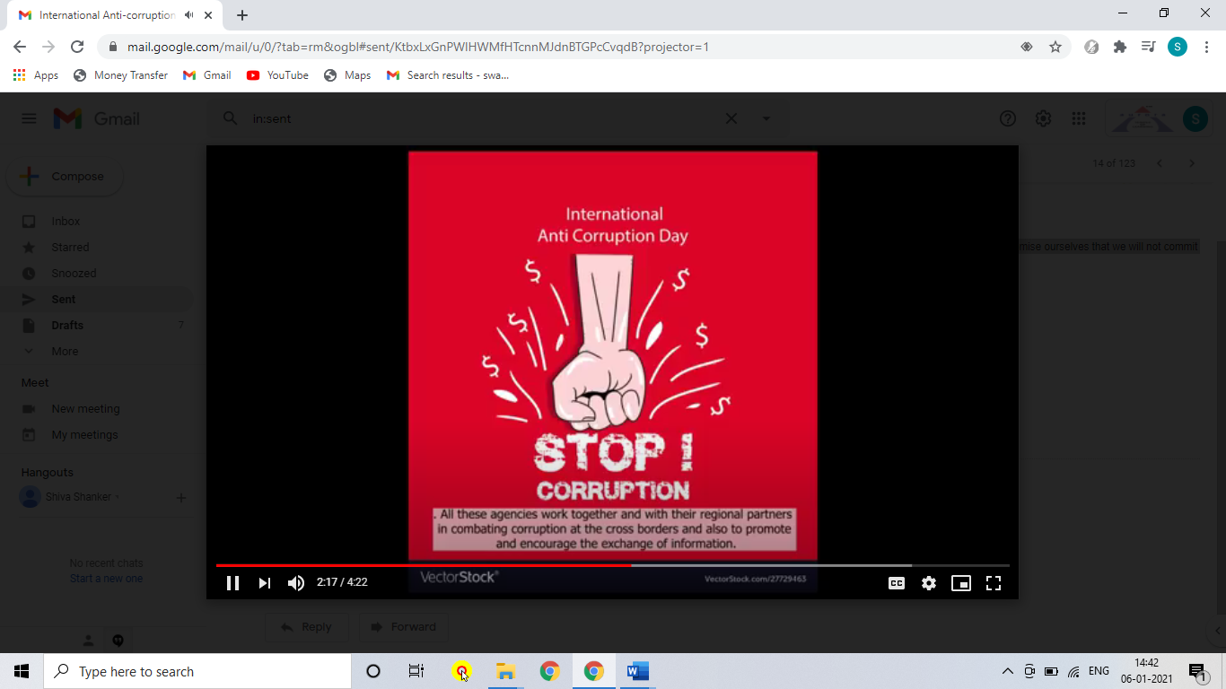
- VIDEO LINK :

https://drive.google.com/file/d/1qdT9TvZQ26Fa6nNnJYgGnVMtQnZyqdX2/view?usp=sharing

--- End of report ---

