Aurora’s Degree & PG College
ACCREDITED BY NAAC WITH ‘B++’ GRAD
Chikkadpally, Hyderabad 500020

NAME OF THE EVENT |  | SAFETY MEASURES ON ROAD
FACULTY INCHARGE |  | T. Aruna
CLASS |  | B.Com. Computer Applications 2 B
DATES |  | 17th February 2021
VENUE |  | Aurora’s Degree & PG College , RTC Block
BUDGET |  | NIL
TARGET AUDIENCE |  | First Year Students
OBJECTIVE:
- To create awareness among students about safety measures on road.

- To educate students about traffic rules, as it is very important in present days.
BRIEF ABOUT THE EVENT:
On 17th February 2021, an event was conducted by Dept. of Commerce – Computer Applications. B.Com. Comp. App. 2 B Students demonstrated the consequences of road accidents through Power Point Presentation and also gave a speech thus created awareness about the road safety measures.

OUT COME:
Students Understood that Traffic rules help and protect every one on the road as well as everyone else driving on the same road. ... Moreover, someone behind any bigger vehicle should also understand that there is limited visibility of the driver, and they should not try to come in the way of such vehicles which can be dangerous for both parties and should not skip signals.

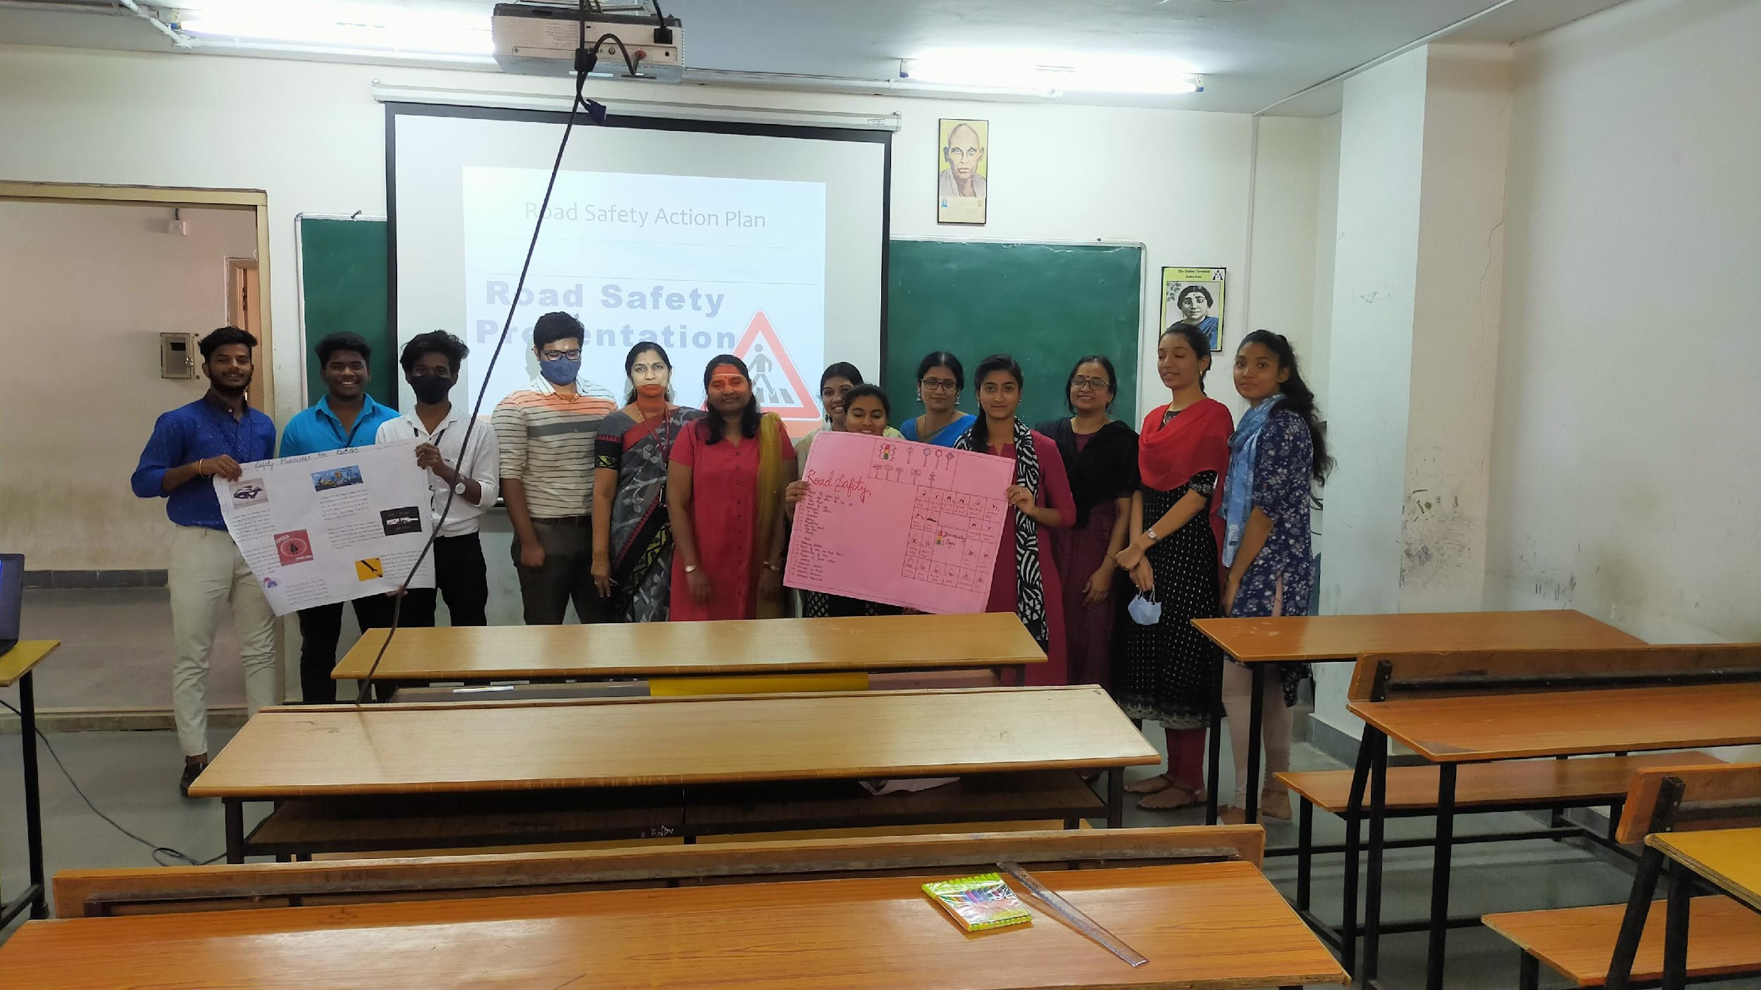

Detailed Report:
- PROGRAM SCHEDULE: 17th February, 2021, 01:00PM
On the day of the event, students from 2nd year of B.com computer applications-B, and the faculty together conducted an event on “Safety Measures on Road”. 1st years were seated inside the classroom and were briefed on the topic by the faculty in charge Mrs.Aruna T and the student coordinators spoke regarding the consequences of violating traffic rules along with a few recent tragedies. The In charge also made a Power Point Presentation and a short video, which were displayed to the students after giving detailed information on safety measures.

PHOTOGRAPHS:

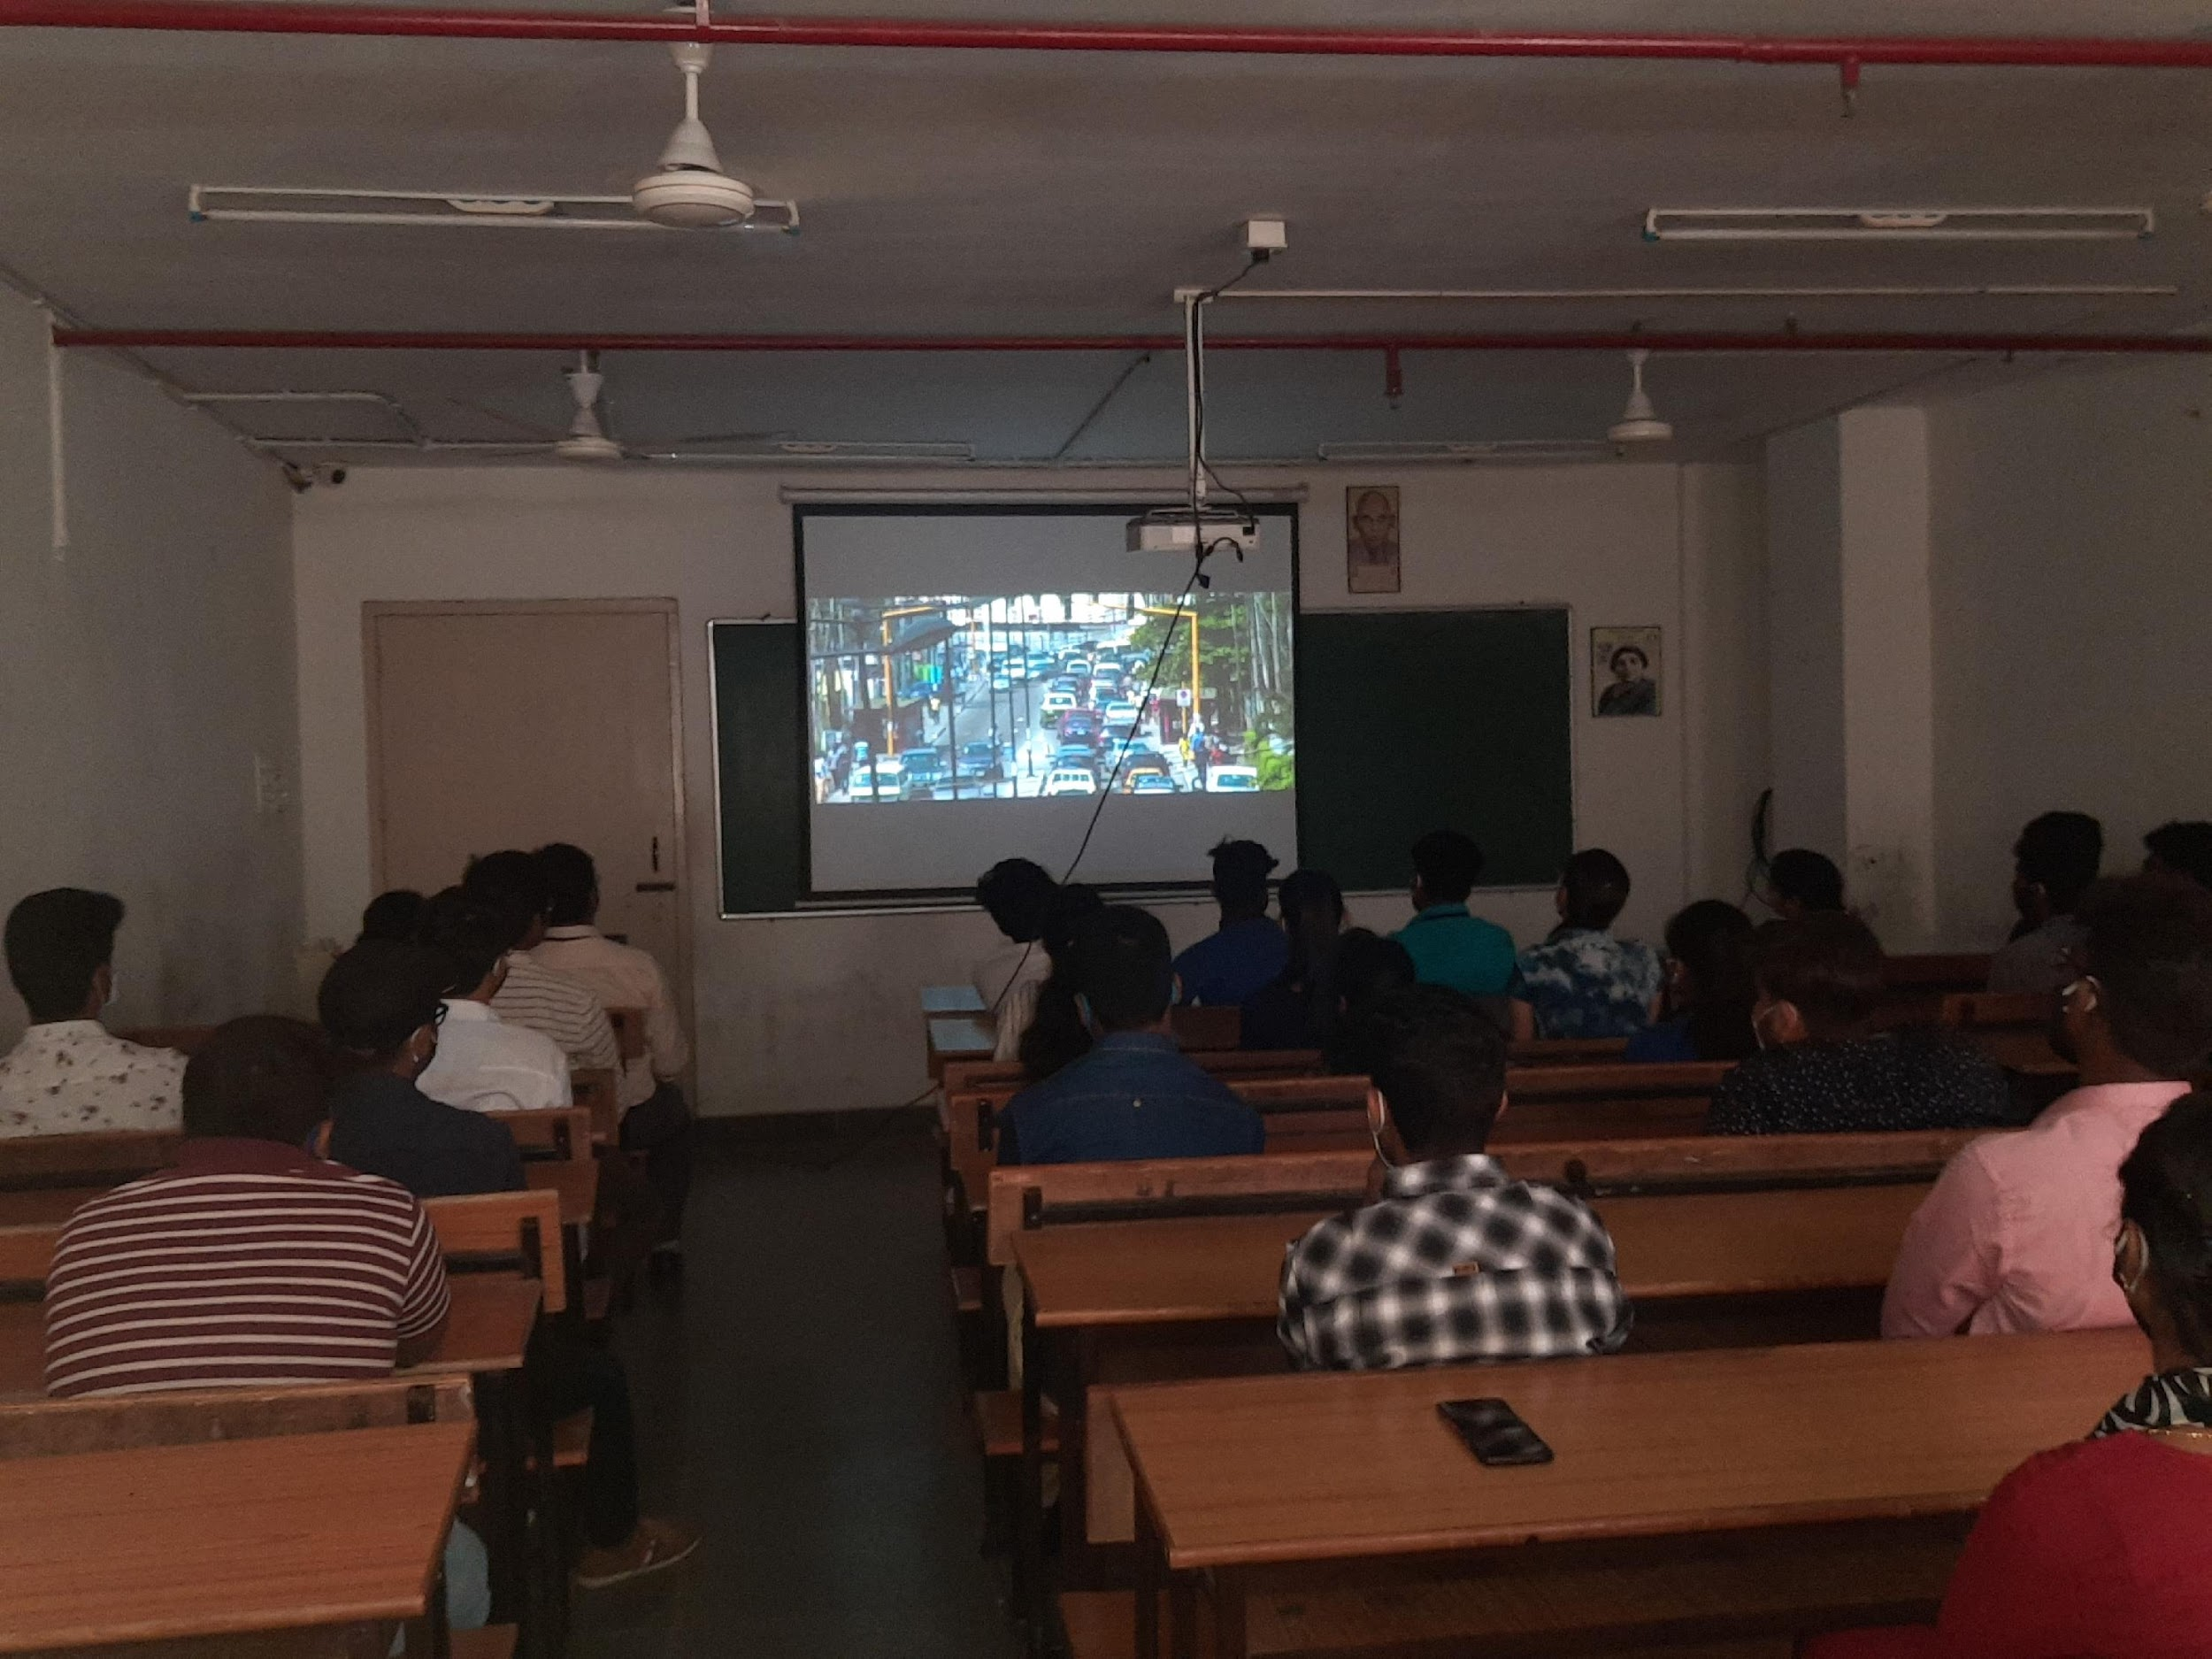
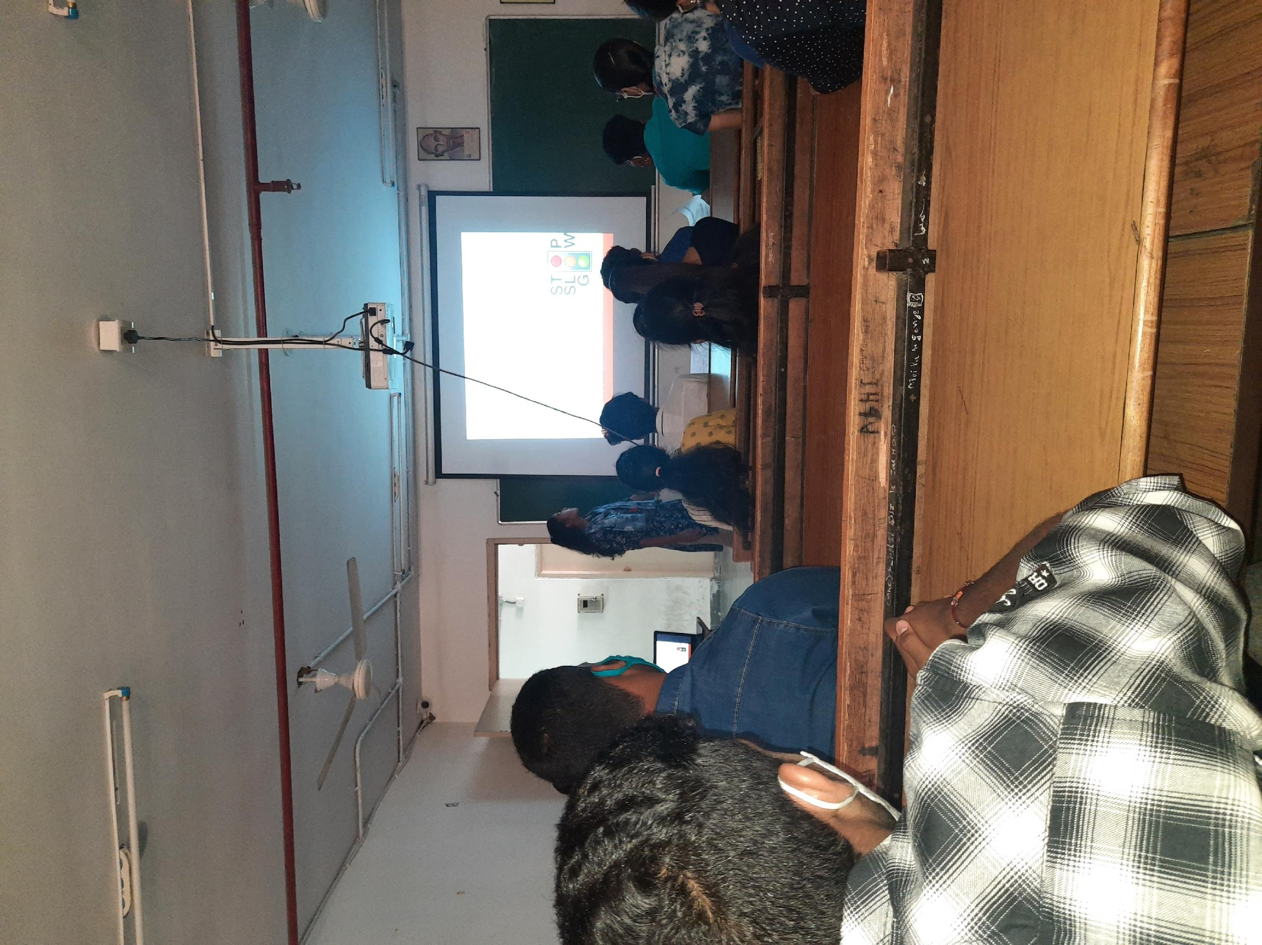
List of student coordinators:
B.Com Computer Applications II B

Roll No | Name | Roll No | Name
1051-19-405-092 | Mocherla Naga Chinmaya | 1051-19-405-126 | Vangapandu Adarsh Kumar
1051-19-405-122 | Vadla Vinay Chary | 1051-19-405-127 | L Abhijit
1051-19-405-123 | Vankayala Shivanni | 1051-19-405-131 | M Tejashiwini
1051-19-405-124 | Kandi Manish | 1051-19-405-133 | Mohith Kumar Akkala

