Aurora’s Degree & PG College
(Accredited by NAAC with 'B++' grade)
Chikkadpally, Hyderabad- 500020
Department of Electronics

EVENT REPORT

EVENT TITLE | Earth Day
TYPE OF EVENT | College level
SPEAKAR’S | Ms. Farida Tampal, State Director WWF India and Ms.SaiSudha M, Senior Educational Officer
FACULTY INCHARGE | P Poornachander
DEPARTMENT | Electronics
DATE & TIME | 22-4-2021 & 11:00am-12:00noon
PLATFORM | Microsoft Teams
TARGET AUDIENCE | MECS & MPCS Students

OBJECTIVE:
To create awareness among the students about Restore Our Earth, this focuses on natural processes, emerging green technologies, and innovative thinking that can restore the world’s ecosystems.
BRIEF ABOUT THE EVENT:
The department of Electronics has organized a guest lecture on “One Earth One Home” on the occasion of Earth Day for MECs and MPCs students.
The virtual meeting was started by Ms. Farida Tampal, State Director WWF India She explained and listed out various aspects of beauty and greatness of nature. The lecture was continued by Ms.SaiSudha M. Senior Education Officer, she explained how to restore our earth she also explained how plastic usage turns in a worse manner (Plastic pollution) and Plastic Ocean. They were about 70 students participated in guest lecture and interacted with guests.

OUTCOME:
Earth Day is an annual event on April 22 to demonstrate support for environmental protection. This Guest lecture has provided a platform to share new ideas relating to Earth and Environment and initiated interactive session between students and Speakers.

PHOTOGRAPH:
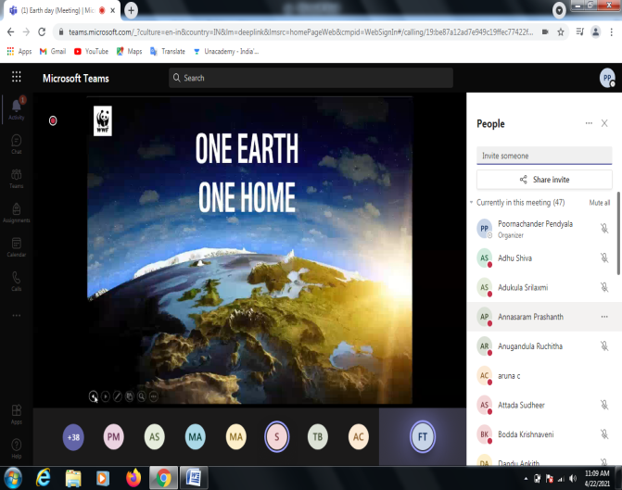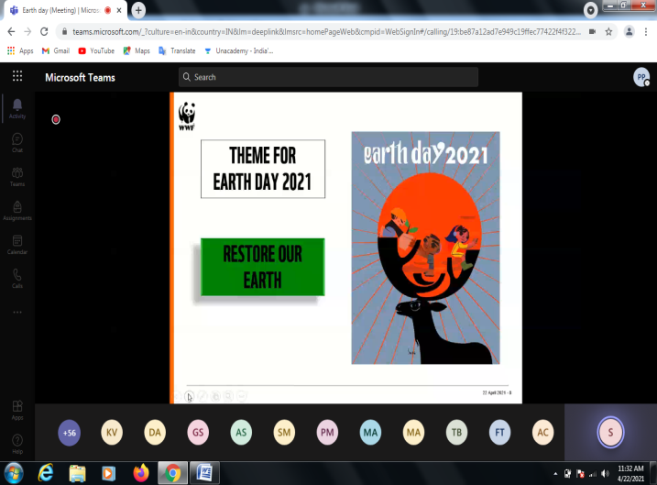

Aurora’s Degree and PG College
(ACCREDITED BY NAAC WITH ‘B++’ GRADE)
Chikkadpally, Hyderabad 500020
Guest lecture
On
One Earth One Home
Detailed Report
Date and Time: 22-04-2021: 11:00 am to 12:00noon
Target Audience: MECs and MPCs Students,
Platform: Microsoft Teams.
Introduction:
Earth Day is an annual event on April 22 to demonstrate support for environmental protection.
The department of Electronics has organized a guest lecture on “One Earth One Home” on the occasion of Earth Day for MECs and MPCs students on 22nd April 2021 through video conferencing application Microsoft teams. Speakers Ms. Farida Tampal, State Director WWF India and Ms.SaiSudha M.Senior Education Officer are invited for the Guest lecture.
Methodology:
We started the registration process for these Guest lectures through electronic media about 95 students have registered.
The virtual meeting was started by Ms. Farida Tampal, State Director WWF India She explained and listed out various aspects of beauty and greatness of nature. She also gave an idea about humanity’s global foot print.
The lecture was continued by Ms.SaiSudha M. Senior Education Officer, she explained how to restore our earth and she explained about natural ecosystem which provides food, water and livelihood to over 400 million people in India . She also explained how plastic usage turns in a worse manner (Plastic pollution) and Plastic Ocean.
Faculty Coordinator: P Poornachander.
Budget: N/A

List of Participants
Full Name | User Action | Timestamp
Poornachander Pendyala | Joined | 4/22/2021, 10:35:50 AM
aruna c | Joined | 4/22/2021, 10:38:30 AM
Farida Tampal | Joined | 4/22/2021, 10:55:40 AM
Marpina Anitha | Joined | 4/22/2021, 10:44:31 AM
ssudha (Guest) | Joined | 4/22/2021, 10:45:46 AM
Mohammed Amer | Joined | 4/22/2021, 10:46:15 AM
Pooja More | Joined | 4/22/2021, 10:49:37 AM
Adukula Srilaxmi | Joined | 4/22/2021, 10:49:37 AM
Suraraj Mandal | Joined | 4/22/2021, 10:52:52 AM
Adhu Shiva | Joined | 4/22/2021, 10:52:53 AM
Govind Sunanda | Joined | 4/22/2021, 10:53:30 AM
Dandu Ankith | Joined | 4/22/2021, 10:54:07 AM
Attada Sudheer | Joined | 4/22/2021, 10:54:10 AM
Pulmaddi Saibalaji | Joined | 4/22/2021, 11:08:00 AM
Kodipe Vara | Joined | 4/22/2021, 11:00:54 AM
P Vaishali | Joined | 4/22/2021, 10:54:29 AM
Pilli Naveena | Joined | 4/22/2021, 10:54:34 AM
Deepak Juluru | Joined | 4/22/2021, 10:55:07 AM
P Sharma | Joined | 4/22/2021, 10:55:24 AM
Gandham Sai | Joined | 4/22/2021, 10:55:40 AM
M Deepak | Joined | 4/22/2021, 10:55:44 AM
Maloth Akash | Joined | 4/22/2021, 10:56:08 AM
Gudhe Jagadeesh | Joined | 4/22/2021, 10:56:26 AM
Tatipally Phanindra | Joined | 4/22/2021, 10:56:47 AM
Pallikonda Madhu | Joined | 4/22/2021, 10:57:39 AM
P Abhinay | Joined | 4/22/2021, 10:58:26 AM
Kavuru Ramesh | Joined | 4/22/2021, 11:00:54 AM
Jallu Vennela | Joined | 4/22/2021, 11:00:54 AM
Para Vardhini | Joined | 4/22/2021, 11:00:54 AM
Singireddy Gouthami | Joined | 4/22/2021, 11:00:54 AM
Naresh Kumar | Joined | 4/22/2021, 11:00:54 AM
Sravan Kumar | Joined | 4/22/2021, 11:29:27 AM
Kushi joshi (Guest) | Joined | 4/22/2021, 11:04:23 AM
Anugandula Ruchitha | Joined | 4/22/2021, 11:06:29 AM
Sanjeeth Prasad | Joined | 4/22/2021, 11:07:04 AM
Annasaram Prashanth | Joined | 4/22/2021, 11:07:11 AM
Pendyala Amulya | Joined | 4/22/2021, 11:08:27 AM
Maramganti Surya | Joined | 4/22/2021, 11:08:44 AM
Bodda Krishnaveni | Joined | 4/22/2021, 11:09:21 AM
M N V Sri | Joined | 4/22/2021, 11:09:37 AM
Pinna Sai | Joined | 4/22/2021, 11:09:44 AM
Vurukula Sanjay | Joined | 4/22/2021, 11:09:45 AM
Yandala Lokesh | Joined | 4/22/2021, 11:10:11 AM
Rajiv S | Joined | 4/22/2021, 11:10:13 AM
Mekala Ruthvik | Joined | 4/22/2021, 11:10:25 AM
Gurrapu Dileep | Joined | 4/22/2021, 11:12:02 AM
Lingam Nikhil | Joined | 4/22/2021, 11:12:02 AM
Lingam Nikhil | Left | 4/22/2021, 12:09:35 PM
Gorenka Prasad | Joined | 4/22/2021, 11:12:15 AM
Mareddy Divya | Joined | 4/22/2021, 11:12:28 AM
G Vivek | Joined | 4/22/2021, 11:12:32 AM
Kura Sai | Joined | 4/22/2021, 11:12:48 AM
Konda Vamshi | Joined | 4/22/2021, 11:12:49 AM
Billa Shravani | Joined | 4/22/2021, 11:13:05 AM
K Kumar | Joined | 4/22/2021, 11:14:50 AM
Yelishetty Manasa | Joined | 4/22/2021, 11:16:42 AM
Divity Sainishkala | Joined | 4/22/2021, 11:17:02 AM
Mandadi Kamalakar | Joined | 4/22/2021, 11:19:24 AM
Alusani Nithish | Joined | 4/22/2021, 11:20:20 AM
Jaligama Aditya Ramana | Joined | 4/22/2021, 11:21:46 AM
Polu Abhinash | Joined | 4/22/2021, 11:21:46 AM
Kusumba Bharath | Joined | 4/22/2021, 11:22:14 AM
Shivvayolla Srikanth | Joined | 4/22/2021, 11:22:32 AM
Alladi Sai | Joined | 4/22/2021, 11:22:35 AM
Rahul Sharma | Joined | 4/22/2021, 11:22:36 AM
Gundelli Rahul | Joined | 4/22/2021, 11:22:44 AM
Sandra Snehalatha | Joined | 4/22/2021, 11:23:16 AM
Baddam Rani | Joined | 4/22/2021, 11:23:17 AM
Thumanapally Achyuth | Joined | 4/22/2021, 11:24:06 AM
Bodha Navya | Joined | 4/22/2021, 11:24:27 AM
Md Zaheer | Joined | 4/22/2021, 11:24:34 AM
Ramavath Sachin | Joined | 4/22/2021, 11:25:12 AM
Sardar Tarandeep | Joined | 4/22/2021, 11:25:26 AM
Kura Srihari | Joined | 4/22/2021, 11:27:00 AM
Chigurlla Arjun | Joined | 4/22/2021, 11:27:02 AM
Varala Sai | Joined | 4/22/2021, 11:27:11 AM
Tandarpelli Shiva | Joined | 4/22/2021, 11:29:27 AM
Mohammed Abdul | Joined | 4/22/2021, 11:29:27 AM
Bandala Madhuri | Joined | 4/22/2021, 11:29:27 AM
Burigari Kiran | Joined | 4/22/2021, 11:31:29 AM
Boddu Kailash | Joined | 4/22/2021, 11:32:21 AM
Posani Nitesh Kumar | Joined | 4/22/2021, 11:33:37 AM
Kammari Dinesh | Joined | 4/22/2021, 11:34:17 AM
Keerthi Babu | Joined | 4/22/2021, 11:35:00 AM
Madhugula Padmavathi | Joined | 4/22/2021, 11:36:34 AM
Bukka Chaitanya | Joined | 4/22/2021, 11:40:44 AM
B Rohit | Joined | 4/22/2021, 11:41:54 AM
Gaddam Nithish | Joined | 4/22/2021, 11:45:35 AM

PHOTOGRAPH:
