Aurora’s Degree and PG College 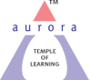
(ACCREDITED BY NAAC WITH ‘B++’ GRADE)
Chikkadpally, Hyderabad 500020
EVENT PROPOSAL
for

WORLD LAUGHING DAY
Event/Activity Name: WORLD LAUGHING DAY CELEBRATION

Event/Activity Title: WORLD LAUGHTER DAY 2021
Cell / Committee/Club Convener/facilitator: K. Sujatha
Faculty coordinators: D. Radhika
Date: 02-05-2021
Venue: Aurora’s Degree and PG College
Target audience: Faculty & Students
Platform: Aurora’s Degree & PG College
Level: College level
Student Volunteer’s: All the B. Com final year captains
Objectives:
- To raise awareness about laughter and its many healing benefits.
- To build up a consciousness of brotherhood and friendship through laughter.
- To create awareness among the people that laughter is a key to relieve from various psychiatric disorders
- To spread smiles and happiness among the people.
Proposed activities:
- Inviting students and faculty to the event of WORLD LAUGHING DAY celebrations.
- Students present powerpoint presentations on the need & importance of celebrating world laughing day.
- Students explain how laughing helps to relieve stress and many psychiatric disorders.
- Students perform a variety of entertainment laughing programs which makes everyone laugh.
Budget: Nil
Cell Convener IQAC Coordinator Principal (K. Sujatha) Dr. Ravi Kiran Dr. Viswanadham Bulusu
Aurora’s Degree & PG College
(Accredited by NAAC with 'B++' grade)
Chikkadpally, Hyderabad- 500020
Department of Commerce

EVENT REPORT

EVENT TITLE | WORLD LAUGHTER DAY 2021
TYPE OF EVENT | Department event
FACULTY INCHARGE | D. Radhika
DEPARTMENT | Commerce
DATE | 02-05-2021
VENUE | Aurora’s Degree & PG College
TARGET AUDIENCE | Faculty and Students
OBJECTIVE:
- To raise awareness about laughter and its many healing benefits.
- To build up a consciousness of brotherhood and friendship through laughter.
- To create awareness among the people that laughter is a key to relieve from various psychiatric disorders
- To spread smiles and happiness among the people.
- BRIEF ABOUT THE EVENT: The event was celebrated to raise awareness about the laughter day event. Students and faculty enthusiastically participated in the event. Two students from B. Com generals i.e., Ayush Chabra (B. Com 2nd Year) and Sony Biradar (B. Com 3rd year) gave a powerpoint presentation on Importance of WORLD LAUGHTER DAY and also, they presented about greatness of Charlie Chaplin and Mr. Bean. One student Akshita (B. Com honours 2nd year) conducted a quiz on menti meter which made everyone very enthusiastic and so excited while participating in that quiz. Students performed a variety of entertainment laughing programs which made everyone laugh. The faculty members of Commerce and Management streams were also present at the event and were greatly impressed with the performance of the volunteers. The students who were present at the event also enjoyed the event thoroughly.
OUTCOME: The students and faculty understood the importance of laughing and how it helps them to relieve stress and many psychiatric disorders.

PHOTOGRAPH:

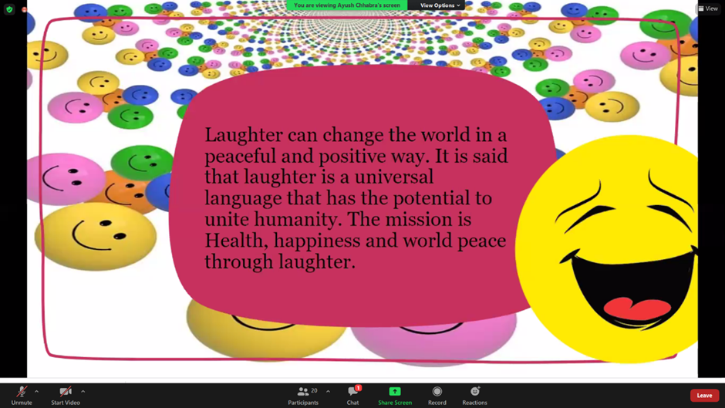

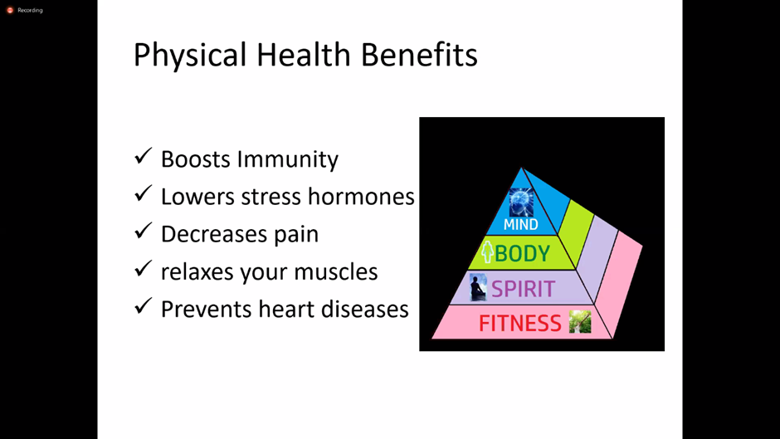

Aurora’s Degree & PG College
(Accredited by NAAC with 'B++' grade)
Chikkadpally, Hyderabad- 500020
Department of Commerce

EVENT REPORT

EVENT TITLE | WORLD LAUGHTER DAY 2021
TYPE OF EVENT | Department event
FACULTY INCHARGE | D. Radhika
DEPARTMENT | Commerce
DATE | 02-05-2021
VENUE | Aurora’s Degree & PG College
TARGET AUDIENCE | Faculty and Students

OBJECTIVE:
- To raise awareness about laughter and its many healing benefits.
- To build up a consciousness of brotherhood and friendship through laughter.
- To create awareness among the people that laughter is a key to relieve from various psychiatric disorders
- To spread smiles and happiness among the people.
- BRIEF ABOUT THE EVENT: The event was celebrated to raise awareness about the laughter day event. Students and faculty enthusiastically participated in the event. Two students from B. Com generals i.e., Ayush Chabra (B. Com 2nd Year) and Sony Biradar (B. Com 3rd year) gave a powerpoint presentation on Importance of WORLD LAUGHTER DAY and also, they presented about greatness of Charlie Chaplin and Mr. Bean. One student Akshita (B. Com honours 2nd year) conducted a quiz on menti meter which made everyone very enthusiastic and so excited while participating in that quiz. Students performed a variety of entertainment laughing programs which made everyone laugh. The faculty members of Commerce and Management streams were also present at the event and were greatly impressed with the performance of the volunteers. The students who were present at the event also enjoyed the event thoroughly.
OUTCOME: The students and faculty understood the importance of laughing and how it helps them to relieve stress and many psychiatric disorders.

DETAILED REPORT:
The WORLD LAUGHTER DAY event is celebrated on May first Sunday every year. This year May first Sunday is on 2nd May, 2021. The event is conducted at college level and invites all the faculty members and students from all the streams. Due to a pandemic situation the event is organized online using Microsoft-teams platform. The student coordinators gave their support for the successful organization of this event.
The event began with the power point presentation by Ayush Chabra on importance of World Laughing Day and contribution of world-famous personalities i.e., Charlie Chaplin and Mr. Bean who makes everyone laugh. Students presented on screen few comedy clipping of Charlie Chaplin and Mr. Bean which made everyone laugh. Later Sony Biradar (B. Com Generals 3rd year) presented a Powerpoint presentation about the importance of laughing and how laughing helps to relieve stress and many psychiatric disorders. Her presentation was thoroughly enjoyed by everyone as it spread smile and happiness among the audience.
Siddala Akshitha (B. Com Honours 2nd year) conducted a quiz on mentimeter in which all the students and faculty members also participated enthusiastically. They were very much excited and enjoyed it thoroughly. Students displayed some memes on the screen which made everyone laugh. Students told some comedy shayaris. Students perform a variety of entertainment laughing programs which makes everyone laugh. Finally, the event ended with the vote of thanks given by D. Radhika, Senior Assistant Professor in Commerce. The event was successful in educating the students about the importance of laughing, its healing benefits and role of laughing in our daily life.
LIST OF STUDENT COORDINATORS.
S.NO | ROLL NO | STUDENT NAME | CLASS | Section
1 | 1051-19-401-151 | AYUSH CHABRA | B.COM GENERALS | 2C
2 | 1051-18-401-156 | SONY BIRADAR | B.COM GENERALS | 3C
3 | 1051-20-407-101 | SIDDALA AKSHITA | B.COM HONOURS | 2B

LIST OF FACULTY PARTICIPANTS.
S.NO | FACULTY NAME |  |  |  |  |  | DEPARTMENT
1 | M. MAMATHA |  |  |  |  |  | COMMERCE
2 | K. SUJATHA |  |  |  |  |  | COMMERCE
3 | N. RENUKA |  |  |  |  |  | COMMERCE
4 | G. SANDHYA RANI |  |  |  |  |  | COMMERCE
5 | J. ANIL KUMAR |  |  |  |  |  | COMMERCE
6 | K. SURESH |  |  |  |  |  | MANAGEMENT
7 | P. MADHURI |  |  |  |  |  | COMPUTER APPLICATIONS
LIST OF STUDENT PARTICIPANTS
S.NO | ROLL NO | STUDENT NAME |  |  | CLASS |  |  | Section
1 | 1051-18-401-270 | R. MUKESH |  |  | B.COM 3rd YEAR |  |  | 3E
2 | 1051-18-401-215 | MADHAVI BIYANI |  |  | B.COM 3rd YEAR |  |  | 3D
3 | 1051-18-401-216 | VEENA TIWARI |  |  | B.COM 3rd YEAR |  |  | 3D
4 | 1051-18-401-136 | SIDDHARTH VYAS |  |  | B.COM 3rd YEAR |  |  | 3C
5 | 1051-18-401-074 | PRANAV SURVE |  |  | B.COM 3rd YEAR |  |  | 3B
6 | 1051-18-401-193 | S. KRISHNA JAIN |  |  | B.COM 3rd YEAR |  |  | 3D
7 | 1051-18-401-044 | NAKKA SUMANTH |  |  | B.COM 3rd YEAR |  |  | 3A
8 | 1051-18-401-042 | MYNAM RAVI TEJA |  |  | B.COM 3rd YEAR |  |  | 3A
9 | 1051-19-401-030 | PUTTI NAVYA SRI |  |  | B.COM 2nd YEAR |  |  | 2A
10 | 1051-18-401-253 | KASU BALA MARY RISHITHA |  |  | B.COM 3rd YEAR |  |  | 3E
11 | 1051-18-401-121 | RAJU LONE |  |  | B.COM 3rd YEAR |  |  | 3C
12 | 1051-18-401-276 | THALASANI BINDU |  |  | B.COM 3rd YEAR |  |  | 3E
13 | 1051-18-401-267 | POLISHETTY ARUN SAI |  |  | B.COM 3rd YEAR |  |  | 3E
14 | 1051-18-401-181 | NAINA DAGA JAIN |  |  | B.COM 3rd YEAR |  |  | 3D
15 | 1051-18-401-199 | SRI RAM VYAS |  |  | B.COM 3rd YEAR |  |  | 3D
16 | 1051-18-401-174 | MAHESH CHANDA |  |  | B.COM 3rd YEAR |  |  | 3C
17 | 1051-18-401-207 | CHIRAG SHANKLA |  |  | B.COM 3rd YEAR |  |  | 3D
18 | 1051-18-401-233 | MADHUKAL DIVYA |  |  | B.COM 3rd YEAR |  |  | 3D
19 | 1051-18-401-275 | TAMBADE ANAGHA |  |  | B.COM 3rd YEAR |  |  | 3E
20 | 1051-18-401-053 | PRATHIVADI BHAYANKARA PRAVALLIKA |  |  | B.COM 3rd YEAR |  |  | 3A
BUDGET: Nil

PHOTOGRAPHS:

