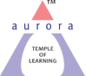
Aurora’s Degree & PG College
(Accredited by NAAC with 'B++' grade)
Chikkadpally, Hyderabad- 500020
Department of Languages

EVENT REPORT

EVENT TITLE | Sanskrit Day
TYPE OF EVENT | Departmental
FACULTY INCHARGE | Dr. Sistla Sailaja  Coordinated by M. Kalyani
DEPARTMENT | Languages
DATE | August 18th 2020
VENUE | Online
TARGET AUDIENCE | UG Students

OBJECTIVE:
To bring awareness among the students about the richness and importance of the language Sanskrit and its learning

BRIEF ABOUT THE EVENT:
Every year Sanskrit day is celebrated on Shravana Purnima day. Sanskrit day is celebrated to increase the awareness and richness imbibed in the language and makes it reachable to each individual. It can be said that the present has its roots deeply established in the past. In the present pandemic times too the rich culture and tradition mentioned in the Sanskrit treatises is being followed. The glory of the language shows the importance with people celebrating the Sanskrit day worldwide.
The richness and subject integration with relevance to Sanskrit has been presented and thrown light.
Sanskrit can be said as a language of civilization which can be mentioned more effectively than the other languages of civilization such as Greek, Chinese, Latin etc.. Sanskrit language is called Devabhasha, Amaravani, Geervani Bhasha too.
Now in every continent and every nation Sanskrit is being learnt as this is the only language through ages which has given the aspects, rules, philosophical truths, administration, polity and social values medicine. In the present day this is also said and believed to be the most compatible language to computer also.
Self-realization of an individual, understanding the world can be achieved though the knowledge of Sanskrit as Sanskrit can be said an embedded language which has in it rich treasures in all kinds of sciences and philosophy to transform oneself into a better individual and in turn a better society can be achieved.
OUTCOME:
The Sanskrit day has enriched the participants in understanding and knowing about the rich culture and tradition embedded in it with respect to the present situations too. It has been understood that the rich culture, traditions and values followed and urged have been mentioned way back through Vedas, Puranas, Upanishads and other Sanskrit treatises.
PHOTOGRAPH
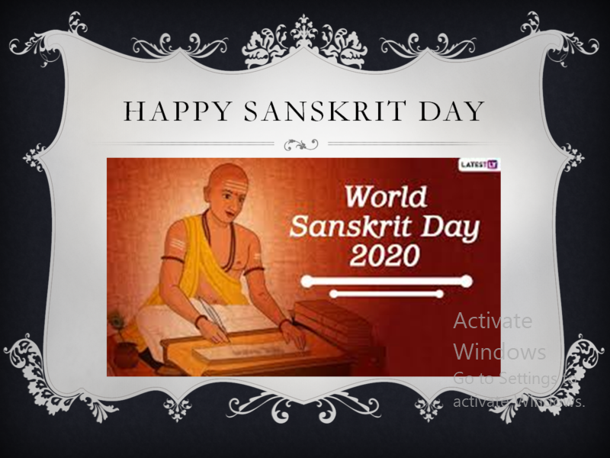
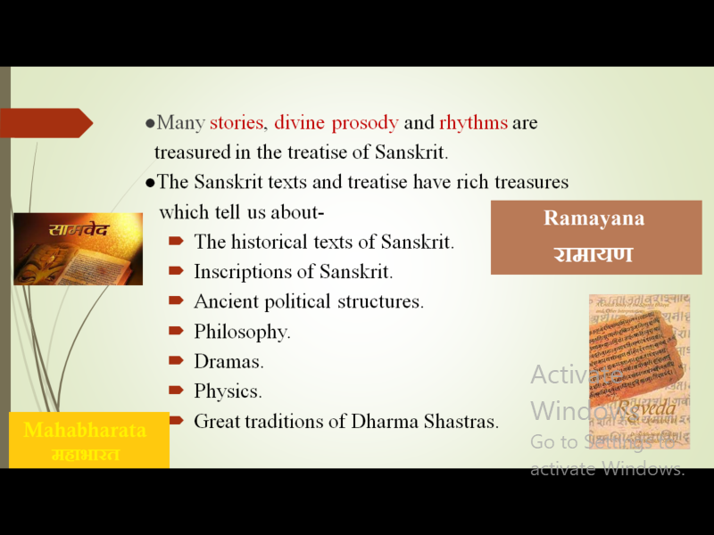
DETAILED REPORT
Sanskrit day is celebrated every year on the Sravana pournima day. It can be said that the present has its roots in the past. Sanskrit through its rich heritage and culture has provided enormous treasure to the mankind. It is the duty of every citizen to know the importance of Sanskrit and preserve the rich culture and heritage. Sanskrit in its treatises has imbibed rich values and aspects to which all the nations are now focusing upon. In the present situations too, the values and aspects mentioned in the treatises are pondered upon and taken into the use.
Sanskrit can be said as a language of civilization which can be mentioned more effective than the other languages of civilization such as Greek, Chinese, Latin etc.. Sanskrit language is called otherwise as Devabhasha, Amaravani, Geervanabhasha too.
Now in every continent and every nation Sanskrit is being learnt as this is the only language through ages which has given the aspects, rules, philosophical truths, administration, polity and social values medicine. In the present day this is also said and believed to be the most compatible language to computer also.
Self realization of an individual, understanding the world can be achieved though the knowledge of Sanskrit as Sanskrit can be said an embedded language which has in it rich treasures in all kinds of sciences and philosophy to transform oneself into a better individual and in turn a better society can be achieved.
The richness of such language Sanskrit has been put forth for the enlightenment, understanding and practicing the values and aspects of culture and heritage dealt through power point presentations.
A significant land mark was made in the history of the growth of Indian research in the field of Sanskrit through Simla Conference in 1911. Sanskrit Language and the works of Sanskrit language uphold the spiritual and moral ideals and helps in the new orientation to the development of the society.
- List of the student coordinators
NAME | ROLL NO | CLASS & SECTION
Jetti Navya | 1051-18-402-024 | B.ComComputers
Naganeeyathi. K | 1051-18-402-035 | B.ComComputers

- Total Number of participants: 25

List of girl participants: 15

S.No | Name of the Student
1 | kalyani merugu
2 | Aditi Mahapatra
 | AluriSandhya AluriSandhya
3 | AvulaManisha AvulaManisha
4 | ChinthalapallySushritha
5 | DSindu DSindu
6 | JettiNavya JettiNavya
7 | Kalvacherla Poojitha
8 | KanderaDivya KanderaDivya
9 | AkulaHemaRao AkulaHemaRao
10 | sowmya bammidi
11 | Surya Kanthi
12 | Vankayala Shivanni Vankayala Shivanni
13 | Rushika Nanaso Patil Rushika Nanaso Patil
14 | ShruthiKanuganti ShruthiKanuganti
15 | Kumari Naga Neeyathi

List of Boy Participants: 10
S.NO | Name of the Student
1 | C A Akhilesh Yadav
2 | GudimetlaRajkumar
4 | Manthri Varun Dev
6 | Pandagirl
8 | RajuladeviYogesh Yogi
9 | Uppunuthula Nikhil
10 | Chakali Ramu

- Budget plan - Nil

- Photographs:

