Aurora’s Degree & PG College 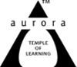
(Accredited by NAAC with 'B++' grade)
Chikkadpally, Hyderabad- 500020
Department of Microbiology

EVENT REPORT

EVENT TITLE | Hans Krebs Birthday
TYPE OF EVENT | Departmental event
FACULTY INCHARGE | K.Mary Manjusha Rani
DEPARTMENT | Microbiology
DATE | 25-8-2020
VENUE | Online Through Google Meet
TARGET AUDIENCE | UG and PG Life Science Students

OBJECTIVE:

The main objective of the session is to create awareness to students on cellular respiration a biochemical process in living cells that extracts energy, chemical reactions that takes place in the cells of humans and many other organisms, namely the citric acid and the urea cycle.

BRIEF ABOUT THE EVENT:

Mrs.K.Manjusha from the department of microbiology organized Sir Hans Krebs’s Birthday through Google meet on 25th August 2020. Life Students from ADC actively participated in awareness program conducted by microbiology department. Participants actively participated in activities like power point presentation, poster presentation and video presentation of the scientist.
Event started at 1:30 pm students from MiGC First Year students, Second year students of MiGC and PG students participated in this event. Introduction was presented by Girvani from PG First Year Followed by Animation video on Krebs cycle. After the presentations students also participated in cross word puzzle and one minute biology.

OUTCOME:

Students will be able to have crucial to our understanding of health and disease on a number of levels. It describes how cells convert sugars, fats, and proteins into intermediates to supply crucial energy (ATP) essential for the support of life. A practical understanding of the importance of the citric acid cycle can be seen in inborn errors of metabolism, where this cycle is disrupted. Hence the event describes about kreb’s life and his research work.

PHOTOGRAPHS:

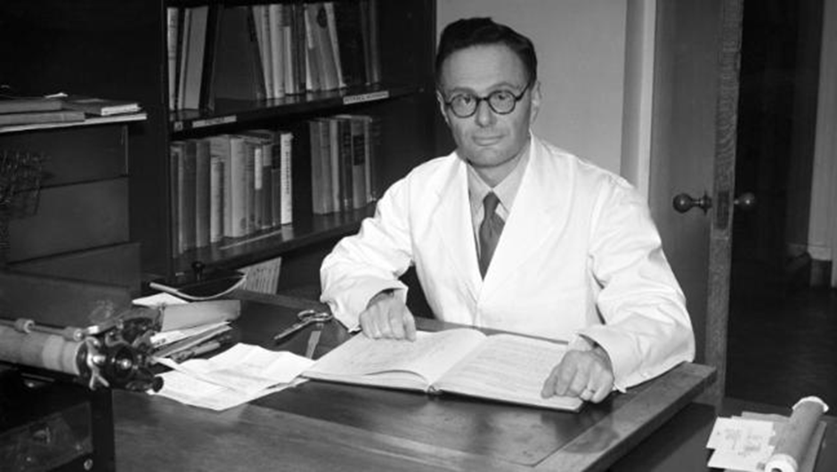

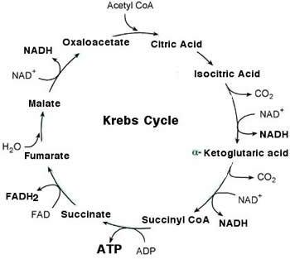

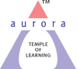
Aurora’s Degree & PG College
(Accredited by NAAC with 'B++' grade)
Chikkadpally, Hyderabad- 500020
Department of Microbiology

EVENT REPORT

EVENT TITLE | Hans Kreb’s Birthday
TYPE OF EVENT | Departmental event
FACULTY INCHARGE | K.Mary Manjusha Rani
DEPARTMENT | Microbiology
DATE | 25-8-2020
VENUE | Online Through Google Meet
TARGET AUDIENCE | UG and PG Life Science Students

OBJECTIVE:
The main objective of the session is to create awareness to students on cellular respiration a biochemical process in living cells that extracts energy, chemical reactions that takes place in the cells of humans and many other organisms, namely the citric acid and the urea cycle.
BRIEF ABOUT THE EVENT:
Mrs.K.Manjusha from the department of microbiology organized Sir Hans Krebs’s Birthday through Google meet on 25th August 2020. Life Students from ADC actively participated in awareness program conducted by Microbiology Department about 21 students participated in the activities like power point presentation, poster presentation and video presentation of the scientist.
Event started at 1:30 pm students from MiGC First Year students, Second year students of MiGC and PG students participated in this event. Introduction was presented by Girvani from PG First Year Followed by Animation video on Krebs cycle. After the presentations students also participated in cross word puzzle and one minute biology.

OUTCOME:
Students will be able to have crucial to our understanding of health and disease on a number of levels. It describes how cells convert sugars, fats, and proteins into intermediates to supply crucial energy (ATP) essential for the support of life. A practical understanding of the importance of the citric acid cycle can be seen in inborn errors of metabolism, where this cycle is disrupted.

List of student coordinators:
S.No | Name of the student | Roll Number | Class & Section
1. | Vidhi S Vasa | 1051-18-459-025 | MiGC 2A

List of the participants:
B.Sc:
S.No | Name of the student | Roll Number | Class & Section
1. | Anagoni Pranay Kumar | 1051-18-459-001 | MiGC 2A
2. | Gurram Vijaya Manjushree | 1051-18-459-009 | MiGC 2A
3. | Mannem Rahul Reddy | 1051-18-459-014 | MiGC 2A
4. | Nandini Kallala | 1051-18-459-015 | MiGC 2A
5. | Jakkula Geethika | 1051-18-459-021 | MiGC 2A
6. | Chethurvedula Lakshmi Kameswari Mani | 1051-18-459-022 | MiGC 2A
7. | Valluri Supriya | 1051-18-459-024 | MiGC 2A
8. | Jannapala Shirisha | 1051-18-459-026 | MiGC 2A
9. | Odnala Arundhati Ramani | 1051-18-459-040 | MiGC 2A

M.Sc:
S.No | Name of the student | Roll Number | Year
1. | Hajra Kazim | 1051-19-518-001 | 1st year
2. | Devarakonda Kaveri | 1051-19-518-005 | 1st year
3. | Chiluka Madhuri | 1051-19-518-006 | 1st year
5. | Kommu Saritha | 1051-19-518-011 | 1st year
6. | Dhara Narender Srujana | 1051-19-518-014 | 1st year
7. | Puchakayala Sowjanya | 1051-19-518-015 | 1st year
8. | Ch Divyarani | 1051-19-518-019 | 1st year
9. | Miryala Shivakumar | 1051-19-518-020 | 1st year
10. | Udari Vasantha | 1051-19-518-021 | 1st year
11. | Anjum Fathima | 1051-19-518-022 | 1st year

Photographs:

