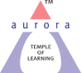
Aurora’s Degree & PG College
(ACCREDITED BY NAAC WITH 'B++' GRADE)
Chikkadpally, Hyderabad 500020

EVENT / ACTIVITY DETAILED REPORT

NAME OF THE EVENT | Eco-friendly Ganesh festival
TYPE OR TITLE OF EVENT / ACTIVITY | Social Activity
FACULTY INCHARGE | P. Chandrakala
DEPARTMENT/CELL/COMMITTEE/CLUB | Social Activity
DATE | 10-09-2021
VENUE | Block I & Block VI Aurora’s Degree & Pg College
TARGET AUDIENCE | Teaching & Non-Teaching Staff

PROGRAM SCHEDULE:
10/09/2021: Pooja at 8am
11/09/2021: Pooja at 9am
FACULTY COORDINATORS:
1. P. Chandrakala, Department of Mathematics,
2. P. Archana, Deparment of Mathematics,
3. G. Sunita, Department of Mathematics.
ABOUT THE PROCEEDINGS:
Despite the threat of an imminent COVID third wave looming large, the auspicious occasion of Ganesh Chaturthi is being celebrated at Aurora’s Degree & PG College, on Friday (September 10). Ganesh Utsav is one of the most celebrated festivals in the college both in Block VI & Main Block. On 9th October, 2021, Ms. Chandrakala, Social Activity coordinator bought the Ganesh Idol and started the decoration. By coordinating with GHMC, Hyderabad, she distributed clay Ganesh Idol on 9th September, 2021 in main block. Ms. P. Archana, Ms. G. Sunita & Ms. Leelamani made a beautiful set up (mandap) with ecofriendly colors and decorated items in both the blocks. On 10th September, 2021, ie. On Ganesh festival, pooja started by Principal with his family and faculty coordinator Ms. M. Devika. Later on Poojs is performed by faculty and non-teaching staff with Prasadams for two days, both in morning and evening sessions.
The final procession was accompanied by Bhajans and Abhishekam, The visarjan took place on 11th September, 2021 in an eco –friendly.
EVENT PHOTOS:
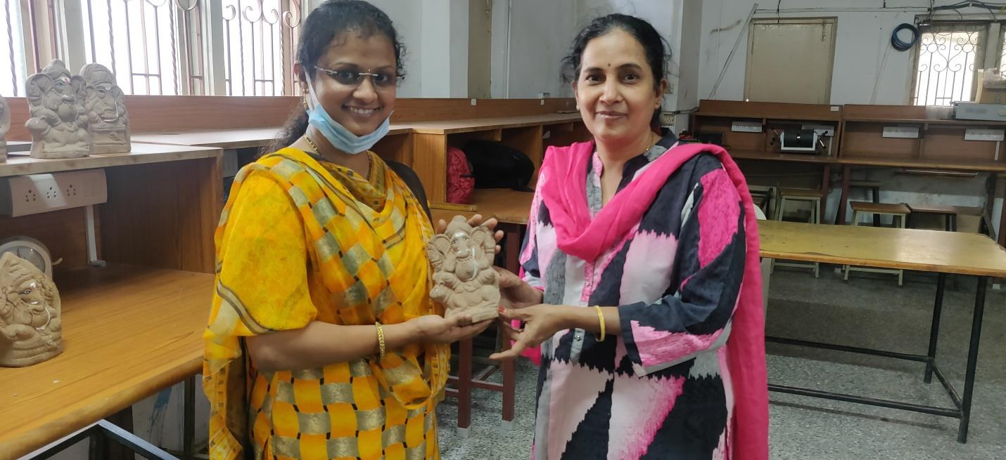

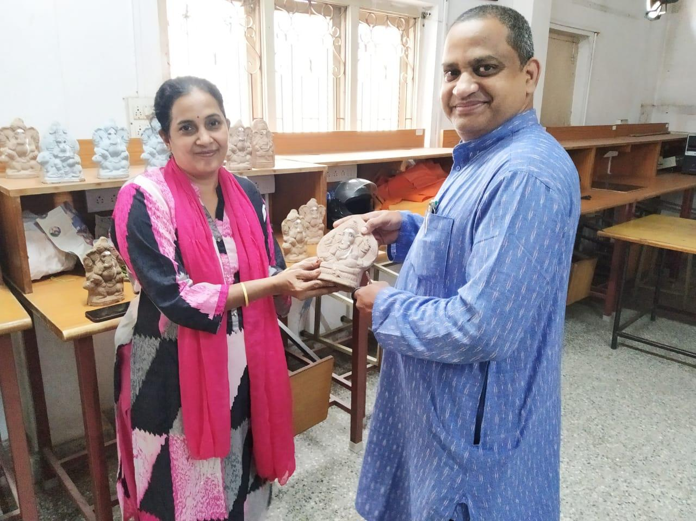
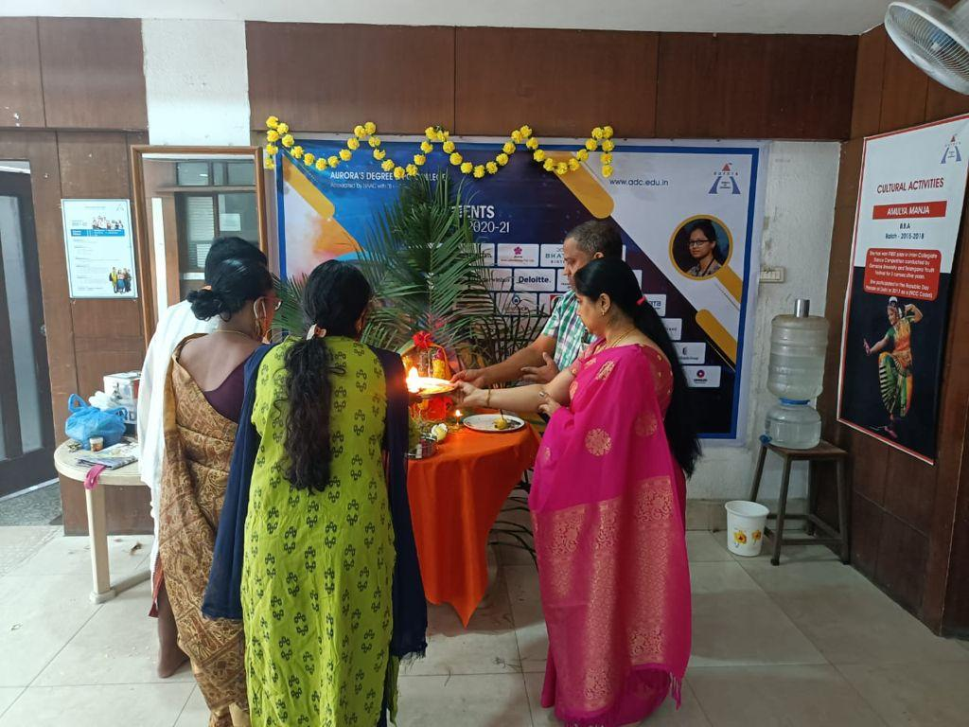

Aurora’s Degree & PG College
(ACCREDITED BY NAAC WITH 'B++' GRADE)
Chikkadpally, Hyderabad 500020

NAME OF THE EVENT | Eco-friendly Ganesh festival
TYPE OF EVENT | Social Activity
FACULTY INCHARGE | P. Chandrakala
CELL | Social Activity
DATE | 10-09-2021
VENUE | Block I & Block VI Aurora’s Degree & Pg College
TARGET AUDIENCE | Teaching & Non-Teaching Staff

OBJECTIVE:
Green or Ecofriendly festival is the theme of every year’s celebration of Ganesh festival.
BRIEF ABOUT THE EVENT:
Despite the threat of an imminent COVID third wave looming large, the auspicious occasion of Ganesh Chaturthi is being celebrated at Aurora’s Degree & PG College, on Friday (September 10). Ganesh Utsav is one of the most celebrated festivals in the college both in Block VI & Main Block. On 9th October, 2021, Ms. Chandrakala, Social Activity coordinator bought the Ganesh Idol . By coordinating with GHMC, Hyderabad, she distributed clay Ganesh Idol on 9th September, 2021 in main block. Ms. P. Archana, Ms. G. Sunita & Ms. Leelamani made a beautiful set up (mandap) with ecofriendly colors and decorated items in both the blocks. On 10th September, 2021, ie. On Ganesh festival, pooja started by Principal with his family and faculty coordinator Ms. M. Devika. Later on Poojs is performed by faculty and non-teaching staff with Prasadams for two days, both in morning and evening sessions.
The final procession was accompanied by Bhajans and Abhishekam, The visarjan took place on 11th September, 2021 in an eco –friendly.
OUTCOME:
- Many students shifted to eco-friendly ways of celebrating Ganesh festival at their home
- This creative, social concept not only teaches students about the environment and art, but also enables the students to gain insight into our Indian Culture

