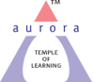
Aurora’s Degree & PG College
(ACCREDITED BY NAAC WITH 'B++' GRADE)
Chikkadpally, Hyderabad 500020

EVENT / ACTIVITY DETAILED REPORT

NAME OF THE EVENT / ACTIVITY | Hindi Diwas
TYPE OR TITLE OF EVENT / ACTIVITY | Hindi Diwas
FACULTY INCHARGE | Dr. Shivhar Biradar
DEPARTMENT/CELL/COMMITTEE/CLUB | Languages
DATE | 14 to16th September 2021
VENUE | Microsoft TEAMS
TARGET AUDIENCE | 2 & 3 years of Hindi Students

- PROGRAM SCHEDULE 14 to16th September 2021
2. LIST OF FACULTY COORDINATORS (DEPARTMENT)
1. Dr. Shivhar Biradar (Languages)
2. R.Heena. (Languages)
3. LIST OF THE STUDENT COORDINATORS (NAME, ROLL NO, CLASS & SECTION)
- Ayush Chhabra – 1051-19-401-151 (B.Com Generals 2 ‘C’)
- Pankaj Kumar sahani-1051-20-401-019 (B.com(general) 1A)

- LIST OF THE PARTICIPANTS (NAME , ROLL NO, CLASS & SECTION, NO OF GIRLS, BOYS, CASTE )
STUDENTS ATTENDED
BOYS:
1. 1051-19-405-167 | Varindani N Bhupesh | BCA2C
2. 1051-19-467-163 | Mohammed abdullah | Mscs - 2d
3. 1051-19-468-150 | P bhaskar sharma | Mpcs2c
4. 1051-19-488-065 | Adnan Karani | Btbic 2b
- 5.1051-20-401-019 | Pankaj Kumar sahani | Bcom(general) 1,A
6. 1051-20-401-028 | Rudraksh Vyas | 1A
- 7.1051-20-401-053 | Syed Tousif Ashrafee | B.com General 1A
- 8.1051-20-401-056 | Navneeth sharma | B.com general 1A
9. 1051-20-401-067 | H.Siddharth singh | Bcom gen 1A
10. 1051-20-405-161 | Tarun Nirwan | BCA-1C
11. 1051-20-405-191 | Bhavish | Bca1 C
12. | Goutham raj dharmi | Mscs1b
13. 1051-20-684-021 | Shaik Amaanahmed | BBA 1A
14. 1051-20-684-027 | Krishna Sharma | BBA1A
15. 1051-20-684-029 | Prateek Saini | BBA 1 A
16. 1051-20-684-028 | Vansh agarwal | BBA1A
17. 1051-20-684-047 | Prashant N Ghanshyani | BBA1A
18. 1051-20-684-080 | Pinjara prashanth | Bba1b
19. 1051-20-684-081 | VIJAY BHOLENATHGUPTHA | BBA1B
20. 1051-20-684-083 | CHITTEM KALYAN SAI | BBA,1B
21. 1051-20-684-103 | Rohit Lahoti | Bba1b
22. 1051-20-684-110 | P.Durga prasad | BBA1C
23. 1051-20-684-112 | B Vishnu vardhana chary | BBA1c
24. 1051-20-684-176 | MUNDE SAINATH | BBA1C
25. 1051-20-684-170 | Akshat shukla | BBA1A
26. 1051-19-401-151 | Ayush Chhabra | B.Com Genral 3C
27. 1051-18-401-15 | Amarnath | B.Computer application 3C
28. 1051-20-401-019 | Pankaj Kumar sahani | Bcom(general) 1,A
GIRLS
1. 1051-19-405-156 | G.RUCHIKA | B.computers application 2C
2. 1051-19-405-162 | Mousumi Samanta | Bcom computer applications2c
3. 1051-19-405-163 | Soniya sunka | Bcom computer application 2C
4. 1051-19-405-190 | seema arni | bca2c
5. 1051-19-459-052 | Sruthi Dubey | BSC migc 2b
6. 1051-19-459-055 | K Priyanjali | Migc 2b
7. 1051-19-459-058 | Sanyukta Singh Rawat | MIGC 2B
8. 1051-19-459-059 | KAINAAT KHOJA | Migc 2B
9. 1051-19-459-063 | Dinky patel | Migc 2b
10. 1051-19-467-153 | Swathi kumari | Mscs-2D
11. 1051-19-467-155 | K. Raga Srinidhi | MSCS - 2D
12. 1051-19-488-056 | B.Hruthvika | Btbic2b
13. 1051-20-401-002 | Monika Agarwal | Bcom(gen) , 1A
14. 1051-20-459-038 | Prerana Sanjay Shankpal | MiGC-1A
15. 1051-20-467-112 | Salve pragnya | Mscs1B
16. 1051-20-488-018 | Kripali Makhecha | Btbic
17. 1051-20-684-005 | Pooja Goyal | BBA 1A
18. 1051-20-684-006 | Anu jain | BBA 1A
19. 1051-20-684-008 | D. Sree nija | BBA 1 A
20. 1051-20-684-010 | SHIVANI KHONDE | BBA 1A
21. 1051-20-684-058 | A. S. Tejaswini | BBA1B
22. 1051-20-684-059 | Radhari Varshitha Yadav | BBA 1 B
23. 1051-20-684-075 | Hemanth badukali | BBA 1B
24. 1051-20-684-124 | AYESHA BIBI | BBA1C
25. 1051-20-684-167 | Anthati thrishika | BBA 1B
26. 1051-19-401-163 | Pragati Oza | B.Com Genral 3C

- PARAGRAPH ABOUT THE PROCEEDINGS (TILL THE END OF THE EVENT)
Aurora Degree & PG College Organized Virtual activity on Hindi Diwas from 14th September to 16th September at Microsoft TEAMS The event started with the prayer song. The convener of the event Dr. Shivhar Biradar (Hindi faculty) from department of languages gave an introduction speech about the importance of Hindi Language, Hindi our official language was given its authority on 14th Sept 1949.

- Welcome song to create awareness among students about Hindi Language.
- To make the online program more interactive and engaging several competitions and activities were organized like online poem recitation, elocution, Quiz Competition wherein students participated with full zeal and enthusiasm.

Faculty Volunteer Dr. Shivhar Biradar also shared a poem which instilled patriotism in everyone.
- Poem Recited by Ayush Chhabra, Pankaj Kumar Sahani, Pragati Oza and many others.
- Speeches were given by the Students on Hindi Bhasha ka Udbhav aur Vikas by Pooja Goyal & Ayush chhabra.

- Vote of Thanks by R. Heena
Hindi diwas is a platform for students to showcase their talent in their National Language and to encourage the students to develop their motherhood and for their growth as an Indian.
The session was concluded with a collective realization of the importance of Hindi language and the resolve to respect it.

Certificates were distributed.

- INCOME AND EXPENDITURE NILL

- EVENT PHOTOS ( MIN 2 MAX 4)
- 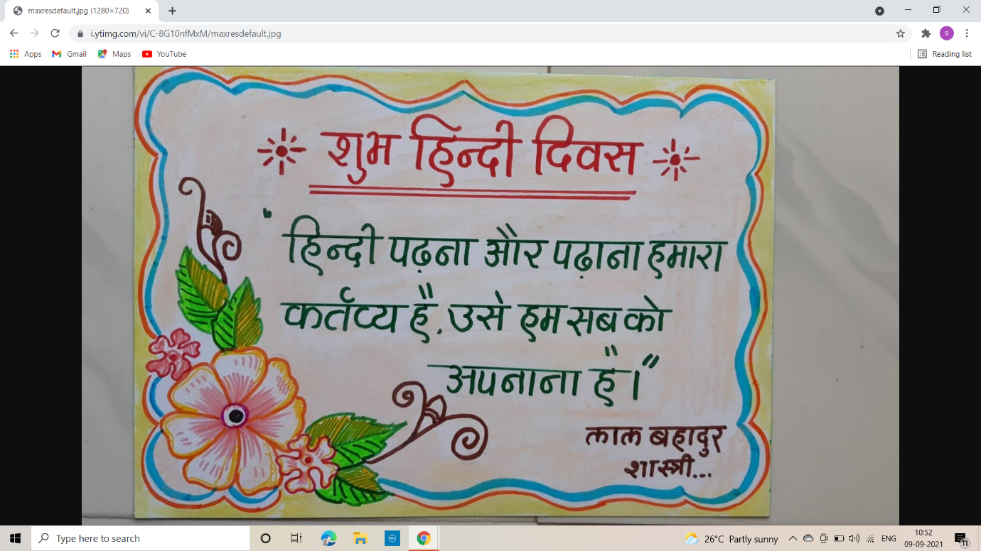
- 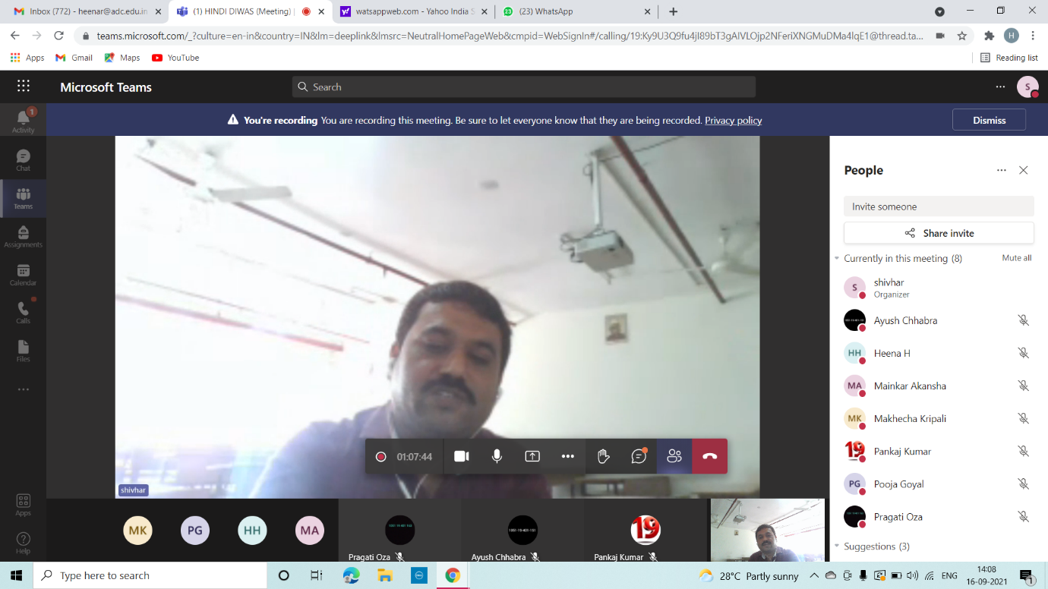
- 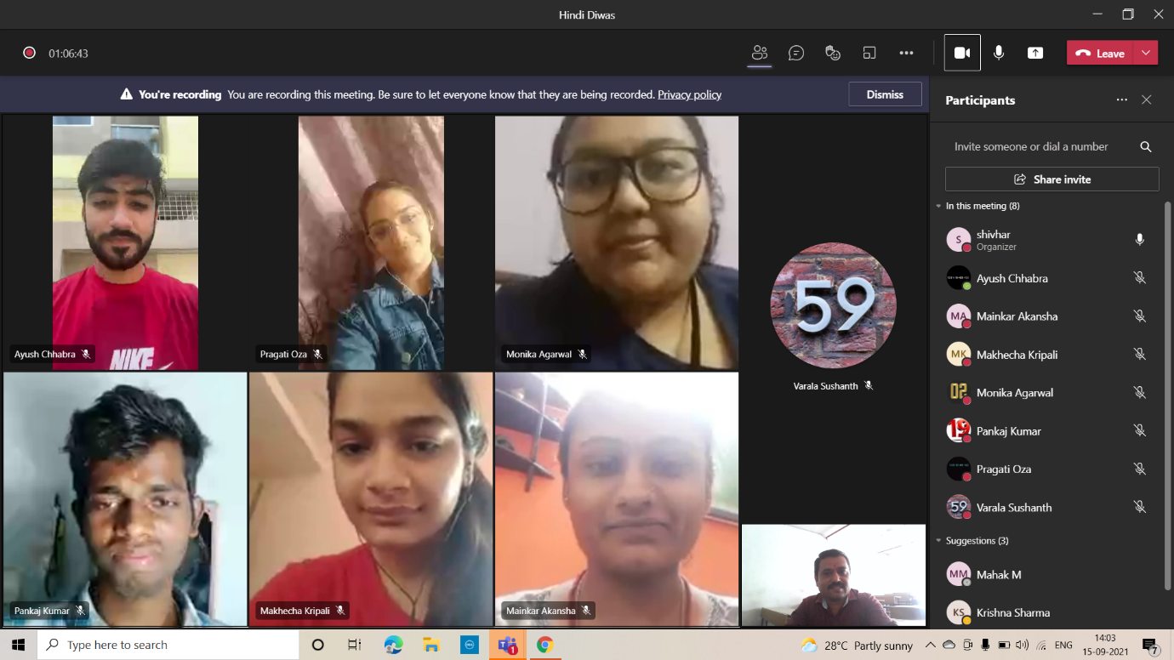
- 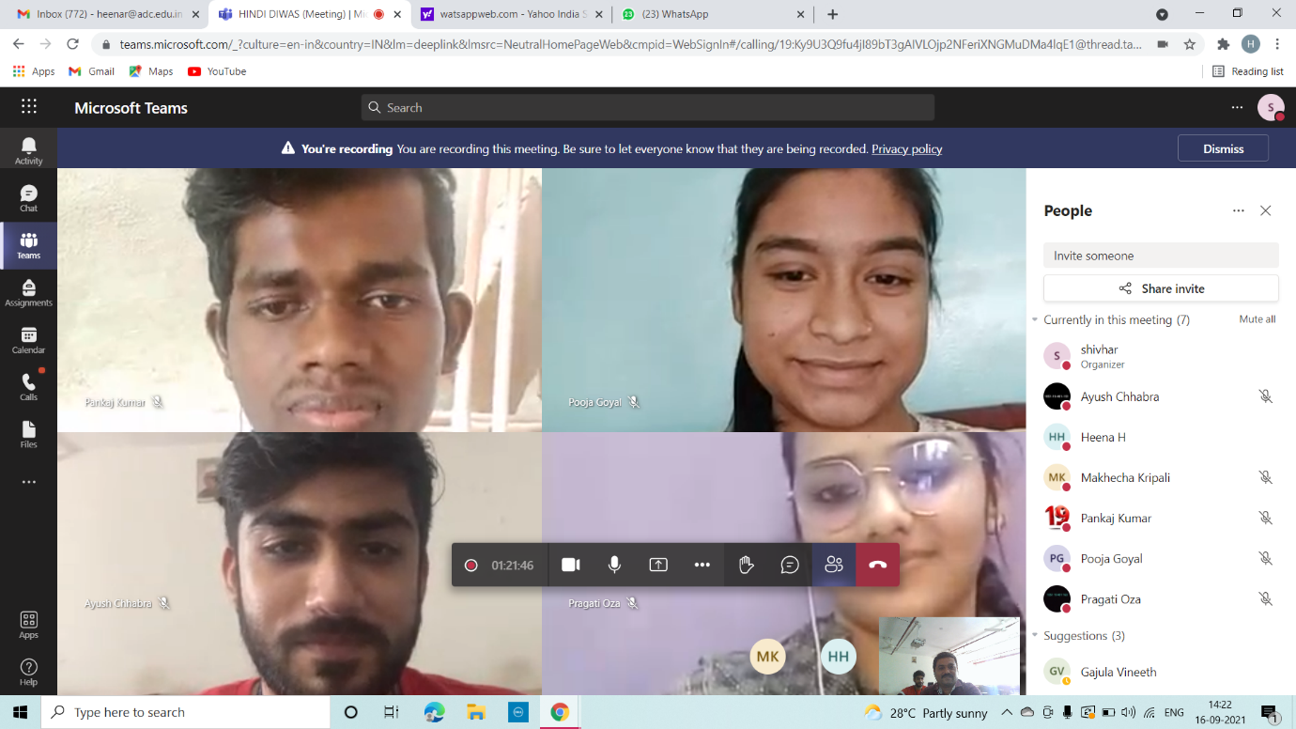
- 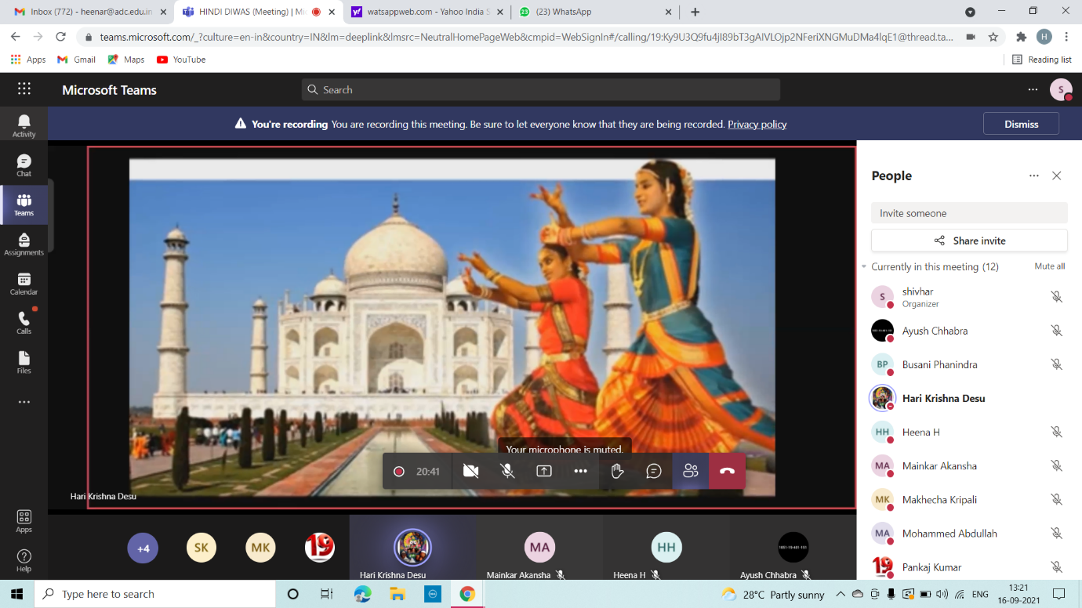
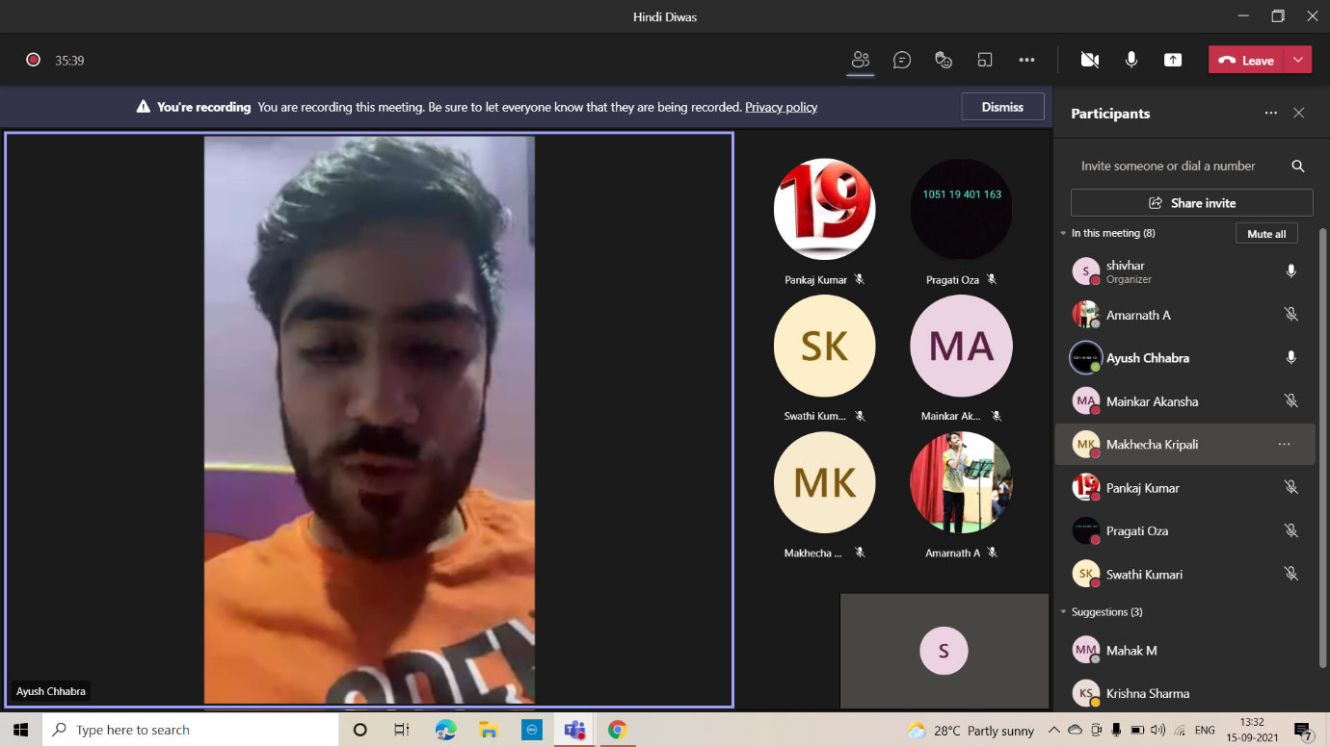

- ATTACHMENTS:
EVENT/ACTIVITY PROPOSAL - Attach
EVENT / ACTIVITY NOTICE - Sent Through WhatsApp
RECEIPTS (IF ANY)
CERTIFICATES (IF ANY) - Soft Copy Participated
LETTERS OF COMMUNICATION (IF ANY)

