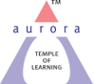
Aurora’s Degree & PG College
(ACCREDITED BY NAAC WITH 'B++' GRADE)
Chikkadpally, Hyderabad 500020

EVENT / ACTIVITY DETAILED REPORT

NAME OF THE EVENT / ACTIVITY | International Internet Day
TYPE OR TITLE OF EVENT / ACTIVITY | International Internet Day
FACULTY INCHARGE | Navneetha, Madhu Priya
DEPARTMENT/CELL/COMMITTEE/CLUB | Computer Science
DATE | 29.10.2021
VENUE | Room No 303, RTC Block
TARGET AUDIENCE | BCom, BSc Final years

- PROGRAM SCHEDULE: Quiz was scheduled on 29.10.2021
- LIST OF FACULTY COORDINATORS (DEPARTMENT):Navneetha N, MadhuPriya A
- LIST OF THE STUDENT COORDINATORS (NAME , ROLL NO, CLASS & SECTION) -NA
- LIST OF THE PARTICIPANTS (NAME , ROLL NO, CLASS & SECTION, NO OF GIRLS, BOYS, CASTE )
Name | Roll No | Class | Section
Satish Yadav | 1051-20-405-124 | Bca2 | B
Salve pragnya | 1051-20-467-112 | Mscs | 2b
CHANDU DASARI | 1051-20-405-102 | Bcom Comp Applications | 2B
Vallabh Choudary | 1051-20-405-08 | BCA2b | 2b
k.sharath | 1051-20-467-076 | mscs | 2b
Sunkari shreya | 1051-20-467-111 | Bsc statistics | Mscs-2b
Kashyap Bharadwaj Srirangam | 105120467087 | MSCs | 2b
D.jagadishwar | 1051-20-405-087 | BCA | B
Gaja Jeevan Sai | 1051-20-405-088 | BCA2b | 2b
A. Sriya | 1051-20-405-063 | Bcom computer applications | A
N Nimisha | 1051-20-405-003 | BCA2A | A
Saka vinesh | 049 | B.com computer application | 2a
EGALA CHINMAYE SAIPRIYA | 105120405113 | BCom Computers Applications | BCA2b
A.Trinath | 1051-20-467-072 | Mscs | 2B
Jaiswal Sejal | 105120405004 | B.com Computer’s Application | A
Yash lal Singh | 105120405178 | 2nd year | Bca-1c

- PARAGRAPH ABOUT THE PROCEEDINGS (TILL THE END OF THE EVENT)
On the occasion of International Internet Day Department of Computer Science has conducted Quiz competition on internet concepts to first years on 28.10.2021 registration link has been shared through what’s app so that interested students can register. On 29.10.2021 at 3.00 pm in Room No 303, the Quiz has been scheduled which consists of 3 rounds.
First round:
15 questions have been shared to students through Quizz.com where each question carries 1 point around 16 students had participated out of which top 6 students have been selected for 2nd round
Second round:
For round2 we made 3 groups (A, B, C) which consists of 2 students/group each group we shared 4 questions through ppt. After this round Group B was leading with 8 points ,Group A with 6 points, Group C with 2 points.
Third round: Round3 is Rapid-fire we share 5 questions for each group which has to be answered in 5 sec. After this round Group B was declared as Winners as they scored 12 points where as Group A scored 9 points and Group C with 3 points

- INCOME AND EXPENDITURE :Nil
- EVENT PHOTOS ( MIN 2 MAX 4)
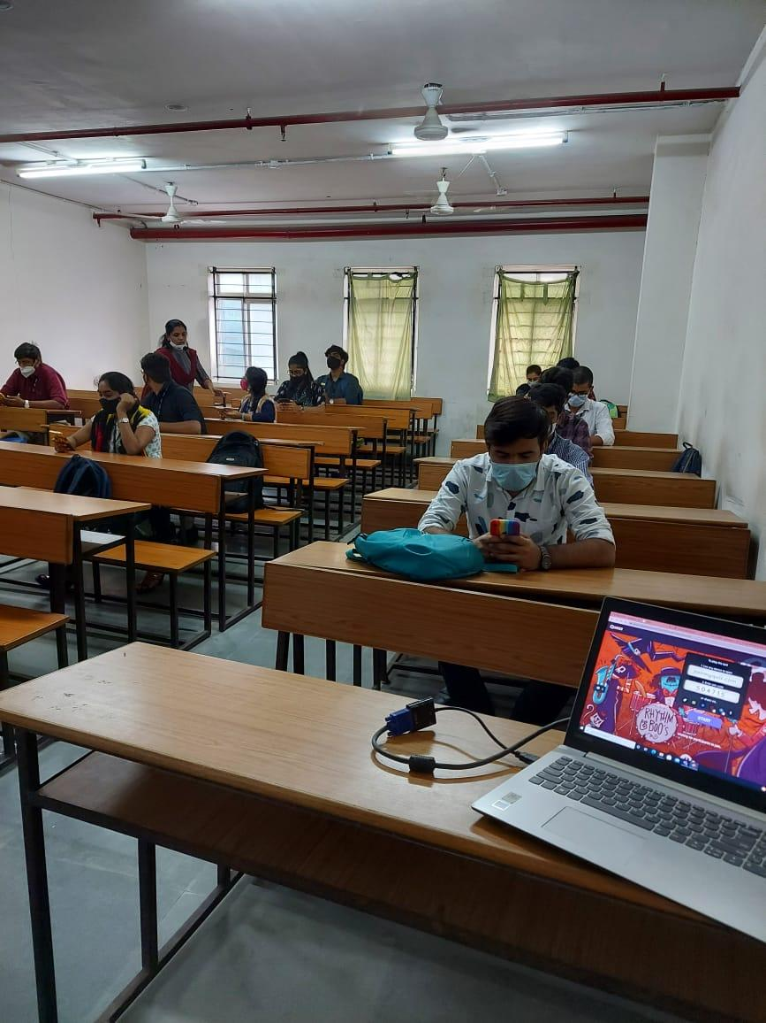
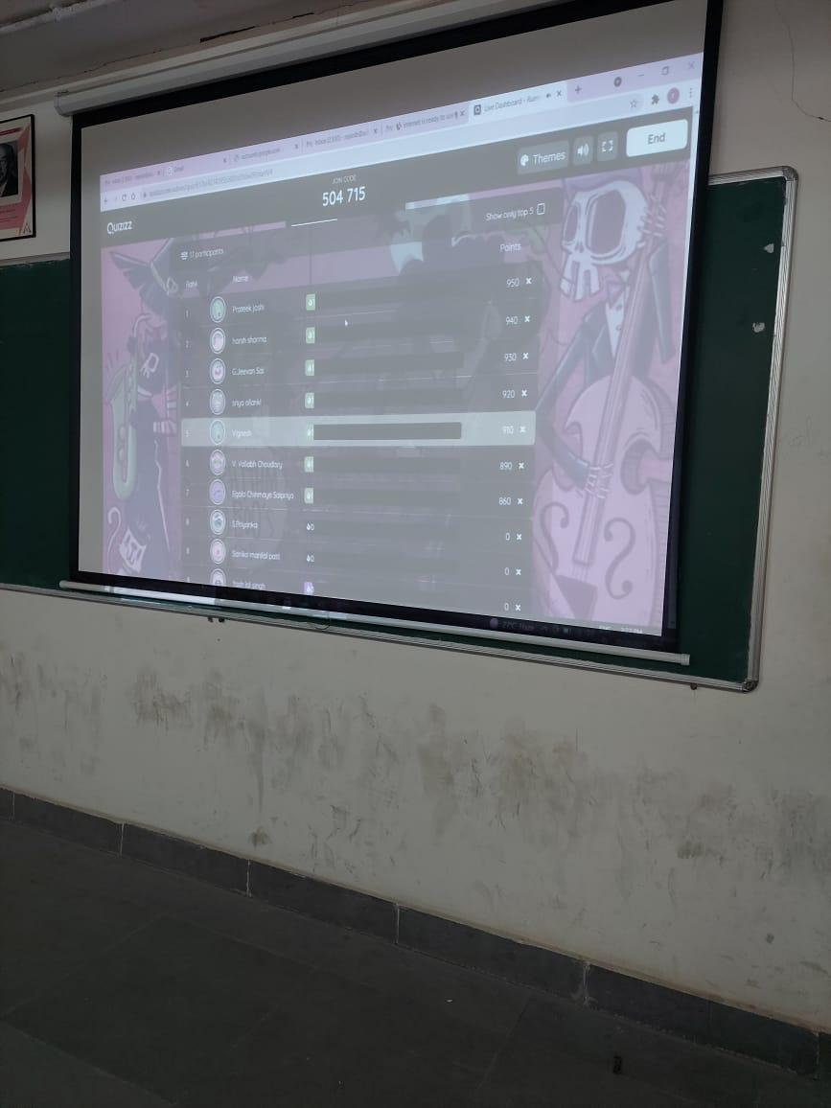

- GUEST PROFILE (IF ANY)-NA
- FEED BACK IF ANY-NA
- ATTACHMENTS:
EVENT/ACTIVITY PROPOSAL: Hardcopy
EVENT / ACTIVITY NOTICE:
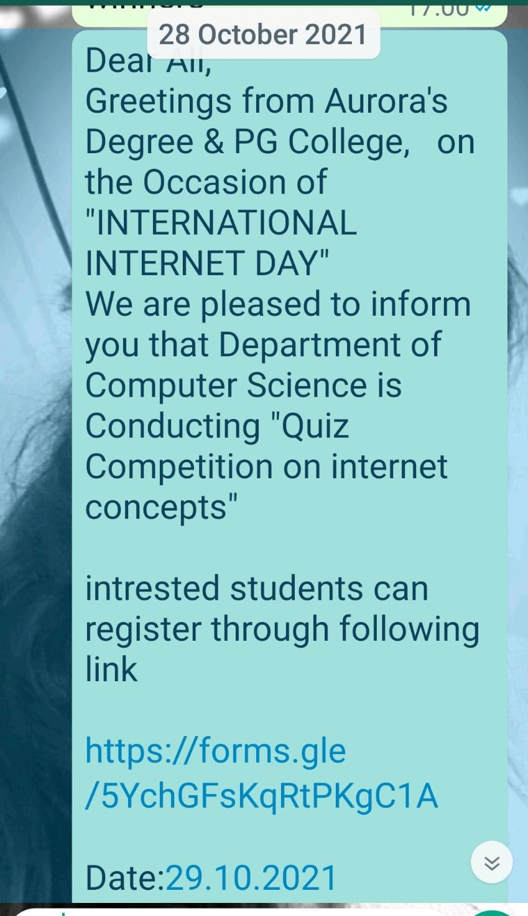
RECEIPTS (IF ANY):NA
CERTIFICATES (IF ANY):NA
LETTERS OF COMMUNICATION (IF ANY):NA

