Aurora’s Degree & PG College
(ACCREDITED BY NAAC WITH 'B++' GRADE)
Chikkadpally, Hyderabad 500020

Brief Report
On
An Orientation program
On the occasion of “E-Waste Management Day”

NAME OF THE EVENT | Orientation program  On the occasion of “E-Waste Management Day”
TYPE OF EVENT | Department level
FACULTY INCHARGE | R.Sravan Kumar
DEPARTMENT | Electronics
DATE | 17th November, 2021
VENUE | Aurora’s Degree and PG College, Chikkadpally
TARGET AUDIENCE | I B.Sc., M.E.Cs and M.P.Cs Students

OBJECTIVE:
To create awareness among the students regarding E-Waste and its re-cycling process by industry experts.
BRIEF ABOUT THE EVENT:
Department of Electronics, Aurora’s Degree and PG College conducts this event with great enthusiasm every year. This year an orientation program was conducted with the help of Mr. Franklin & Mr. Balaji Chowdhary, Earthsense Recycle Pvt.Ltd., Hyderabad on E-Waste and its re-cycling process. Mr.Balaji explained about how Electronic waste will harm the Earth and different measurements taken by industries to recycle the E-waste. Also he was shown different machines used for recycle of E-Waste through his PowerPoint presentation.

OUTCOME:
Students gained practical knowledge through this power point presentation and also they gained knowledge on different machines used in the industry for recycling of E-Waste. They also learned how to discard E-Waste materials without causing of any damage to Earth.
Photographs:
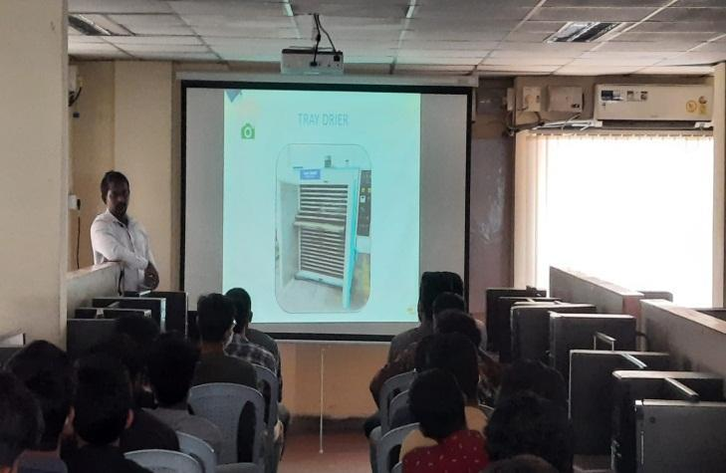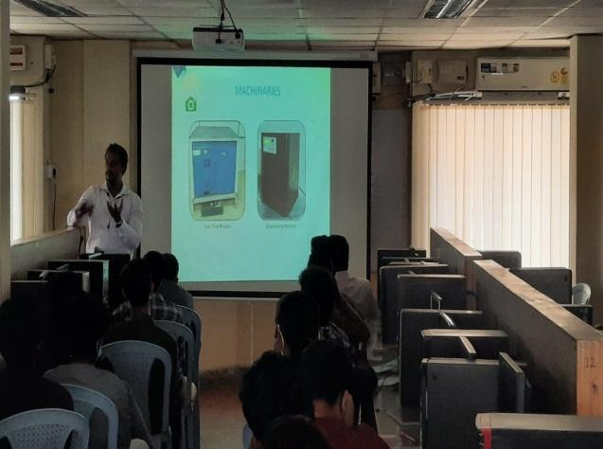

Aurora’s Degree & PG College
Chikkadpally, Hyderabad -500020
A Detailed Report
On
An Orientation program
On the occasion of “E-Waste Management Day”

NAME OF THE EVENT | Orientation program  On the occasion of “E-Waste Management Day”
TYPE OF EVENT | Department level
FACULTY INCHARGE | R.Sravan Kumar
DEPARTMENT | Electronics
DATE | 17th November, 2021
VENUE | Aurora’s Degree and PG College, Chikkadpally
TARGET AUDIENCE | I B.Sc., M.E.Cs and M.P.Cs Students

PROGRAM SCHEDULE: 17th November, 2021 from 10:30 am to 11:45 am. at Aurora’s Degree and PG College –Block-I in Computer lab from 10:30 am to 11:45 am.
VENUE: Aurora’s Degree and PG College – Block I (Computers Lab)
LIST OF FACULTY COORDINATORS: R.Sravan Kumar, Assoc.Prof, Dept. of Electronics.
LIST OF THE PARTICIPANTS:
S.No | Name of the student | Group
1 | Nuthakanti Rohan | M.P.Cs
2 | Rathod Prem Lal
3 | Nimmala Sravan Kumar
4 | Goli Vinay
5 | Lagishetty Vigneshwar
6 | Domala Naveen
7 | Koraveni Shruthi Odenna
8 | S Akhil
9 | Kurva Premkumar
10 | Nuthakanti Rohan
11 | Rathod Prem Lal
12 | Nimmala Sravan Kumar
13 | Goli Vinay
14 | Lagishetty Vigneshwar
15 | Domala Naveen
16 | Koraveni Shruthi Odenna
17 | S Akhil
18 | Kurva Premkumar
19 | Polagowni Sathwik
20 | Suda Thirupathi Reddy
21 | Madishetty Bhanu Prakash
22 | Biyyala Hari Krishna
23 | Cheduravally Lokesh Goud
24 | Dudekula Abdul Rahman
25 | Polagowni Sathwik
26 | Suda Thirupathi Reddy
27 | Madishetty Bhanu Prakash
28 | Biyyala Hari Krishna
29 | Cheduravally Lokesh Goud
30 | Dudekula Abdul Rahman
31 | Basavaraj Sajjan | M.E.Cs
32 | Mohammed Ghouse Pasha
33 | Siddula Satish Netha
34 | Syed Adnan Hussain
35 | Gandhi Raj Basumatary
36 | Mohammed Parvez
37 | Dyavar Naveen Kumar
38 | P Vishnuvardhan Reddy
39 | Pershettiwar Sai Bharath
40 | CH Naga Srija
41 | V Vishnu Vardhan Chary
42 | C Harshavardhan Reddy
43 | Kavali Bhanu Prasad
44 | Naini Ashish Kumar
45 | Deepak Urade
46 | Shaik Abdul Rajak
47 | Madyanam Karthik Reddy
48 | Sharvirala Krishna Priya
49 | D Sandeep
50 | Anugu Rohith Reddy
51 | Kurva Hanmanth
52 | Veerabathini Anvesh
53 | Bende Sriram
54 | S Sai Manoj Kumar
55 | Uyyala Sowmya
56 | Boini Akshay Yadav
57 | Yellasani Dhanush Yadav
58 | Ratanparkhe Shubham
59 | Katakam Nithin
60 | Bhimanavajjula Sai Subrahmanya Akhil
61 | Bidar Pranith Raj
62 | A Pavan Datta

ABOUT THE EVENT PROCEEDINGS:

The term "e-waste" is an abbreviation of "electronic and electrical waste". E-Waste is a term used to cover items of all types of electrical and electronic equipment and its parts that have been discarded by the owner as waste without the intention of re-use. Examples of electronic waste are TVs, computer monitors, printers, scanners, keyboards, mice, cables, circuit boards, lamps, clocks, flashlight, calculators, phones, answering machines, digital/video cameras, radios, VCRs, DVD players, MP3 and CD players.
Department of Electronics, Aurora’s Degree and PG College conducts this event with great enthusiasm every year. This year an orientation program was conducted on E-Waste and its re-cycling process by Mr. Franklin & Mr. Balaji Chowdhary, Earth sense Recycle Pvt.Ltd., Hyderabad.
The program was conducted in the computer lab from 10:30 to 11:40 am. Mr. Balaji explained how Electronic waste will harm the Earth and different measurements taken by industries to recycle the E-waste. In his Power point presentation he explained about the working mechanism of different machines like Tray Drier, Melting Furnace, Hard disk breaking machine…etc. which are used for the recycling process.
He also explained how Refrigerator gas is extracted from a machine before recycling a refrigerator. With the help of a video he showed a complete recycle mechanism of the fridge. In his lecture he explained the Acts framed by the Government of India in the process of recycling mechanism. If the unused Electronic gadgets are not properly discarded, how it will harm nature and what are the gases produced by such materials and how it will harm to human health such things also explained by him with good examples.

To check the objective of the Orientation programme met, we collected feedback orally from students. Everyone gave good feedback.

EVENT PHOTGRAPHS:

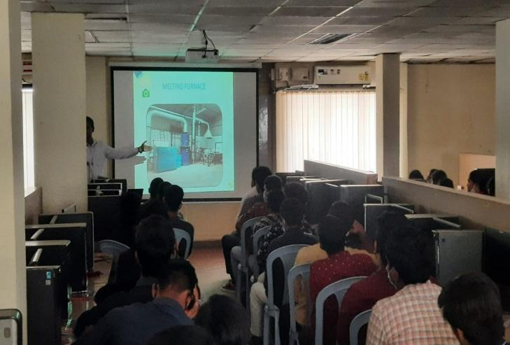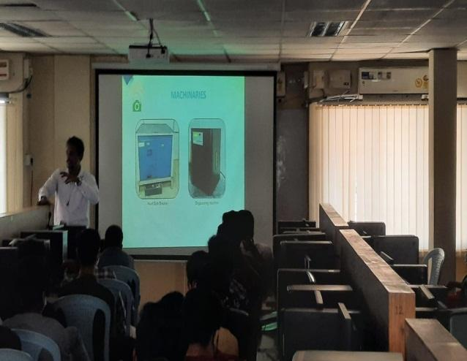

GUEST PROFILE:
Mr. Franklin,B.E., M.B.A, Technical Head, Earth Sense Recycle Pvt Ltd.
Mr. Balaji Chowdhary, M.B.A, Business Head, Earth Sense Recycle Pvt Ltd.
Contact no: 9676931233.

Aurora’s Degree and PG College 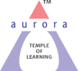
(ACCREDITED BY NAAC WITH ‘B++’ GRADE)
Chikkadpally, Hyderabad 500020
Department of Electronics

EVENT PROPOSAL
for

E-Waste Management Day

Event Name: E-Waste Management Day
Event Title: E-Waste Management Day
Department Event: Electronics Department
Faculty coordinator: R.Sravan Kumar
Date& Venue: 17/11/2021 & Aurora’s Degree&PG College, Chikkadpally
Target audience: I- B.Sc., M.E.Cs and M.P.Cs Students
Platform: Offline
Level: Department level
Student Volunteer’s: N/A
Budget: N/A

Objective: To create awareness among the students regarding E-Waste and its re-cycling process by industry experts.

Proposed activities:
- An orientation program on E-Waste and its re-cycling process by Mr. Franklin & Mr. Balaji Chowdhary, Earthsense Recycle Pvt.Ltd., Hyderabad.

.
Event Coordinator IQAC Coordinator Principal

APPRECIATION LETTERS TO SPEAKERS:
.
