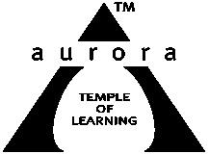
Aurora’s Degree & PG College
(ACCREDITED BY NAAC WITH 'B++' GRADE)
Chikkadpally, Hyderabad 500020
Department of Microbiology

NAME OF THE EVENT | Departmental Event
TYPE OF EVENT | Webinar
EVENT TITLE | International Day Against Drug Abuse and Illicit Trafficking
SPEAKER | Dr.Rajasekhar Chikati
TYPE OF EVENT | College Event
FACULTY INCHARGE | Mrs. Manjusha
DEPARTMENT | Microbiology
DATE | 26th June 2021
VENUE | Online through Microsoft Teams (10 AM to 12Noon )
TARGET AUDIENCE | PG and UG Students and Faculty

PROGRAM SCHEDULE
Date of the event: 26th June 2021
Time of the event: 10:00 am to 12.00 pm
Event type: Online
Venue: Aurora’s Degree & PG College
FACULTY COORDINATOR
S.No | Name of the faculty | Department
1 | Manjusha | Microbiology

S.No | Name of the Faculty | Dept | College
1 | Mrs.Padma Madham | Microbiology | Aurora’s Degree and PG College
2 | Mr.Vasudevan Ranganathan | Microbiology | Aurora’s Degree and PG College
3 | Mrs. G.Hiranmayee | Microbiology | Aurora’s Degree and PG College

List of students (UG)

S.No | Name of the student | Roll No | Class/Section
1 | Sadineni Shreyas | 1051-20-471-004 | MiBiC 1 | No of Boys  3
2 | K K Sai Sundaresan | 1051-18-459-025 | MiGC 1
3 | Damagatla Akshay | 1051-20-471-007 | MiGC1
4 | Prerana Sanjay | 1051-20-459-038 | MiGC 1 | No of Girls  8
5 | Vancha Nandini | 1051-20-471-001 | MiBiC 1
6 | Bandari Varsha | 1051-20-471-012 | MiGC1
7 | Namita Yadav | 1051-20-459-032 | MiGC 1
8 | Charitha Sheri | 1051-20-459-019 | MiGC1
9 | Jarugumalli Jhansi | 1051-19-459-057 | Mi BiC1
10 | Megha Relekar | 1051-18-459-017 | MiGC 2A
11 | Odnala Ramani | 1051-18-459-041 | MiGC 3A

List of M.Sc Microbiology students
S.No | Name of the student | Roll No | No of Girls 7
1 | Gangavarapu Kumar Reddy | 1051-19-518-019
2 | Kommu Saritha | 1051-19-518-011
3 | Balaka Manisha | 1051-19-518-032
4 | KachamYamini K | 1051-19-518-007
5 | Kasam Haripriya | 1051-19-518-028
6 | Adepu Ramya | 1051-19-518-030
7 | Hajra Kazim | 1051-19-518-001

S.No | Name of the participant
1 | Dr. Shaik Nagoor Meera Vali

Paragraph about the proceedings

On 26 June, every year International Day against Drug Abuse and Illicit Trafficking is observed to spread awareness about the extreme cultural and economic harm the trade is still doing across the globe. It is necessary to strengthen global action and cooperation to achieve the goal of an international society of drug abuse.
Celebrated each year on June 26th, the UN Office on Drugs and Crime uses the commemorative day to highlight the dangers of drug use and their illegal trade and provides educational material to teachers and public officials all over the world to help spread the message about the extreme cultural and economic harm the trade in drugs is still doing across the globe one hundred years after the war on drugs was initially launched in Shanghai around the start of the 20th Century.

The importance of the strategy was reinforced when the UN decided to hold a General Assembly on drugs to mark a milestone in the progress of an earlier policy document which called on members states to combat both drug demand and supply, while improving access to treatment for addicts.

If we will not reduce the demand for illicit drugs, we can never fully tackle cultivation, production or trafficking. To tackle the problem that illicit drugs is supported by communities, different organisations and people from all over the world. The main principle of them is to protect the youth and to promote welfare to human kind.

According to United Nations Office on Drugs and Crime (UNODC) executive director “By listening to the needs of children and young people, prevention can contribute to their safety, health and well-being, and enable them realize their potential. All our societies would be better off if more resources were devoted to supporting evidence-based drug prevention strategies, which are a sound and effective investment in families, schools and communities”.

Also, Research suggests that early-to late adolescence is a critical risk period for the initiation of substance use. To grow healthy and safe life for young people it is necessary to break the chain of social, neurological and psychological factors and inequalities that can increase susceptibility to drug use disorders.

Therefore, we can say that International Day against drug abuse and illicit trafficking is celebrated to spread awareness about the drug abuse and its side effects that not only affects the individual health but as a whole society, family etc.

INCOME & EXPENDITURE: NIL

EVENT PHOTOS
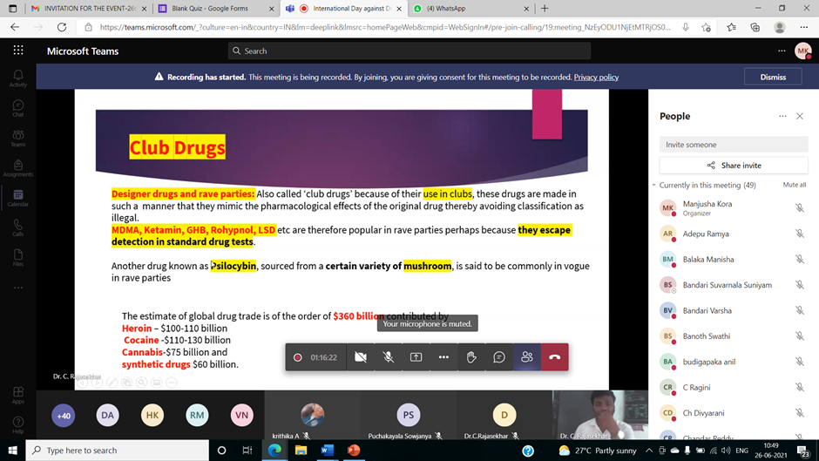

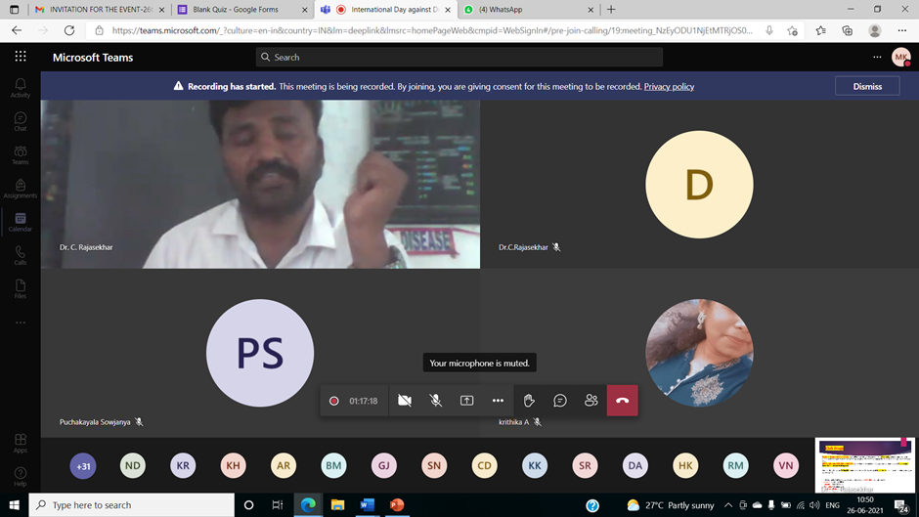

GUEST PROFILE

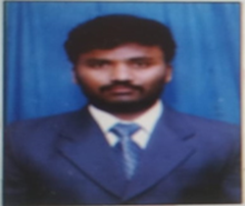

Dr. Rajasekhar Chikati
Academic Consultant Department of Biochemistry,
Yogi Vemana University, Kadapa, Andhra Pradesh, India

Dr. Rajasekhar Chikati , he pursued graduation in ‘Biotechnology, Botany and Chemistry’ at Govt Degree College (for Men) in Kurnool, affiliated to Sri Krishna Devaraya University, Anantapuram, Andhra Pradesh in 2003. Following this, he earned a Master degree in Biochemistry from Sri Krishana Devaraya University, Anantapuram, Andhra Pradesh. He qualified Graduate Aptitude Test (GATE-2007) in Life Sciences; and joined for a Master of Philosophy in Biochemistry from Sri Krishana Devaraya University, Anantapuram, Andhra Pradesh. And continued 2009-2014 for Ph.D., in Biochemistry with specialization in Cancer Biology and Bioinformatics under the supervision of Prof., Chitta Suresh Kumar, DBT- Bioinformatics Infrastructure Facility, Dept of Biochemistry, Sri Krishnadevaraya University, Anantapur, A.P, INDIA. Thesis Title : Molecular Studies on Evaluation of RNase and Phytol as cytoskeleton targeting elements in Cancer.
He got Ph.D awarded in 25th February 2014 later in joined as UGC- Dr. S. Kohari Post Doctoral Fellow, under Mentorship of Dr. Surya S. Singh, Department of Biochemsitry, University College of Sciences, Osmania University, Hyderabad, Andhra Pradesh, India, PDF Topic: Design, Synthesis and Molecular Evaluation of EGCG Analogues on Apoptosis Regulated Proteins and Transcriptional factors involved in Tumorigenesis and now working as Asst Professor on Contract basis in Department of Biochemistry.He Published More than 20 Research Articles in reputed International Journalsvlike Elseiver, Springer, Taylor & Francies, conducted more than 15 workshops in Bionformatics, gave guidance to the projects students (65 students). Delivered many lecturers in different colleges/institutes for both UG & PG.

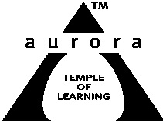
AURORA’S DEGREE & P.G. COLLEGE
Accredited by NAAC with B++ Grade

Department of Microbiology

Event Proposal

INTERNATIONAL DAY AGAINST DRUG ABUSE AND ILLICIT TRAFFICKING
Event Name: Departmental Event

Event Title: International Day Against Drug Abuse and Illicit Trafficking

Faculty coordinator: Mrs. Manjusha

Guest Speaker:Dr.Rajasekhar Chikati

Date :26th June 2021

Duration: 10:00AM to 12:00 Noon

Venue: Online

Target audience: UG and PG students

Platform: Microsoft Teams

Level: College level

Students Volunteers: Geervani (MSc2nd year), Vidhi (MiGC3A)

Objective: The event is scheduled on the occasion of International Day Against Drug Abuse and Illicit Trafficking. The purpose of organizing the online event to create awareness on the use of illegal drugs which impacts life style of human.

Proposed activities:
Webinar on International Day Against Drug Abuse and Illicit Trafficking
Poster Presentation
Power Point presentation
Online quiz

Faculty Coordinators IQAC Coordinators Principal
Manjusha Dr.Ravi Kiran Dr.Viswanadham Bulusu

