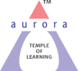
Aurora’s Degree & PG College
(ACCREDITED BY NAAC WITH 'B++' GRADE)
Chikkadpally, Hyderabad 500020

EVENT / ACTIVITY DETAILED REPORT

NAME OF THE EVENT / ACTIVITY | World Paper Free Day
TYPE OR TITLE OF EVENT / ACTIVITY | AD Making Competition
FACULTY INCHARGE | K. Sujatha
DEPARTMENT/CELL/COMMITTEE/CLUB | Department of Commerce
DATE | 6th November 2021
VENUE | Block VI, Room 101 &102
TARGET AUDIENCE | Students from all streams

- PROGRAM SCHEDULE:
6th November, 2021 at 11:30 AM
- LIST OF FACULTY COORDINATORS (DEPARTMENT)
Mrs. K.Sujatha (Department of Commerce)
- LIST OF THE STUDENT COORDINATORS (NAME , ROLL NO, CLASS & SECTION)
S Akshitha | 1051-19-407-101 | BCOM HONORS | 3B
B Harshini | 1051-19-407-034 | BCOM HONORS | 3A

- LIST OF THE PARTICIPANTS (NAME , ROLL NO, CLASS & SECTION, NO OF GIRLS, BOYS, CASTE )
S.NO | NAME | ROLL.NO | CLASS | Section
1. | Harsh Ramawat | BCOM Business Analytics | BCOM Business Analytics | -
2. | Simran Vazir Manjiyani | BCOM HONS 1 | BCOM HONS 1 | -
3. | Sangu Upasana | Mscs | Mscs | 1B
4. | Gayathri saxena | 1051-20-401-003 | Bcom general | 2A
5. | Shree jhitri | 1051-20-401-025 | Bcom general | 2A
6. | Pankaj kumar sahani | 1051-20-401-019 | Bcom(general) | 2A
7. | Challa Sriram | 1051-20-401-130 | B. Com generals | 2B
8. | Reshma jiwani | Bcom honours 1st year | Bcom honours 1st year | -
9. | N sri kousthub | Mibic 1 | Mibic 1 | -
10. | Yasha buchha | B. Com honours 1 year | B. Com honours 1 year | -
11. | Shivarathri Aakanksha | BCOM Comp APP | BCOM Comp APP | 1C
12. | Singavarapu arya gupta | Bcom hons 1 | Bcom hons 1 | -
13. | Chavi shah | B.com honours first year | B.com honours first year | -
14. | Prateek Saini | 1051-20-684-029 | BBA | 2A
15. | Meghana Sunchu | Bcom honours 1 | Bcom honours 1 | -
16. | RAJPUT SIDDHI | mscs | mscs | 1B
17. | S. Manav Raj | 1051-20-405-150 | Bca | 2C
18. | Asim Saif | 1051-20-405-148 | BCA | 2C
19. | Akhila Dev | B.com Comp App 1 | B.com Comp App 1 | -
20. | Yamini Agarwal - winner | Bcom honours (1 year) | Bcom honours (1 year) | -
21. | N.rajavigneshwaran | 1051- 20- 405-166 | BCA | 2C
22. | Jeevan Sai | 1051-20-405-088 | BCA | 2B
23. | Yash Lal Singh | 1051-20-405-178 | BCA | 2C
24. | B Sanjana- Runner up | BSC MSDS | BSC MSDS | -
25. | P Uday Kiran | 1051-19-407-045 | BCOM Hons | 3A
26. | M Pavani | BSC MSCS 1 | BSC MSCS 1 | -

TOTAL NO. OF BOYS | 13
TOTAL NO. OF GIRLS | 13

- PARAGRAPH ABOUT THE PROCEEDINGS (TILL THE END OF THE EVENT)
The main objective is to create a “World Paper Free Future” and enlighten students on various alternatives that can be used instead of paper through AD Making Competition on the occasion World Paper Free Day. The event “World Paper Free Day” was conducted on 6th November, 2021 at Block VI. On the occasion of World Paper Free Day, AD Making competition was conducted to bring out innovative ideas on the reduction of paper usage. Students across the college have enthusiastically taken part and came up with creative ideas which fulfilled the purpose of the theme. The event started off with the introduction on world Paper Free Day and the need for it by one of the student coordinators. The participants were clearly articulated on the rules and regulations that has to be followed during the competition. The students were asked to present the Ad either in the form of a video or manually. The competition was conducted in three rounds based on Clarity of idea, Viability of idea and Promotion of an idea and were asked to participate as a team of 2 or individual participation. There was a total of 26 participants and they were screened out based on the rules given in each round. The competition was extremely friendly and smooth. The participants cooperated well throughout the event. The winner was appreciated with a Trophy from the Faculty Coordinator Mrs. Sujata. There were so many takeaways from the competition as the participants came up with unique ideas and have demonstrated it in such a way that it would persuade the audience to go paper free
- INCOME AND EXPENDITURE
INCOME | -
EXPENDITURE | 275/-

- EVENT PHOTOS ( MIN 2 MAX 4)
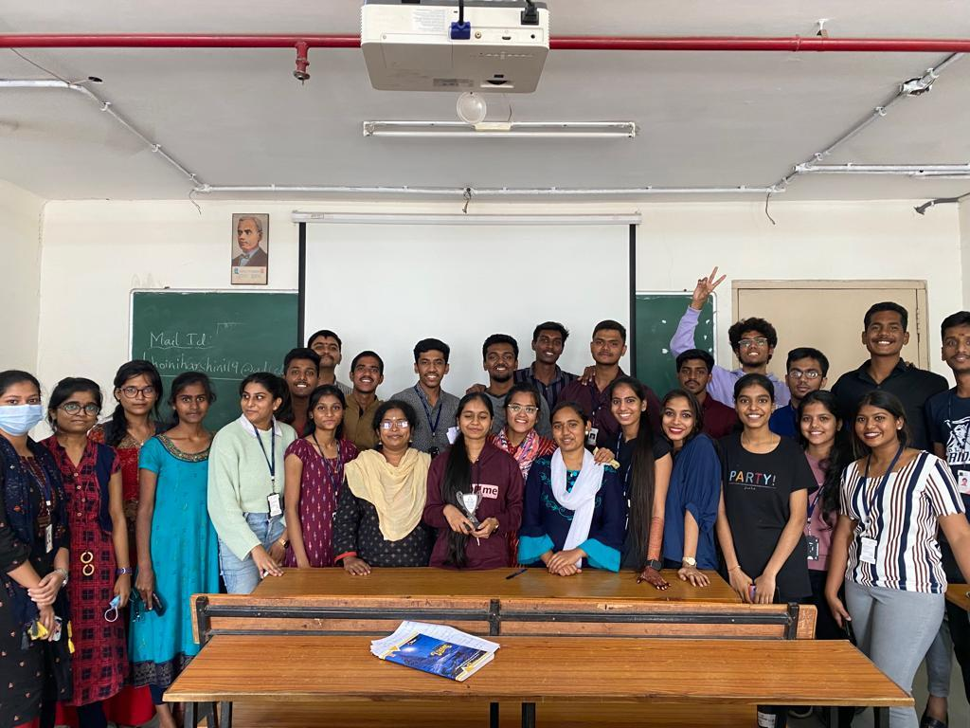

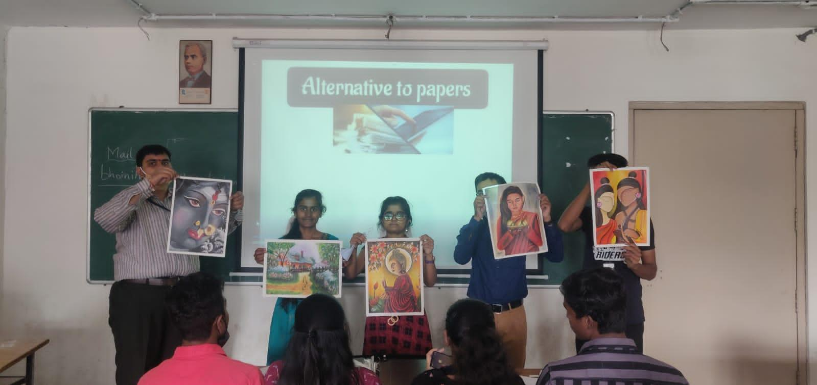
- GUEST PROFILE (IF ANY: Nil
- FEED BACK IF ANY
- ATTACHMENTS:
EVENT/ACTIVITY PROPOSAL
EVENT / ACTIVITY NOTICE
RECEIPTS (IF ANY)
CERTIFICATES (IF ANY)
LETTERS OF COMMUNICATION (IF ANY)

