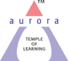
Aurora’s Degree & PG College
(ACCREDITED BY NAAC WITH 'B++' GRADE)
Chikkadpally, Hyderabad 500020

NATIONAL EDUCATION DAY - LONG REPORT

NAME OF THE EVENT / ACTIVITY | National Education Day
TYPE OR TITLE OF EVENT / ACTIVITY | National Education Day
FACULTY INCHARGE | Veena Malkhed
DEPARTMENT/CELL/COMMITTEE/CLUB | Department of Commerce – Computer Applications
DATE | 11/11/2021
VENUE | Room No. 202, Block VI
TARGET AUDIENCE | B.Com (Computer Applications and General) 3rd Year Students &  B.Com ( Computer Applications ) 1st Year Students

- PROGRAM SCHEDULE :
Students of M.Com Sem II visited B.Com I, II, III year classes in the morning and afternoon and presented the poster. Later the poster was displayed on the college notice board to enlighten the students of other streams. The students prepare PPT and was presented in the class.

- FACULTY COORDINATOR : Veena Malkhed
- LIST OF THE STUDENT COORDINATORS (NAME , ROLL NO, CLASS & SECTION) - NIL

- LIST OF THE PARTICIPANTS:
S.No | Roll No | Name
1 | 1051-20-408-003 | Bolla Vaishnavi
2 | 1051-20-408-005 | Garvandula Mounica
3 | 1051-20-408-006 | Sadiq H Yaligar
4 | 1051-20-408-007 | Duvvala Preethi
5 | 1051-20-408-008 | Bondla Bhavani
6 | 1051-20-408-009 | Jareena Begum
7 | 1051-20-408-010 | Pandiri Kavya
8 | 1051-20-408-011 | Gudipally Sree Mallika
9 | 1051-20-408-013 | Rathod Mohan
10 | 1051-20-408-016 | Pittala Shireesha
11 | 1051-20-408-018 | Garvandula Akhila
12 | 1051-20-408-021 | S Jahangir Basha
13 | 1051-20-408-022 | Marati Maheshwari
14 | 1051-20-408-030 | Mullapudi Venkata Ramana
15 | 1051-20-408-031 | Hamilpur Omkar

Total Number of Girls : 10

Total Number of Boys : 5

- PARAGRAPH ABOUT THE PROCEEDINGS (TILL THE END OF THE EVENT)
This Event was conducted to orient the students on the contributions of our First Education Minister of our country. The students of M.Com Sem II prepared and presented the poster in all B.Com classes. Another student from M.Com II Sem (P Kavya) presented PPT in the class. Students learnt on various contribution of Maulana Azad. Further, the role education in development of a country is also understood by the students

- INCOME AND EXPENDITURE : NIL

- EVENT PHOTOS ( MIN 2 MAX 4)

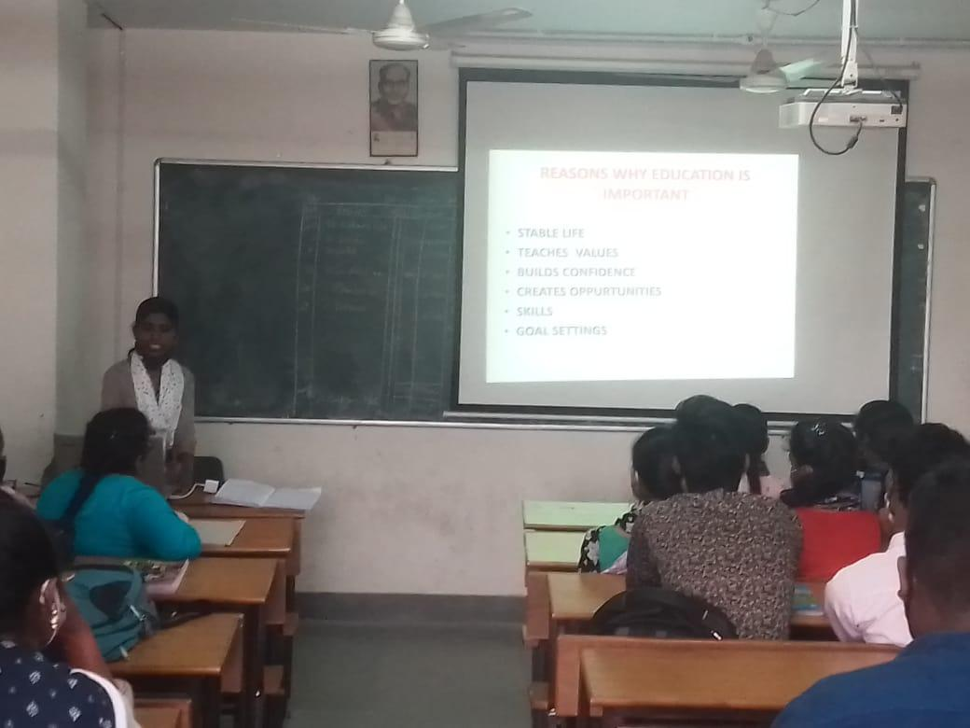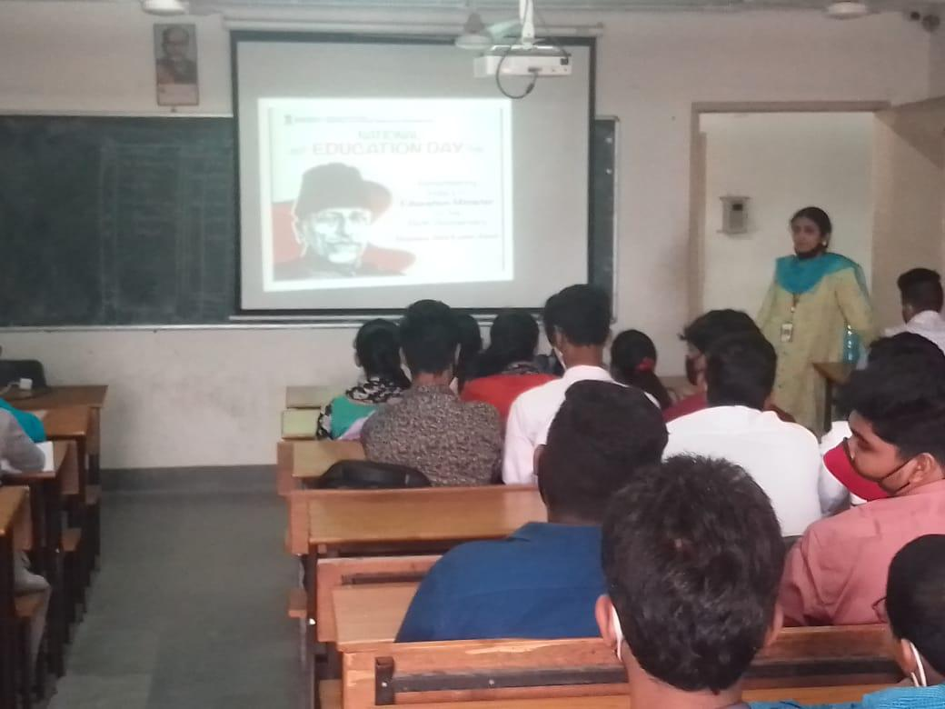

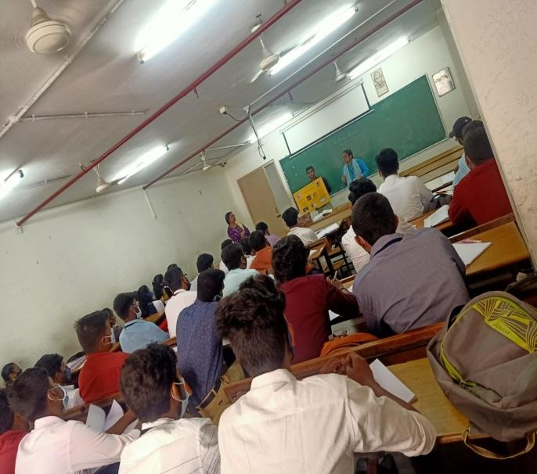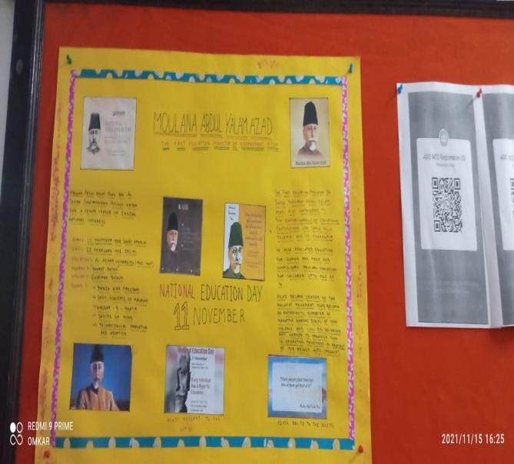

- GUEST PROFILE (IF ANY) - NIL
- FEED BACK IF ANY - NIL
- ATTACHMENTS:
EVENT/ACTIVITY PROPOSAL - ATTACHED
EVENT / ACTIVITY NOTICE - NIL
RECEIPTS (IF ANY)
CERTIFICATES (IF ANY)
LETTERS OF COMMUNICATION (IF ANY)

