Aurora’s Degree & PG College
(Accredited by NAAC with 'B++' grade)
Chikkadpally, Hyderabad- 500020
Department of Microbiology

EVENT REPORT
Program Schedule

EVENT TITLE | Prof. Jayashankar Agricultural University Open Day
TYPE OF EVENT | Departmental Event
FACULTY INCHARGE | Mrs. Padma M (HOD)
FACULTY COORDINATOR | K. Mary Manjusha Rani
DEPARTMENT | Microbiology
DATE | 3rd December 2021
VENUE | Professor Jayashankar Telangana State Agricultural University, Rajendranagar, Hyderabad, India
TARGET AUDIENCE | UG and PG Students

PROGRAM SCHEDULE
Date of the event: 3-12-2021
Time of the event: 10:00 am to 4:00 pm
Platform: Offline

List of faculty coordinators
S.No | Name of the faculty | Department
1 | Mrs M. Padma (HOD) | Microbiology
2 | K. Mary Manjusha | Microbiology

List of faculty attended
S.No | Name of the faculty | Department
1 | R.Vasudevan | Microbiology
2 | G.Hiranmayee | Microbiology

List of student coordinators
S.No | Name of the student | Roll No | Section
1 | Kiran shukla | 1051-20-518-034 | MSc-Micro
2 | K.Pranitha | 1051-20-518-007 | MSc-Micro
3 | Prerana S Shankpal | 1051-20-459-038 | MiGC2

List of Students attended Industrial Visit
S.No | Class | Roll No | Student Name | Caste | Gender
1 | MiGC-1 | 1051-21-459-012 | C.Vivek Sagar | BC-D-B | M
2 | MiGC-1 | 1051-21-459-005 | Sreenath | BC-B-B | M
3 | MiGC-1 | 1051-21-459-009 | Srinivas Swaminathan | OC-B | M
4 | MiGC-1 | 1051-21-459-019 | S. Vanaja Chowdary | OC-G | F
5 | MiGC-1 | 1051-21-459-013 | Y.Lohitha naidu | OC-G | F
6 | MiGC-1 | 1051-21-459-003 | Swetha Kumari | OC-G | F
7 | MiGC-1 | 1051-21-459-001 | Firdous | OC-G | F
8 | MiGC-1 | 1051-21-459-002 | Tejaswini | SC-G | F
9 | MiGC-1 | 1051-21-459-026 | P.Kavya | BC-D-G | F
10 | MiGC-1 | 1051-21-459-025 | S.Deekshitha | BC-D-G | F
11 | MiGC-1 | 1051-21-459-021 | P. Yamini Sindhu | ST-G | F
12 | MiGC-1 | 1051-21-459-008 | Pradeep | SC-B | M
13 | MiGC-1 | 1051-21-459-030 | Maseedhpally Sanjana | BC-B-G | F
14 | MiGC-1 | 1051-21-459-016 | CH.Deekshitha | BC-D-G | F
15 | MiGC-1 | 1051-21-459-010 | E.Namaami | SC-G | F
16 | MiGC-1 | 1051-21-459-007 | M. Rohith kumar | SC-B | M
17 | MiGC-1 | 1051-21-459-027 | John Simon | BC-C-B | M
18 | MiGC-1 | 1051-21-459-017 | M.Rithish Reddy | OC-B | M
19 | MiGC-1 | 1051-21-459-006 | Akanksha | BC-A-G | F
20 | MiGC-1 | 1051-21-459-028 | S.Shivani | OC-G | F
21 | MiGC-1 | 1051-21-459-018 | KSN Renu Vaishnavi | OC-G | F
22 | MiGC-1 | 1051-21-459-015 | A.Neehaarika | SC-G | F
23 | MiGC-1 | 1051-21-459-029 | Kairamkonda Raju Kumar | BC-B-B | M
24 | MiGC-1 | 1051-21-459-020 | C.Jahnavi | BC-B-G | F
25 | MiBiC-1 | 1051-21-471-011 | T.Keerthi Bhargavi | SC-G | F
26 | MiBiC-1 | 1051-21-471-002 | A.Sumanth | BC-B-B | M
27 | MiBiC-1 | 1051-21-471-006 | G.Sai Krishna Reddy | OC-B | M
28 | MiBiC-1 | 1051-21-471-014 | G.Shivani | BC-B-G | F
29 | MiBiC-1 | 1051-21-471-013 | Raghuvamsh Veladi | OC-B | M
30 | MiBiC-1 | 1051-21-471-001 | Sapna Ghosh | OC-G | F
31 | MiGC-2 | 1051-20-459-001 | Ch.Jerome Elliot | BC-C-B | M
32 | MiGC-2 | 1051-20-459-011 | M.Arun kumar | BC-B-B | M
33 | MiGC-2 | 1051-20-459-019 | Charitha Sheri | BC-B-G | F
34 | MiGC-2 | 1051-20-459-004 | Machiraju Vagdevi | OC-G | F
35 | MiGC-2 | 1051-20-459-010 | K.Ganesh babu | BC-B-B | M
36 | MiGC-2 | 1051-20-459-005 | k.Nitisha | BC-D-G | F
37 | MiGC-2 | 1051-20-459-038 | Prerana S Shankpal | BC-B-G | F
38 | MiGC-2 | 1051-20-459-009 | KK Sai Sundareshan | OC-B | M
39 | MiBiC-2 | 1051-20-471-004 | Shreyas Saddineni | OC-G | M
40 | MSc-Microbiology | 1051-20-518-031 | Krupa Rani | Bc-A | F
41 | MSc-Microbiology | 1051-20-518-007 | K.Pranitha | OC | F
42 | MSc-Microbiology | 1051-20-518-015 | B.Suniyam | BC C | F
43 | MSc-Microbiology | 1051-20-518-034 | Kiran shukla | OC | M

PARAGRAPH OF THE PROCEEDINGS
This report is on the visit to the Prof. Jayashankar Agricultural University Open Day for UG and PG students. The extension study trip was on 3rd December 2021. The entire students consisting of 43 students which includes16 girls and 17 boys visited the Prof. Jayashankar Agricultural University accompanied by the Course Teacher K.Mary Manjusha, R.Vasudevan and G.Hiranmayee Assistant Professors, Department of Microbiology, Aurora’s Degree and Pg College, Hyderabad. It was an interesting experience for the student having studied the theory of microbiology and then to experience it in the laboratory directly.
The event has proceeded by few of the concerned concepts such as –
- Biofertilizer production
- Biopesticide unit
- Fermentation chamber and Fermentation process
- Feeding processing and collection of inoculums
- Preservation of microbial cultures
- Long term preservation (Lyophilization)
- Fungal cultivation Trichoderma viride
- Estimation of soil Nutrients (N, P)

INCOME AND EXPENDITURE:

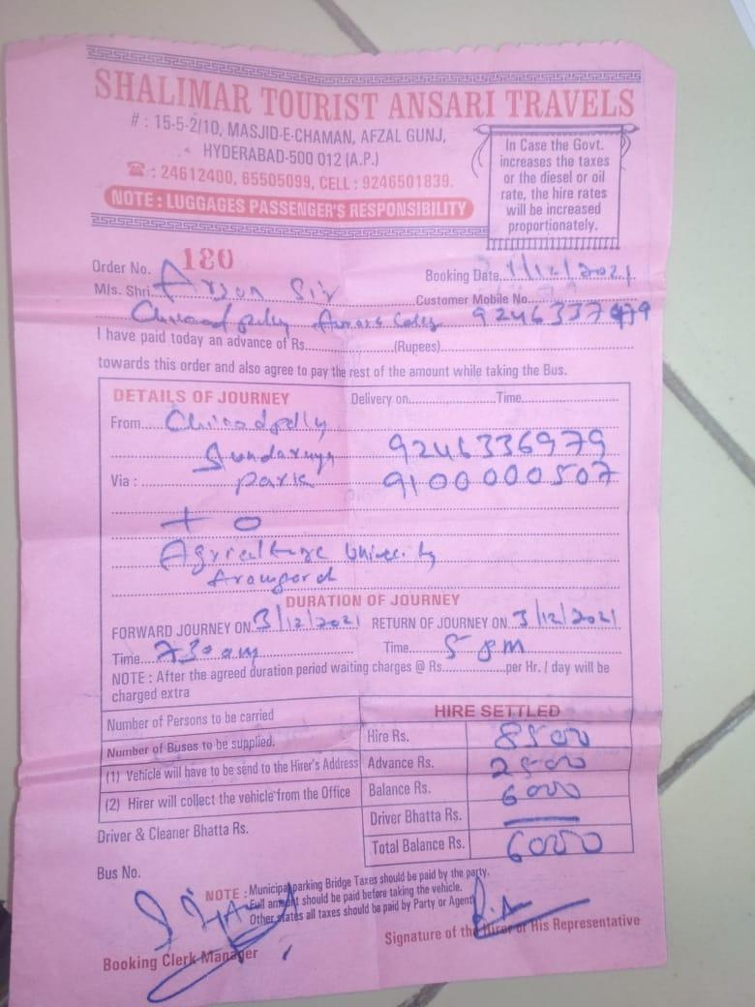
EVENT PHOTOS

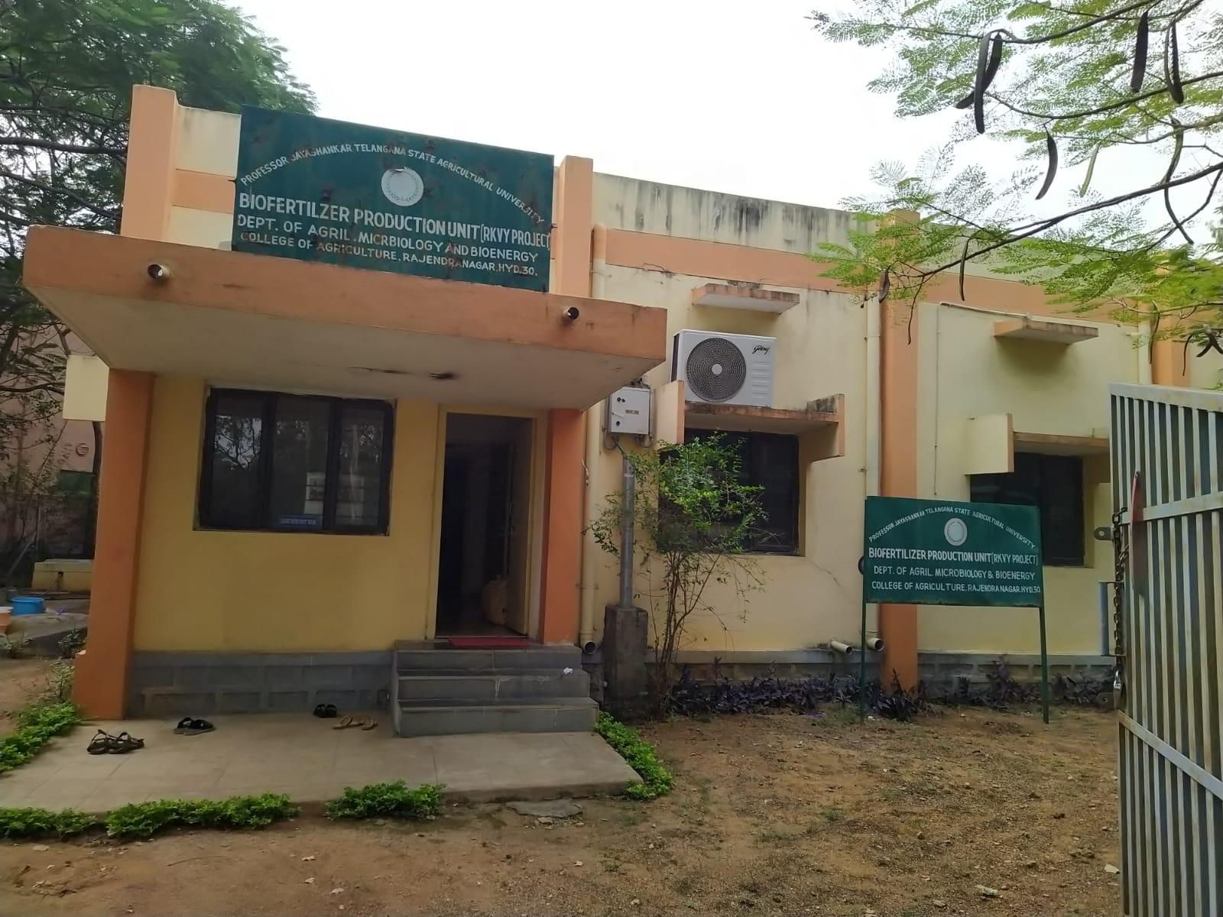
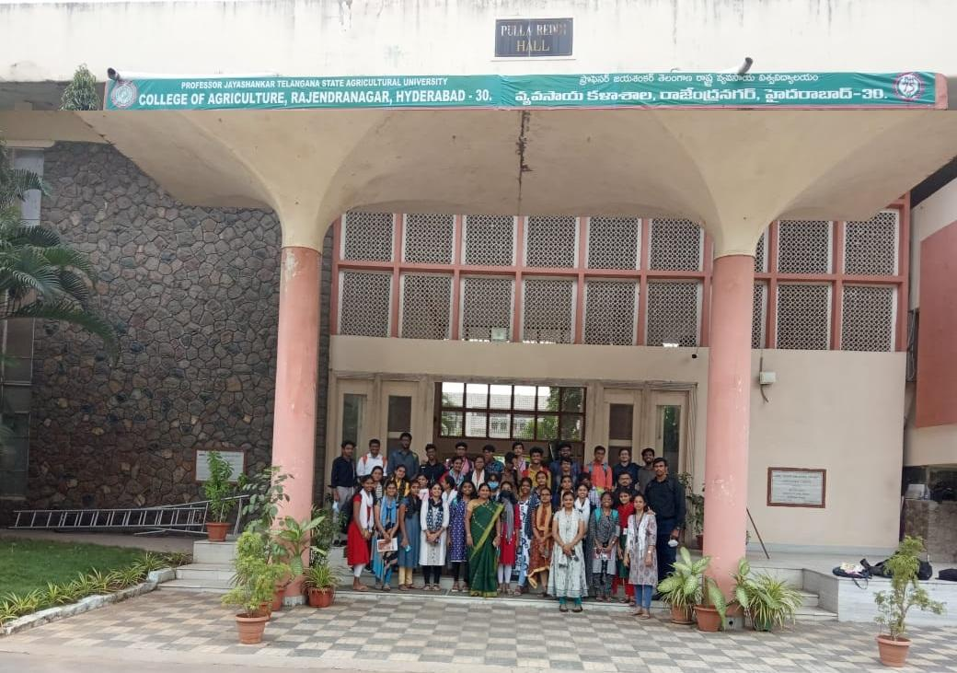
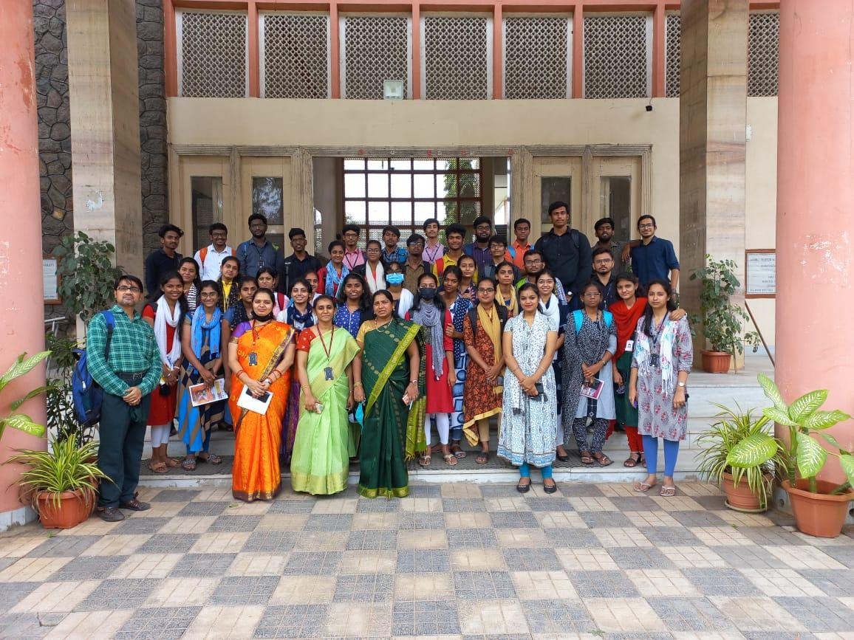

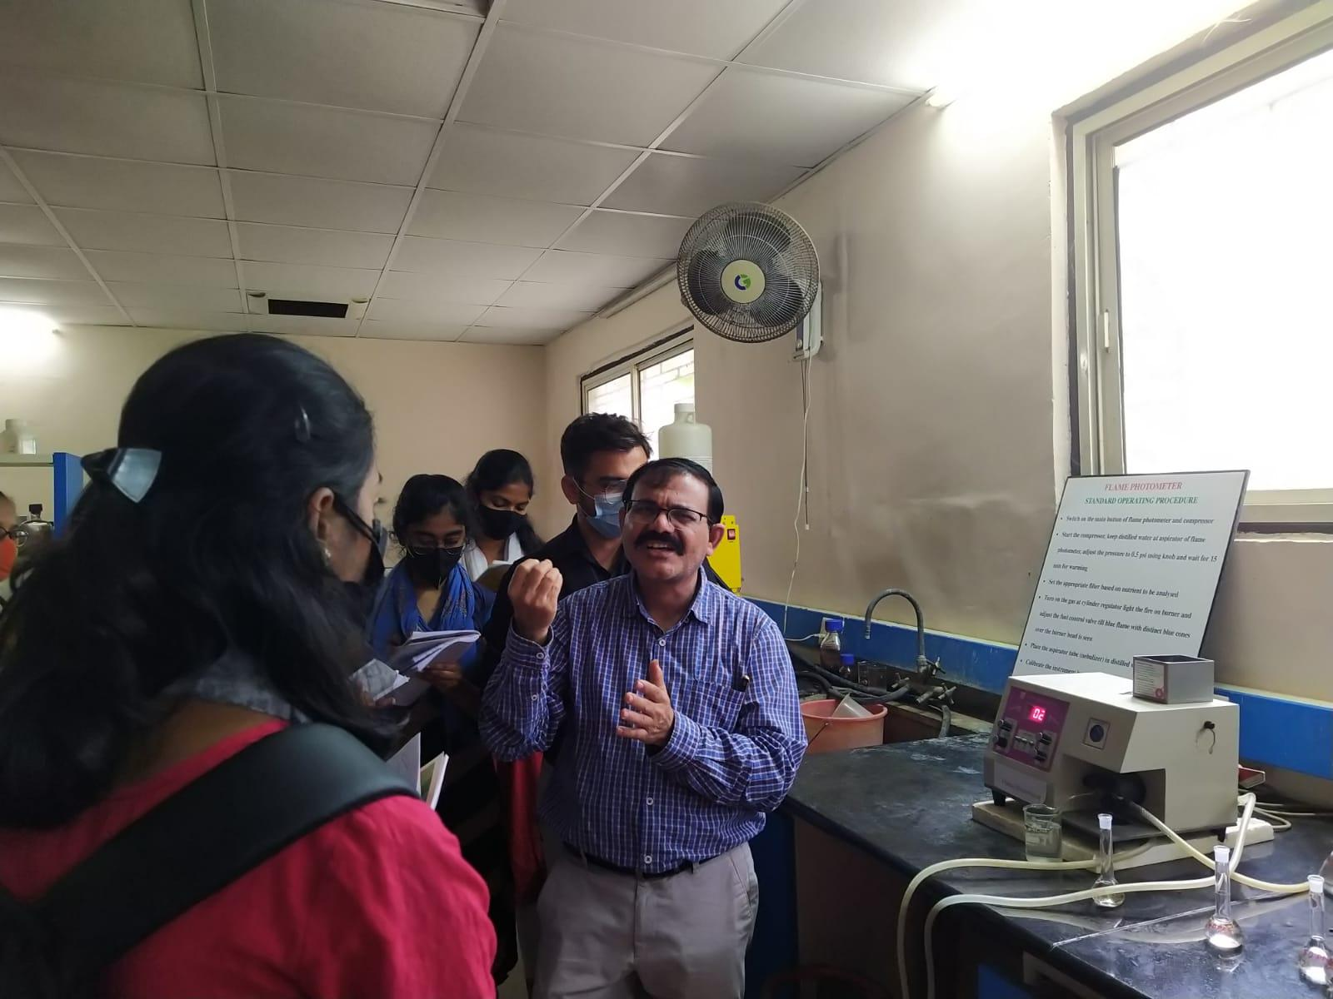
FEED BACK:
Aurora's Degree & PG College
(Accredited by NAAC with B++ Grade)
Department of Microbiology
EDUCATIONAL TOUR
Place: | Prof.Jayashankar Agricultural University, Rajendranagar
Date of visit: | 03-12-2021
S.No | Class | Roll No | Student Name | Caste | Gender | Feed back
1 | MiGC-1 | 1051-21-459-012 | C.Vivek Sagar | BC-D-B | M | Very Good
2 | MiGC-1 | 1051-21-459-005 | Sreenath | BC-B-B | M | Excellent
3 | MiGC-1 | 1051-21-459-009 | Srinivas Swaminathan | OC-B | M | excellent
4 | MiGC-1 | 1051-21-459-019 | S. Vanaja Chowdary | OC-G | F | excellent
5 | MiGC-1 | 1051-21-459-013 | Y.Lohitha naidu | OC-G | F | excellent
6 | MiGC-1 | 1051-21-459-003 | Swetha Kumari | OC-G | F | Very Good
7 | MiGC-1 | 1051-21-459-001 | Firdous | OC-G | F | Very Good
8 | MiGC-1 | 1051-21-459-002 | Tejaswini | SC-G | F | Very Good
9 | MiGC-1 | 1051-21-459-026 | P.Kavya | BC-D-G | F | excellent
10 | MiGC-1 | 1051-21-459-025 | S.Deekshitha | BC-D-G | F | excellent
11 | MiGC-1 | 1051-21-459-021 | P. Yamini Sindhu | ST-G | F | EXCELLENT
12 | MiGC-1 | 1051-21-459-008 | Pradeep | SC-B | M | EXCELLENT
13 | MiGC-1 | 1051-21-459-030 | Maseedhpally Sanjana | BC-B-G | F | EXCELLENT
14 | MiGC-1 | 1051-21-459-016 | CH.Deekshitha | BC-D-G | F | Very Good
15 | MiGC-1 | 1051-21-459-010 | E.Namaami | SC-G | F | excellent
16 | MiGC-1 | 1051-21-459-007 | M. Rohith kumar | SC-B | M | excellent
17 | MiGC-1 | 1051-21-459-027 | John Simon | BC-C-B | M | Excellent
18 | MiGC-1 | 1051-21-459-017 | M.Rithish Reddy | OC-B | M | Excellent
19 | MiGC-1 | 1051-21-459-006 | Akanksha | BC-A-G | F | Very Good
20 | MiGC-1 | 1051-21-459-028 | S.Shivani | OC-G | F | Very Good
21 | MiGC-1 | 1051-21-459-018 | KSN Renu Vaishnavi | OC-G | F | excellent
22 | MiGC-1 | 1051-21-459-015 | A.Neehaarika | SC-G | F | excellent
23 | MiGC-1 | 1051-21-459-029 | Kairamkonda Raju Kumar | BC-B-B | M | excellent
24 | MiGC-1 | 1051-21-459-020 | C.Jahnavi | BC-B-G | F | excellent
25 | MiBiC-1 | 1051-21-471-011 | T.Keerthi Bhargavi | SC-G | F | excellent
26 | MiBiC-1 | 1051-21-471-002 | A.Sumanth | BC-B-B | M | Very Good
27 | MiBiC-1 | 1051-21-471-006 | G.Sai Krishna Reddy | OC-B | M | Very Good
28 | MiBiC-1 | 1051-21-471-014 | G.Shivani | BC-B-G | F | Very Good
29 | MiBiC-1 | 1051-21-471-013 | Raghuvamsh Veladi | OC-B | M | Very Good
30 | MiBiC-1 | 1051-21-471-001 | Sapna Ghosh | OC-G | F | Very Good
31 | MiGC-2 | 1051-20-459-001 | Ch.Jerome Elliot | BC-C-B | M | Very Good
32 | MiGC-2 | 1051-20-459-011 | M.Arun kumar | BC-B-B | M | Very Good
33 | MiGC-2 | 1051-20-459-019 | Charitha Sheri | BC-B-G | F | Very Good
34 | MiGC-2 | 1051-20-459-004 | Machiraju Vagdevi | OC-G | F | Very Good
35 | MiGC-2 | 1051-20-459-010 | K.Ganesh babu | BC-B-B | M | excellent
36 | MiGC-2 | 1051-20-459-005 | k.Nitisha | BC-D-G | F | excellent
37 | MiGC-2 | 1051-20-459-038 | Prerana S Shankpal | BC-B-G | F | excellent
38 | MiGC-2 | 1051-20-459-009 | KK Sai Sundareshan | OC-B | M | excellent
39 | MiBiC-2 | 1051-20-471-004 | Shreyas Saddineni | OC-G | M | excellent
40 | MSc-Microbiology | 1051-20-518-031 | Krupa Rani | Bc-A | F | excellent
41 | MSc-Microbiology | 1051-20-518-007 | K.Pranitha | OC | F | excellent
42 | MSc-Microbiology | 1051-20-518-015 | B.Suniyam | BC C | F | excellent
43 | MSc-Microbiology | 1051-20-518-034 | Kiran shukla | OC | M | excellent

EVENT PROPOSAL
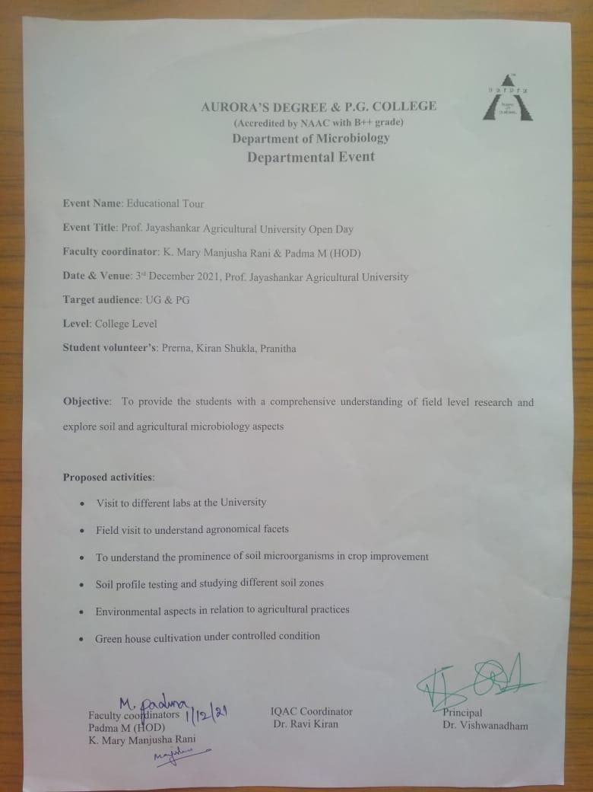

Aurora’s Degree & PG College
Chikkadpally, Hyderabad - 500020
PARENT UNDERTAKING FORM

To, Date:
The Principal,
Aurora’s Degree & PG College,
Chikkadpally,
Hyderabad.

Sir,

I _____________________________________ Parent/Guardian of __________________ studying course ________ in your college bearing Roll no _________________________ of section ____________ year ____________ having the attendance ____________ %. Our ward is interested in visiting Prof. Jayashankar Agricultural University, Hyderabad on 3rd December 2021 as it is an open day to visit the University on the occasion of World Agricultural Month.

I am aware of the normal risks associated with the industrial visit and my ward will follow COVID-19 protocols during the visit.

Parent/Guardian Name & signature: - Name & Signature of the student
Contact number: - Contact number:-

