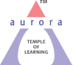
Aurora’s Degree & PG College
(ACCREDITED BY NAAC WITH 'B++' GRADE)
Chikkadpally, Hyderabad 500020

EVENT / ACTIVITY DETAILED REPORT

NAME OF THE EVENT | Dr. Babu Rajendra Prasad’s Birth Day Celebrations
TYPE OR TITLE OF EVENT | Dr. Babu Rajendra Prasad’s Birth Day Celebrations
FACULTY INCHARGE | M.Devika
DEPARTMENT/CELL/COMMITTEE/CLUB | Mathematics
DATE | 03/12/2021
VENUE | Room No 202, Block1, Aurora’s Degree and PG College
TARGET AUDIENCE | MECS1

- PROGRAM SCHEDULE:
S.No | Activity | Timing
1 | Introduction by M. Devika | 11:40am - 11:45am
2 | PPT Presentation by Karthik & Basavaraj | 11:45am – 12:00pm
3 | PPT Presentation by Rooshini,Shravani & Naveena | 12:00pm – 12:15pm
4 | Poster presentation | 12:15pm – 12:20pm
5 | Documentary Presentation | 12:20pm – 2:30pm
6 | Vote of thanks by M.Devika | 12:30pm – 12:35pm

- LIST OF FACULTY COORDINATORS (DEPARTMENT): M.Devika

- LIST OF THE STUDENT COORDINATORS (NAME , ROLL NO, CLASS & SECTION)
S.No | Name | Roll No | Class | Section
1 | Kalia Roshni | 1051-19-474-078 | B.Sc(MECs 3) | B
2 | Pilli Naveena | 1051-19-474-098 | B.Sc(MECs 3) | B
3 | Nalla Sravani | 1051-19-474-056 | B.Sc(MECs 3) | B

- LIST OF THE PARTICIPANTS (NAME , ROLL NO, CLASS & SECTION, NO OF GIRLS, BOYS, CASTE )
S.NO | RollNO | Name of the Student | Section
1 | 1051-21-474-010 | CH Naga Srija | MECS1
2 | 1051-21-474-023 | Bende Sriram | MECS1
3 | 1051-21-474-032 | Bidar Pranith Raj | MECS1
4 | 1051-21-474-003 | Siddula Satish Netha | MECS1
5 | 1051-21-474-029 | Katakam Nithin | MECS1
6 | 1051-21-474-009 | Pershettiwar Sai Bharath | MECS1
7 | 1051-21-474-025 | Uyyala Sowmya | MECS1
8 | 1051-21-474-006 | Mohammed Parvez(-67) | MECS1
9 | 1051-21-474-002 | Mohammed Ghouse Pasha | MECS1
10 | 1051-21-474-001 | Basavaraj Sajjan | MECS1
11 | 1051-21-474-033 | A Pavan Datta(-83) | MECS1
12 | 1051-21-474-018 | Sharvirala Krishna Priya | MECS1
13 | 1051-21-474-022 | Veerabathini Anvesh | MECS1
14 | 1051-21-474-031 | Durgapuram Aravind(-100) | MECS1
15 | 1051-21-474-005 | Gandhi Raj Basumatary | MECS1
16 | 1051-21-474-011 | Vadla Vishnu Vardhan Chary | MECS1
17 | 1051-21-474-028 | Ratanparkhe Shubham | MECS1
18 | 1051-21-474-004 | Syed Adnan Hussain | MECS1
19 | 1051-21-474-012 | C Harshavardhan Reddy | MECS1
20 | 1051-21-474-019 | D Sandeep | MECS1
21 | 1051-21-474-024 | Samudrala Sai Manoj Kumar | MECS1
22 | 1051-21-474-008 | Pagunta Vishnuvardhan Reddy | MECS1
23 | 1051-21-474-021 | Kurva Hanmanth | MECS1
24 | 1051-21-474-017 | Madyanam Karthik Reddy | MECS1
25 | 1051-21-474-026 | Boini Akshay Yadav | MECS1
26 | 1051-21-474-030 | Bhimanavajjula Sai Subrahmanya Akhil | MECS1
27 | 1051-21-474-020 | Anugu Rohith Reddy | MECS1
28 | 1051-21-474-016 | Shaik Abdul Rajak | MECS1
29 | 1051-21-474-015 | Deepak Urade | MECS1
30 | 1051-21-474-013 | Kavali Bhanu Prasad | MECS1
31 | 1051-21-474-014 | Naini Ashish Kumar | MECS1
32 | 1051-21-474-007 | Dyavar Naveen Kumar | MECS1
33 | 1051-21-474-027 | Yellasani Dhanush Yadav | MECS1

No Boys: 30
No Girls: 03
- PARAGRAPH ABOUT THE PROCEEDINGS (TILL THE END OF THE EVENT)
Aurora has a tradition of celebrating the Birthdays of eminent historical persons. As a part of it, we celebrated Dr. Babu Rajendra Prasad’s Birth Day Celebrations on 03/12/2021.
Dr. Rajendra Prasad was the first President of independent India. He was the President of the Constituent Assembly that drafted the Constitution. He had also served as a cabinet minister briefly in the first Government of independent India. Dr. Rajendra Prasad was one of the foremost disciples of Gandhiji and he played a crucial role in Indian freedom struggle.
On the day of event, the event started with introductory speech about Dr. Babu Rajendra Prasad by M. Devika faculty coordinator followed by PPT presentations by Karthik and Basavaraj students of MECS1 and Roshini, Naveena, Shraavana from MECS3B on topics of the life, work and the to-be inspired contents of Rajendra Prasad’s life. Documentary on life history of Rajendra prasad was played. Soon after the faculty gave a comprehension about the importance of celebrating such events. Presented hand-made posters prepared by students of MECS1 in the class. The event ended with a good applause from students.
Competitions Conducted:
- Collage competition on Interesting facts about the first president of India
Dr. Babu Rjendra Prasad conducted on 02/12/2021:
List of Participants & Evaluation sheet:

S.NO | Roll NO | Name of the student | Class&Section | Content(5) | Presentation  (5) | Handwriting & originality  (5) | Grammar  (5) | Total  (20)
1 | 1051-21-474-026 | Boini Akshay Yadav | MECS1 | 3 | 2 | 3 | 3 | 11
2 | 1051-21-474-027 | Yellasani Dhanush Yadav | MECS1 | 2 | 2 | 3 | 3 | 10
3 | 1051-21-474-032 | Bidar Pranith Raj | MECS1 | 5 | 5 | 4 | 4 | 18
4 | 1051-21-474-014 | Naini Ashish Kumar | MECS1 | 2 | 2 | 2 | 3 | 9
5 | 1051-21-474-029 | Katakam Nithin | MECS1 | 2 | 3 | 3 | 3 | 11
6 | 1051-21-474-015 | Deepak Urade | MECS1 | 2 | 3 | 2 | 3 | 10
7 | 1051-21-474-002 | Mohammed Ghouse Pasha | MECS1 | 5 | 3 | 3 | 3 | 14
8 | 1051-21-474-016 | Shaik Abdul Rajak | MECS1 | 2 | 2 | 2 | 3 | 9
9 | 1051-21-474-004 | Syed Adnan Hussain | MECS1 | 2 | 2 | 2 | 3 | 9
10 | 1051-21-474-009 | Pershettiwar Sai Bharath | MECS1 | 5 | 3 | 3 | 3 | 14
11 | 1051-21-474-023 | Bende Sriram | MECS1 | 3 | 3 | 3 | 3 | 12
12 | 1051-21-474-030 | Bhimanavajjula Sai Subrahmanya Akhil | MECS1 | 2 | 3 | 3 | 3 | 11
13 | 1051-21-474-031 | Durgapuram Aravind | MECS1 | 2 | 2 | 2 | 3 | 9
14 | 1051-21-474-033 | A Pavan Datta | MECS1 | 2 | 3 | 3 | 3 | 11
15 | 1051-21-474-008 | Pagunta Vishnuvardhan Reddy | MECS1 | 2 | 2 | 3 | 3 | 10
16 | 1051-21-474-003 | Siddula Satish Netha | MECS1 | 3 | 3 | 3 | 3 | 12
17 | 1051-21-474-006 | Mohammed Parvez(-67) | MECS1 | 3 | 2 | 2 | 3 | 10
18 | 1051-21-474-017 | Madyanam Karthik Reddy | MECS1 | 5 | 5 | 5 | 5 | 20
19 | 1051-21-474-007 | Dyavar Naveen Kumar | MECS1 | 3 | 3 | 4 | 3 | 13
20 | 1051-21-474-013 | Kavali Bhanu Prasad | MECS1 | 2 | 3 | 3 | 3 | 11
21 | 1051-21-474-010 | CH Naga Srija | MECS1 | 2 | 2 | 2 | 3 | 9
22 | 1051-21-474-025 | Uyyala Sowmya | MECS1 | 2 | 2 | 3 | 2 | 9
23 | 1051-21-474-001 | Basavaraj Sajjan | MECS1 | 5 | 5 | 4 | 4 | 18

2. Essay competition on life history of Dr. Babu Rjendra Prasad on 02/2/2021:
List of Participants & Evaluation sheet:
S.NO | Roll NO | Name of the Student | Class&Section | CREATIVITY  (5) | CLARITY WITH RESPECT TO THEME(5) | ORIGNALITY OF WORK(5) | VISUAL IMAPCT(5) | Total  (20)
1 | 1051-21-474-032 | Bidar Pranith Raj | MECS1 | 5 | 5 | 5 | 5 | 20
2 | 1051-21-474-010 | CH Naga Srija | MECS1 | 4 | 4 | 5 | 4 | 18
3 | 1051-21-474-025 | Uyyala Sowmya | MECS1 | 4 | 4 | 5 | 4 | 18
4 | 1051-21-474-016 | Shaik Abdul Rajak | MECS1 | 3 | 4 | 4 | 3 | 17
5 | 1051-21-474-004 | Syed Adnan Hussain | MECS1 | 3 | 3 | 3 | 3 | 12
6 | 1051-21-474-015 | Deepak Urade | MECS1 | 3 | 4 | 4 | 3 | 14
7 | 1051-21-474-028 | Ratanparkhe Shubham | MECS1 | 4 | 4 | 3 | 2 | 13
8 | 1051-21-474-026 | Boini Akshay Yadav | MECS1 | 3 | 4 | 2 | 4 | 13
9 | 1051-21-474-027 | Yellasani Dhanush Yadav | MECS1 | 4 | 4 | 3 | 2 | 13
10 | 1051-21-474-033 | A Pavan Datta | MECS1 | 3 | 3 | 3 | 3 | 12
11 | 1051-21-474-014 | Naini Ashish Kumar | MECS1 | 3 | 3 | 3 | 3 | 12

List or Winners:
S.NO | Roll NO | Name of the student | Class & Section | Competition | Score | Position
1 | 1051-21-474-017 | Madyanam Karthik Reddy | MECS1 | Essay | 20 | 1
2 | 1051-21-474-001 | Basavaraj Sajjan | MECS1 | Essay | 18 | 2
3 | 1051-21-474-032 | Bidar Pranith Raj | MECS1 | Essay | 18 | 2
4 | 1051-21-474-032 | Bidar Pranith Raj | MECS1 | Collage | 20 | 1
5 | 1051-21-474-010 | CH Naga Srija | MECS1 | Collage | 18 | 2
6 | 1051-21-474-025 | Uyyala Sowmya | MECS1 | Collage | 18 | 2

OUTCOME:
- By this event students came to know many things about Dr. Babu Rjendra Prasad his contributions in the Indian Independence movement
- All the students came to know the importance of the Indian Constitution.
- The students came to know the importance of freedom and sacrifice of freedom fighters like Dr. Babu Rajendra Prasad and determination in unity to reach the goal (Freedom).

- EVENT PHOTOS ( MIN 2 MAX 4)
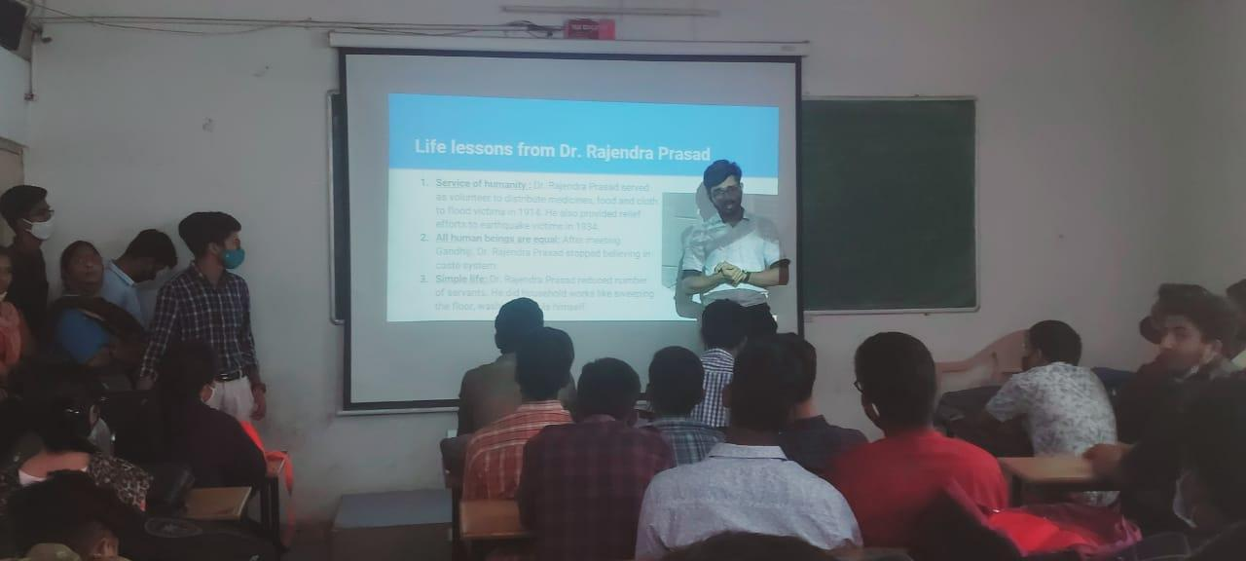

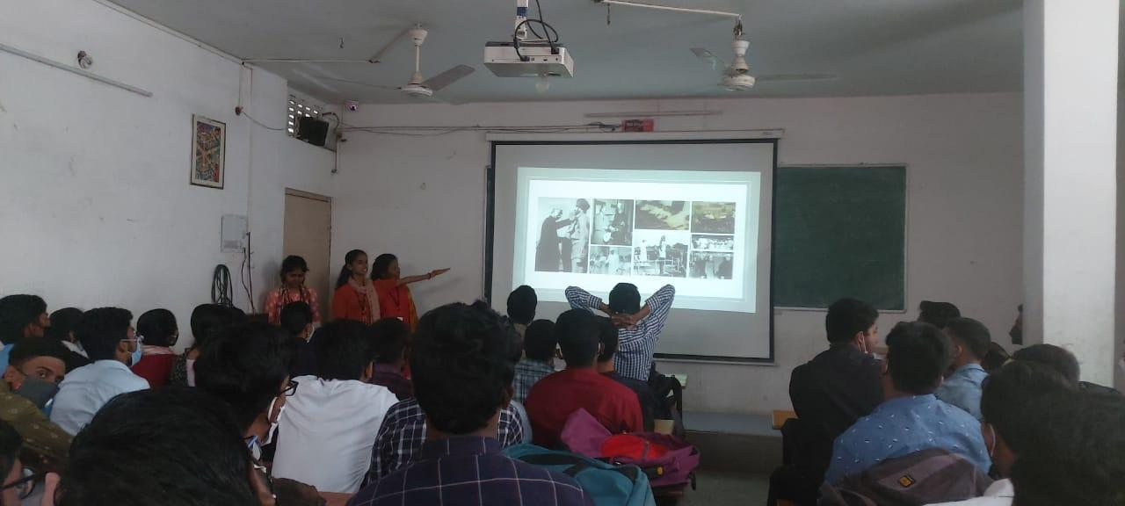

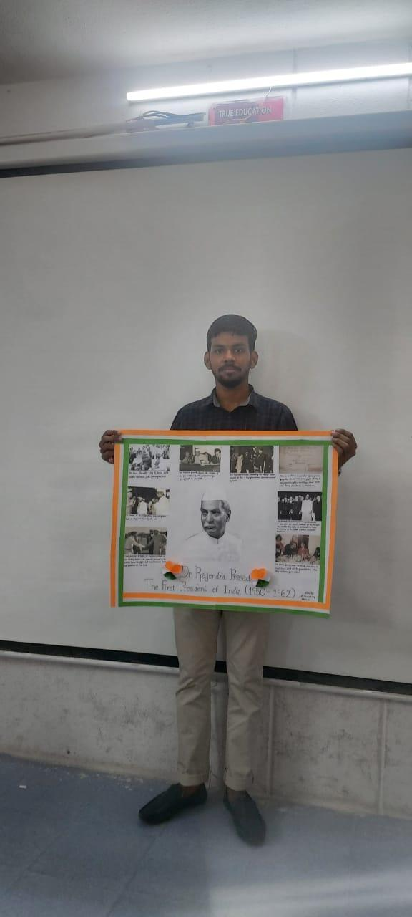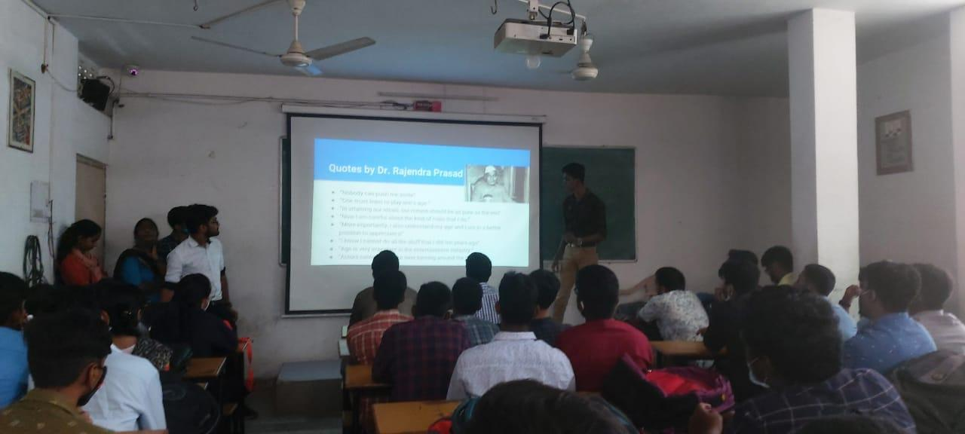

- FEEDBACK: IF ANY
- Budget: Nill
- ATTACHMENTS:

EVENT PROPOSAL
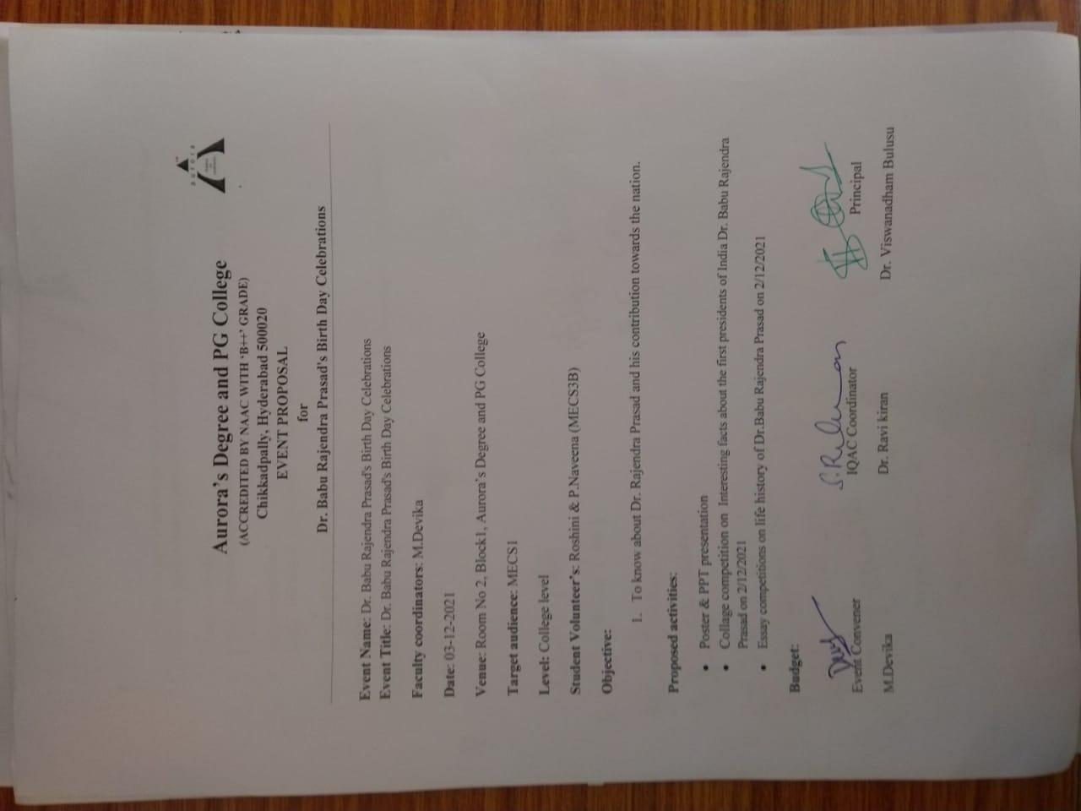

EVENT NOTICE
