Aurora’s Degree & PG College
(ACCREDITED BY NAAC WITH 'B++' GRADE)
Chikkadpally, Hyderabad 500020

EVENT / ACTIVITY DETAILED REPORT

NAME OF THE EVENT / ACTIVITY | National Statistics Day
TYPE OR TITLE OF EVENT / ACTIVITY | Applications of Statistics in Wildlife Sciences
FACULTY INCHARGE | K Parimala Diana Sudhir and J. Vinita
DEPARTMENT/CELL/COMMITTEE/CLUB | Statistics
DATE | 29-6-2021
VENUE | Aurora Degree and PG College
TARGET AUDIENCE | Faculty and Students

- PROGRAM SCHEDULE: National level seminar on Applications of Statistics in Wildlife sciences on account of National Statistics Day .
- LIST OF FACULTY COORDINATORS (DEPARTMENT) : K. Parimala Diana Sudheer (Statistics) & J.Vinita(Statistics)
- LIST OF THE STUDENT COORDINATORS (NAME , ROLL NO, CLASS & SECTION) :
Name: O.Priyanka (PG App Statistics)
Roll No: 1051-19-507- 003
Class: MSc Applied Statistics first year

Name: B.Arun Kumar (PG App Statistics)
Roll No: 1051-19-507- 025
Class: MSc Applied Statistics first year

- LIST OF THE PARTICIPANTS (NAME , ROLL NO, CLASS & SECTION, NO OF GIRLS, BOYS, CASTE )
Email | Full Name | Designation | Department | Organization | City | State
rajyalakshmid@adc.edu.in | D Rajya Lakshmi | Assistant Professor | Statistics | Aurora's Degree & PG College | Hyderabad | Telangana
saqib.parvaze@gmail.com | Saqib Parvaze Allaie | Research Scholar | Farm Machinery and Power Engineering | Sam Higginbottom University of Agriculture, Technology and Sciences | Srinagar | Jammu and Kashmir
ashwinshrivastava88@gmail.com | Ashwin Shrivastava | Assistant professor | E&TC | Sgsits | Indore | M.P
Gigijerlajahnavi20@adc.edu.in | Jahnavi gigijerla | student | msds | aurora | jagital | Telangana
gmounika_pg19@adc.edu.in | G Mounika | Student | Statistics | Aurora's degree and Pg college | Hyderabad | Telangana
valavanmurugesan@gmail.com | Mr.M.VALAVAN | Assistant Professor of Statistics | Statistics | DEPARTMENT OF STATISTICS, GOVT. ARTS COLLEGE (AUTONOMOUS), SALEM-7 | SALEM | TAMILNADU
rebeccashravanthia@adc.edu.in | A.Rebecca Shravanthi | Assistant Professor | MAnagement | Aurora's degree and PG college | hyderabad | Telanagana
sangeethabcit@gmail.com | B Sangeetha | Assistant Professor | Mathematics | Coimbatore Institute of Technology | Coimbatore | Tamil Nadu
nirajengine@gmail.com | Niraj Kumar Prajapati | Student | Agriculture | Tilak Dhari PG College, Jaunpur, UP | Varanasi | Uttar Pradesh
salvepragnya20@adc.edu.in | Salve pragnya | Student | Bsc statistics | Aurora degree and PG college | Hyderabad | Telangana
rajender.sas@gmail.com | M Rajendar | Asst.Professor | H&S | CMR TECHNICAL CAMPUS | Hyderabad | Telangana
ramanaseenu8@gmail.com | PADETI VENKATARAMANAIAH | STUDENT | Agriculture | State Agriculture | Tirupati | Andhra Pradesh
divyatulasi.dt@gmail.com | G Divya Sri | STUDENT | Statistics | SIDDARATHA PG college | HYDERABAD | Telangana
sabah.parvaze@gmail.com | Sabah Parvaze | Research Scholar | Soil & Water Engineering | College of Agricultural Engineering and Technology,SKUAST-Kashmir | Srinagar | Kashmir Valley Division
naresh.ygr@gmail.com | Dr. M. Naresh | Academic Consultant | Statistics | Sri Venkateswara University | Tirupati | Andhra Pradesh
nancyji.1323@gmail.com | NANCY JASMINE KUNJA | Assistant Professor | Soil Science and Agricultural Chemistry | ANGRAU | Tirupati | Andhra Pradesh
tkannan1985@gmail.com | Kannan Thiruvengadam | Research Scholar | Statistics | ICMR - NIRT | Chennai | Tamil Nadu
ranjith572000@gmail.com | P. Ranjith Kumar | Student | Statistics | Periyar EVR college,trichy | Ariyalur | Tamilnadu
tutupalli.sravani@gmail.com | TUTUPALLI SRAVANI | STUDENT | STATISTICS | JAHNAVI DEGREE AND PG COLLEGE | HYDERABAD | Telangana
madhushekar80@gmail.com | B Raja Madhu Shekar | Scientist (TOT) at DAATTC Bhuvanagiri | Agricultural Extension | Professor Jayashankar Telangana State Agricultural University | Hyderabad | Telangana
yasminmscag@gmail.com | C.Yasmin | Scientist | Soil Science | Agricultural Research Station | Ananthapuramu | Andhra Pradesh
smsubrat362@gmail.com | Subrat Kumar Mahapatra | Assistant Professor | Department of Agricultural Statistics | School of Agriculture, GIET University, Gunupur | Rayagada | Odisha
Karanam.lakshmi12@gmail.com | Karanam Lakshmi | Assistant professor | Statistics | Bankatlal Badruka college for information technology | HYDERABAD | Tela3
saravananvignesh2006@gmail.com | Dr. K.CHITHRA | Assistant Professor of Mathematics | Mathematics | Government College of Arts and Sciences, Kallakurichi | Kallakurichi | Tamilnadu
lohikumar72@gmail.com | Lohith Kumar N | Student | CIVIL engineering | Reva university | Channapatna | Karnataka
ayushisonker26@gmail.com | Ayushi Sonker | student | Science | not yet join | Allahabad | Uttar Pradesh
akanshatalwar1@gmail.com | Akanksha Talwar | Student | Statistics | St Ann's College For Women Hyderabad | Hyderabad | Telangana
Pavan.stat@gmail.com | K.Pavan | Lecturer | Statistics | Sri sai vignan Bharati degree college for women | Hyderabad | Telengana
Manishamani8142@gmail.com | Erraboiana manisha kumari | Student | MSC statistics | Jahnavi degree and pg college | Hyderabad | Telangana
gautham012@gmail.com | R Gautham Goud | Asst.Prof | H&S | CVR College of Engineering | Hyderabad | Telangana
vadlakondasupriya03@gmail.com | Supriya vadlakonda | Student | Statistics | Jahnavi degree and pg college | Hyderabad | Telangana
sreeparimala.r@sece.ac.in | Dr.R.SREE PARIMALA | ASSOCIATE PROFESSOR | MATHEMATICS | SRI ESHWAR COLLEGE OF ENGINEERING | COIMBATORE | TAMILNADU
merginblessed123@gmail.com | MERGIN BLESSED M | STUDENT | STATISTICS | PERIYAR E.V.R COLLEGE | TIRUCHIRAPPALLI | TAMILNADU
nagu.shaan@gmail.com | Nunavathu Nagendra Babu | Assistant Professor | Agricultural Extension | Acharya N.G.Ranga Agricultural University | Peddapuram | Andhra Pradesh
rupeshkumarreddyb@gmail.com | Dr.B.Rupesh Kumar Reddy | Assistant Professor | Genetics and Plant Breeding | S.V.Agricultural College Tirupati ANGRAU | Tirupati | Andhra Pradesh
mandavasrikanth3@gmail.com | Mandava Srikanth | Welfare Education Secretary | Panchayati Raj | Ward Sachivalayam | Guntur | Andhra Pradesh
bogamadhavi@gmail.com | B. Madhavi | Asst. Professor | H&S | Sreedatta Institute of engineeting and science | Hyderabadi | Telangana
Bshivani20@adc.edu.in | B.Shivani | Student | Bsc (Statistics ) | National webinar on application of statistics in wildlife sciences | Hyderabad | Telangana
gaddamanunya20@adc.edu.in | Gaddam anunya reddy | Student | Bsc. Mscs1A | Aurora degree college | Rajanna sircilla | Telangana
sowmyagovindaraju999@gmail.com | Sowmya Govindaraju | Student | Msc Stats | Vivekananda degree college | Hyderabad | Telangana
jananishreejs10@gmail.com | JANANISHREE.V | Student | Mathematics | Rathinam college of Arts and science | Coimbatore | Tamilnadu
kchandrikabai_pg@adc.edu.in | Kadam Chandrika bai | Student | MSc(Applied statistics) | Aurora degree&pg college | Hyderabad | Telangana
yaminireddy1999@gmail.com | Yamini Reddy | Student | Statistics | Siddhartha P.G College | Hyderabad | Telangana
nafishaik123@gmail.com | Dr Shaik Nafeez Umar | Assistant Professor | Statistics and Computer Applications | S V Agricultural College | TIRUPATI | ANDHRA PRADESH
Shaikabdulrahmath20@gmail.com | shaik abdul rahmath | student | statistics | Indira priyadarshini govt degree college for women | hyderabad | telangana
balamanju114@gmail.com | Manjubala M | Research Scholar | Department of Agricultural Engineering | Institute of Agricultural Sciences, BHU | Varanasi | Uttar Pradesh
ranjani22696@gmail.com | Ranjani M | Ph. D Research Scholar | Statistics | Bharathiar University | Coimbatore | Tamilnadu
christstat@gmail.com | K. Christin Selvaraj | Assistant Professor | Community Medicine | Dhanalakshmi Srinivasan Medical College and Hospital | Perambalur | Tamil Nadu
drbramanamurthy@gmail.com | Dr. B. RAMANA MURTHY | Assistant Professor | Statistics and Computer Applications | S.V. Agricultural College, Acharya N.G. Ranga Agricultural University, Tirupati | Tirupati | Andhra Pradesh
sardarsumanjeetkaur_pg19@adc.edu.in | Sardarsumanjeetkaur | Student | Statistics | Aurora degree and pg college | Hyderabad | Telengana
GANTAJI DEEPIKA | GANTAJI DEEPIKA | MPSO | DEPARTMENT OF ECONOMICS AND STATISTICS,GOVERNMENT OF TELANGANA | PLANNING | SAROORNAGAR | Telangana
pratik310thakur@gmail.com | Pratik Dharmendrasingh Thakur | Student | Civil Engineering | Shri Ramdeobaba College of Engineering and Management Nagpur | Malkapur | Maharashtra
indukurilavanyalahari_pg@adc.edu.in | I.lavanya Lahari | Student | Msc applied statistics | Aurora’s UG and PG college | Hyderabad | Telangana
tvramanas@gmail.com | TVRamana | Assistant Professor | Statistics | Jawahar Bharati Degree College | Kavalk | AP
reddyupendra36@gmail.com | UPENDRA REDDY UMMADI | Student | IABM TIRUPATI | Agribusines Management | Nandyal | Andhra Pradesh
Pavanidurgatungala@gmail.com | Tungala Pavani Durga | Lecture | Statistics | KMICS | Hyderabad | Telangana
bsrianjani20@adc.edu.in | Bomma Sri Anjani | Student | Statistics | Aurora's degree and Pg college | Hyderabad | Telangana
Manimekalai@drngpasc.ac.in | Dr MANIMEKALAI S | Assistant Professor | Mathematics | Dr.N.G.P Arts and Science College | Coimbatore | Tamilnadu
anilstats@gmail.com | Dr.Anil Kumar.K | Assistant Professor | Mathematics | GITAM University | Hyderabad | Telangana
vollalaruchitha_pg@adc.edu.in | Vollala Ruchitha | Student | Statistics | Aurora Degree and PG College | Hyderabad | Telangana
sujatha.agro12@gmail.com | Sujatha vemana | Scientist | Agronomy | Agricultural research station,peddapuram- | Peddapuram | Andhra Pradesh
rajesh.stats85@gmail.com | J. Rajesh | Assistant Professor | Statistics | DRBCCC Hindu College | Chennai | Tamil Nadu
amanbind8858@gmail.com | Aman Kumar Bind | Student | MSc ag | T D P G COLLEGE JAUNPUR | Bhadohi | UP
abhishekpromax59@gmail.com | Abhishek Kumar | Student | Computer Science Engineering | Sanaka Educational Trust's Group Of Institutions | Giridih | JHARKHAND
mohd.faisalmeraj07@gmail.com | Muskan amreen | Student | Statistics | Swami Vivekananda degree and PG college | Mahabubnagar | Telangana
reddyanitha1985@gmail.com | Anitha Mudhireddy | Assistant Professor | Statistics | St.Pious X Degree and PG College for Women | Hyderabad | Telangana
SHEESHKYADAV154@GMAIL.COM | SHEESH KUMAR YADAV | Student | Statistics | TDpgcollege Jaunpur | AZAMGARH | Uttar Pradesh
gangireddytejaswini@gmail.com | GANGIREDDY TEJASWINI REDDY | Msc statistics | Department of statistics | Student | KURNOOL | ANDHRA PRADESH
anusha.chamakuri888@gmail.com | Chamakuri Anusha | Research Scholar | Statistics | Osmania University | Hyderabad | telangana
matetiusha1996@gmail.com | Mateti prathyusha | Student | Statistics | Aurora degree and pg college | HYDERABAD | Telangana
prithamgoudbende99@gmail.com | Bende Pritham Goud | Student | Stats | Aurora's degree and pg college | Hyderabad | TELANGANA
farhanahmad078654@gmail.com | MD FARHAN AHMAD | STUDENT | MECHANICAL ENGINEERING | DR SUDHIR CHANDRA SUR INSTITUTE OF TECHNOLOGY AND SPORTS COMPLEX | KOLKATA | West Bengal
rekhamadhuri12345@gmail.com | Patwari Rekhamadhuri | Assistant professor | Statistics | Swamy vivekananda Degree and pg college | Mahabubnagar | Telangana
ujwala.aeco@gmail.com | Ujwala Rani Seedari | Assistant Professor | Agricultural Economics | Acharya N.G.Ranga Agricultural University | Tirupati | Andhra Pradesh
rajashekarg67@gmail.com | Gollapelly Rajashekar | Lecturer | Statistics | Stora degree and P.G college | Karimnagar | Telangana
s.shanmugam1982@gmail.com | Dr. S. SHANMUGAN | Assistant Professor | Physics | Koneru Lakshmaiah Education Foundation | Vijayawada | Andhra Pradesh
sbiswasvet@gmail.com | Dr. Sukanta Biswas | Associate Professor | Dept of Veterinary Extension Education | West Bengal university of Animal and Fishery Science | Kolkata | West Bengal
pnavaneetha20@adc.edu.in | P Navaneetha | Student | Mscs | Aurora Degree And PG College | Hyderabad | Telangana
20ust011@muthayammal.in | Roopika | Student | B.sc., statistics | Muthayammal college of arts and science | Rasipuram | Tamilnadu
manasadevireddy3@gmail.com | Dumbala Manasa | Student | Statistics | Jahnavi Degree & Pg College | Hyderabad | Telangana
Palakmishra226@gmail.com | Dr. Palak Mishra | Assistant Professor | Extension Education | Dr. K.N. Modi University Niwai Rajasthan | Tonk | Rajasthan
ratnadeepc4@gmail.com | Ratnadeep Chakraborty | Student | EE | Seacom Engineering College | Jalpaiguri | West Bengal
chinnidevadas110@gmail.com | Chinni Devadasu | Ph D Scholar | Agricultural statistics | ANGRAU | Guntur | Andhra Pradesh
darghyasubhra@gmail.com | Arghya Subhra Das | Student | Mechanical engineering | Institute of Engineering & Management | Hooghly | West Bengal
Medipavani2002@gmail.com | Medi Pavani | Student | Statistics | St.pious degree and PG college | Hyderabad | Telangana
Kamanpallyshruthi20@adc.edu.in | Kamanpally shruthi | Student | Statistics | Aurora degree and pg college | Hyderabad | Telangana
pritamsharma2k17@gmail.com | Pritam Sharma | Student | Electronics and Communication | Swami Vivekananda Institute of Science and Technology | Kolkata | West Bengal
deepa.v@sece.ac.in | Mrs.V.Deepa | Assistant Professor | Mathematics | Sri Eshwar College of Engineering | Coimbatore | Tamilnadu
bollisravanich0@gmail.com | Bolli sravani | Student | Statistics | Jahnavi pg college | Nizamabad | Telangana
ravichandran@psgcas.ac.in | RAVICHANDRAN M | ASSISTANT PROFESSOR | STATISTICS | PSG COLLEGE OF ARTS & SCIENCE | COIMBATORE | Tamil Nadu
anjaneekalaga9@gmail.com | Kalaga V N S Anjanee Gayatri | Student | MSC STATISTICS | AURORA'S DEGREE AND PG COLLEGE | Hyderabad | Telangana state
lmlreddy36@gmail.com | Dr. L.MADHAVILATHA | Senior Scientist | Genetics and plant breeding | ARS, PERUMALLAPALLE. ANGRAU | Tirupati | Andhra Pradesh
gopalgolvankar@gmail.com | Dr. Gopal Maruti Golvankar | Research Associate | Agricultural Entomology | Dr. Balasaheb Sawant Konkan Krishi Vidyapeeth, Dapoli | Dapoli | Maharashtra
sireesha.yeturi@gmail.com | Sireesha Yeturi | Assistant Professor | Plant Pathology | College of Horticulture, ARPeta | Railway kodur | Andhra Pradesh
mr.jdboy2000@gmail.com | JISHNUDEEP SAMANTA | Student | Information Technology | Haldia Institute Of Technology | KHARAGPUR | West Bengal
chetanasri19@gmail.com | N.Chetana | Assistant professor in statistics | Statistics | BANKATLAL BADRUKA COLLEGE FOR INFORMATION TECHNOLOGY | Hyderabad | Telangana
Yakshitha_pg@adc.edu.in | YELLANNAGARI AKSHITHA | Student | Msc statistics | Aurora degree &pg college | Hyderabad | Telangana
vtshedole@gmail.com | Dr VARALAXMI T SHEDOLE | Assistant Professor | Department of Statistics | Government Science College (Autonomous), Bengaluru | Bengaluru | Karnataka
sri.stats18@gmail.com | B Sridevi | Associate Professor | Statistics | BBCIT | Hyderabad | Telangana
Botturama99@gmail.com | B.Rama | Assistant professor | Statistics | BBCIT | Hyderabad | Telangana
cse20070@cemk.ac.in | SOHAG CHAKRABORTY | STUDENT | COMPUTER SCIENCE AND ENGINEERING | COLLEGE OF ENGINEERING & MANAGEMENT, KOLAGHAT | KOLAGHAT | West Bengal
Viswanadharaghuteja@gmail.com | Puvvala Viswanadha Raghuteja | Research scholar | Entomology (Horticulture) | Dr. Y. S. R. Horticultural University | Rajahmahendravaram | Andhra Pradesh
deepaykamat1@gmail.com | Dr Deepa Yogesh Kamat | Assistant professor | STATISTICS | GOVERNMENT SCIENCE COLLEGE BANGALORE | Bangalore | Karnataka
dasimounikasree97@gmail.com | Dasi Mounika Sree | Faculty | Statistics | TSWRAFPDCW,Bhongir | Hyderabad | Telangana
akatrga@gitam.edu | K. ARUNA KUMARI | Assistant Professor | Mathematics | Gitam University | VISAKHAPATNAM | ANDHRA PRADESH
krprasad456@gmail.com | KALLURI RAJENDRA PRASAD | SCIENTIST | PLANT BREEDING | PJTSAU | WARANGAL | TELANGANA
haripriyasiripuram1532@gmail.com | S.Haripriya | M.sc Agricultural Economics | Agricultural Economics | COA, CAU, Imphal, Manipur | Karimnagar | Telangana
niteesh487@gmail.com | NITEESH KUMAR SINGH | Student | Agricultural Economics & Statistics Department | VBSPU JAUNPUR | Jaunpur | Uttar Pradesh
ansariahmed7091@gmail.com | Shoaib Akhter | Student | Civil engineering | Asansol Engineering college | Asansol | West bangal
dongalavenkatesh543@gmail.com | Dhongala venkatesh | Student | Statistics | Aurora | Hyderabad | Telangana
sunilagri94@gmail.com | SUNIL R | Research Scholar | Genetics and Plant Breeding | CCS HAU | Hisar | Haryana
durairajshanthini@gmail.com | Ganeshan D | Assistant Professor | Mechanical | SRM Institute of Science and Technology | Chennai | Tamil Nadu
kanilkumar268@gmail.com | KANDIKANTI ANIL KUMAR | Lecturer | Statistics | R.G. KEDIA COLLEGE OF COMMERCE | Hyderabad | Telangana
ivsrama@gmail.com | I. V. SRINIVASA REDDY | ASSOCIATE PROFESSOR | HORTICULTURE | PROFESSOR JAYASHANKAR TELANGANA STATE AGRICULTURAL UNIVERSITY, HYDERABAD | ASWARAOPET | Telangana
malathisanmugam1988@gmail.com | S Malathi | Assistant professor | Statistics | RSGC | Thanjavur | Tamil Nadu
ankudas2003@gmail.com | Anku Das | Student | Electronics And Communication Engineering | Ramkrishna Mahato Government Engineering college | Purba bardhoman | West Bengal
adityavishwakarma610@gmail.com | Aditya Kumar | Student | Electrical engineering | Central university of Haryana | Pinjore | Haryana
bnagstat@gmail.com | Bhola Nath | Research Scholar | Department of Agricultural Statistics | Institute of Agriculture, Visva-Bharati | Bolpur | West Bengal
tej.satish1@gmail.com | Y Satish | Senior Scientist (PB) | Plant Breeding | RARS, Maruteru | Maruteru | Andhra Pradesh
dhranianandh243@gmail.com | A.Dharani | Student | M.sc., Mathematics | Sri sarada niketan college of science for women, Karur. | Karur | Tamilnadu
ramyamancha70@gmail.com | Mancha.Ramya | Student | Msc.Statistics | Sri padmavati mahila Vishwavidyalaya, tirupathi | Chirala, Prakasam district | Andhra Pradesh
srirangamkashyapbharadwaj20@adc.edu.in | KASHYAP BHARADWAJ | Student | B.sc (MSCs | Aurora degree and pg College | Hyderabad | Telangana
mamathatandle0029@gmail.com | Tandle Mamatha | Student | Statistics | Aurora Degree and pg college | Hyderabad | Telangana
anushaakv63@gmail.com | Madella Anusha | Student | Statistics | Aurora degree and pg college | Hyderabad | Telangana
amitbaikar3487@gmail.com | AMIT ARUN BAIKAR | Research & Development Officer, Entomology | Entomology | Reckitt Benckiser India Pvt. Ltd. | Gurgaon | Haryana
shradhdhabakutra@gmail.com | Bakutra Shradhdha B. | Student | Department of Agricultural Economics | Navsari Agricultural University | Junagadh | Gujarat
madhusurya.kadiri98@gmail.com | Kadiri Madhusurya | Post Graduate Student | Department of Statistics | Vikrama Simhapuri University College | Nellore | Andhra Pradesh
nirmalalaxman2002@gmail.com | Dr. G. Nirmala Devi | Assistant Professor | Food Science and Nutrition | ANGRAU | Guntur | Andhra Pradesh
rithikapyreddy0307@gmail.com | Pyreddy Reethika | Student | Horticulture | Horticulture | Nandyal | Andhra Pradesh
hortidoctorpks@gmail.com | Dr. K. Prakash | Assistant Professor | Horticulture | SRM college of Agricultural Science | chengalpet | Tamil Nadu
bonbon.deepika@gmail.com | Bonbon Deepika | Assistant Professor | Statistics | St Ann's Degree College for Women | Hyderabad | Telangana

- PARAGRAPH ABOUT THE PROCEEDINGS (TILL THE END OF THE EVENT) :
Objective: The objective of statistics day is to popularize the use of Statistics in everyday life and sensitize the public as to how Statistics helps in shaping and framing policies in every field. It is celebrated on the birth anniversary of Prof. P C Mahalanobis .
Date: 29-06-2021
Brief about the event: This event was organized on 29-06-2021, Tuesday for Faculty , Research Scholars ,Students from all over country. This session was started with the introductory speech by J. Vinita, Senior Assistant Professor, Department of Statistics. Post that, PG Applied Statistics first year student O.Priyanka briefed students about the achievements and importance of PC Mahalanobis . The speaker Mr . Nilanjan Chatterjee , Masters in Statistics , Indian Statistical Institute spoke about the Applications of Statistics in Wildlife sciences . The speaker highlighted the branches, pattern , mechanism , challenges faced and enlightened about the ecology system of Wild life sciences.
OUTCOME: The participants were enlightened about the applications of statistics in wildlife sciences .
INCOME AND EXPENDITURE : Nil
- EVENT PHOTOS ( MIN 2 MAX 4) :
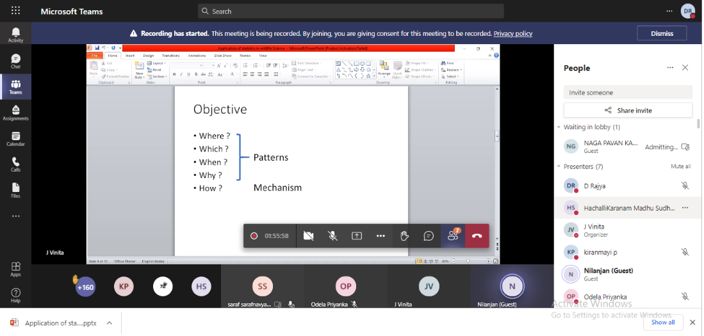
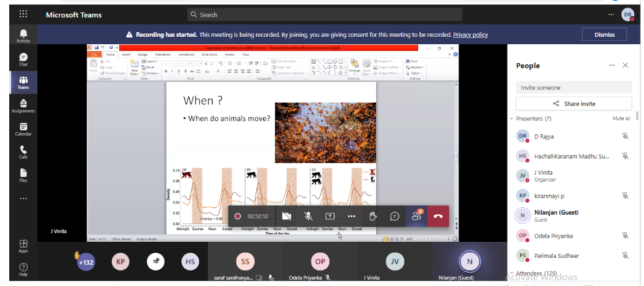
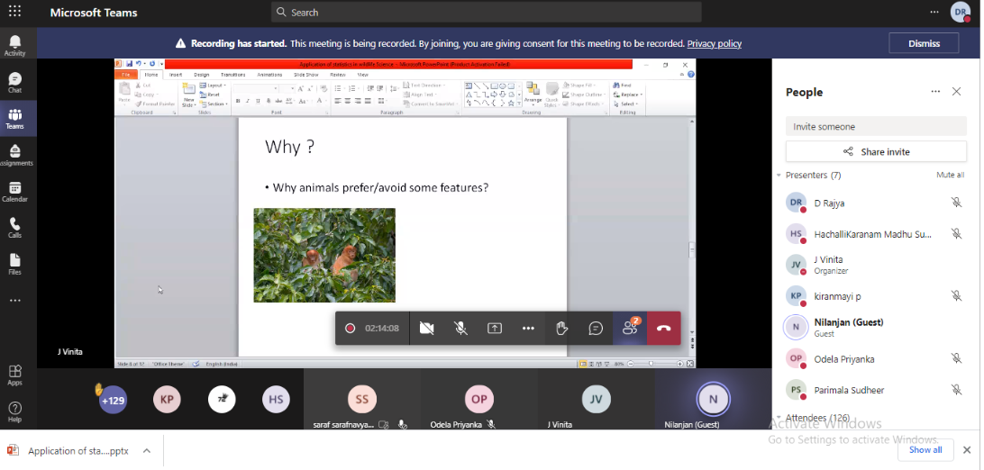
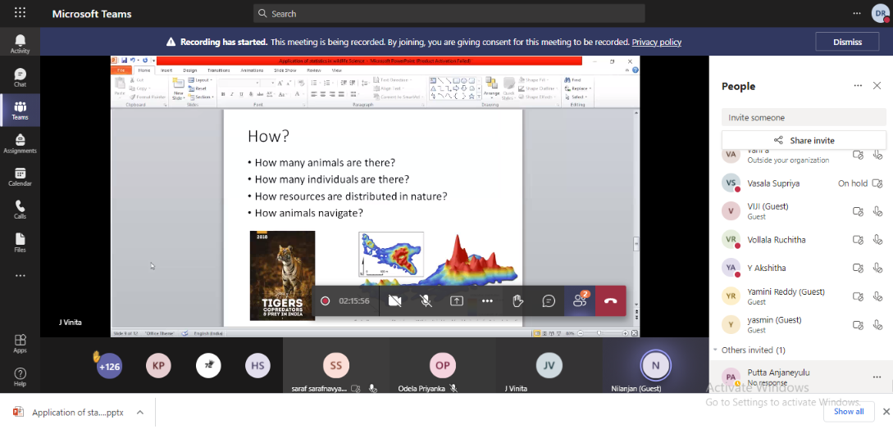

- GUEST PROFILE (IF ANY) : Nil
- FEED BACK IF ANY : Nil
- ATTACHMENTS:
EVENT/ACTIVITY PROPOSAL: Yes
EVENT / ACTIVITY NOTICE : Nil
RECEIPTS (IF ANY) : Nil
CERTIFICATES (IF ANY) : Nil
LETTERS OF COMMUNICATION (IF ANY) : Nil
Aurora’s Degree and PG College
(ACCREDITED BY NAAC WITH ‘B++’ GRADE)
Chikkadpally, Hyderabad 500020
EVENT PROPOSAL
for
NATIONAL STATISTICS DAY CELEBRATION
Event/Activity Title: NATIONAL STATISTICS DAY
Faculty coordinators: J.Vinita
Date: 29TH June 2021
Venue: Aurora’s Degree and PG College
Target audience: Students
Platform: Online
Level: State
Student Volunteer’s: O.Priyanka (PG App Statistics) B.Arun Kumar (PG App Statistics)
Objective: The objective of statistics day is to popularize the use of Statistics in everyday life and sensitize the public as to how Statistics helps in shaping and framing policies in every field. It is celebrated on the birth anniversary of Prof. P C Mahalanobis
Proposed activities:
Activities on 28th June 2021(only for Aurora ug and pg statistics students)
- STATISTICAL CROSSWORD PUZZLE :
- STATISICIANS HUNTER GAME:
Activities on 29th June 2021
Webinar on”Application of statistics in Wildlife Sciences” by Nilanjan Chatterjee an Alumini of ISI, at 11.30am -12.30am on 29th june 2021

Guest/Speaker details: Nilanjan Chatterjee an Alumini of ISI, Phd student in Widlife Institute of Indian , Dehradun .
Budget: Nil
Coordinator IQAC Coordinator Principal
1) J.Vinita Dr. Ravi kiran Dr. Viswanadham Bulusu
2)K.Parimala Diana sudhir

