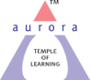
Aurora’s Degree & PG College
(ACCREDITED BY NAAC WITH 'B++' GRADE)
Chikkadpally, Hyderabad 500020

EVENT DETAILED REPORT

NAME OF THE EVENT | Tribute to Lala Lajpat Rai
TYPE OR TITLE OF EVENT | Class event
FACULTY INCHARGE | Mr. Shiva Shanker G
DEPARTMENT | Commerce – Computer Applications
DATE | 28th January, 2022
VENUE | Online (Platform - Microsoft Teams)
TARGET AUDIENCE | Students of B.Com 3 Computer Applications “C” section

1. PROGRAM SCHEDULE:

Date | Timings | Activities done
28-01-2022 | 1:00 pm – 1:45 pm | Speeches, PPT presentation & Quiz

2. LIST OF FACULTY COORDINATORS

Sl. No. | Name of the faculty | Department | Designation
1 | Mr. Shiva Shanker G | Commerce | Assistant Professor

3. LIST OF THE STUDENT COORDINATORS:

Sl. No. | Roll Number | Name of the student | Section
1 | 1051-19-405-153 | Shifa Khan | B.Com 3 Comp Appl “C” section
2 | 1051-19-405-150 | Abdur Rehman Khan | B.Com 3 Comp Appl “C” section
3 | 1051-19-405-166 | Sourav Agarwal | B.Com 3 Comp Appl “C” section
4 | 1051-19-405-190 | Arni Sham Seema | B.Com 3 Comp Appl “C” section
5 | 1051-19-405-142 | Anne Vaishnavi | B.Com 3 Comp Appl “C” section
6 | 1051-19-405-151 | Vineet Joshi | B.Com 3 Comp Appl “C” section
7 | 1051-17-405-037 | Nemtoori Hari Chandana | B.Com 3 Comp Appl “C” section

4. LIST OF THE PARTICIPANTS : (B.Com 3 Comp Appl “C” section)

S.No | Roll No. | Name | College Email ID
1 | 1051-19-405-141 | Katika Naga Pavan | katikanagapavan19@adc.edu.in
2 | 1051-19-405-142 | Anne Vaishnavi | annevaishnavi19@adc.edu.in
3 | 1051-19-405-143 | G Dharma Vardhan | gdharmavardhan19@adc.edu.in
4 | 1051-19-405-144 | Mula Varun Kumar | mulavarunkumar19@adc.edu.in
5 | 1051-19-405-145 | Muzammil Masood Al Behlooli | muzammilmasoodalbehlooli19@adc.edu.in
6 | 1051-19-405-146 | Konda Akshay | kondaakshay19@adc.edu.in
7 | 1051-19-405-147 | Mohammed Shoaib Amir | mohammedshoaibamir19@adc.edu.in
8 | 1051-19-405-148 | Mana Uday Kumar | manaudaykumar19@adc.edu.in
9 | 1051-19-405-149 | Mohd Waseem Ahmed | mohdwaseemahmed19@adc.edu.in
10 | 1051-19-405-150 | Abdur Rehman Khan | abdurrehmankhan19@adc.edu.in
11 | 1051-19-405-151 | Vineet Joshi | vineetjoshi19@adc.edu.in
12 | 1051-19-405-152 | Md Fazal Ulla Choudri | mdfazalullachoudri19@adc.edu.in
13 | 1051-19-405-153 | Shifa Khan | shifakhan19@adc.edu.in
14 | 1051-19-405-155 | Sandha Manoj | sandhamanoj19@adc.edu.in
15 | 1051-19-405-156 | Gudiniya Ruchika | gudiniyaruchika19@adc.edu.in
16 | 1051-19-405-157 | Kusum Santra | kusumsantra19@adc.edu.in
17 | 1051-19-405-158 | Pandey Mrityunjay | pandeymrityunjay19@adc.edu.in
18 | 1051-19-405-159 | S Lokesh Raj Agarwal | slokeshrajagarwal19@adc.edu.in
19 | 1051-19-405-160 | Vikas Biswal | vikasbiswal19@adc.edu.in
20 | 1051-19-405-161 | Roshan Singh | roshansingh19@adc.edu.in
21 | 1051-19-405-162 | Mousumi Samanta | mousumisamanta19@adc.edu.in
22 | 1051-19-405-163 | Sunka Soniya Anil | sunkasoniyaanil19@adc.edu.in
23 | 1051-19-405-164 | Abhishek | abhishek19@adc.edu.in
24 | 1051-19-405-165 | Ravani Riyaz | ravaniriyaz19@adc.edu.in
25 | 1051-19-405-166 | Sourav Agarwal | souravagarwal19@adc.edu.in
26 | 1051-19-405-167 | Varindani N Bhupesh | varindaninbhupesh19@adc.edu.in
27 | 1051-19-405-168 | Kashif Khan | kashifkhan19@adc.edu.in
28 | 1051-19-405-169 | Ramavatar Khandelwal | ramavatarkhandelwal19@adc.edu.in
29 | 1051-19-405-170 | Mohammed Aqeem Uddin | mohammedaqeemuddin19@adc.edu.in
30 | 1051-19-405-171 | Harsh Verma | harshverma19@adc.edu.in
31 | 1051-19-405-172 | Dhannawat Rusheel | dhannawatrusheel19@adc.edu.in
32 | 1051-19-405-173 | Abhishek Kongle | abhishekkongle19@adc.edu.in
33 | 1051-19-405-174 | B Yash Kumar | byashkumar19@adc.edu.in
34 | 1051-19-405-175 | Sandeep Kumar Yadav | sandeepkumaryadav19@adc.edu.in
35 | 1051-19-405-176 | C S Rithvik | csrithvik19@adc.edu.in
36 | 1051-19-405-177 | Rajnish Kumar Jha | rajnishkumarjha19@adc.edu.in
37 | 1051-19-405-178 | Daulat Dhani | daulatdhani19@adc.edu.in
38 | 1051-19-405-179 | Suraj Lal Varma | surajlalvarma19@adc.edu.in
39 | 1051-19-405-180 | Ravula Rohan Kumar | ravularohankumar19@adc.edu.in
40 | 1051-19-405-181 | Krishi Singh | krishisingh19@adc.edu.in
41 | 1051-19-405-182 | Mir Zulfequar Ali | mirzulfequarali19@adc.edu.in
42 | 1051-19-405-183 | Ranjit Singh Solanki | ranjitsinghsolanki19@adc.edu.in
43 | 1051-19-405-184 | Faiz Dhanani | faizdhanani19@adc.edu.in
44 | 1051-19-405-185 | Devarshi Aaditya | devarshiaaditya19@adc.edu.in
45 | 1051-19-405-186 | Aryan | aryan19@adc.edu.in
46 | 1051-19-405-187 | Aiman Ahmed Farooqi | aimanahmedfarooqi19@adc.edu.in
47 | 1051-19-405-188 | Priyansh Kumar Surana | priyanshkumarsurana19@adc.edu.in
48 | 1051-19-405-189 | Mohd Sohail Khan | mohdsohailkhan19@adc.edu.in
49 | 1051-19-405-190 | Arni Sham Seema | arnishamseema19@adc.edu.in
50 | 1051-19-405-191 | Shravan Kumar Singh | shravankumarsingh19@adc.edu.in
51 | 1051-19-405-192 | Amit Agarwal | amitagarwal19@adc.edu.in
52 | 1051-19-405-193 | Shashank Tiwari | shashanktiwari19@adc.edu.in
53 | 1051-19-405-194 | Haiyawala Yesh Singh | haiyawalayeshsingh19@adc.edu.in
54 | 1051-19-405-195 | Mirza Mehmood Ali Baig | mirzamehmoodalibaig19@adc.edu.in
55 | 1051-19-405-196 | Harsh Karnani | harshkarnani19@adc.edu.in
56 | 1051-19-405-197 | Swaraj Sanghi | swarajsanghi19@adc.edu.in
57 | 1051-19-405-198 | R Sirisha | rsirisha19@adc.edu.in
58 | 1051-19-405-199 | Mohammed Faiyaz Khan | mohammedfaiyazkhan19@adc.edu.in
59 | 1051-19-405-200 | Mohd Irfan | mohdirfan19@adc.edu.in
60 | 1051-19-405-201 | Kasanaboina Nikitha | kasanaboinanikitha19@adc.edu.in
61 | 1051-19-405-202 | Pooja Kishan Motwani | poojakishanmotwani19@adc.edu.in
62 | 1051-19-405-203 | Kadaji Datta | kadajidatta19@adc.edu.in
63 | 1051-19-405-204 | Naveen Kumar Mishra | naveenkumarmishra19@adc.edu.in
64 | 1051-19-405-205 | Laxman Dass Koushal Raj | laxmandasskoushalraj19@adc.edu.in
65 | 1051-19-405-206 | Shaik Mohammed Iftekhar | shaikmohammediftekhar19@adc.edu.in
66 | 1051-19-405-207 | Deepak Shinde | deepakshinde19@adc.edu.in
67 | 1051-19-405-208 | K Dinesh Kumar | kdineshkumar19@adc.edu.in
68 | 1051-19-405-209 | Chetan Lahoti | chetanlahoti19@adc.edu.in
69 | 1051-19-405-301 | Netra Bogati | netrabogati19@adc.edu.in
70 | 1051-18-405-225 | N Akshitha | nakshitha18@adc.edu.in
71 | 1051-17-405-037 | Nemtoori Hari Chandana | nemtooriharichandana@adc.edu.in

5. PARAGRAPH ABOUT THE PROCEEDINGS:

The shots that hit me are the last nails to the coffin of British rule in India
On the day of 28th January, 2022 the students of B.Com 3 Computer Applications “C” section students were conducted an event on occasion Lala Lajpat Rai’s Birth anniversary at sharp 1:15 pm in online platform using Microsoft Teams. Lala Lajpat Rai was the great Indian fighter who was known as Punjab Kesari or Lion. During the event they presented their PPTs, Speeches and also conducted a quiz round.
Firstly, participants were introduced about Lala Lajpat Rai’s legacy and his influence on the society. The next participant explained about how he contributed in freedom fight and what are the policies which he protested against British. They even did PPT presentation on his educational and political career. After that the students gave speeches about his contribution towards our Freedom fight and his different social works. One of the participant, read few phrases which was wrote or said by Lala Lajpat Rai, which were quite inspiring. Finally conducted a quick quiz round where all the students were participated interestingly and answered to all the questions. The event was concluded with a vote of thanks. The students were actively participated entire the session.

6. INCOME AND EXPENDITURE: - NIL -

7. EVENT PHOTOS:
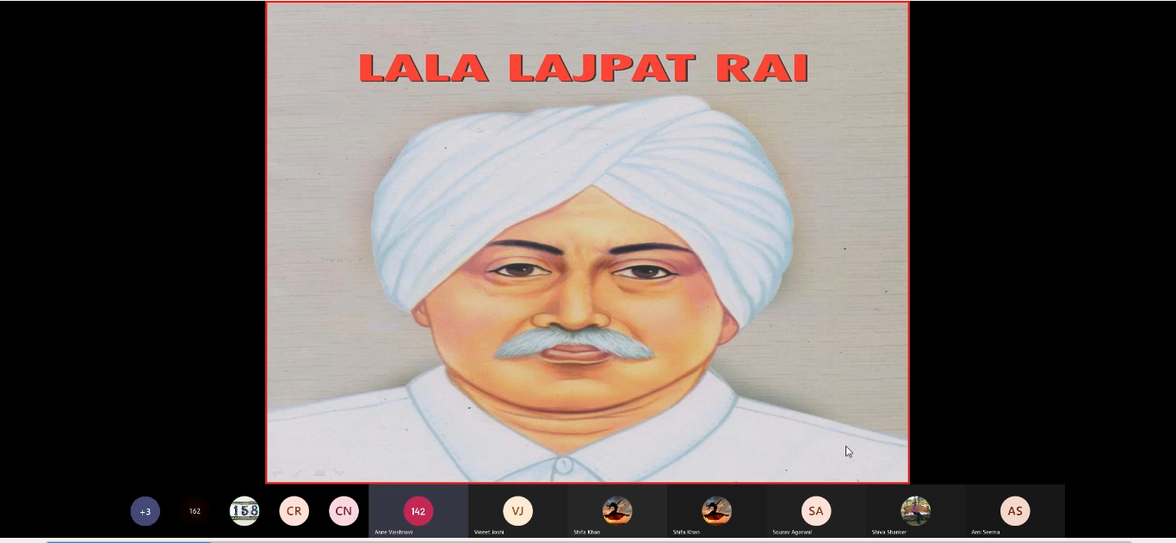

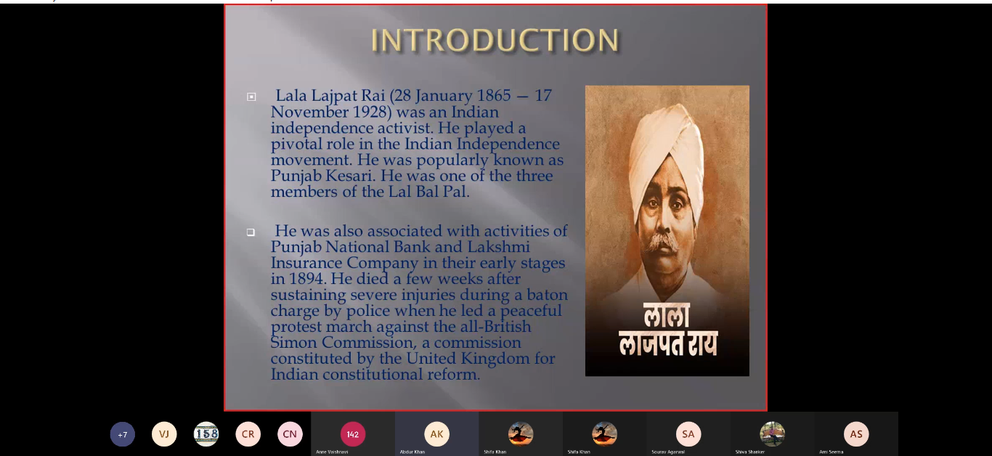
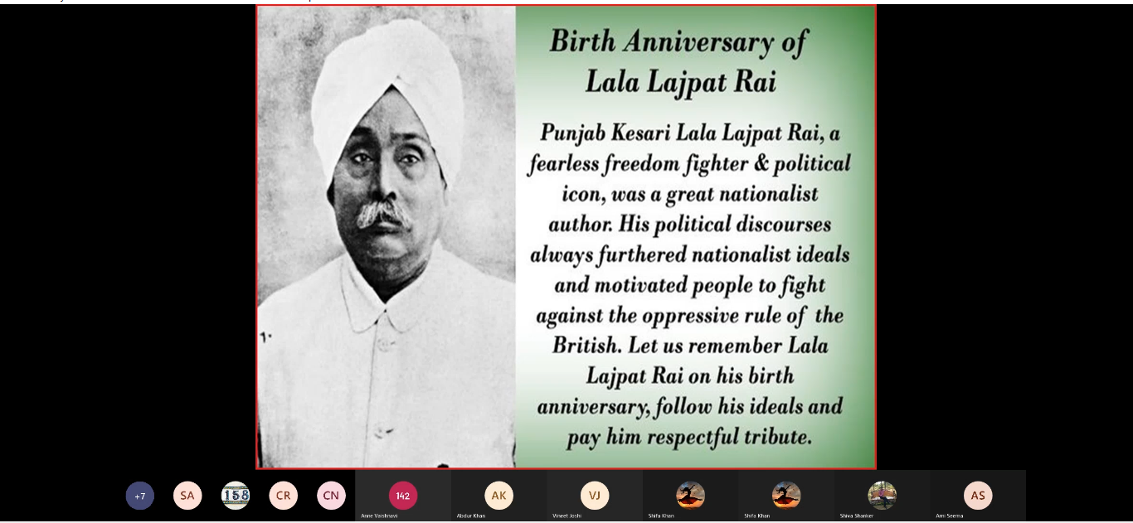

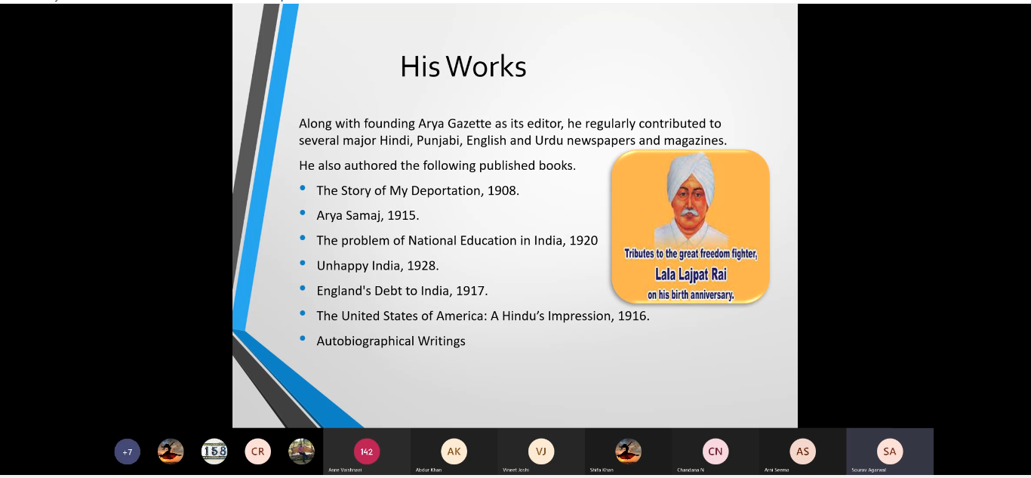
8. GUEST PROFILE: -NIL-

9. FEED BACK IF ANY: -NIL-

10. ATTACHMENTS: PFA OF EVENT PROPOSAL & EVENT VIDEO RECORDING LINK

VIDEO LINK:
https://drive.google.com/file/d/1JWcsPOatXXX82hNh5bZoTYnf3C4GoJ8V/view?usp=sharing

EVENT PROPOSAL
Type of Event: Class event
Event Title: Tribute to Lala Lajpat Rai
Cell conener: MS. Sujatha K
Faculty in charge: Mr. Shiva Shanker G
Date & Venue: on 28th January, 2022 & Online mode (Platform-Microsoft Teams)
Target audience: Students of B.Com Computer Applications – 3C Section
Level: College
Budget: Nil
Student volunteer’s: Captain, Group leaders & other students of the class
Objective: To let students know about Lala Lajpat Rai and his contribution towards India
Proposed activities: Quiz, Power point Presentation & Speeches.

Faculty Co-Ordinator IQAC Coordinator Principal
G Shiva Shanker Dr. Ravi Kiran Dr. Viswanadham Bulusu

