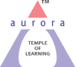
Aurora’s Degree & PG College
(ACCREDITED BY NAAC WITH 'B++' GRADE)
Chikkadpally, Hyderabad 500020

GUIDO VAN ROSSUM’S BIRTHDAY EVENT
DETAILED REPORT

NAME OF THE EVENT / ACTIVITY | Guido van Rossum’s Birthday Celebration
TYPE OR TITLE OF EVENT / ACTIVITY | Guido van Rossum’s Birthday Celebration
FACULTY INCHARGE | Ms. V Sirisha
DEPARTMENT/CELL/COMMITTEE/CLUB | Computer Science
DATE | 31-01-2022
VENUE | Aurora’s Degree & PG College
TARGET AUDIENCE | B.Sc 1st Year Students (Physical Sciences)

- PROGRAM SCHEDULE
Guest lecture on “Python in Data Science” is conducted by Department of Computer Science on 31-01-2022 for B.Sc first year students (Physical Sciences) in online mode using Microsoft Teams platform.

- LIST OF FACULTY COORDINATORS (DEPARTMENT)
Ms. V Sirisha, Assistant Professor, Computer Science Department

- LIST OF THE STUDENT COORDINATORS (NAME , ROLL NO, CLASS & SECTION)
NIL

- LIST OF THE PARTICIPANTS (NAME , ROLL NO, CLASS & SECTION, NO OF GIRLS, BOYS, CASTE )
Participants list in soft copy is attached

- PARAGRAPH ABOUT THE PROCEEDINGS (TILL THE END OF THE EVENT)
Two distinguished data science experts
- Amarendra Vajjhala, Aurora college alumni, IIT-Bombay Adjunct Instructor - New York University , Entrepreneur; Ex Lehman Brothers, Nomura, United Network of Professionals (UNP - an e-learning platform on AI and Data Science) Director.
- Vivek Kalyanarangan, BTech, WBUT, Data Science Leader, Financial Services - UNP Advisor
delivered a lecture on ‘ Python in data science.’ Both of the speakers are experienced data science leaders in Machine Learning Tools like Python, Tensorflow, Spark, R, Elasticsearch etc.
The speakers started off the event by introducing Guido Van Rossum, followed by explaining the importance of python programming language in data science and its applications. They also explained how the students should go about to become successful data scientists.
Nearly 75 students attended this Guest Lecture from different streams of B.Sc 1st year Physical Sciences.
The students have understood the applications of python programming language in the field of data science and the difference between python and other languages. They got their doubts clarified about the field of data science regarding the career opportunities.

- INCOME AND EXPENDITURE
NIL

- EVENT PHOTOS ( MIN 2 MAX 4)
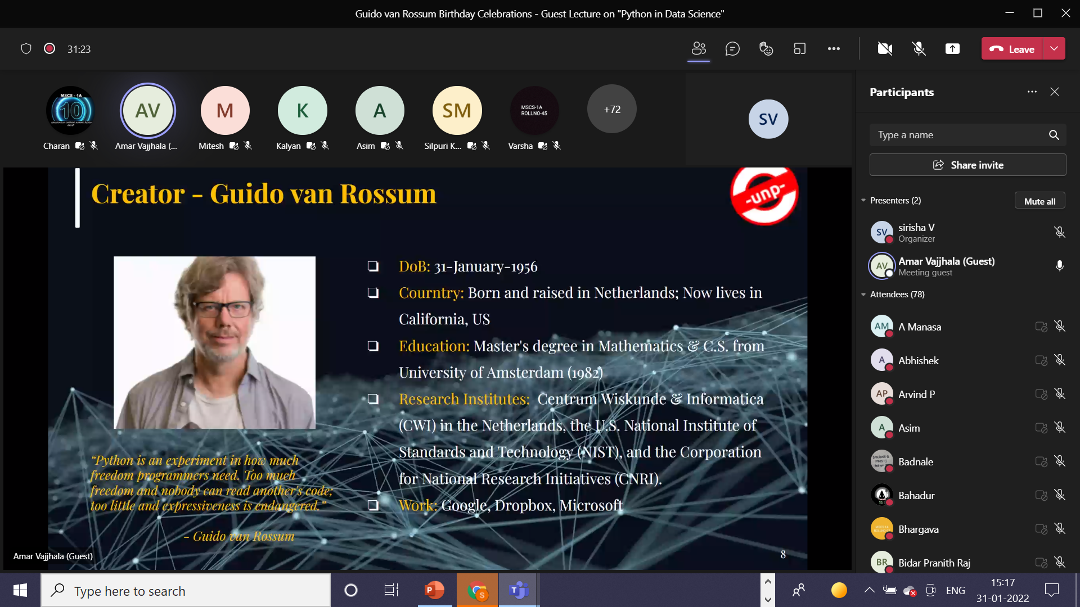
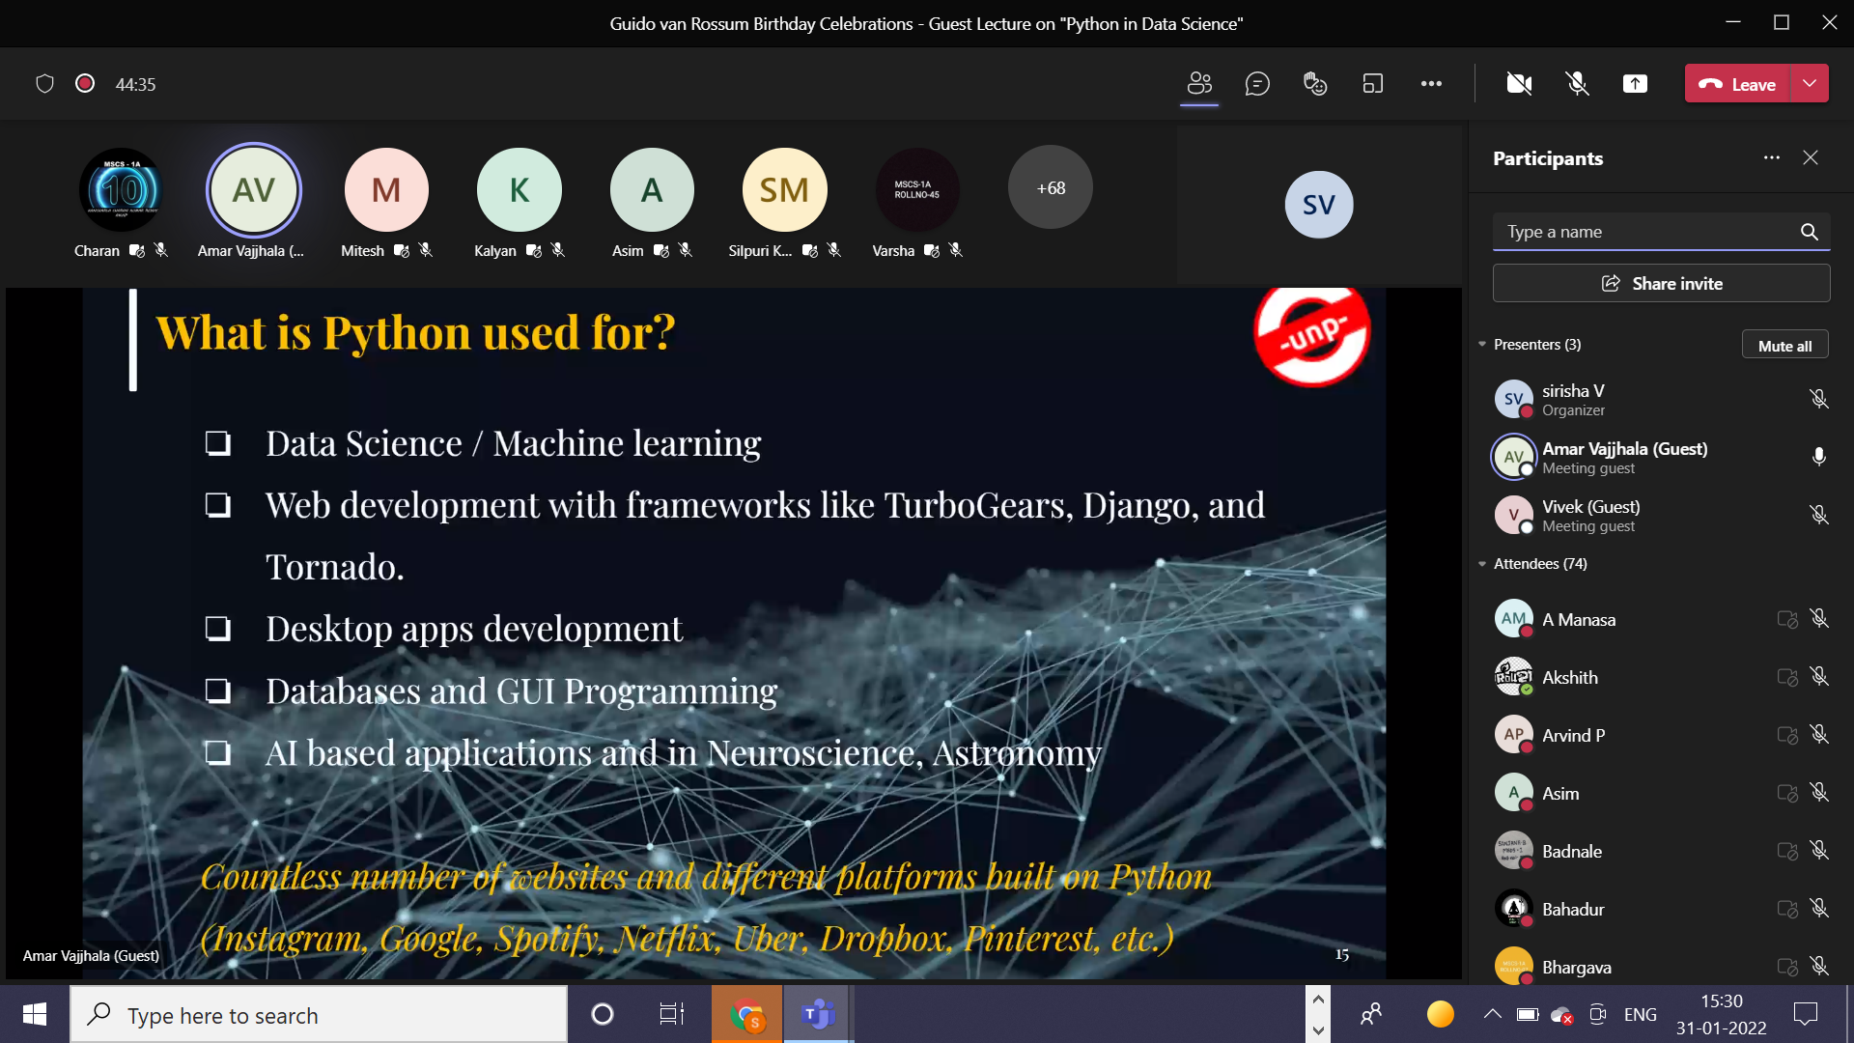

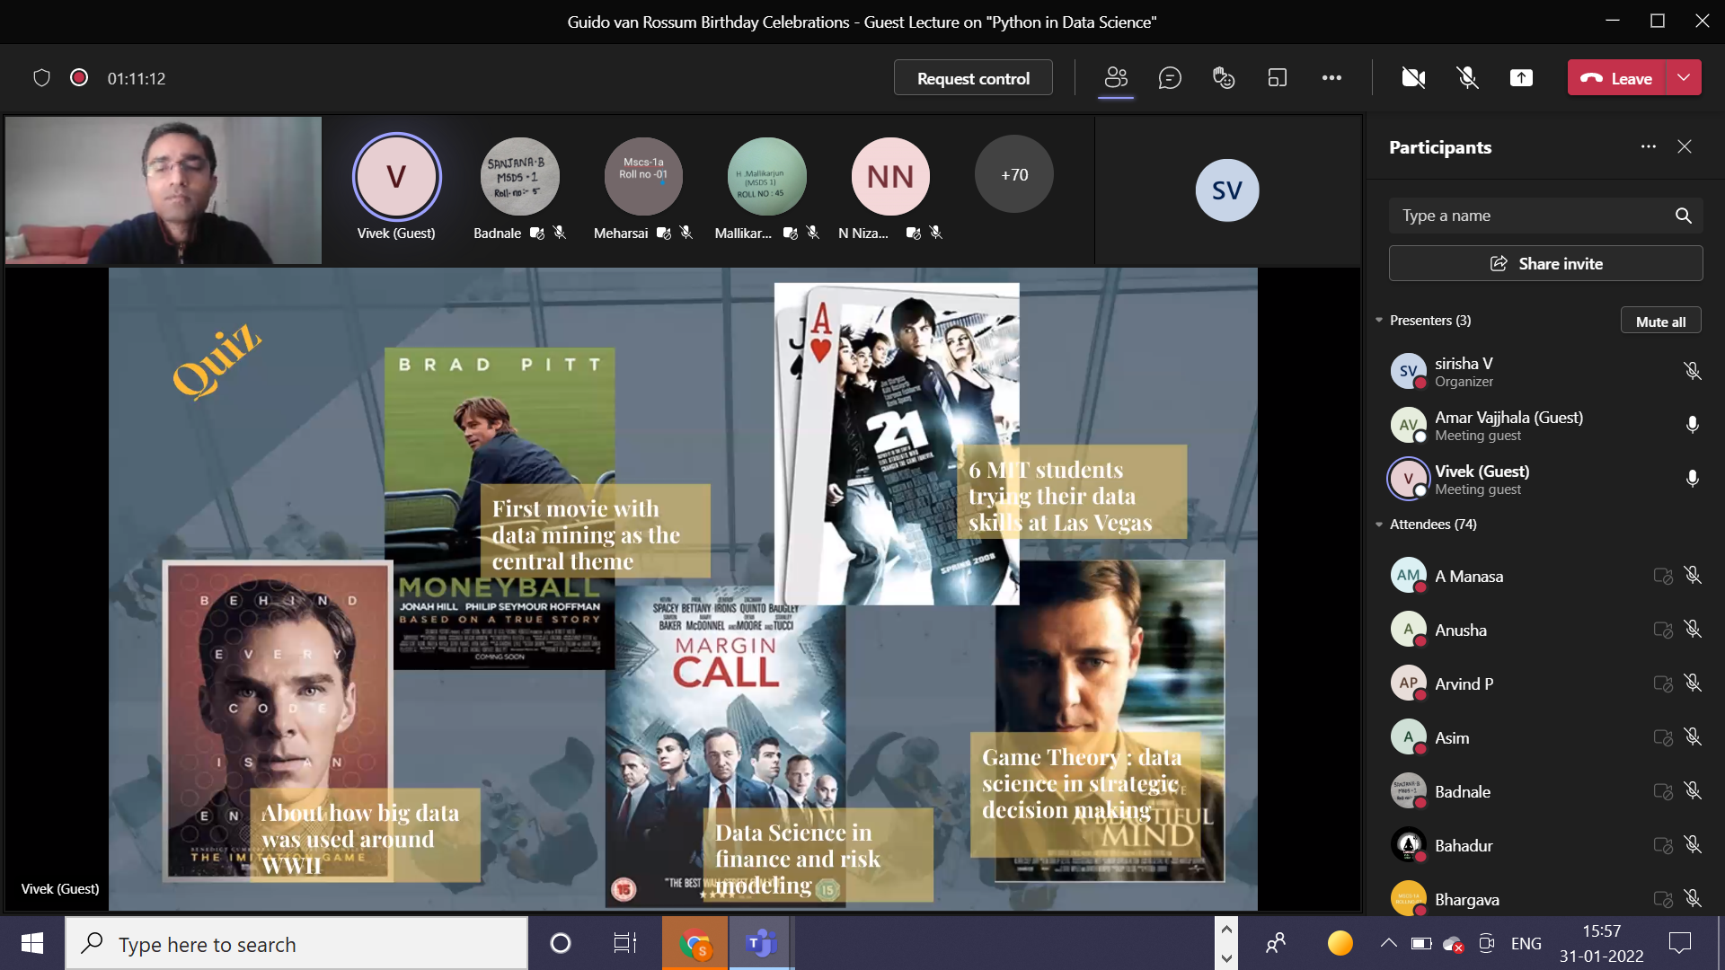

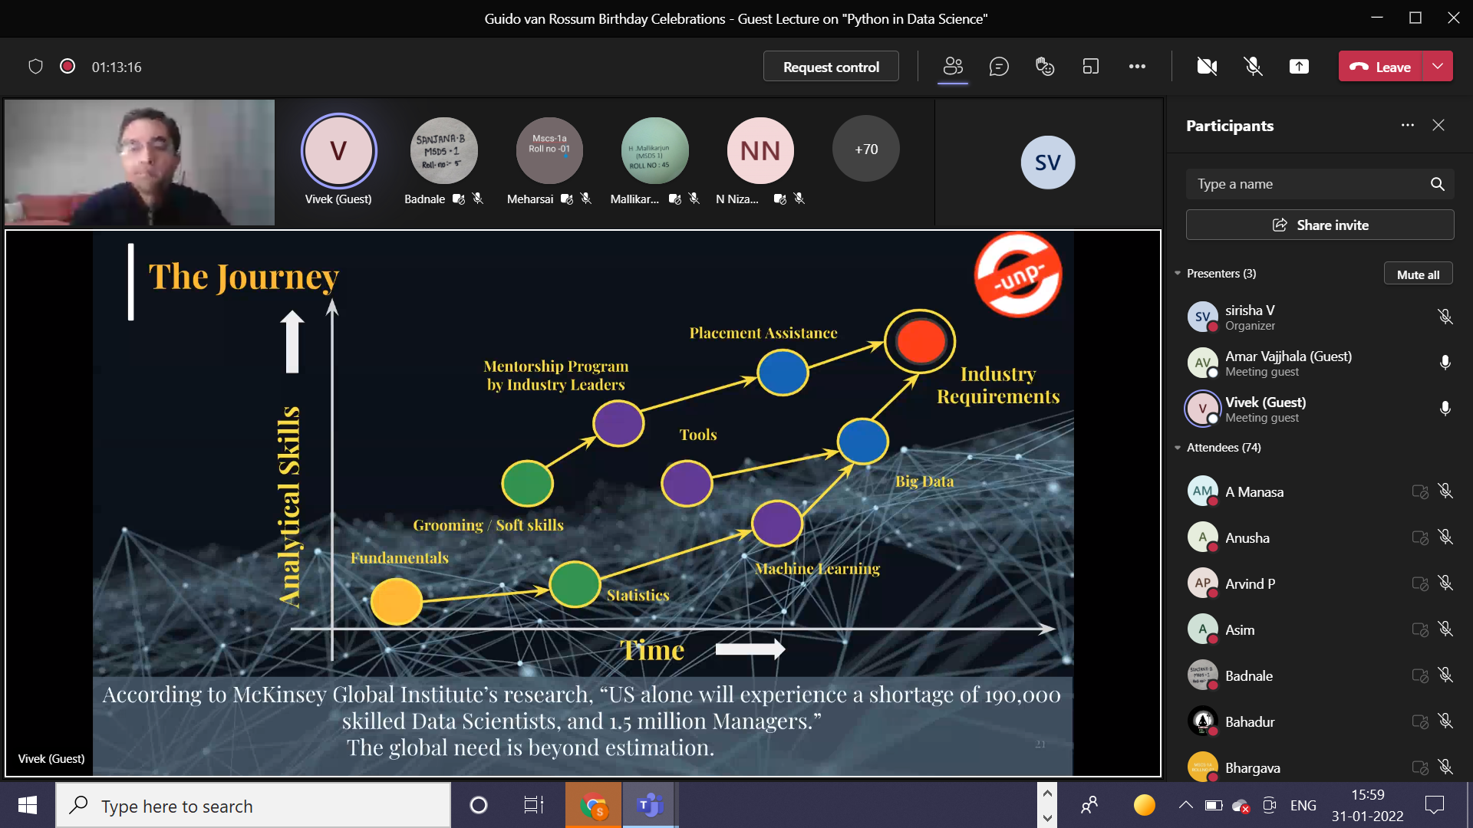
- GUEST PROFILE (IF ANY)
Two distinguished data science experts delivered lecture on “Python in Data Science”.
      - Amarendra Vajjhala is an Entrepreneur, Educator, and ex-Investment Banker. After completing his B.Sc. (M.S.CS) from Aurora Degree College., he pursued M.Sc. in Applied Statistics & Informatics from IIT-Bombay. Amar has worked with global investment banks, Lehman Brothers, and Nomura as an equity analyst and in a leadership role and founded a start-up. Amar is passionate about teaching and mentoring juniors in their academic and professional endeavors. He is an Adjunct Instructor at New York University and Director at United Network of Professionals (unp.education), an e-learning platform on AI and Data Science.
      - Vivek Kalyanarangan is a Data Science leader with 8+ years of hands-on experience in Machine Learning Tools like Python, Tensorflow, Spark, R, Elasticsearch etc. Vivek has worked across domains mainly in Banking, Healthcare, Travel and Hospitality. He wishes to make a trilingual contribution to the industry – Technology, Business, Analytics and is passionate about sharing knowledge with others. Vivek is one of the lead instructors at United Network of Professionals (UNP) and specializes on courses in Machine Learning and Big Data

- FEED BACK IF ANY
NIL
- ATTACHMENTS:
EVENT/ACTIVITY PROPOSAL : Softcopy is attached
EVENT / ACTIVITY NOTICE : NIL
RECEIPTS (IF ANY) : NIL
CERTIFICATES (IF ANY) : NIL
LETTERS OF COMMUNICATION (IF ANY) : NIL

