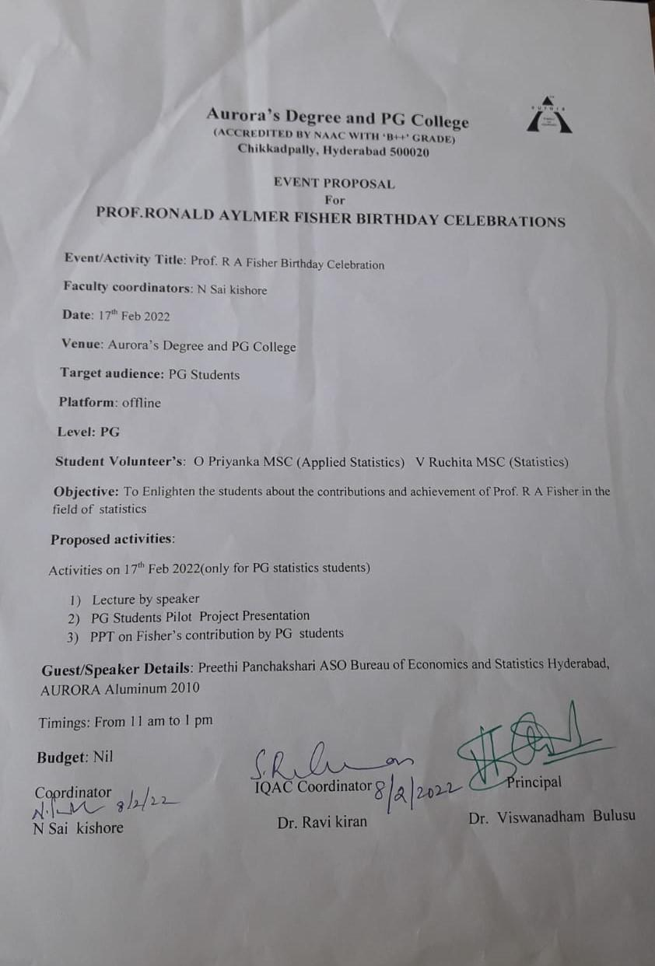

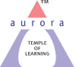
Aurora’s Degree & PG College
(ACCREDITED BY NAAC WITH 'B++' GRADE)
Rtc x roads, Hyderabad 500020

EVENT / ACTIVITY SHORT REPORT

NAME OF THE EVENT | R.A. FISHER’S BIRTHDAY CELEBRATIONS
TYPE OF EVENT | R.A. FISHER BIRTHDAY(Departmental Event)
FACULTY INCHARGE | N SAI KISHORE
DEPARTMENT | Department of Statistics
DATE | February 17th 2022
VENUE | Aurora’s Degree and PG college, Rtc x road, Hyderabad.
TARGET AUDIENCE | PG-MSc(Statistics)

OBJECTIVE: To aware the students about the contributions of Prof. R.A. Fisher in the field of Statistics. Motivating and inspiring the students regarding his studies.

BRIEF ABOUT THE EVENT: The event was conducted on occasion of the birthday of Prof. R.A. Fisher Father of modern statistics on 17th February. The event was conducted to inspire the students about the life and his achievements of Prof .R.A .Fisher.
On this occasion, The Department of Statistics conducted PowerPoint presentations, poster presentations and knowledge exchange program of mini projects by MSC(statistics) and MSC(Applied statistics) 1st and 2nd year .
Student coordinators:
1. V Ruchitha(PG 2nd^{st} year statistics)
2. O. Priyanka (PG 2nd^{st} year Applied Statistics)
The participant students:
- MSC(Statistics & Applied Statistics 2nd years)
- MSC(Statistics & Applied Statistics 1nd years)

- LIST OF THE STUDENTS WHO PRESENTED THE PPT’S POSTERS (NAME, ROLL NO, CLASS &SECTION,)

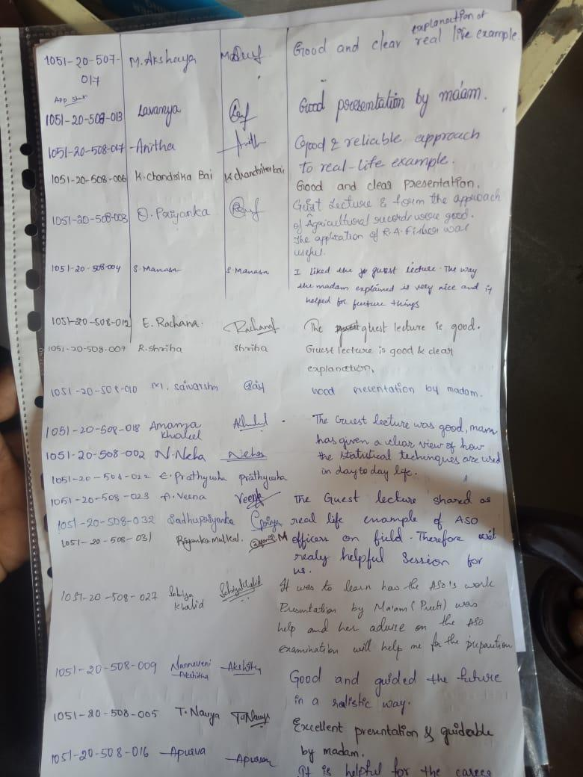

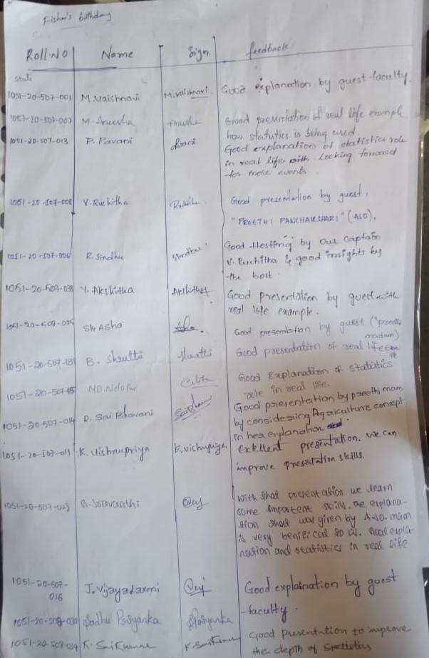

OUTCOME: This event has made student centric, students actively participated in different power point presentations. Students came to know about the various contributions and works done by Sir Fisher in the field of Statistics.

Guess Lecture p. preethi working as Assistant Statistical officer in Directorate of Economics and statistics, khairtabad

PHOTOGRAP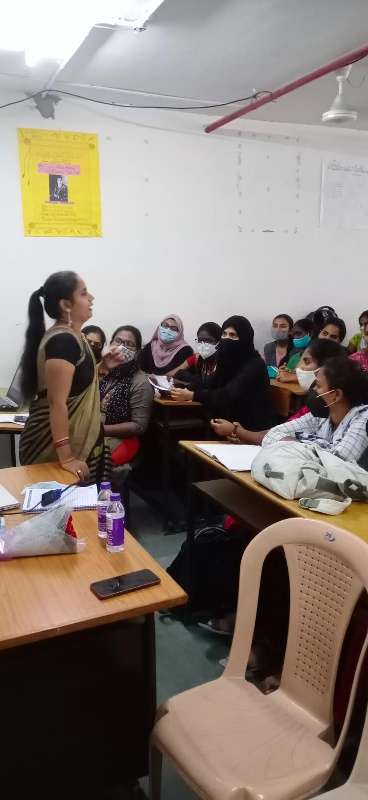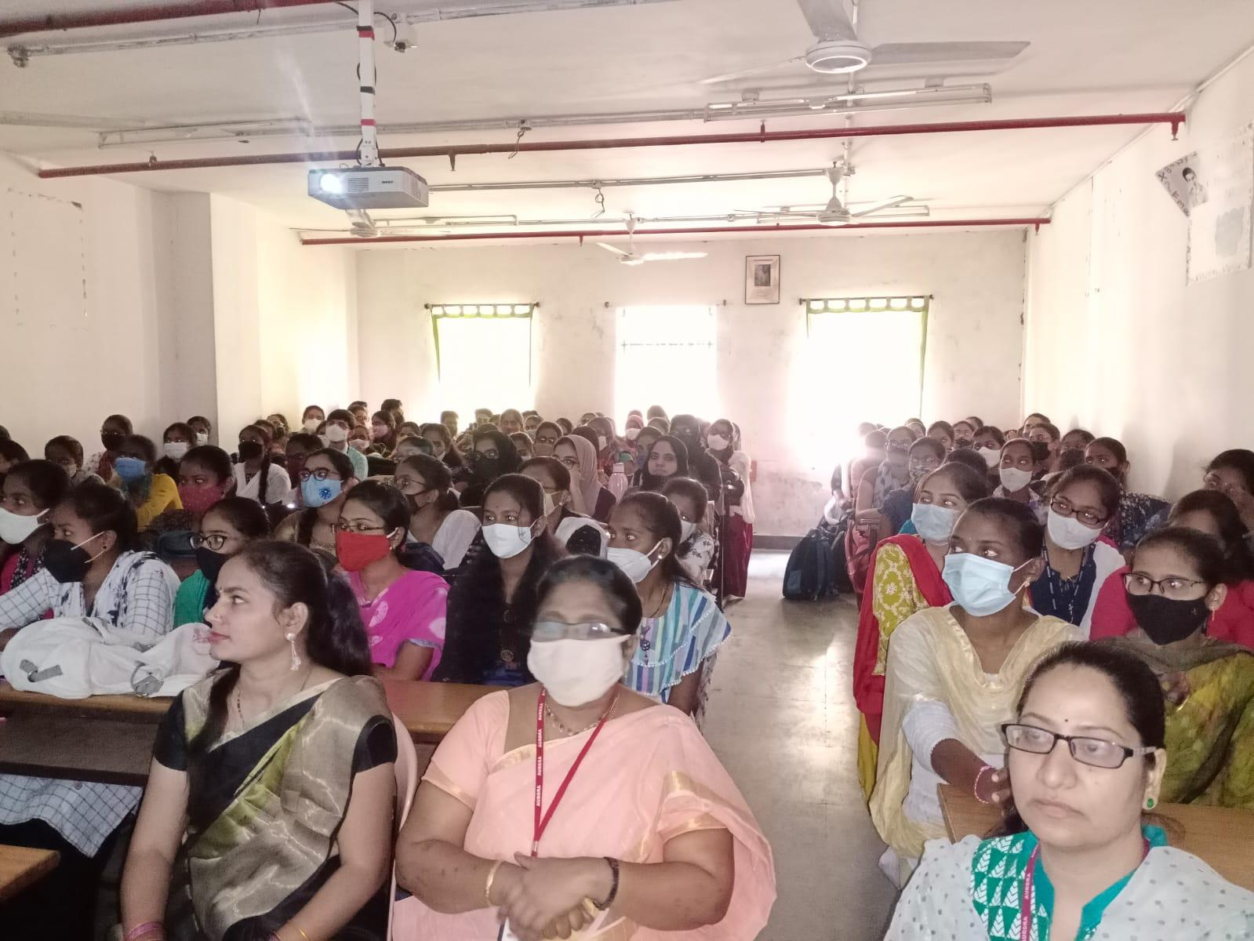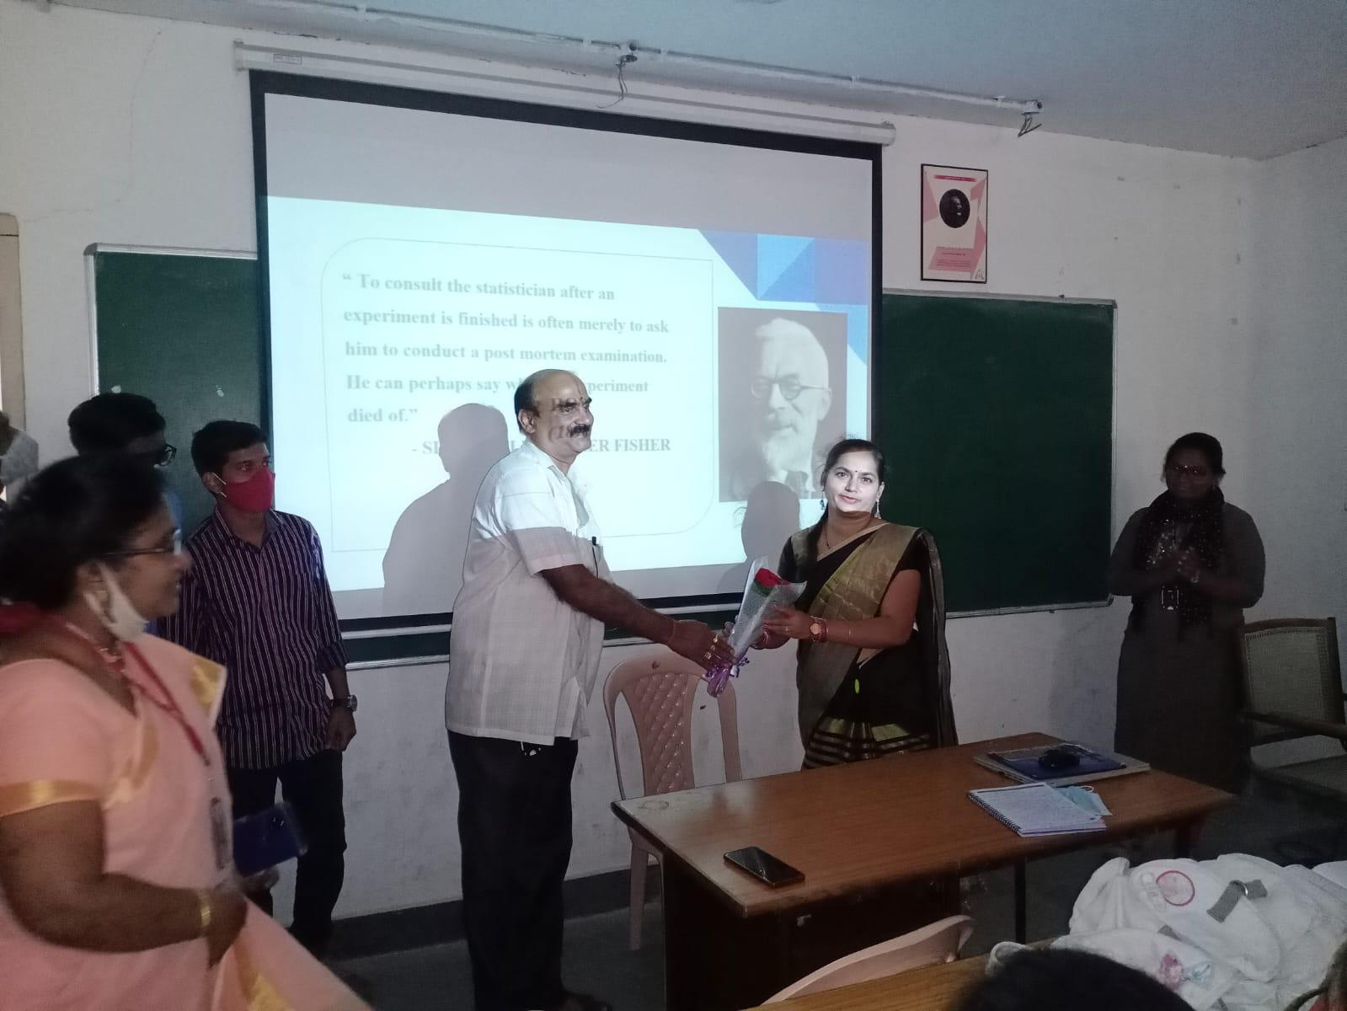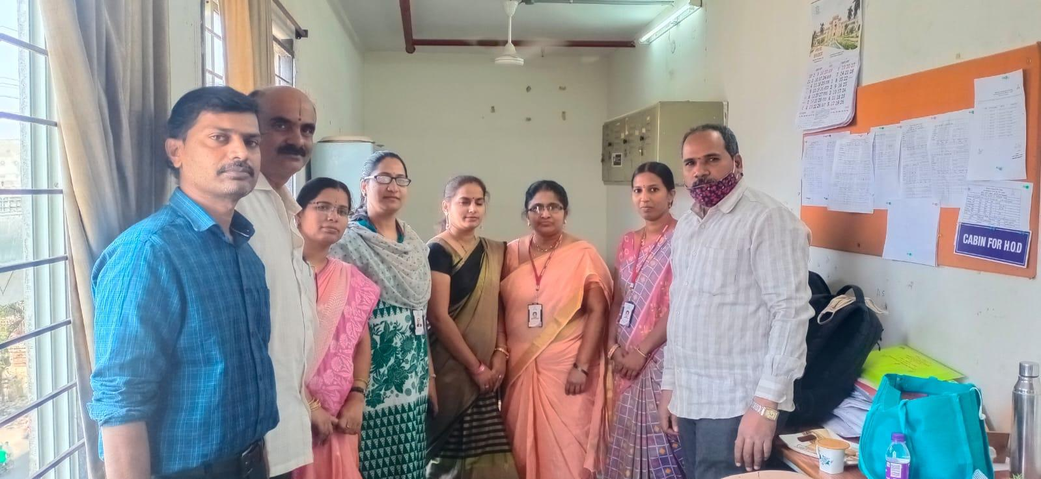

Detail report
OBJECTIVE: To aware the students about the contributions of Prof. R.A. Fisher in the field of Statistics. Motivating and inspiring the students regarding his studies.
The event was conducted on occasion of the birthday of Prof. R.A. Fisher Father of modern statistics on 17th February. The event was conducted to inspire the students about the life and his achievements of Prof .R.A .Fisher.
Students gather information about RA Fisher and his contributions in statistics that may be PPT And mini project by PG -2nd year (Applied statistics and statistics)

After presentation of power point by students madhusudhan sir lectured about RA FISHER&HIS CONTRIBUTIONS.
OUTCOME: This event has made student centric, students actively participated in different power point presentations. Students came to know about the various contributions and works done by Sir Fisher in the field of Statistics.
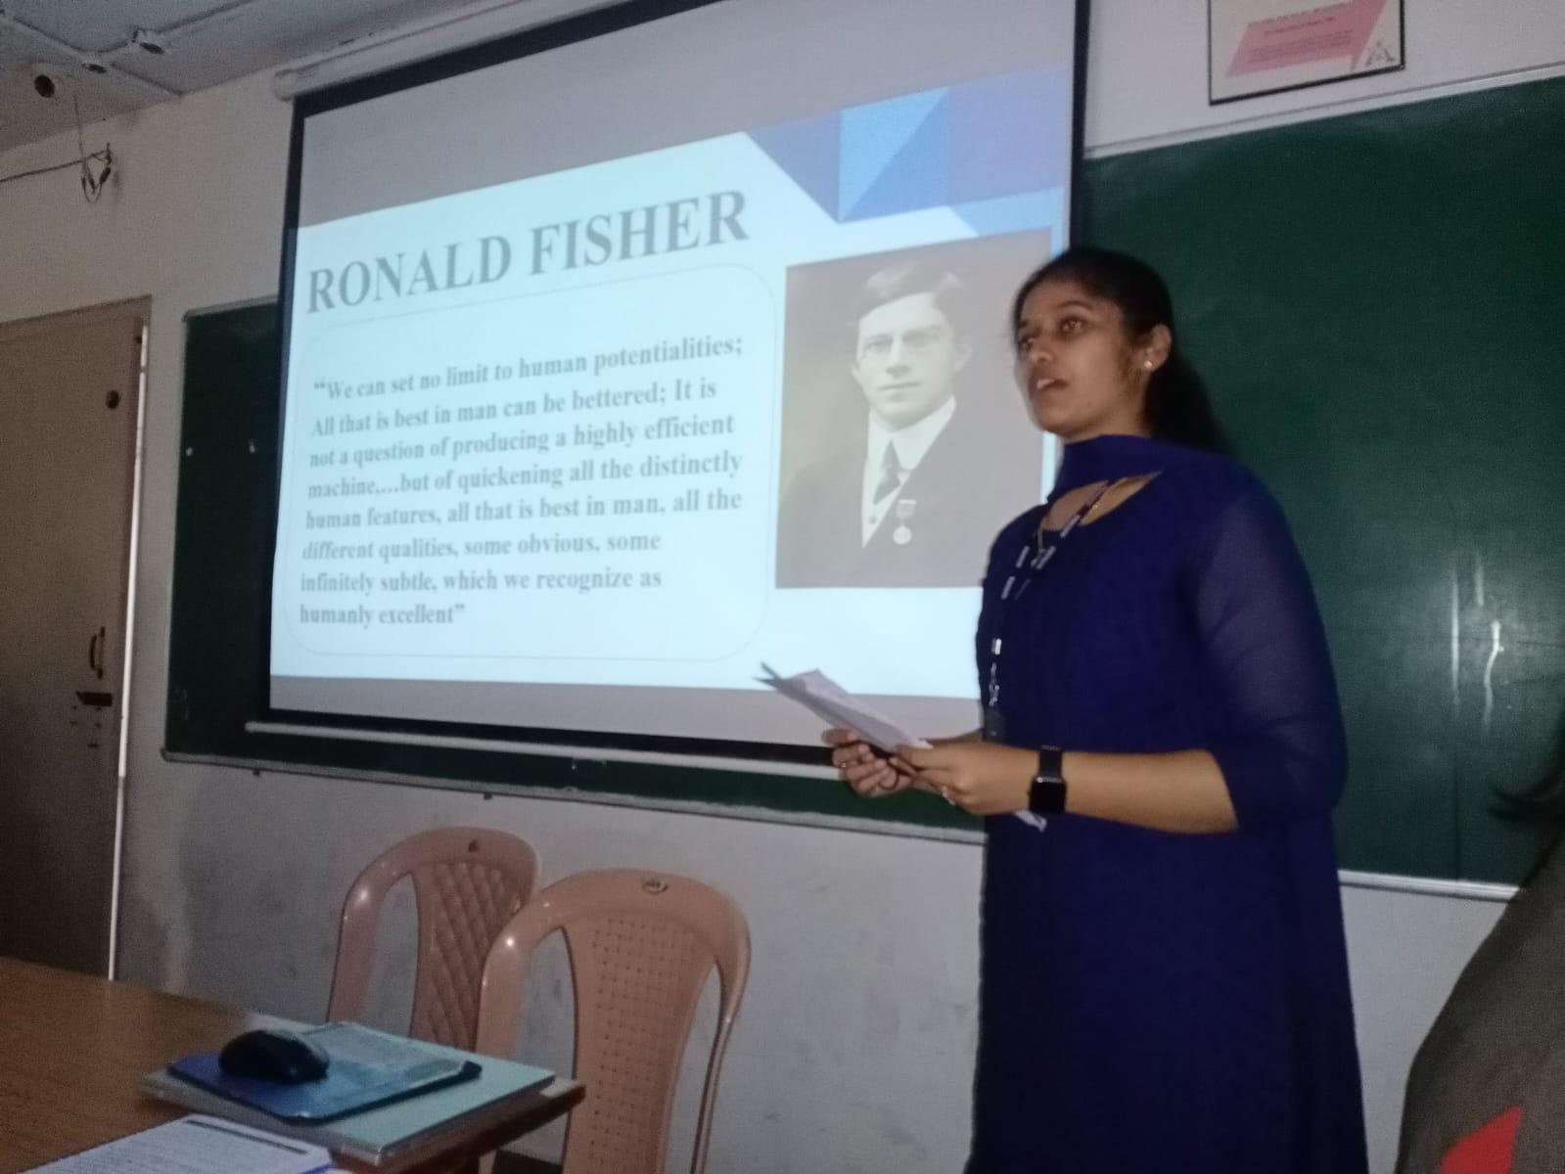

Mini project presentation by PG 2nd year (statistics and Applied statistics)

