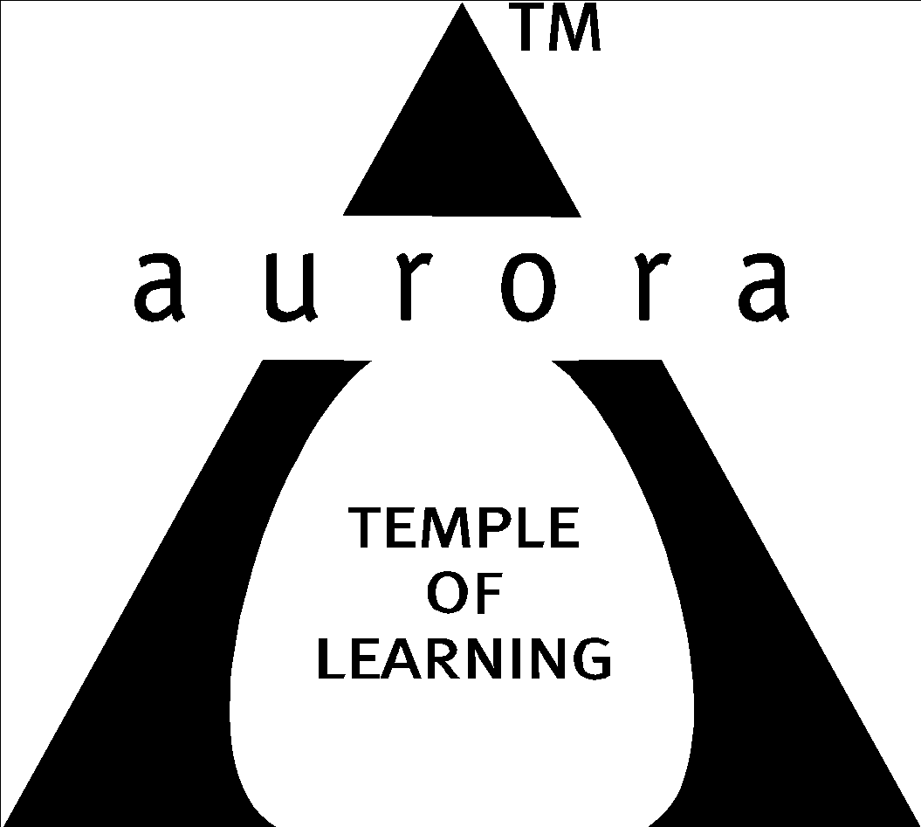

Aurora’s Degree & PG College
(ACCREDITED BY NAAC WITH 'B++' GRADE)
Chikkadpally, Hyderabad 500020

EVENT / ACTIVITY DETAILED REPORT

NAME OF THE EVENT / ACTIVITY | Prof.C.R. Rao 102nd Birthday Celebrations (LIVING LEGEND)
TYPE OR TITLE OF EVENT / ACTIVITY | Prof.C.R. Rao 102nd Birthday Celebrations (LIVING LEGEND)
FACULTY INCHARGE | Parimala Diana Sudhir. K (Convener) & D.Rajyalakshmi (Coordinator)
DEPARTMENT/CELL/COMMITTEE/CLUB | Statistics
DATE | 10-9-2022
VENUE | Seminar Hall-Aurora’s Degree and PG College
TARGET AUDIENCE | Degree & +2 students (Twin city level)

- PROGRAM SCHEDULE:
Day 1 - 8th September 2022:
- Introduction and Welcome Address - Anchors(students)
- Conveners Address
- Principal’s Address
- Hod’s Address
- Speakers Address
- Announcements related to Poster Presentation competition
- PPT on C.R.Rao’s contribution by Student
- Vote of thanks by convener
- Rendering Birthday song to Prof.C.R.Rao (Living Legend)102nd Birthday
- Closing Remark
- Poster Presentation competition
Day 2 - 10th September 2022
- Welcome address by convener
- Student presentation on C.R.Rao’s contribution
- Speakers Address
- Prize winner’s announcement by Hod
- Vote of thanks by convener

- LIST OF FACULTY COORDINATORS (DEPARTMENT): K. Parimala Diana Sudhir (Convener) & D. Rajyalakshmi (Coordinator)
- LIST OF THE STUDENT COORDINATORS (NAME, ROLL NO, CLASS & SECTION)
- Name: Pooja,
Roll No: 1051-20-578-
Class: MSCS3A
- Name: Ashrita,
Roll No: 1051-20-539-005
Class: MSDS 3
- Name: Siddi.R
Roll No: 1051-21-578- 080
Class: MSCS 2B
- Name: Sruthi .N
Roll No: 1051-21-539-012
Class: MSDS 2

- LIST OF THE PARTICIPANTS
Prof.C.R.Rao 's Birthday Celebration-Participants list (other institutions)
NAME | COLLEGE NAME | PHONE NUMBER | MAIL ID
G.Madhu Chandrika | Wesley Degree College | 9014464285
Ch.Satya Sailakshmi | Wesley Degree College | 8184825732 | sailaxmi376@1234
A. Anusha | Don Bosco Degree College | 6301806536
T.Supriya | Sri Sai College | 9666158846 | thonnerusupriyasupriya@gmail
K.Siddhu | Sri Sai College | 9705946496 | k.siddhu603@gmail.com
E.Arjun | Sri Sai College | 9657758822 | ajamma5847@gmail.com
S.Satish | Sri Sai College | 9014519880 | satishshabhada@gmail.com
N.Raviteja | Prathibha Degree College | 9052024102 | mamalaravi2004@gmail.com
K.Revanth Kumar | Prathibha Degree College | 9392543387 | kumarrevanth@gmail.com
Vikram Kumar | Prathibha Degree College | 7093041103 | urvikramthakur@gmail.com
Aditya | Sri Sai College | 8639544973 | adityadeshpande@gmail.com
D. Uday kiran | Sri Sai College | 6300425175 | udaykiran1452@gmail.com
M. Lokesh | Sri Sai College | 7075235723 | lokeshgoud7075@gmail.com
S. Ramesh | Sri Sai College | 6309429110 | ramsandeveni@gmail.com
G. Srikanth | Sri Sai College | 6302628523 | srikanthgoudguddierguddier@gmail.com
G.Prashanth | Sri Sai College | 9347922180 | prashanthreddy77252@gmail.com
M. Rajendar Reddy | Sri Sai College | 7287008267 | rajendarreddy7675@gmail.com
R.Balu | Sri Sai College | 7815942673 | baluramanth@gmail.com
J.Shiva | Sri Sai College | 8522914420 | shivajampala43@gmail.com
J. Yeshwanth | Sri Sai College | 9553279875 | yashwanthjuvvi@gmail.com
K.Divya | Sri Sai College | 9392500271 | kdivya@gmail.com
B.Praneesha | Sri Sai College | 7095147359 | bodigeammulu@gmail.com
B.Archana | Sri Sai College | 9346637236 | bangadarchana2003@gmail.com
R.Anusha | Sri Sai College | 7842003112 | anugoud311@gmail.com
M.Komala | Sri Sai College | 8008935133 | komalamaramoni@gmail.com
A.Anusha | Sri Sai College | 7416402640 | anushaandoju103@gmail.com
K.Srujana | Sri Sai College | 8919337541 | ksrujana1@gmail.com
G.Saikumar | Raghava Laxmi Devi College | 8790103010 | gsai6098@gmail.com
T.Sai kumar | Raghava Laxmi Devi College | 7386131991 | tonksaikumar@gmail.com
T.Bhuvaneshwari | Raghava Laxmi Devi College | 9182039982 | bhuvaneshwatitungana@gmail.com
K.Rajesh | Raghava Laxmi Devi College | 8179390423 | kallapallirajesh123@gmail.com
K.V.V.Swami | Raghava Laxmi Devi College | 9069862374 | swamykoppisetti09@gmail.com
N.Sharon | Raghava Laxmi Devi College | 7036041450 | chinnachanti50@gmail.com
T.Sai Teja | Raghava Laxmi Devi College | 9398573976 | pavanitunjaa@gmail.com
S.Harshavardhan | Raghava Laxmi Devi College | 9346340753 | surendar
B.Greeshma | Sri Sai College | 8978848929 | greeshmab944@gmail.com
B.Tejaswi | Sri Sai College | 9618679507 | guptatejaswi@gmail.com
J.Sravani | Jagruthi Degree College | 9059169145 | jatangisravani947@gmail.com
B.Anjali | Saguti Degree College | 6305525428 | anjali2B1@gmail.com
Pooja Swamy | Sri Sai Vignan Bharathi | 7093588502 | poojaswamy2003@gmail.com
K.Kundanika | St. Francis Women’s College | 8523053693 | rundanikaatshiva@gmail.com
Hemalatha | Sri Sai Vignan Bharathi | 9618244695 | mrao356@gmail.com
Noushin | Wesley Degree College | 8247321481
Sameera | Wesley Degree College | 9121491017
Kalyani | Wesley Degree College | 9347391980 | soududinnekalyani@gmail.com
Alekya | Don Bosco Degree College | 9398363869 | pujarialekya2105@gmail.com

And all MSCS & MSDS 2nd & 3rd year students participated in the event -total 250.

- PARAGRAPH ABOUT THE PROCEEDINGS (TILL THE END OF THE EVENT):
The event was celebrated on the 8th and 10th of September 2022. The MSCS & MSDS 2nd & 3rd-year students advertised the competition for poster presentations on the topics of "Role of Statistics in Artificial Intelligence" and "Role of Statistics in Building Nation" to 103 institutions in the twin cities before the event.
Day-1: 8th September 2022
Speakers: 1) Dr. Yugandhar, Chief Executive, C.R.Rao’s, AIMSCS
2) Dr. Pradeepthi, Assistant Professor, C.R.Rao’s, AIMSCS
Ms. Chetana from MSDS3 and Ms. from MSCS3A serve as the program's anchors. The program began with an introduction to the event and a welcome to the guests, after which the lamp was lighted. The MSCS 2B student Mr. Goutham performed the prayer song. The program's convener, Mrs. Parimala Diana Sudhir, gave a brief history of Prof. C.R. Rao's life and career. Dr. Yugandhar, who was the first speaker, discussed the advantages of higher education, how to prepare for it, and how the C.R. Rao Institute operates. Dr. Pradeepthi was the second speaker and she discussed on “Understanding Big Data- In Today's Context” and its applications. After giving a PPT presentation on the departmental activities, Mr. Ajay from MSCS3A introduced Ms. Upasana, an MSCs 2B participant in the Guinness Book of World Records for Sketching & Coloring, who displayed her paintings and sketches of Prof. C. R. Rao for the audience. Welcoming the internal judges to the audience. Followed by a vote of thanks by the Convener Mrs. K.Parimala Sudhir, the program closed with the rendering of the Birthday Song for Prof.C.R.Rao and the National Anthem.
The competition for poster presentations was held at the end of the session. Twenty colleges had taken part. Dr. Meera Joshi, a professor in the mathematics department, and Ms. Rajini, the head of computer science, were the competition's internal judges, and the speakers served as the competition's external judges to evaluate the participants.
DAY-2: 10th September 2022
The program started with the introduction given by the convener, followed by
Ms. Ashruthi's presentation on the life and achievements of Prof. C. R. Rao. Our guest speaker, Dr.Hina Gokhale has given thought-provoking examples of history and anecdotes of Statistics. Ms. Vinita Head, Department of Statistics announced the prize winners of the poster presentation competition and concluded with vote of thanks.
Junior Level:
1st prize: Bhargav Kiran -Kendriya Vidyalaya, AFS, Begumpet (Cash award of Rs500/-)
Degree Level:
1st Prize: Kundanika - St. Francis Degree & PG College for Women (Cash award of Rs500/-)
2nd Prize: Gayatri - Keshav Memorial Institute of Technology (Cash award of Rs200/-)
Ms.Rajyalakshmi coordinated completely campaigning of the event with the help of students to 102 colleges in Hyderabad. And all other department faculty coordinated & supported in successfully organizing the event.
- INCOME AND EXPENDITURE: Rs. 4180/- ( funded by college)
a)Guests honorarium (2) - Rs. 2500
b)Students cash award(1st& 2nd prizes) - Rs.1200
c) Stationery+Gift rapper for C.R.Rao photo - Rs.150
d) Bouquets - Rs.250
e) Refreshments - Rs.80
--------------
Total - Rs.4180

- EVENT PHOTOS (MIN 2 MAX 4):
Upasana of MSCS 2B, a Guinness Book of World Records participant, drew a pencil sketch of Prof. C. R. Rao's image.
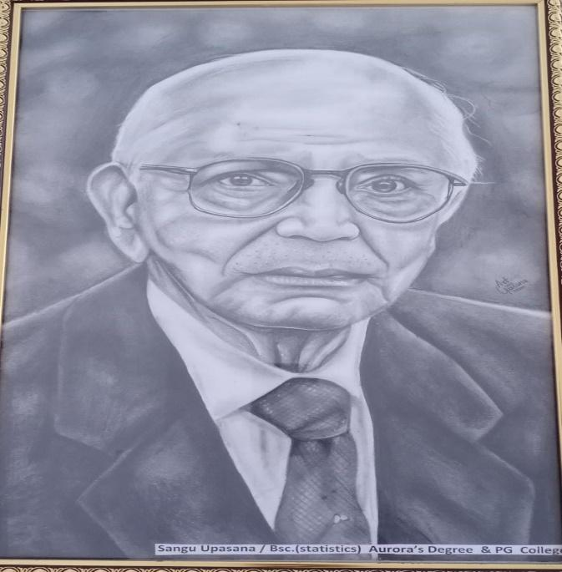

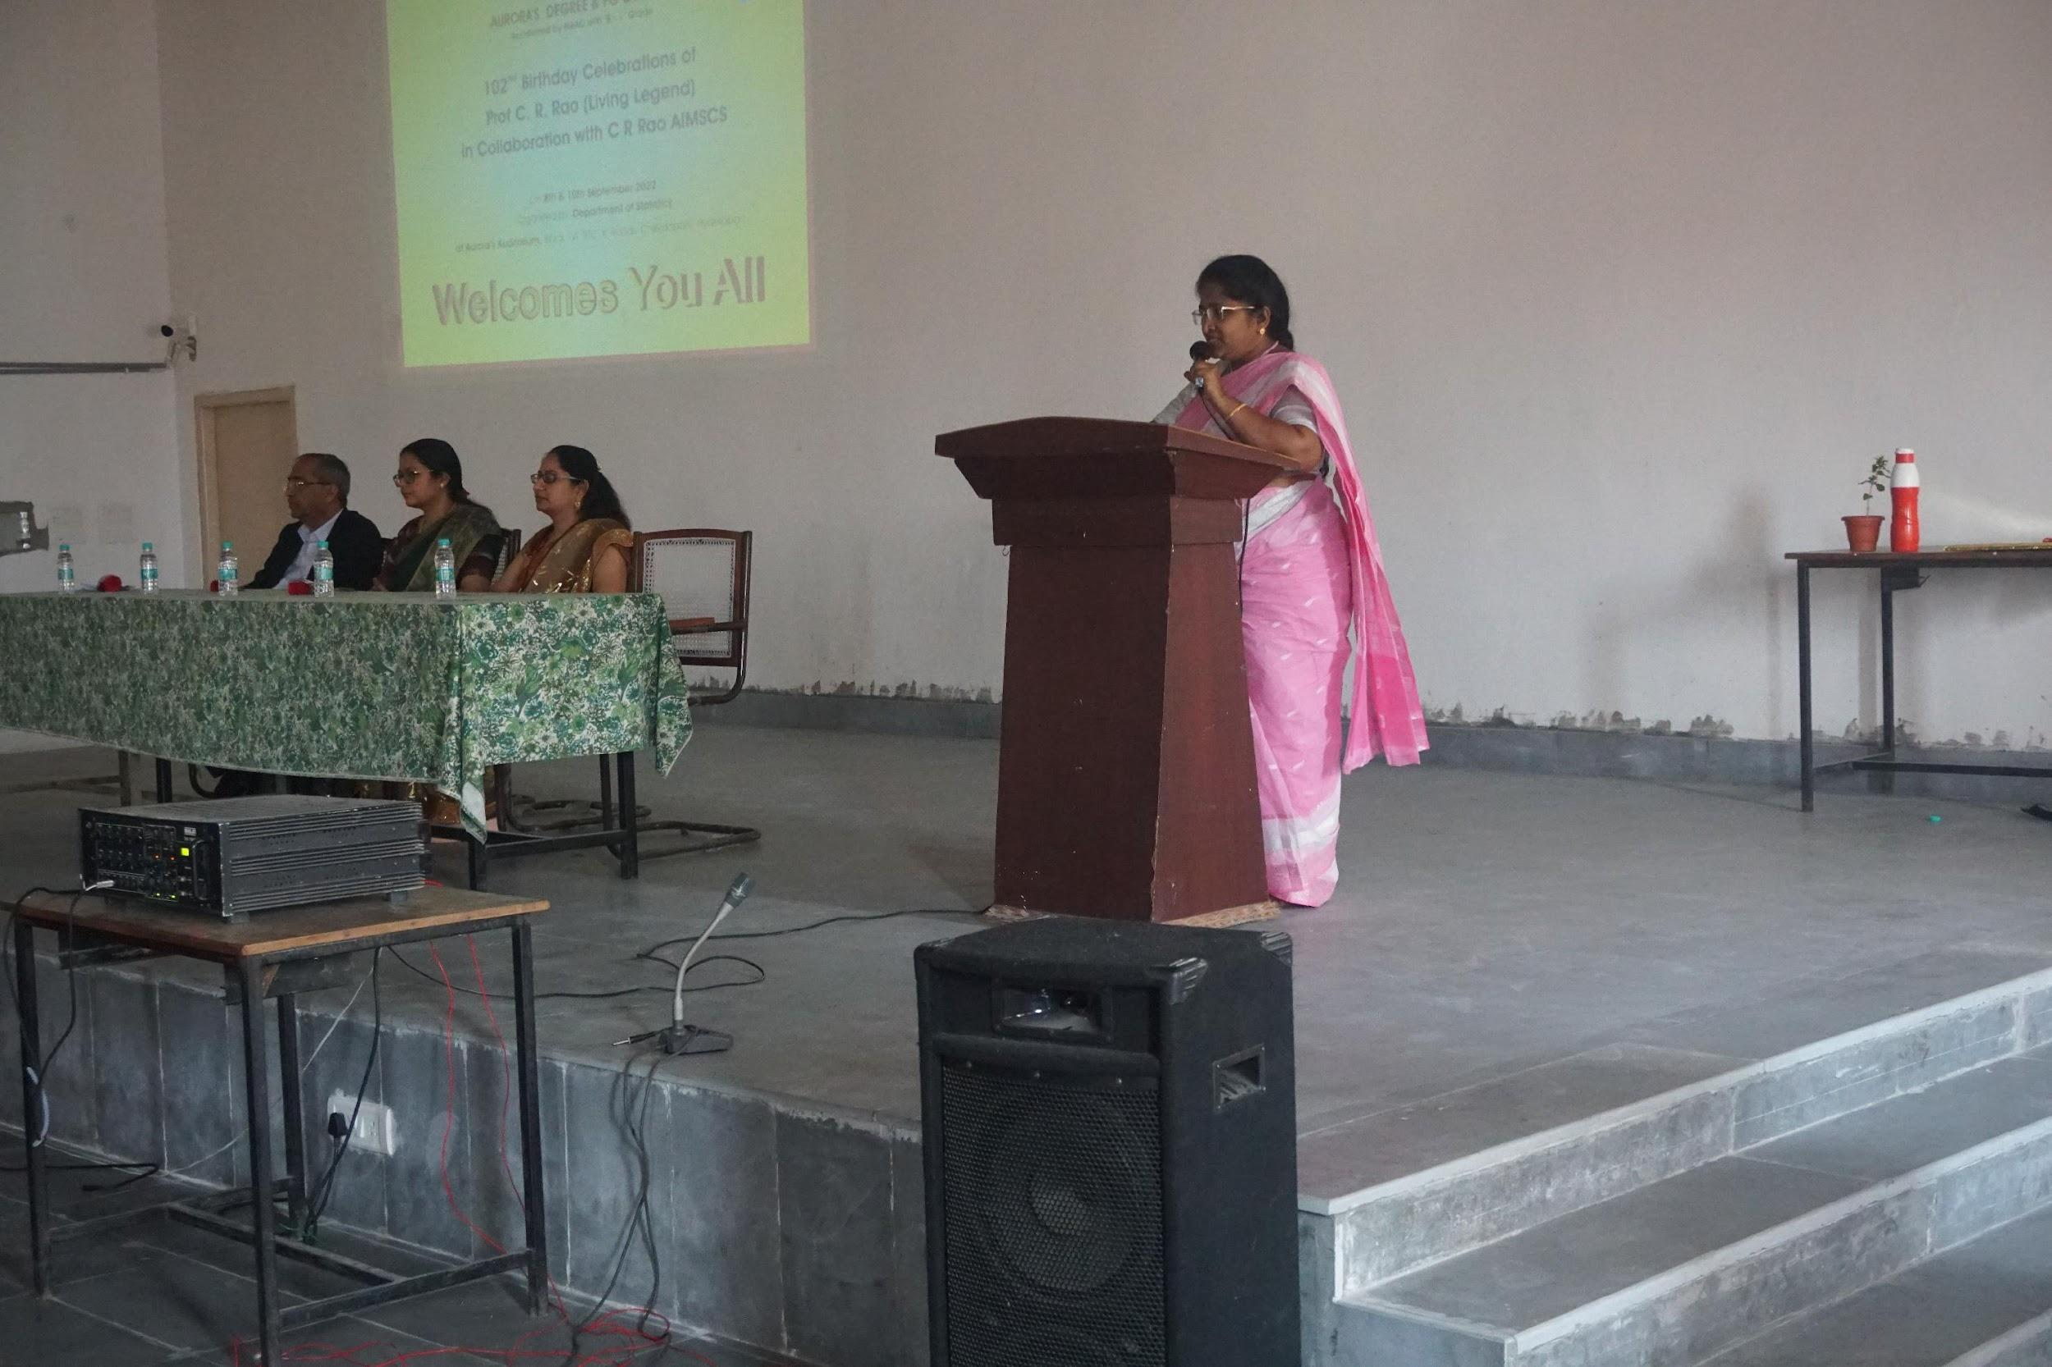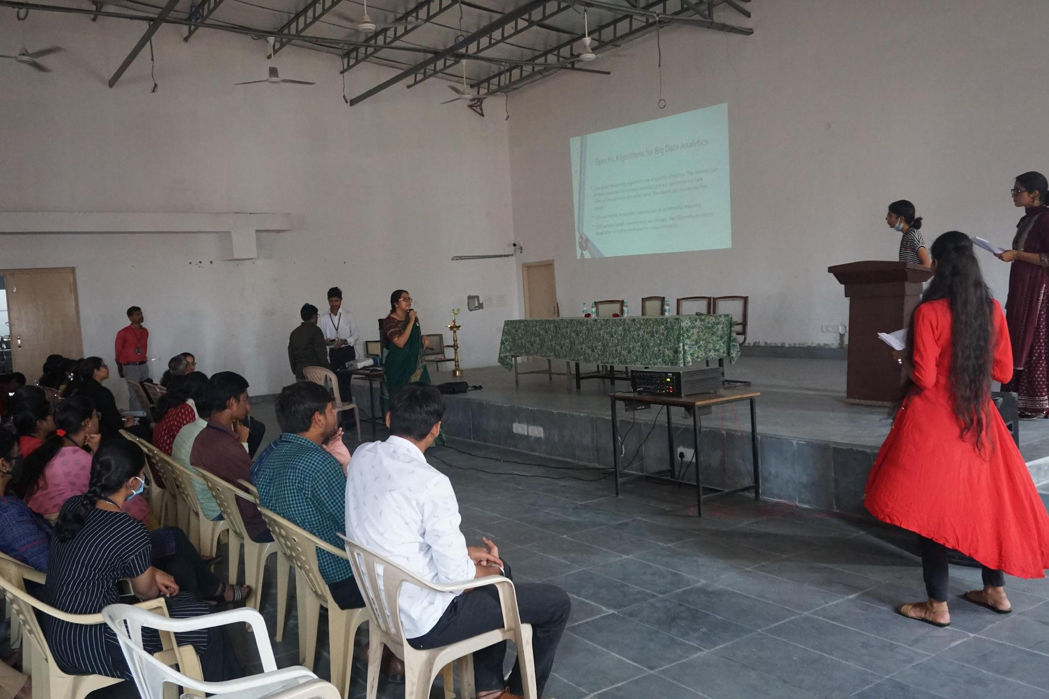

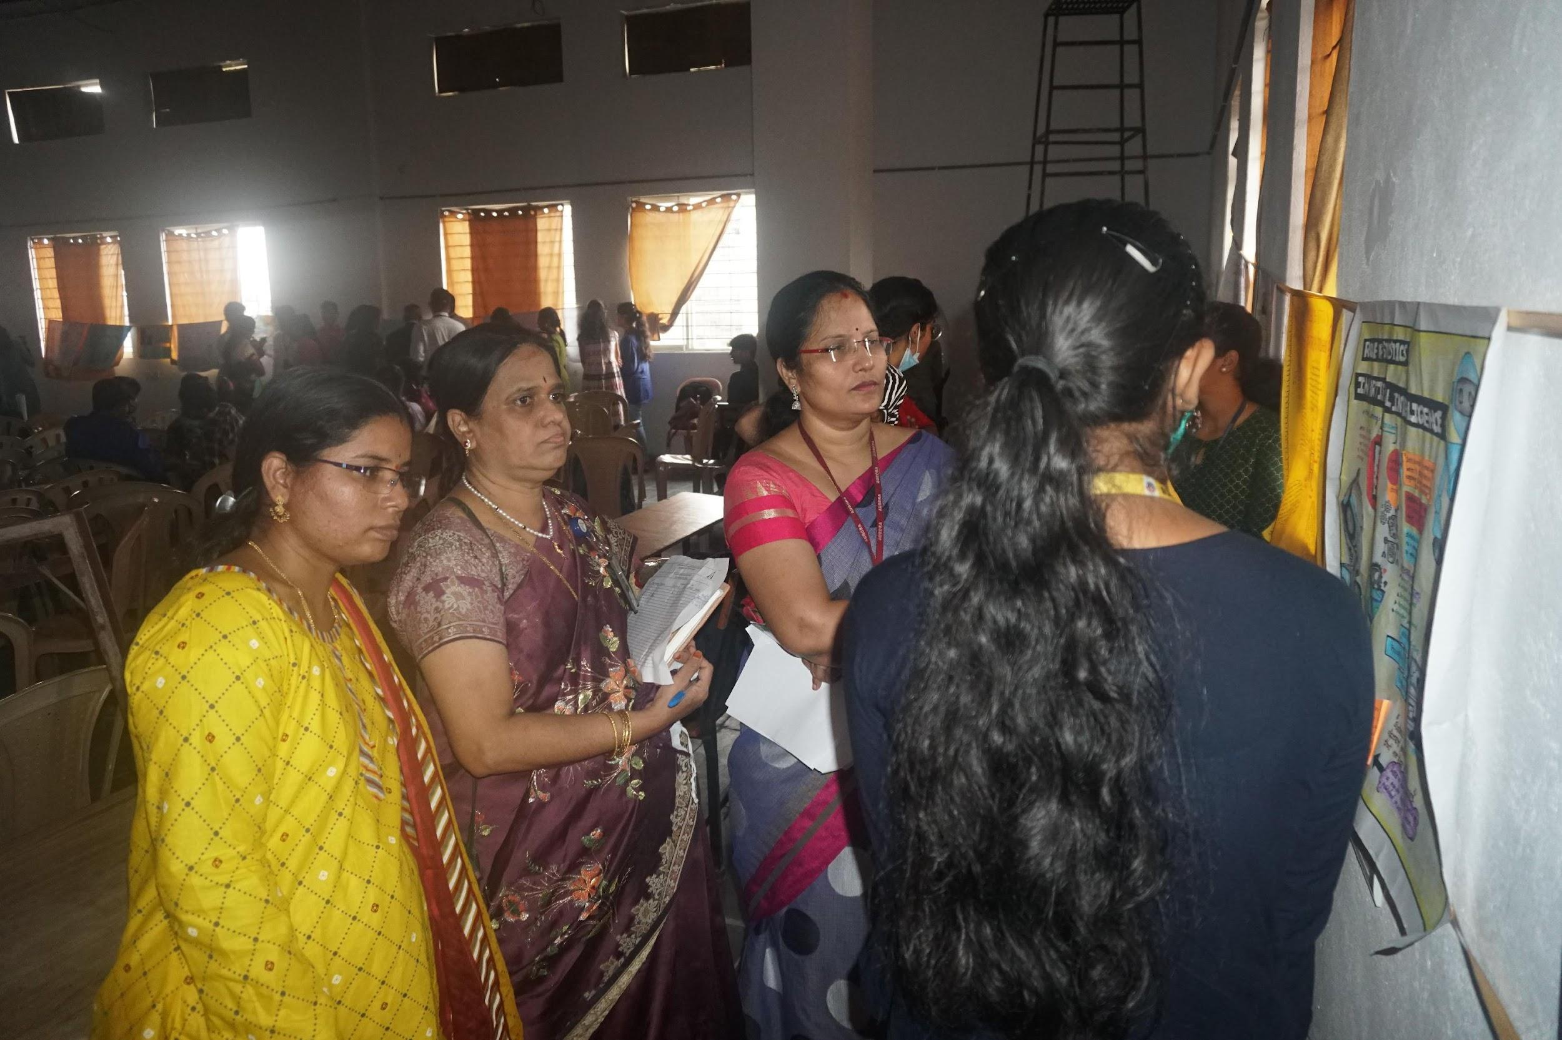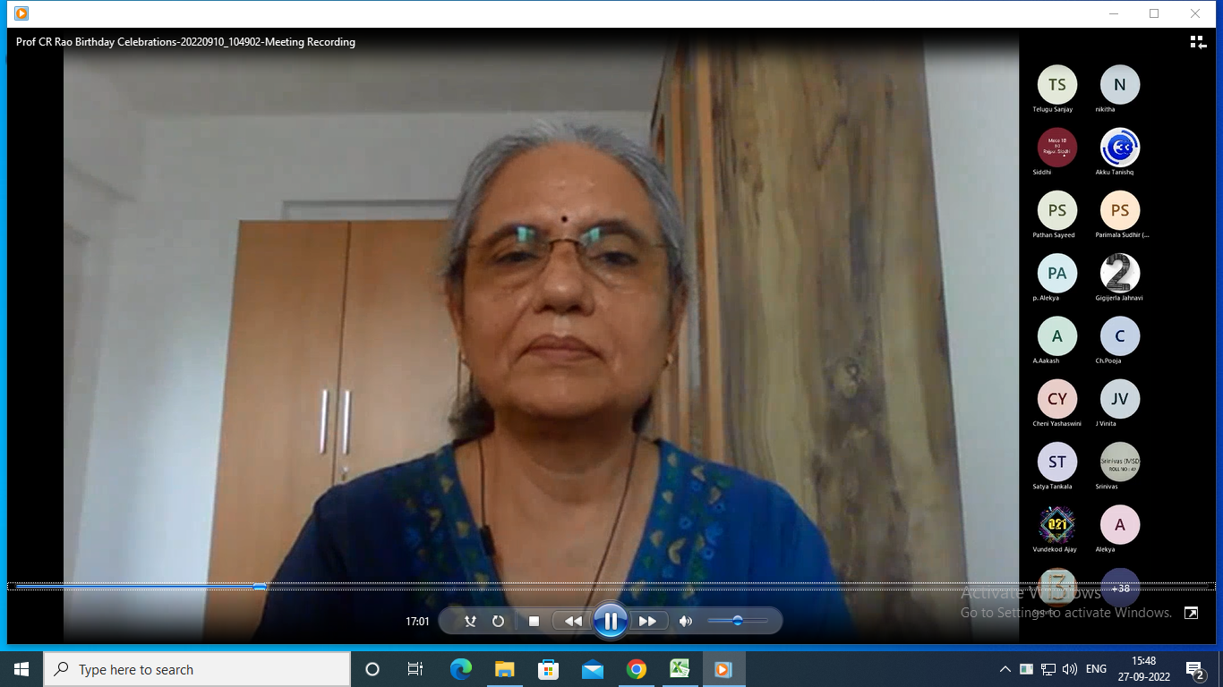

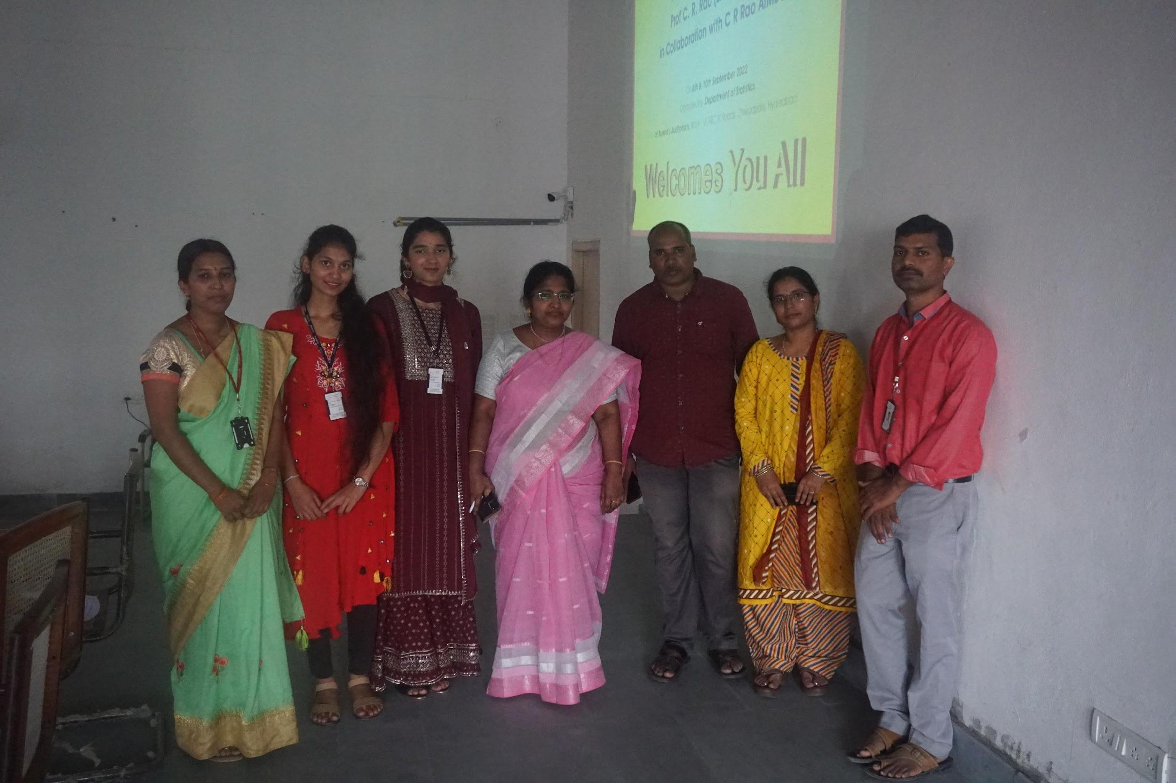

- GUEST PROFILE (IF ANY):
Dr.Yugandhar:
Qualification : Ph.D in Chemstry from Osmania University, Hyderabad in the year 1997.
Present Designation : Chief Executive (BD) (Jan. 2020 to till date)
C R Rao Advanced Institute of Mathematics, Statistics
and Computer Science (AIMSCS), University of
Hyderabad, Gachibowli, Hyderabad-500046.
Past Experience at AIMSCS : Director (Management Services) (Jan 2015 to Jan 2020)
C R Rao Advanced Institute of Mathematics, Statisticsand Computer Science (AIMSCS), University of Hyderabad, Gachibowli, Hyderabad-500046.
Role in the C R Rao Advanced Institute of Mathematics Statistics and Computer Science
(AIMSCS):
• Co founder and member of Governing Board of AIMSCS (2005 to till date )
• Member of Governing Council of AIMSCS ( 2005 to 2019)
• Member Secretary, Governing Board (Society) (2015-2019)
• Member of committee to identify talent and recruitment of professionals for CR Rao
Advanced Institute of Mathematics, Statistics and Computer Science (AIMSCS),
which was started to promote research in the areas Mathematics, Statistics and
Computer Science in the year 2005. AIMSCS is involved in the crucial areas of
research viz., Cryptography and Cyber Security.
• Coordinated with scientists of AIMSCS in executing projects of National
importance for strategic GoI agencies.
• Coordinating with various important and sensitive GoI agencies including PMO for
funding and collaboration.
• Coordinating with other institutes / Universities like IITs, IISER ,IIIT,
Hyderabad/University of Hyderabad for collaboration.
• Negotiated with Police University, Rajasthan and entered MoU with them for collaboration and deputed their students for research work and offered placements for some of them.
Published/Presented Research Papers in National / International Journals /conferences/
Patents/ Copyrights:

Pradeepthi KV:

Dr. Pradeepthi is currently working as Assistant Professor in C R Rao Advanced Institute of Mathematics, Statistics and Computer Science. Her research interests are in the areas of Cyber Security, Machine Learning and Computer Networks. She obtained Ph.D under UGC-BSR funding from College of Engineering, Guindy, Anna University. She has worked in Infosys Technologies prior to this. She has delivered guest lectures for the Ministry of Statistics-Indian Statistical Officers, State Bank of India Officers , and many other organizations. She also teaches Security and Machine Learning related subjects to Postgraduate students and University of Hyderabad.

Dr.HINA GOKHALE:

PhD, Adjunct Professor, IIT Bombay
Former Director General (HR), DRDO HQ

Education:
B.Sc. (Mathematics) from Gujarat University in 1979
M.S. (Multivariate Analysis) from University of Pittsburgh, USA in 1982
(Thesis: On Some methods of Discriminant Analysis)
Ph.D. (Applied Statistics) from University of Pittsburgh, USA in 1985
(Thesis: Some Contributions to Analysis of Familial Data)

Certification:
CIPM: IPMA Certificate in Project Management
CrHCM: Certificate in Human Capital Management
CrPRM: IPMA Certificate in Project Risk Management

International Diploma in Project Management (PMA, India)

Experience:
• Independent Director, Paras Defence and Space Technologies Pvt. Ltd.
(Since April 2020)
Teaching and Industrial Consultancy
• Since July 2019 working as Adjunct Professor at Department of Metallurgical
Engineering and Materials Science (MEMS) at IIT Bombay, Mumbai.
o Undergraduate Core course on “Data Analysis and Interpretation”
o Postgraduate Elective on “Statistics and Probability for Metallurgy”
o Co-supervising MTech Thesis
o Guiding UG and PG Seminar courses
o Industrial Consultancy on Data Analytics with several Steel Industiries
Administration and HRM
• July 2017 to September 2018 served as Director General HR

• March 2018 to September 2018 served as Vice Chancellor Defence Institute of
Advanced Technology (additional Charge)
• June 2015 to June 2017 served as Director of Personnel
• April 2013 to December 2015 served as Director Human Resource Development at
DRDO HQ.
Project Management, Technical Coordination and HRM
• Defence Metallurgical Research Laboratory (February 1988 – March 2013
o Designed Project Monitoring System to suit DMRL projects
o Designed and developed relevant software to implement the same
o The DMRL experiment in project management has been published in the
International Journal of Project Management and other conferences of
International Project Management Association.

• November 1993 took over responsibility as Technical Coordinator, covering
o Project Management
o HR Management
o Intellectual Property Rights
o International Export Control Regimes
• During this period, initiated work on statistical applications in Materials Engineering
o Design experiment and Analysis for metallurgical processes
o Statistical analysis and derivations for design allowable for indigenously
developed alloys and components for defence applications
o Statistical designs for round robin tests to arrive at chemical standards for
indigenous alloys
o Application of heuristic methods to statistically analyze the data and provide
optimal solution to materials engineering processes

• June 2007 initiated work in the area of Uncertainty Modeling in metallurgy and
materials engineering.
o Demonstrated the Uncertainty modeling and its application to Life
Prediction on Gun Barrel Steels. This included
▪ Statistical profiling of fracture toughness, strength and other
properties of Gun Barrel Steels
▪ Statistical estimation of remaining fatigue life of gun barrel steels
within metallurgical theories on fatigue life.

o Initiated a programme of data generation and estimation of Probability of
Detection (POD) of various NDT techniques used in Life Prediction
Technologies for Aero Engine Components.

Teaching Assistant and Teaching Fellow at University of Pittsburgh
USA and CSIR Pool Officer
• Worked as Teaching Fellow for 5 years which included class room teaching of
Algebra, Trigonometry, Calculus, Analytical Geometry, Linear Algebra and
Differential Equations.
• Worked as Teaching Assistant for 1 year covering tutorials for course on Biostatistics
• Worked for about 2 years as CSIR Pool Officer at Hyderabad Central University.
Taught courses on Mathematical Statistics, Quality Control and Design of
Experiments

Publications
• More than 30 publications in Project Management and Statistics in various
International Journals, Conferences and Technical Reports.
• Several Articles in Gujarati for the Journal “Suganitam”
• English to Gujarati Translation of the book “Diary of Ann Frank” for Gujarati
Literary Journal “Kumar”

- FEED BACK IF ANY:
Student’s well received with speakers note and the information on the achievement’s and prospects for statistics subject.

- ATTACHMENTS:
EVENT/ACTIVITY PROPOSAL
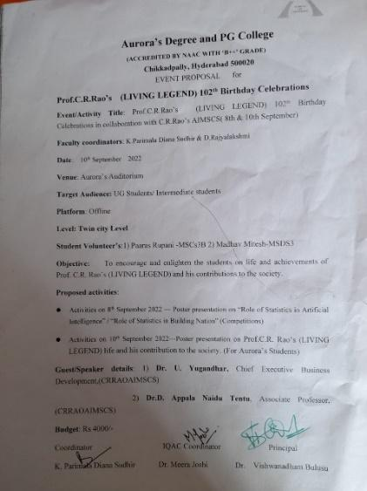

EVENT / ACTIVITY NOTICE
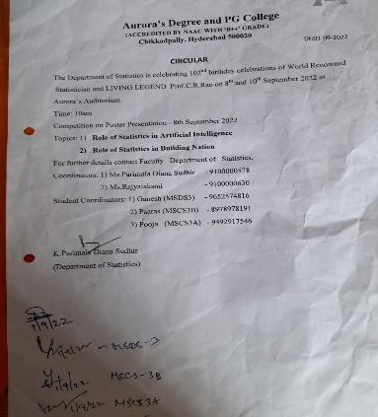
RECEIPTS (IF ANY):
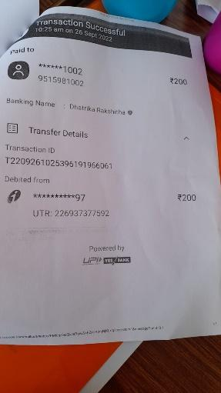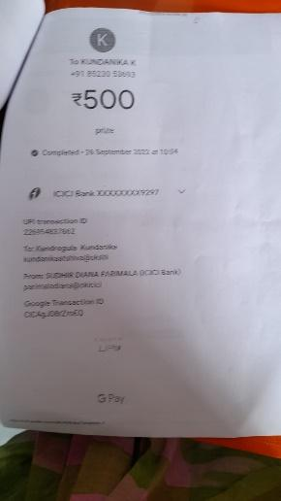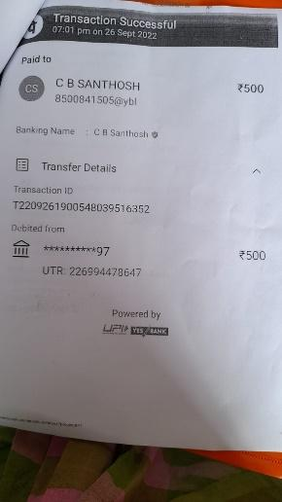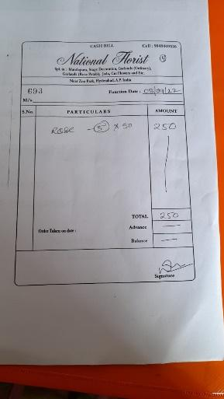

CERTIFICATES (IF ANY): 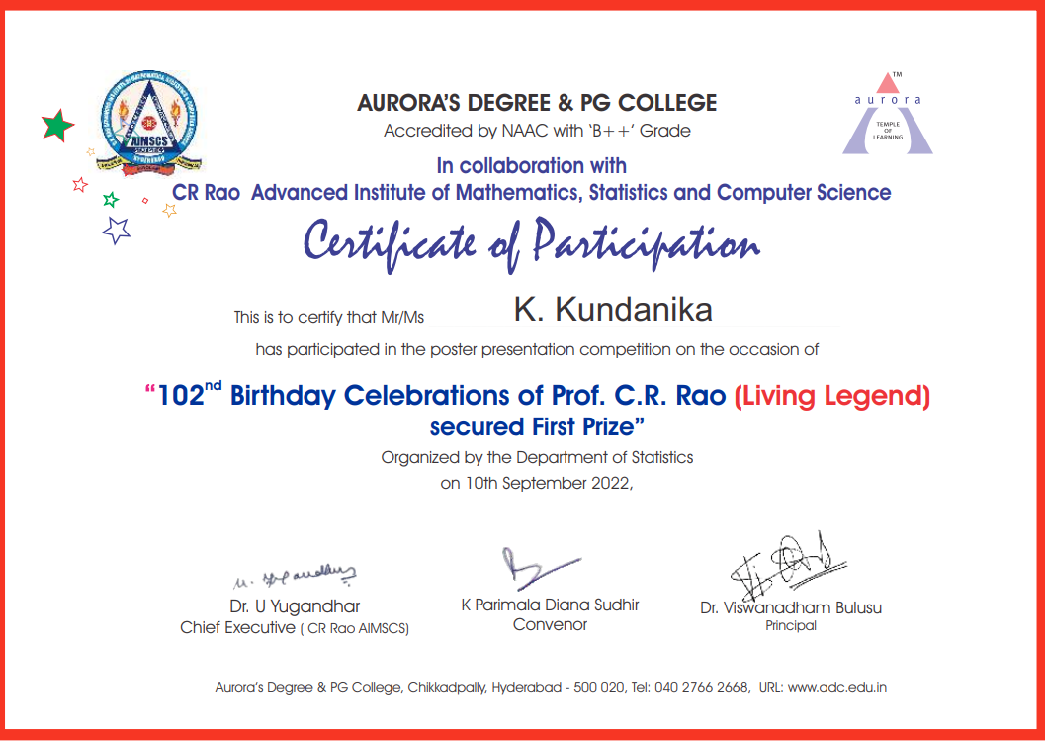
LETTERS OF COMMUNICATION (IF ANY):

Parimala Sudhir <parimalasudheer@adc.edu.in>

Invitation for C.R.Rao's Birthday celebrations

Parimala Sudhir <parimalasudheer@adc.edu.in> | Tue, Sep 6, 2022 at 10:39 AM
To: hinagokhale@yahoo.co.on
Good Morning Mam,
Thank you for accepting our invitation . We request you to address our students on any application and your experiences with Prof.C.R.Rao mam.
The program starts at 11am.We will send the link of Microsoft teams. Request to send the latest profile.
Also we are conducting a conference in offline/online mode related to "Sciences & Technology" . We request you to be on the advisory board and the panel member.Kindly give your consent.

Request to give any suggestion regarding the event.
Thank you,

Regards,
Parimala Diana Sudhir.K
Associate Professor, Department of Statistics
Aurora's Degree & PG College

