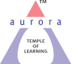
Aurora’s Degree & PG College
(ACCREDITED BY NAAC WITH 'B++' GRADE)
Chikkadpally, Hyderabad 500020

EVENT / ACTIVITY DETAILED REPORT

NAME OF THE EVENT / ACTIVITY | HENRI FAYOL’S BIRTHDAY  CELEBRATION
TYPE OR TITLE OF EVENT / ACTIVITY | Class
FACULTY INCHARGE | Anil Kumar Javvaji
DEPARTMENT/CELL/COMMITTEE/CLUB | Commerce
DATE | 29-07-2022
VENUE | Andhra Vidyalaya High School
TARGET AUDIENCE | 9th & 10th Class Students of Andhra Vidyalaya High School

- PROGRAM SCHEDULE:

DATE | TIME
24/07/2022 | 10.00 AM to 11.30 AM

The event was celebrated to celebrate the life and achievements of Henry Fayol. Students and faculty enthusiastically participated in the event. Four student volunteers from B. Com (Honors) presented charts which outlined life to Fayol. The student volunteers presented in great detail all his contributions towards the field of Management. The faculty members of Commerce and Management streams were also present at the event and were greatly impressed with the fluence of the volunteers. The students who were present at the event also were keen to learn about Fayol and also asked for further information as well as information related to time management and life skills.

2.FACULTY COORDINATOR: ANIL KUMAR JAVVAJI
3. LIST OF THE PARTICIPANTS:
ROLL NO. | STUDENT NAME | CLASS
001 | D. Swathi | 9th
002 | D. Nagesh | 9th
003 | Ch. Swathi | 9th
004 | K. Swathi | 9th
005 | M. Mahalakshmi | 9th
006 | S. Sanjana | 9th
007 | G. Teja | 9th
008 | P. Pavani | 9th
009 | M. Ramya | 9th
010 | Ch. Mounika | 9th
011 | N. Rekha | 9th
012 | Harsha | 9th
013 | T. Ravi Vignesh | 9th
014 | A. Ajay | 9th
015 | Rajesh | 9th

ROLL NO. | STUDENT NAME | CLASS
001 | B Trivedi | 10th
002 | B Ganga ram | 10th
003 | K.C.P. Chandu | 10th
004 | Veera Venkat | 10th
005 | Prithvi Raj | 10th
006 | K. Anusha | 10th
007 | C. Govind | 10th
008 | Kavala Chandana | 10th
009 | Sandhya | 10th
010 | Bola Naga Teja | 10th
011 | Pavani | 10th
012 | I. Manisha | 10th
013 | Karan Raj | 10th
014 | Naveen Kumar | 10th
015 | Sandhya Choudhary | 10th

Total Number of Girls: 16
Total Number of Boys: 14
4. PARAGRAPH ABOUT THE PROCEEDINGS
The event began with Ms. Saranya giving the audience an introduction about the great Henry Fayol. The presentation was shared among three students Farhaan, Kavya Shree & Chavis Shah. They explained in great detail the life and achievements of Mr. Henry Fayol. They spoke about contributions to Management, his education, his life and achievements. They also spoke about tips for time management and life skills. The students presented this to the students of 9th and 10th class and faculty members. The students were able to learn about the time management techniques which are being applied in day-to-day life with or without their knowledge.
The event was successful in giving the students an insight into the life and achievements of Henry Fayol and how to manage time and use life skills.

5.INCOME AND EXPENDITURE: Nil
6.EVENT PHOTOS

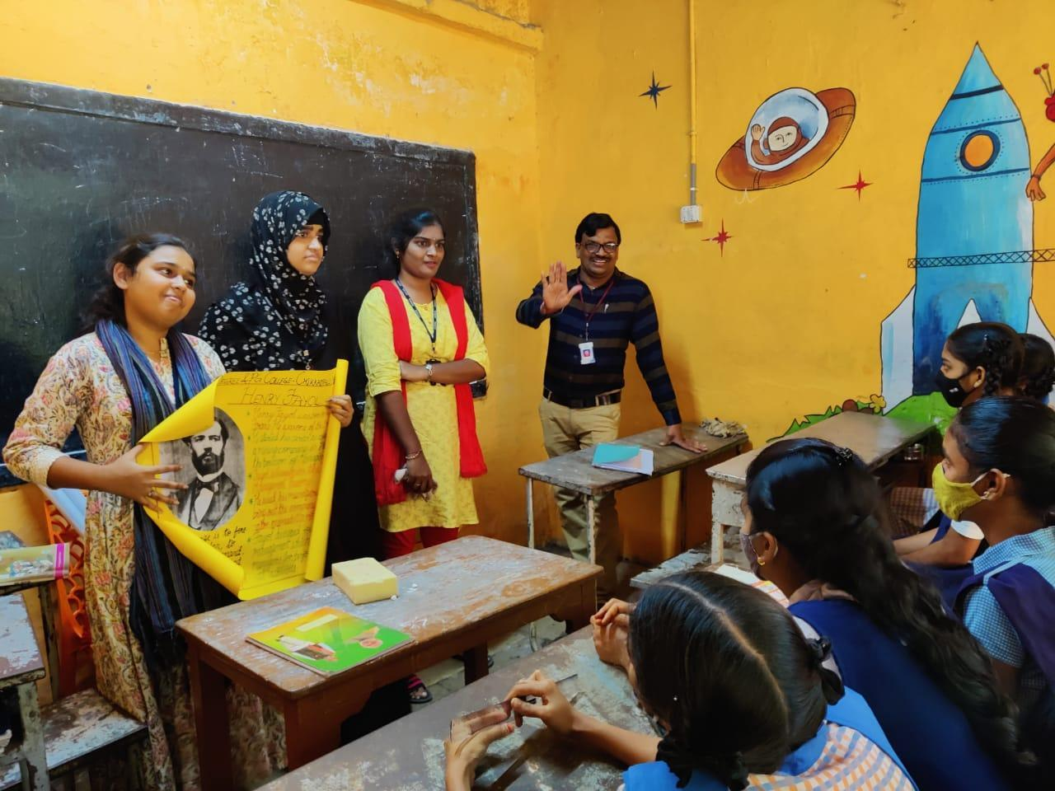
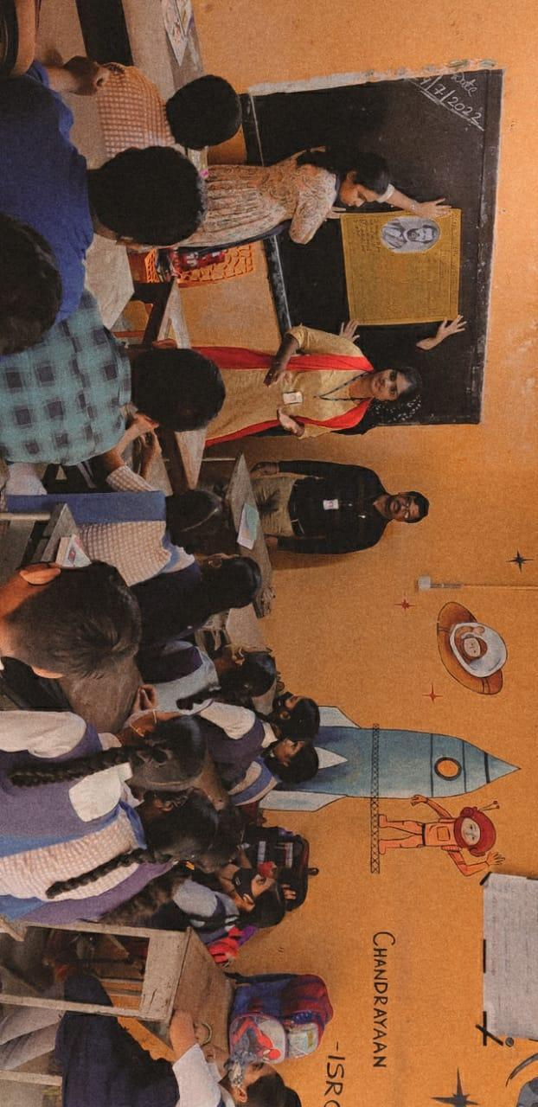

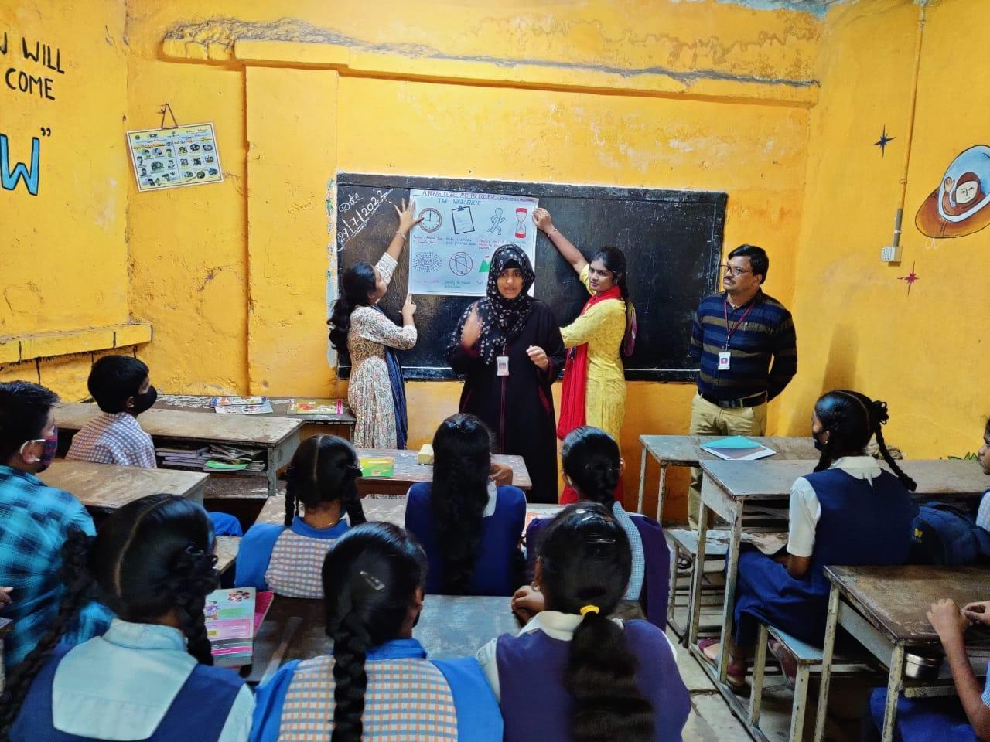
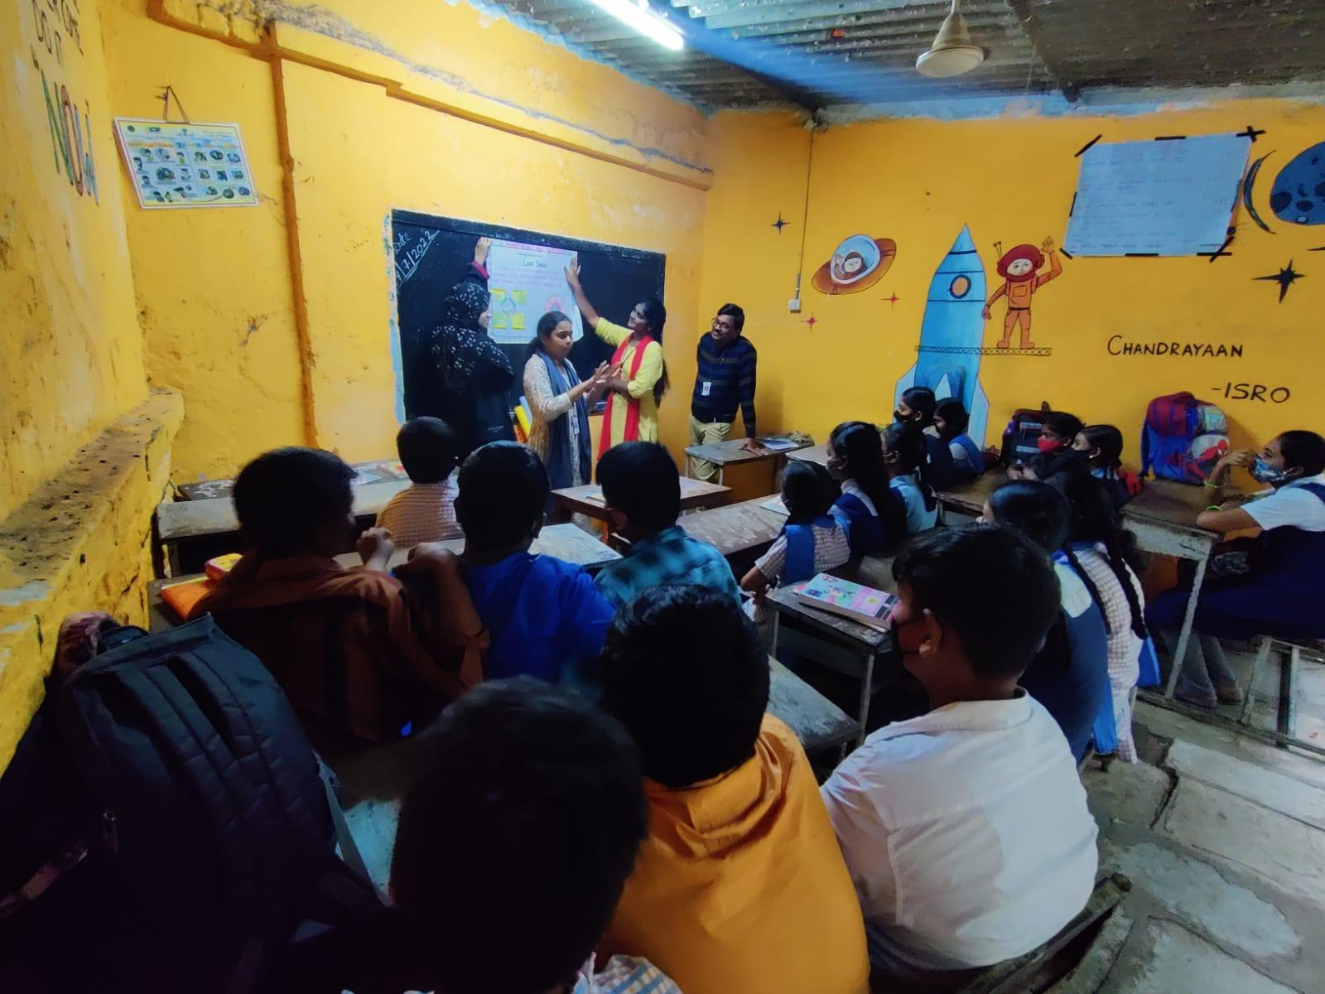
7.FEED BACK
ROLL NO. | STUDENT NAME | CLASS | Feed back
001 | D. Swathi | 9th | Excellent
002 | D. Nagesh | 9th | Nice
003 | Ch. Swathi | 9th | Very Good
004 | K. Swathi | 9th | Excellent
005 | M. Mahalakshmi | 9th | Good
006 | S. Sanjana | 9th | Very Good
007 | G. Teja | 9th | Excellent
008 | P. Pavani | 9th | Good
009 | M. Ramya | 9th | Never Mind
010 | Ch. Mounika | 9th | Nice
011 | N. Rekha | 9th | Never Mind
012 | Harsha | 9th | Not Bad
013 | T. Ravi Vignesh | 9th | Nice
014 | A. Ajay | 9th | Not Bad
015 | Rajesh | 9th | Excellent

ROLL NO. | STUDENT NAME | CLASS | Feed back
001 | B Trivedi | 10th | Excellent
002 | B Ganga ram | 10th | Not Bad
003 | K.C.P. Chandu | 10th | Very Good
004 | Veera Venkat | 10th | Not Bad
005 | Prithvi Raj | 10th | Never Mind
006 | K. Anusha | 10th | Nice
007 | C. Govind | 10th | Not Bad
008 | Kavala Chandana | 10th | Very Good
009 | Sandhya | 10th | Excellent
010 | Bola Naga Teja | 10th | Not Bad
011 | Pavani | 10th | Never Mind
012 | I. Manisha | 10th | Not Bad
013 | Karan Raj | 10th | Nice
014 | Naveen Kumar | 10th | Good
015 | Sandhya Choudhary | 10th | Very Good

8.ATTACHMENTS:
EVENT ACTIVITY PROPOSAL: Attached

