Aurora’s Degree & PG College
(Accredited by NAAC with 'B++' grade)
Chikkadpally, Hyderabad- 500020

DEPARTMENT OF MICROBIOLOGY

WORLD ANTIMICROBIAL AWARENESS WEEK
NAME OF THE EVENT | Departmental Event
EVENT TITLE | College Event
TYPE OF EVENT | World Antimicrobial Awareness Week (WAAW)Celebrations
FACULTY INCHARGE | Mrs. K.Mary Manjusha
DEPARTMENT | Microbiology
DATE | 18TH – 24TH November 2022
VENUE | Main Block,Room No:306
TARGET AUDIENCE | PG and UG Students and Faculty

PROGRAM SCHEDULE
Date of the event: 18th – 24th November 2022
Time of the event: 12:00 pm to 01.00 pm
Event type: College Event
Venue: Aurora’s Degree & PG College
FACULTY COORDINATOR
S.No | Name of the faculty | Department
1 | K. Mary Manjusha | Microbiology

S.No | Name of the Faculty | Dept | College
1 | Mrs.Padma Madham | Microbiology | Aurora’s Degree and PG College
2 | Mr.Vasudevan Ranganathan | Microbiology | Aurora’s Degree and PG College
3 | Mr.Dr.Lakshminarayana | Microbiology | Aurora’s Degree and PG College

OBJECTIVE:
The event is arranged on the occasion of World Antimicrobial Awareness Week (WAAW) is celebrated annually to improve awareness and understanding of AMR and to raise awareness of the risks posed by overuse and misuse of antimicrobials, including antibiotics, and to encourage their more responsible use.

BRIEF ABOUT THE EVENT:
The event was scheduled for a week from 18th to 24th of November 2022 with the intent of elaborating the raising awareness, increasing monitoring and research, reducing infections, making the best use of antimicrobial medications and committing to “sustainable investment. “The main objective of the program to increase awareness of the growing problem of resistance to antibiotics and other antimicrobial medicines. The objective of the week is to raise awareness of global antimicrobial resistance, encouraging best practices among the general public, schools and colleges to avoid further emergence and spread of drug-resistant infections. The event scheduled for entire week started at 12:00pm and lasted for an hour.

OUT COMES:

The event will disclose the following facets

- To enable the students to reflect on their understanding of Antibiotics and its proper usage
- To clarify the differences between Resistant forms and sensitive forms of organisms
- To increase the understanding of the concept if antibiotics and antifungals lose their effectiveness, then we lose the ability to treat infections.
- Students able to know how to decrease the spread of infectious diseases or healthcare-associated infections (HAIs) across healthcare facilities.
- Better understanding on how to reduce the incidence of infection through effective sanitation, hygiene and infection prevention measures

List of Events for World Antimicrobial Awareness Week
18th to 24th November- 2022
Day | Date | Event
1 | 18-11-2022 | Awareness campaign to public, schools and colleges
2 | 19-11-2022 | Guest lecture on Emergence of Drug Resistance Strains in Bacteria
3 | 21-11-2022 | Models Display on Antibiotics and Bacterial Resistance
4 | 23-11-2022 | Antibiotic Quiz  PPT Presentation (Theme: Drug Resistance in Bacteria)
5 | 24-11-2022 | Rangoli on Era of Antibiotics

Day1:18/11/22
EVENT:Awareness campaign to public, schools and colleges :

Awareness campaign completed successfully by PG students guided by faculty Manjusha. Visited Dr Ambedkar college ,New Era Junior and St Judes school distributed pamplets to public and spoke on Antibiotic Awareness.These are the few words quoted by students.Antibiotics are medicine used to treat infections caused by bacteria.Antibiotic Resistance refers to resistance developed by bacteria against antibiotics or the ability of bacteria to mutate or change so as to resist the effects of antibiotics.

LIST OF STUDENT PARTICIPENTS PG MICROBIOLOGY SEM3 STUDENTS PARTICIPATED IN AWARENESS CAMPAIGN :
S.NO | NAME | ROLL NO | GENDER
1. | Afiya Kausar | 1051-21-518-003 | F
2. | Syeda Amena Banu | 1051-21-518-004 | F
3 | Gorige Ganesh | 1051-21-518-007 | M
4 | Rayapudi Mary Evanjali | 1051-21-518-009 | F
5 | Nashita Fatima | 1051-21-518-013 | F
6 | Thonta Pauly Christina | 1051-21-518-014 | F
7 | Yatham Shanmukhi Sphoorthi | 1051-21-518-025 | F
8 | Dandugundu Vivekananda | 1051-21-518-026 | M
9 | Pandella Sai Sumanth Reddy | 1051-21-518-027 | M
10 | Leburi Vedasai | 1051-21-518-028 | M
11 | Pereji Jemimah Blessy | 1051-21-518-032 | F
12 | Pallav Dash | 1051-21-518-033 | M

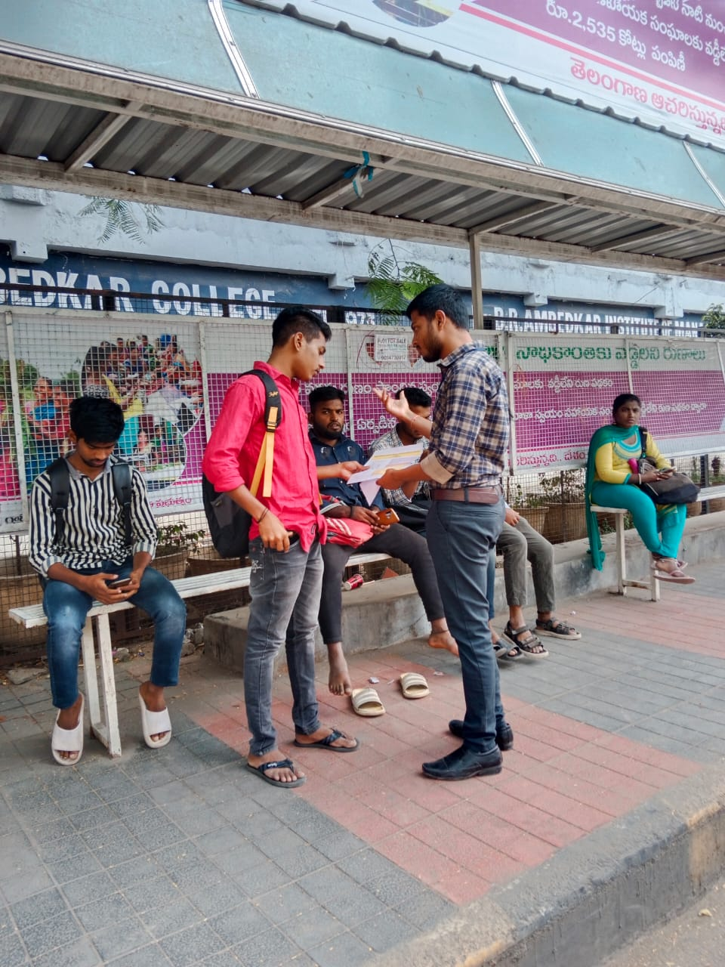
PHOTOGRAPHS:

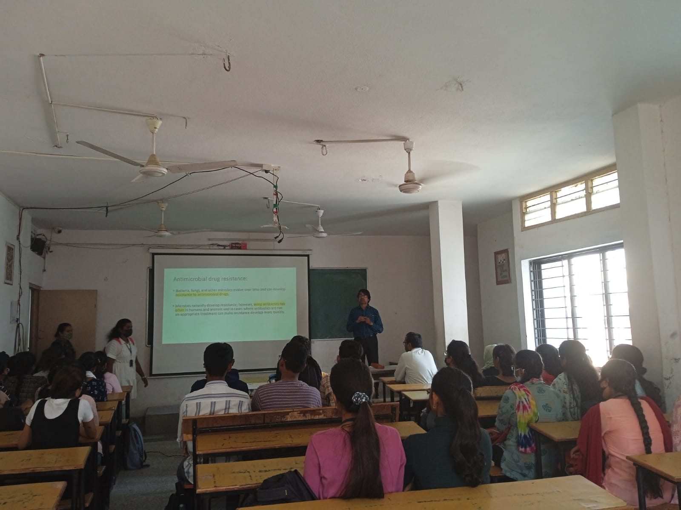

DAY 2:19-11-2022

EVENT:Guest lecture on Emergence of Drug Resistance Strains in Bacteria
Lecture on Emergence of Drug Resistance Strains in Bacteria given by Faculty R.Vasudevan Sir and Dr.Lakshmi Narayan Sir from Department of Microbiology,ADC.The lecture Started at 12 pm and concluded by 1:00pm.Students from UG Semester 1 Sections( BtBiC, MiGC and MiBiC ) and PG Microbiology students also a part of the lecture.
The Following are the key points quoted

Key Facts about Antibiotics:
- Antibiotics are usually taken by mouth, but can sometimes be given into a vein (intravenous), into a muscle (intramuscular) or applied to the skin (topical).
- Different types of antibiotics treat different kinds of infection.
- Antibiotics are commonly prescribed for respiratory infections, but most of these are caused by viruses not bacteria.
- Colds and most coughs are caused by viruses not bacteria, so antibiotics will not help.
- If you take antibiotics when you don’t need them, they may lose their ability to kill bacteria.
Use of antibiotics wisely-The only solution
- Before taking any antibiotic ask your physician if it is required and beneficial
- Always take antibiotics as prescribed by the physician
- Take antibiotics to treat only bacterial infections
- Do not take antibiotics in viral infections such as cold, cough, or flu
- Do not repeat the same antibiotic for the next time you get sick
- Do not stop antibiotic before complete prescribed course of treatment
- Do not skip doses

LIST OF STUDENT PARTICIPENTS PG MICROBIOLOGY SEM3 STUDENTS PARTICIPATED IN GUEST LECTURE :

S.NO | NAME | ROLL NO | GENDER | STREAM
1. | Afiya Kausar | 1051-21-518-003 | F | MICROBIOLOGY
2. | Syeda Amena Banu | 1051-21-518-004 | F | MICROBIOLOGY
3 | Gorige Ganesh | 1051-21-518-007 | M | MICROBIOLOGY
4 | Rayapudi Mary Evanjali | 1051-21-518-009 | F | MICROBIOLOGY
5 | Nashita Fatima | 1051-21-518-013 | F | MICROBIOLOGY
6 | Thonta Pauly Christina | 1051-21-518-014 | F | MICROBIOLOGY
7 | Yatham Shanmukhi Sphoorthi | 1051-21-518-025 | F | MICROBIOLOGY
8 | Dandugundu Vivekananda | 1051-21-518-026 | M | MICROBIOLOGY
9 | Pandella Sai Sumanth Reddy | 1051-21-518-027 | M | MICROBIOLOGY
10 | Leburi Vedasai | 1051-21-518-028 | M | MICROBIOLOGY
11 | Pereji Jemimah Blessy | 1051-21-518-032 | F | MICROBIOLOGY
12 | Pallav Dash | 1051-21-518-033 | M | MICROBIOLOGY
UG SEMESTER 1 STUDENTS PARTICIPANT LIST
S.NO | NAME | ROLL NO | GENDER | STREAM
1. | Thakur Rajneesh Singh | 1051-22-471-003 | M | MiBiC
2 | Kalleda Abhinav Reddy | 1051-22-459-004 | M | MiGC
4 | Mohammed Abdul Moid | 1051-22-459-005 | M | MiGC
5 | N Mamatha | 1051-22-459-006 | F | MiGC
6 | Samar Fatima | 1051-22-459-007 | F | MiGC
7 | Anaparthy Vijaya Vaishnavi | 1051-22-459-008 | F | MiGC
8 | Ayila Suvarna Lahari | 1051-22-459-009 | F | MiGC
9 | G Likhita | 1051-22-459-010 | F | MiGC
10 | Gajji Vignesh | 1051-22-459-011 | M | MiGC
11 | Guguloth Surendra Nayak | 1051-22-459-012 | M | MiGC
12 | Harshitha Chandergi | 1051-22-459-013 | F | MiGC
13 | Jajimogga Snehitha | 1051-22-459-014 | F | MiGC
14 | Kakarla Ashritha | 1051-22-459-015 | F | MiGC
15 | Kapalavai Dharika | 1051-22-459-016 | F | MiGC
16 | M B Pranav | 1051-22-459-017 | M | MiGC
17 | Mariyappan Benny Hinn | 1051-22-459-018 | M | MiGC
18 | Nethi Laxmi Sai Prasanna | 1051-22-459-019 | F | MiGC
19 | Peta Geethika | 1051-22-459-020 | F | MiGC
20 | Pujyam N S M M Srinivas Ganesh | 1051-22-459-021 | M | MiGC

PHOTOGRAPHS:
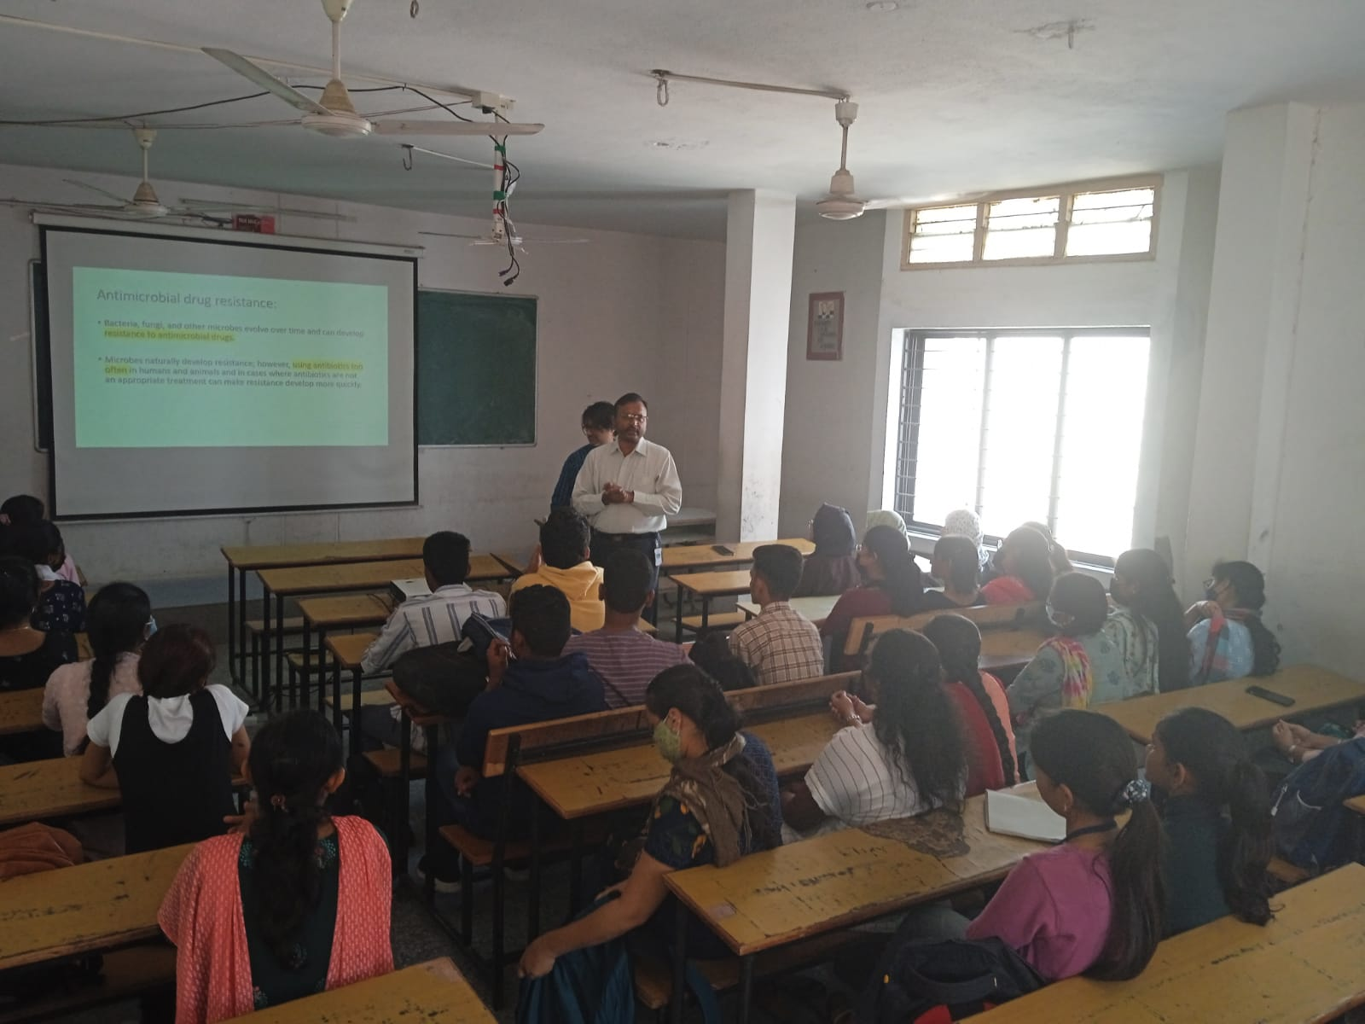

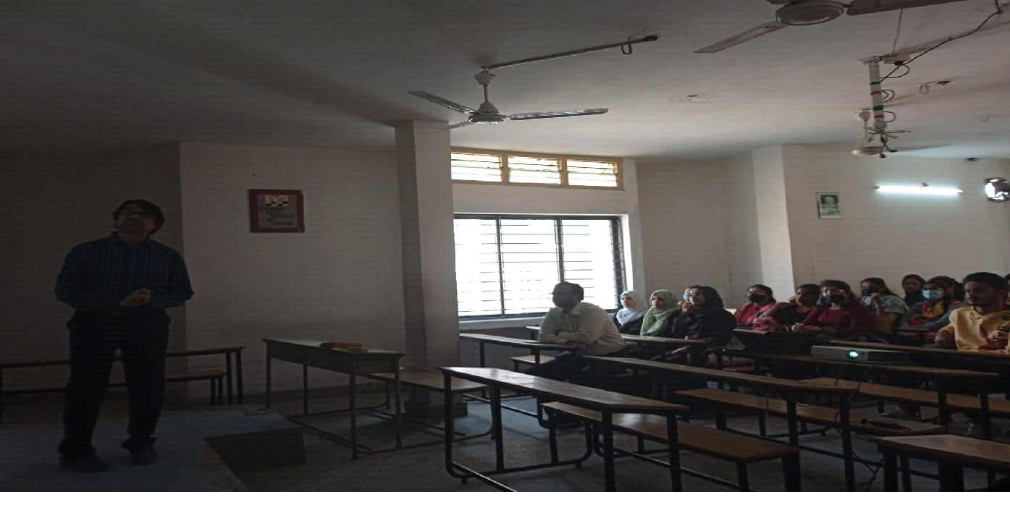

DAY 3: 21-11-2022
EVENT:Models Display on Antibiotics and Bacterial Resistance

Students from PG MICROBIOLOGY SME 3 and UG SEM1 SECTION MiGC/MiBiC participated in the Models Display on Antibiotics and Bacterial Resistance. The main objective to conduct this program to make the students more understand about antibiotic resistance by visual aids in the form of charts, thermocol models etc

LIST OF STUDENT PARTICIPENTS PG 2ND YEAR MICROBIOLOGY SEM3 STUDENTS AND UG FIRST YEAR SEM 1 PARTICIPATED IN MODELS DISPLAY ON ANTIBIOTICS AND BACTERIAL RESISTANCE :

S.NO | NAME | ROLL NO | GENDER | STREAM
1. | Afiya Kausar | 1051-21-518-003 | F | MICROBIOLOGY
2. | Syeda Amena Banu | 1051-21-518-004 | F | MICROBIOLOGY
3 | Gorige Ganesh | 1051-21-518-007 | M | MICROBIOLOGY
4 | Rayapudi Mary Evanjali | 1051-21-518-009 | F | MICROBIOLOGY
5 | Nashita Fatima | 1051-21-518-013 | F | MICROBIOLOGY
6 | Thonta Pauly Christina | 1051-21-518-014 | F | MICROBIOLOGY
7 | Yatham Shanmukhi Sphoorthi | 1051-21-518-025 | F | MICROBIOLOGY
8 | Dandugundu Vivekananda | 1051-21-518-026 | M | MICROBIOLOGY
9 | Pandella Sai Sumanth Reddy | 1051-21-518-027 | M | MICROBIOLOGY
10 | Leburi Vedasai | 1051-21-518-028 | M | MICROBIOLOGY
11 | Pereji Jemimah Blessy | 1051-21-518-032 | F | MICROBIOLOGY
12 | Pallav Dash | 1051-21-518-033 | M | MICROBIOLOGY
UG SEMESTER 1 STUDENTS PARTICIPANT LIST
S.NO | NAME | ROLL NO | GENDER | STREAM
1. | Thakur Rajneesh Singh | 1051-22-471-003 | M | MiBiC

PHOTOGRAPHS
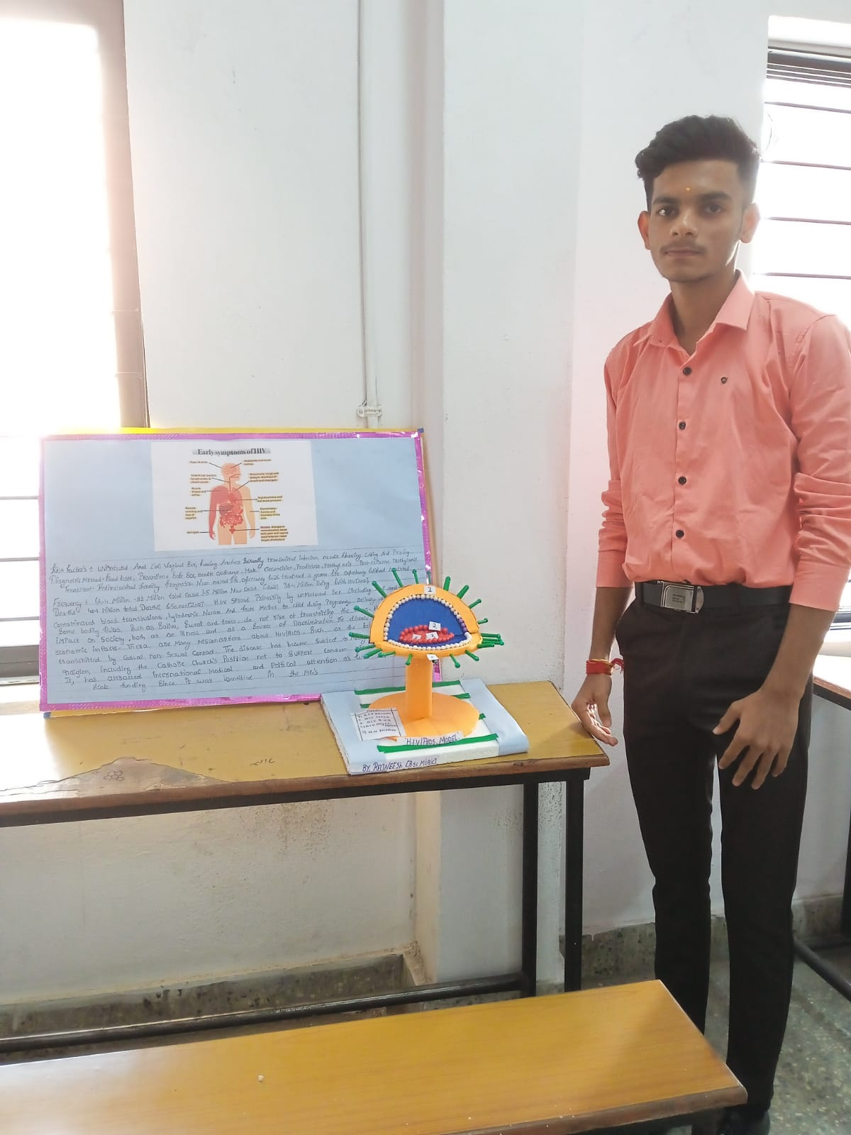

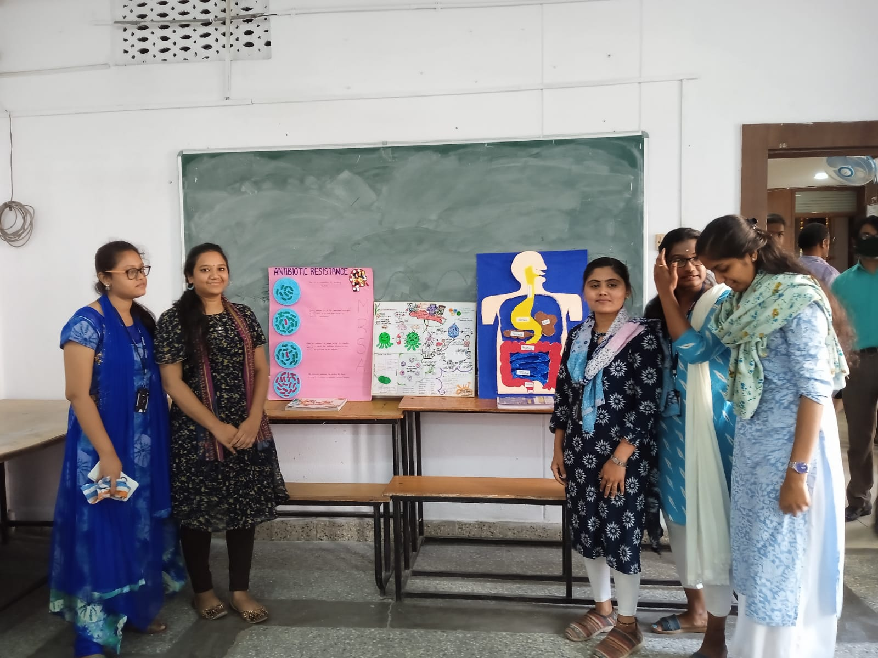

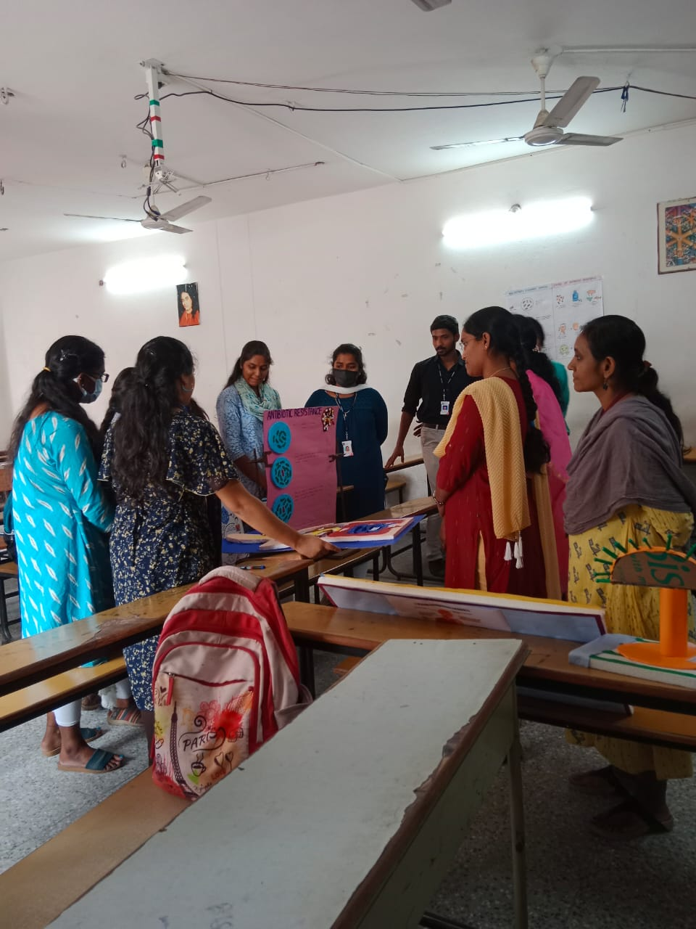

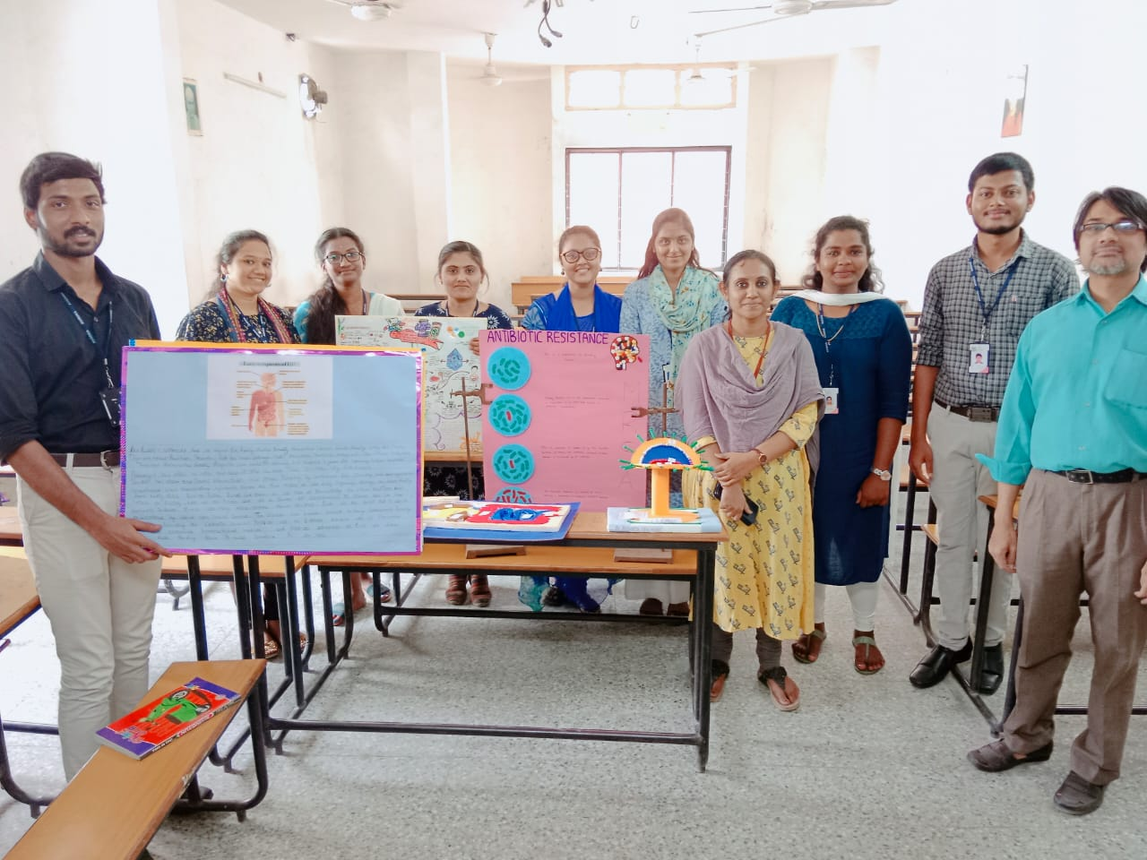
DAY 4: 23-11-2022
EVENT:Antibiotic Quiz and PPT Presentation (Theme: Drug Resistance in Bacteria)

Students from PG MICROBIOLOGY SEM 3 and UG SEM1 SECTION(MiGC/MiBiC) participated in Antibiotic Quiz and PPT Presentation. The main content is to test the knowledge of students and their understanding ability in terms of the topic concerned. Many students enthusiastically participated in the quiz and ppt presentations.

LIST OF STUDENT PARTICIPENTS PG MICROBIOLOGY SEM3 STUDENTS and UG SEM1(MiGC/MiBiC) ANTIBIOTIC QUIZ AND PPT PRESENTATION :

S.NO | NAME | ROLL NO | GENDER | STREAM
1. | Afiya Kausar | 1051-21-518-003 | F | MICROBIOLOGY
2. | Syeda Amena Banu | 1051-21-518-004 | F | MICROBIOLOGY
3 | Gorige Ganesh | 1051-21-518-007 | M | MICROBIOLOGY
4 | Rayapudi Mary Evanjali | 1051-21-518-009 | F | MICROBIOLOGY
5 | Nashita Fatima | 1051-21-518-013 | F | MICROBIOLOGY
6 | Thonta Pauly Christina | 1051-21-518-014 | F | MICROBIOLOGY
7 | Yatham Shanmukhi Sphoorthi | 1051-21-518-025 | F | MICROBIOLOGY
8 | Dandugundu Vivekananda | 1051-21-518-026 | M | MICROBIOLOGY
9 | Pandella Sai Sumanth Reddy | 1051-21-518-027 | M | MICROBIOLOGY
10 | Leburi Vedasai | 1051-21-518-028 | M | MICROBIOLOGY
11 | Pereji Jemimah Blessy | 1051-21-518-032 | F | MICROBIOLOGY
12 | Pallav Dash | 1051-21-518-033 | M | MICROBIOLOGY
UG SEMESTER 1 STUDENTS PARTICIPANT LIST
S.NO | NAME | ROLL NO | GENDER | STREAM
1. | Thakur Rajneesh Singh | 1051-22-471-003 | M | MiBiC
2 | Kalleda Abhinav Reddy | 1051-22-459-004 | M | MiGC
3 | Mohammed Abdul Moid | 1051-22-459-005 | M | MiGC
4 | N Mamatha | 1051-22-459-006 | F | MiGC
5 | Samar Fatima | 1051-22-459-007 | F | MiGC
6 | Anaparthy Vijaya Vaishnavi | 1051-22-459-008 | F | MiGC
7 | Ayila Suvarna Lahari | 1051-22-459-009 | F | MiGC
8 | G Likhita | 1051-22-459-010 | F | MiGC
9 | Gajji Vignesh | 1051-22-459-011 | M | MiGC
10 | Guguloth Surendra Nayak | 1051-22-459-012 | M | MiGC
11 | Harshitha Chandergi | 1051-22-459-013 | F | MiGC
12 | Jajimogga Snehitha | 1051-22-459-014 | F | MiGC
13 | Kakarla Ashritha | 1051-22-459-015 | F | MiGC
14 | Kapalavai Dharika | 1051-22-459-016 | F | MiGC
15 | Nethi Laxmi Sai Prasanna | 1051-22-459-019 | F | MiGC
16 | Peta Geethika | 1051-22-459-020 | F | MiGC
17 | Pujyam N S M M Srinivas Ganesh | 1051-22-459-021 | M | MiGC

PHOTOGRAPHS:
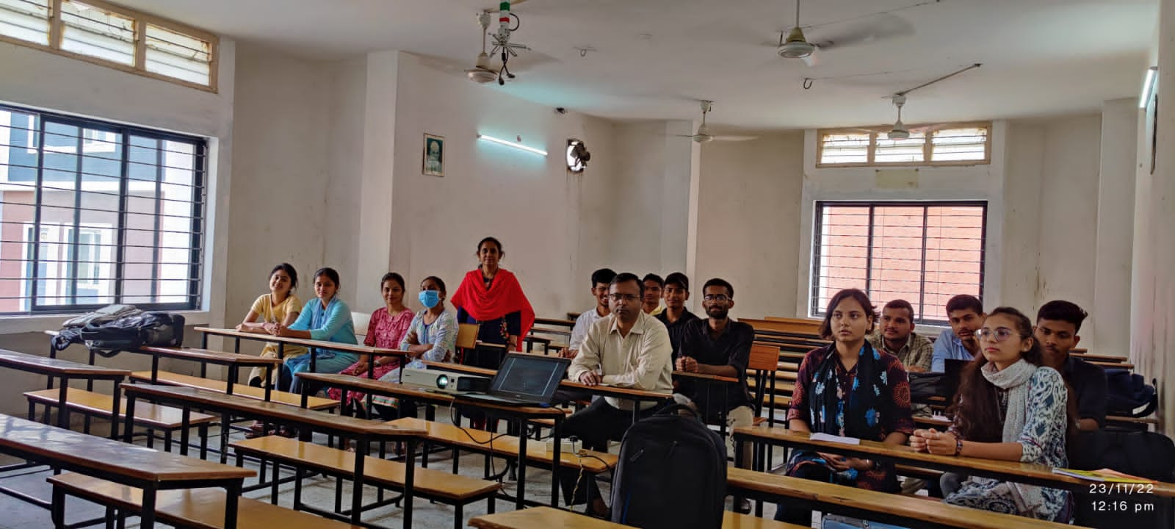

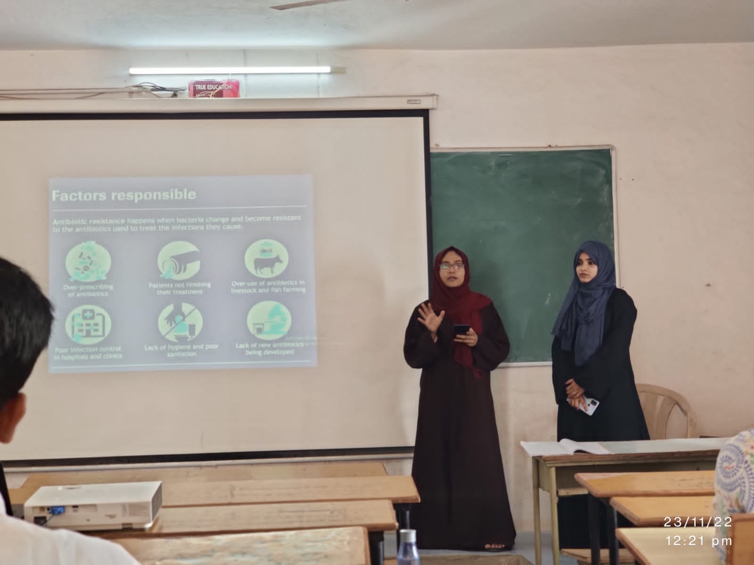

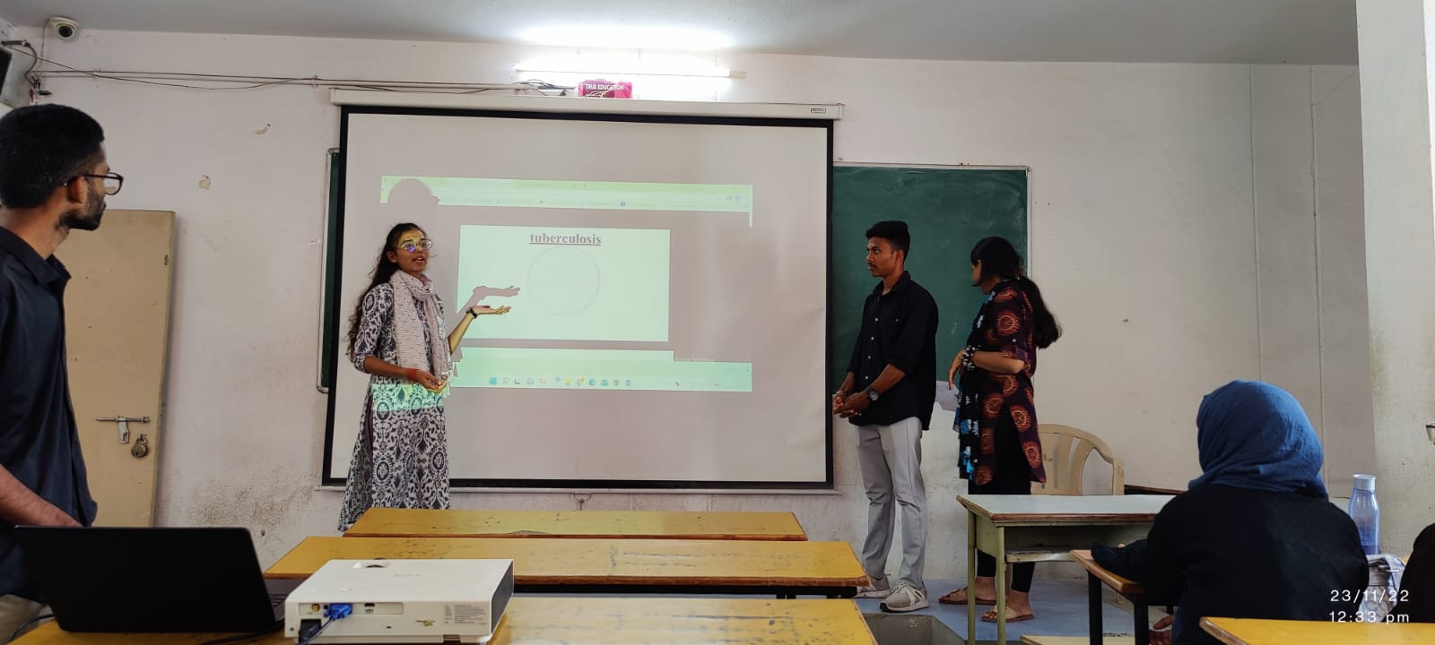

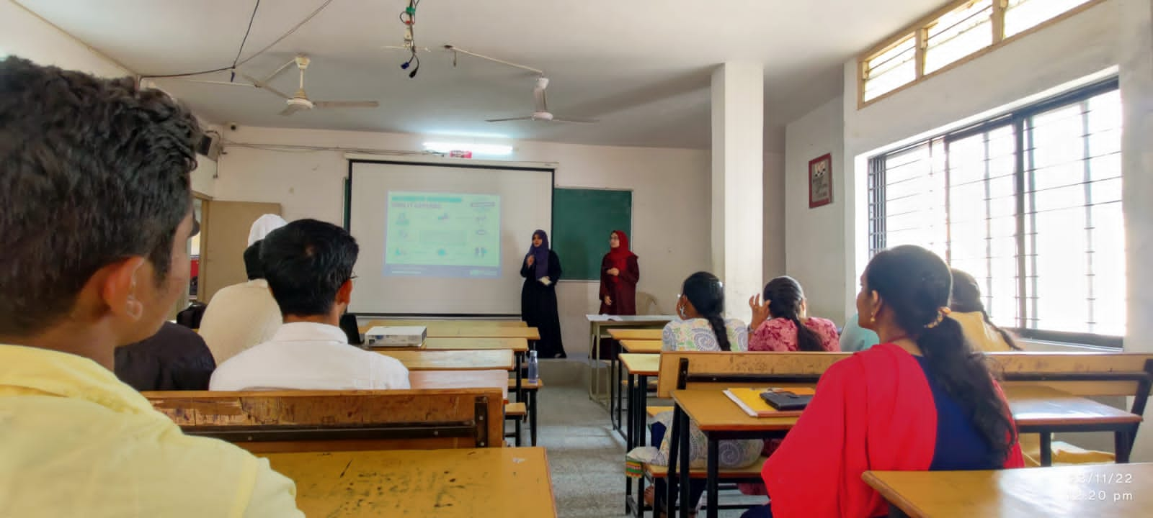

DAY 5: 24-11-2022
EVENT:Rangoli on Era of Antibiotics
Students from PG MICROBIOLOGY SEM 3, PG BIOCHEMISTRY SEM3 and UG SEM1 SECTION(MiGC/MiBiC) participated in Rangoli event on Era of Antibiotics.The event started at 12pm and ended by 3:30pm.Head of the Deapartment of Microbiology Mrs:Padma, Head of the Deapartment of Biochemistry Mrs:Sunitha,Faculty from second languages Dr.Suryakanthi,Dr. Leelamani from Department of Biotechnology,Mrs Romana from Genetics,Chemistry Faculty Dr.Viritha and Dr.latha etc visited the event.Students very well explained relavent point related antibiotic rangoli.Many questions asked by faculty students very enthusiastically clarified the question with relavent explanation.The event went on well.Hence we concluded the last day of event on 24th November 2022at 3:30pm.

LIST OF STUDENT PARTICIPENTS PG MICROBIOLOGY/BIOCHEMISTRY SEM3 STUDENTS and UG SEM1(MiGC/MiBiC) :

PG MICROBIOLOGY SEM3/PG BIOCHEMISTRY SEM3
S.NO | NAME | ROLL NO | GENDER | STREAM
1 | Afiya Kausar | 1051-21-518-003 | F | MICROBIOLOGY
2 | Syeda Amena Banu | 1051-21-518-004 | F | MICROBIOLOGY
3 | Nashita Fatima | 1051-21-518-013 | F | MICROBIOLOGY
PG BIOCHEMISTRY SEM3
4 | K.Shivani | 1051-21-514-012 | F | BIOCHEMISTRY
5 | Kota.Shivani | 1051-21-514-014 | F | BIOCHEMISTRY
6 | T.Pranitha | 1051-21-514-006 | F | BIOCHEMISTRY
7 | BVS.Yasaswini | 1051-21-514-029 | F | BIOCHEMISTRY
8 | R.Sudha Gayathri | 1051-21-514-010 | F | BIOCHEMISTRY
9 | K.Bhanu Sree | 1051-21-514-028 | F | BIOCHEMISTRY
UG SEMESTER 1 STUDENTS PARTICIPANT LIST
S.NO | NAME | ROLL NO | GENDER | STREAM
1 | Dave Roshni Kamlesh | 1051-22-459-002 | F | MiGC
2 | Kalleda Abhinav Reddy | 1051-22-459-004 | M | MiGC
3 | N Mamatha | 1051-22-459-006 | F | MiGC
4 | Anaparthy Vijaya Vaishnavi | 1051-22-459-008 | F | MiGC
5 | Ayila Suvarna Lahari | 1051-22-459-009 | F | MiGC
6 | G Likhita | 1051-22-459-010 | F | MiGC
7 | Gajji Vignesh | 1051-22-459-011 | M | MiGC
8 | Kapalavai Dharika | 1051-22-459-016 | F | MiGC
9 | Mariyappan Benny Hinn | 1051-22-459-018 | M | MiGC
10 | Peta Geethika | 1051-22-459-020 | F | MiGC
11 | Tanneru Chennakeshwarlu | 1051-22-459-022 | M | MiGC
12 | Jandhyam Nikitha | 1051-22-459-030 | F | MiGC
13 | Jukuru Vasundhara | 1051-22-459-031 | F | MiGC
14 | Koya Sravya | 1051-22-459-032 | F | MiGC
15 | Andhagulu Vaishnavi | 1051-22-471-001 | F | MiBiC
16 | Sakina Ruqsar | 1051-22-471-002 | F | MiBiC
17 | Yambrala Sriya | 1051-22-471-004 | F | MiBiC

PHOTOGRAPHS:
