Aurora’s Degree and PG College 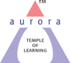
(ACCREDITED BY NAAC WITH ‘B++’ GRADE)
Chikkadpally, Hyderabad 500020
Department of Electronics
EVENT PROPOSAL

Event/Activity Name: Transistor Invention Day
Event/Activity Title: Work shop on "Mini Project Ideas" in Collaboration with Innovative technologies..
Event Conducted Department: Department of Electronics
Faculty coordinators: Poornachander P
Date: 16-12-2022.
Venue: Aurora’s Degree & PG College – Main Block.
Target audience: B.Sc (MPCS and MECs) Final Year.
Level: College
Student Volunteer’s: N/A

Objective: The main objective of this event is to create knowledge on
- Selecting Projects
- Design and development.
Proposed activities:
- Workshop on Design and Development of Mini Projects in Electronics and Physics by Innovative technologies
Guest/Speaker details: Director Innovative technologies
Budget: Nil
.

Coordinators IQAC Coordinator Principal
Poornachander P Dr. Meera Joshi Dr. ViswanadhamBulusu
Aurora’s Degree and PG College
(ACCREDITED BY NAAC WITH ‘B++’ GRADE)
Chikkadpally, Hyderabad 500020
Brief Report
On
Workshop
On the occasion of “Transistor Invention Day”

NAME OF THE EVENT | Workshop  On the occasion of “Transistor Invention Day”
TYPE OF EVENT | Department level
FACULTY INCHARGE | P Poornachander
DEPARTMENT | Electronics
DATE | 16th December, 2022
VENUE | Aurora’s Degree and PG College, Chikkadpally
TARGET AUDIENCE | III B.Sc., M.E.Cs & M.P.Cs

OBJECTIVE:
- To motivate the students towards Electronics/Physics Projects .
- Create awareness among the students about basic electronics components.
- Transform theoretical knowledge into practical applications

BRIEF ABOUT THE EVENT:
Department of Electronics organized a One day Workshop on “Mini Project Ideas " for B.Sc., III Year M.E.Cs and M.P.Cs Students.
In this workshop students designed “Water Level Indicator”, is an electronic circuit that switches ON when water crosses limited point.
Totally 30 Students from III year M.E.Cs and M.P.Cs participated and feedback from the students were also highly positive.

OUTCOME:
- Confidence in designing a project and testing it
- Improves the subject knowledge and boost confidence.

PHOTOGRAPHS:
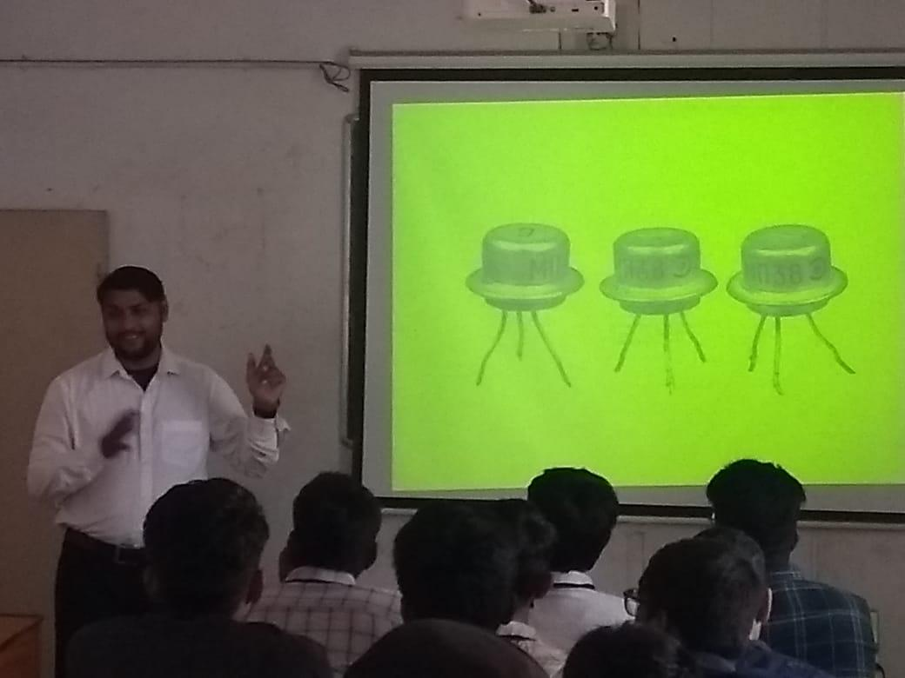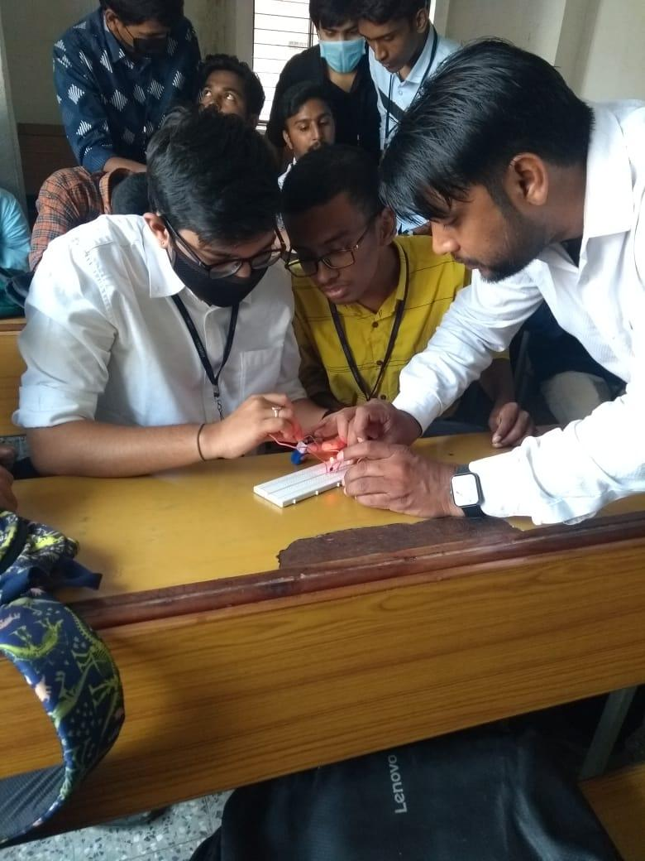

Aurora’s Degree & PG College
Chikkadpally, Hyderabad -500020
A Detailed Report
On
Workshop
On the occasion of “Transistor Invention Day”

NAME OF THE EVENT | Workshop  On the occasion of “Transistor Invention Day”
TYPE OF EVENT | Department level
FACULTY INCHARGE | P Poornachander
DEPARTMENT | Electronics
DATE | 16th December, 2022
VENUE | Aurora’s Degree and PG College, Chikkadpally
TARGET AUDIENCE | III B.Sc., M.E.Cs and M.P.Cs

PROGRAM SCHEDULE: 16thDecember, 2021 from 10:30 am to 12:30pm.
Session 1: Theory session on “Basic components “
Session 2 : Designing a Circuit
Assembling the components on Bread Board
Testing the Circuit

VENUE: Aurora’s Degree and PG College, Chikkadpally

FACULTY COORDINATOR: P Poornachander , Department of Electronics.

PARAGRAPH ABOUT THE PROCEEDINGS

Introduction of the Event:
Department of Electronics organized a One day Workshop on "Mini Project Ideas in Electronics and Physics" for B.Sc., III-Year M.E.Cs and M.P.Cs Students.
The Workshop is designed such that students learn subject in detail apart from their regular curriculum. The workshop provides more practical knowledge to the students in designing electrical circuits.
In this workshop students designed “Water Level Indicator”, is an electronic circuit that switches ON when water crosses limited point.

Methodology:
Department of Electronics, Aurora’s Degree and PG College conducts this event with great enthusiasm every year. This year workshop was conducted on "Mini Project Ideas in Electronics and Physics" for B.Sc., final Year M.E.Cs and M.P.Cs Students by Mr. Hamed Raza Director, Innovative technologies, Hyderabad.
The program was conducted in Block-1 lab from 10:30 to 12:30pm. Mr. Hamed Raza explained about basic components in electronics and importance of transistor in session -I.
He also explained Designing of simple electronic circuits and designing of Water Level Indicator. In practical session he explained how to assemble components on Bread board and After completion of design , he tested the circuit.
Totally 30 Students from Final year M.E.Cs and M.P.Cs participated and feedback from the participants was also highly positive.
INCOME AND EXPENDITURE : Nil

EVENT PHOTGRAPHS:

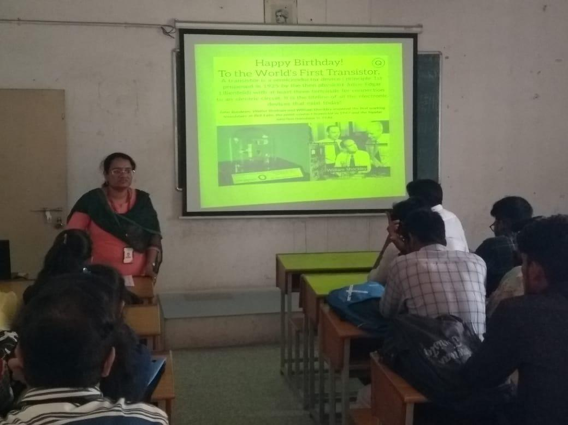
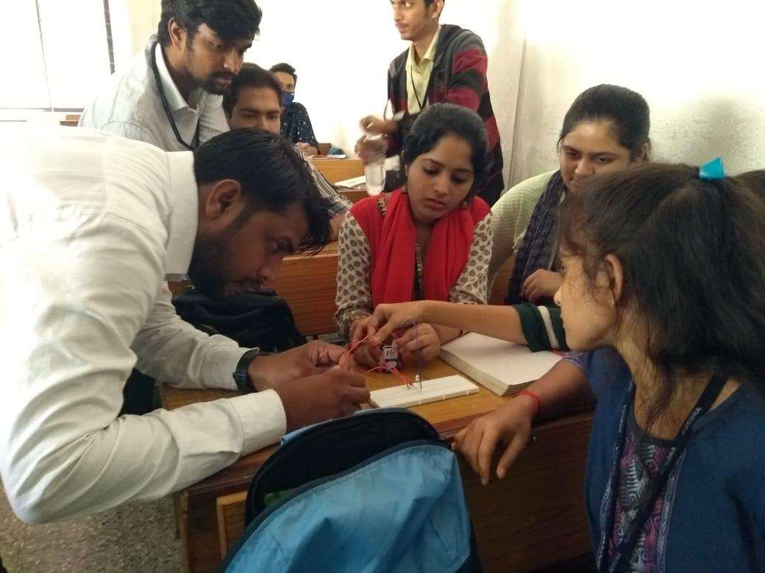

GUEST PROFILE: MrHamedRazaDirector, Innovative technologies
FEED BACK : Students gave positive feedback and they felt happy for conducting this event.

