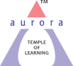
Aurora’s Degree & PG College
(ACCREDITED BY NAAC WITH 'B++' GRADE)
Chikkadpally, Hyderabad 500020

EVENT / ACTIVITY DETAILED REPORT

NAME OF THE EVENT / ACTIVITY | International Data Privacy Day
TYPE OR TITLE OF EVENT / ACTIVITY | Cyber Security
FACULTY INCHARGE | N. Padma shri
DEPARTMENT/CELL/COMMITTEE/CLUB | Computer Science
DATE | 28-01-2023
VENUE | Aurora’s Degree & PG College, Block -VI, RTC X ROAD’S , Hyderabad
TARGET AUDIENCE | BCA,MSCS,MSDS,  MSc(computer Science) students

- PROGRAM SCHEDULE: International Data Privacy Day

LIST OF COORDINATORS (DEPARTMENT): N. Padma shri
- LIST OF THE PARTICIPATED:
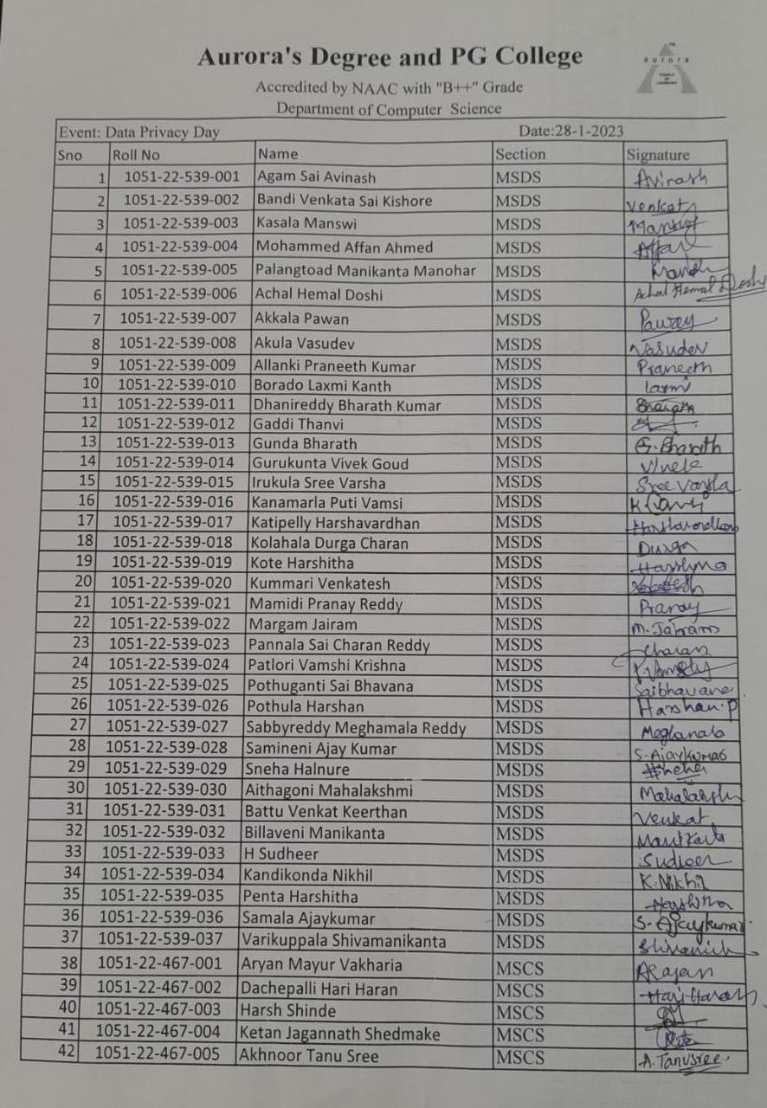

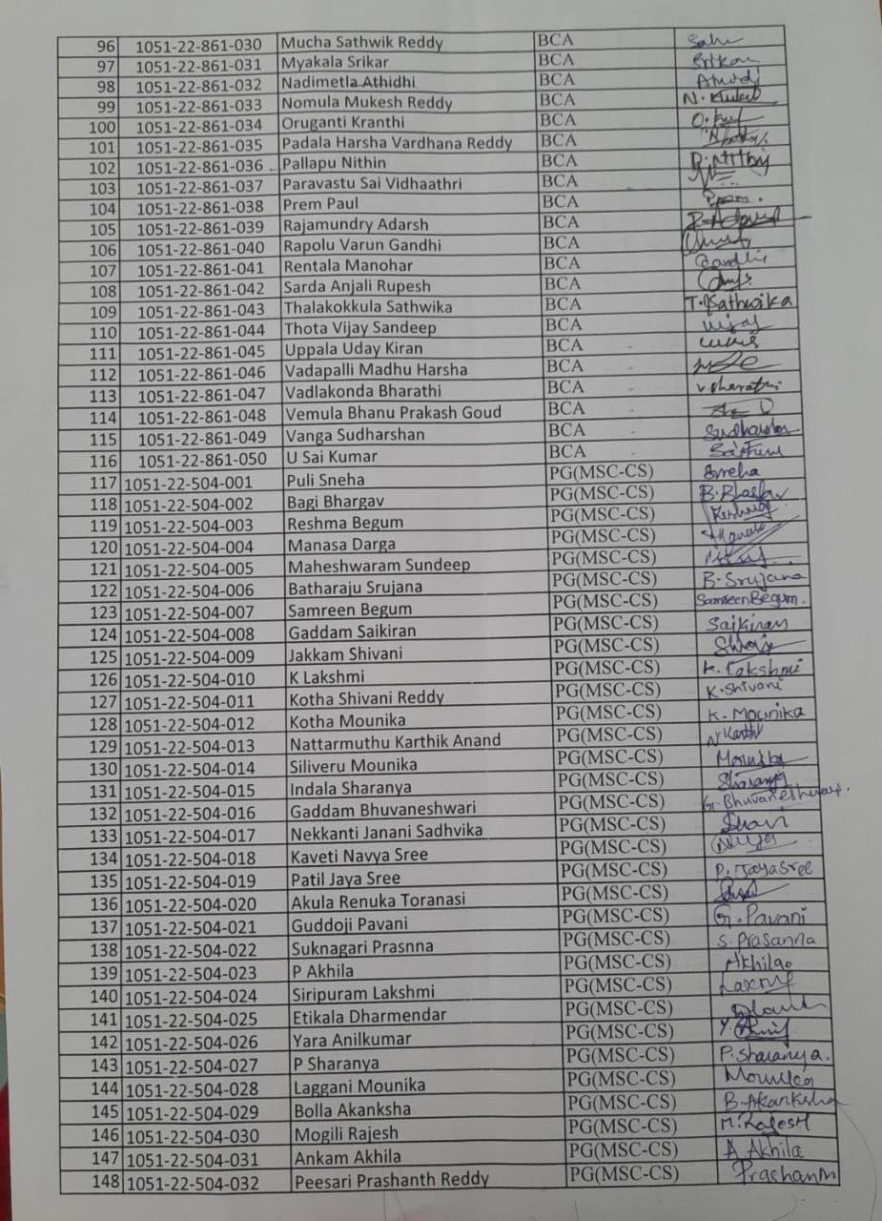
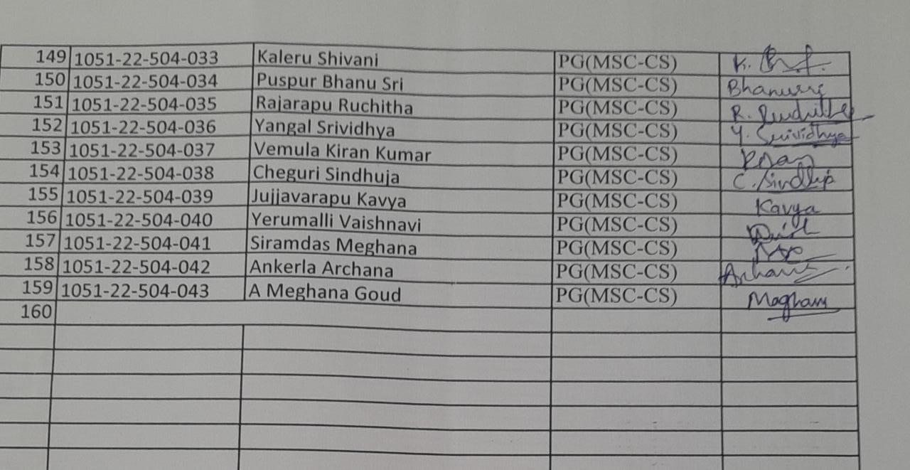

- PARAGRAPH ABOUT THE PROCEEDINGS (TILL THE END OF THE EVENT)
- The Event has been Scheduled in Aurora’s Degree & PG College, Block VI, RTC X ROAD’S, Computer lab on 28th Jan,20234 at 11.00 am , Total 159 participants had attended the seminar by the Speaker Mr. N. Narasimha Murthy.
- Data/Digital Privacy or Information privacy is a part of the data protection where and how data is collected, stored managed and shared with others based on its sensitivity and importance with data security.
- Hacking, Virus dissemination, Logic bombs ,Denial-of-Service attack
Phishing, Email bombing and spamming, Web jacking, Cyber stalking
Data diddling, Identity Theft and Credit Card and Debit Card Frauds
Salami slicing attack, Software Piracy and cyber bullying & pornography.

- INCOME AND EXPENDITURE :Nil
- EVENT PHOTOS ( MIN 2 MAX 4)

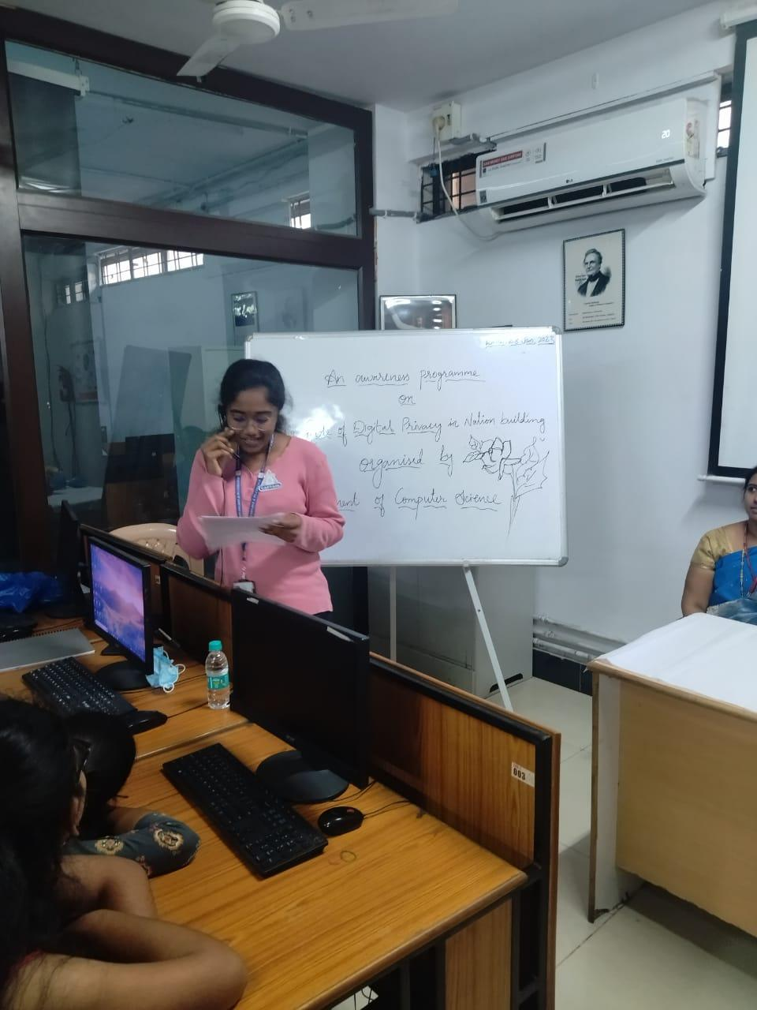

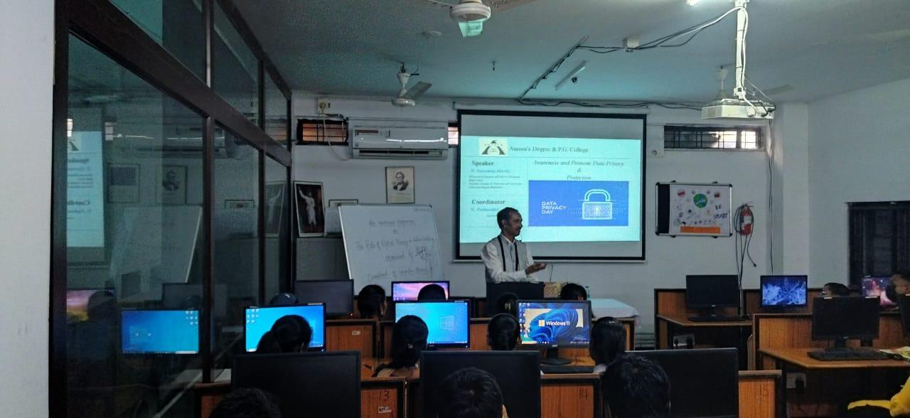

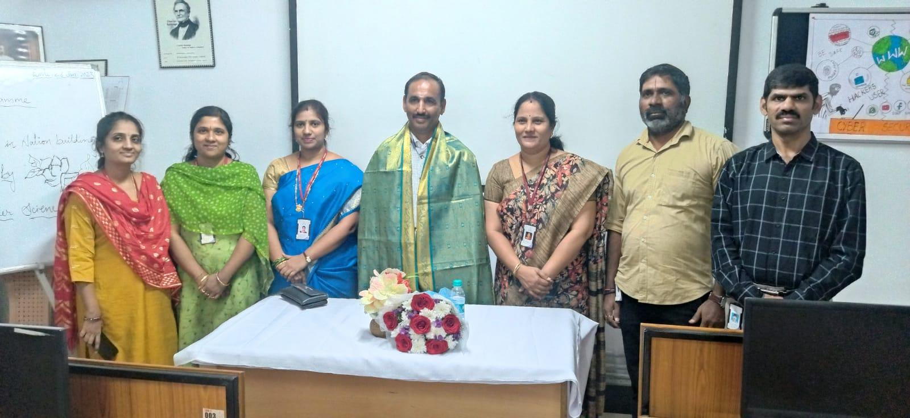

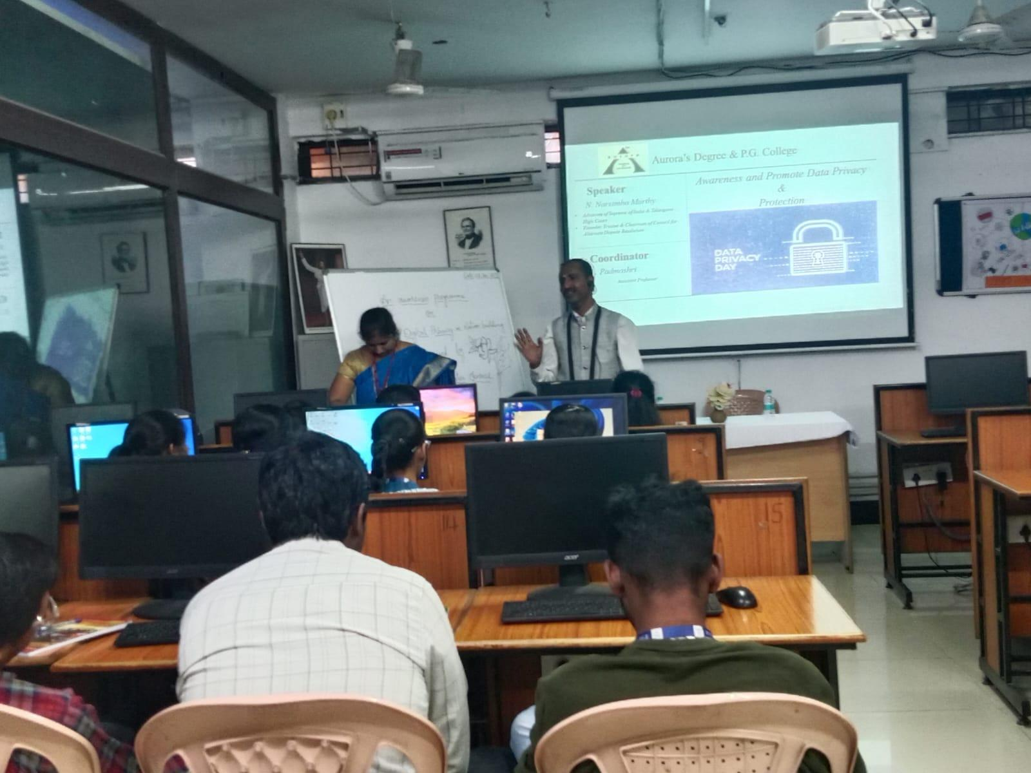

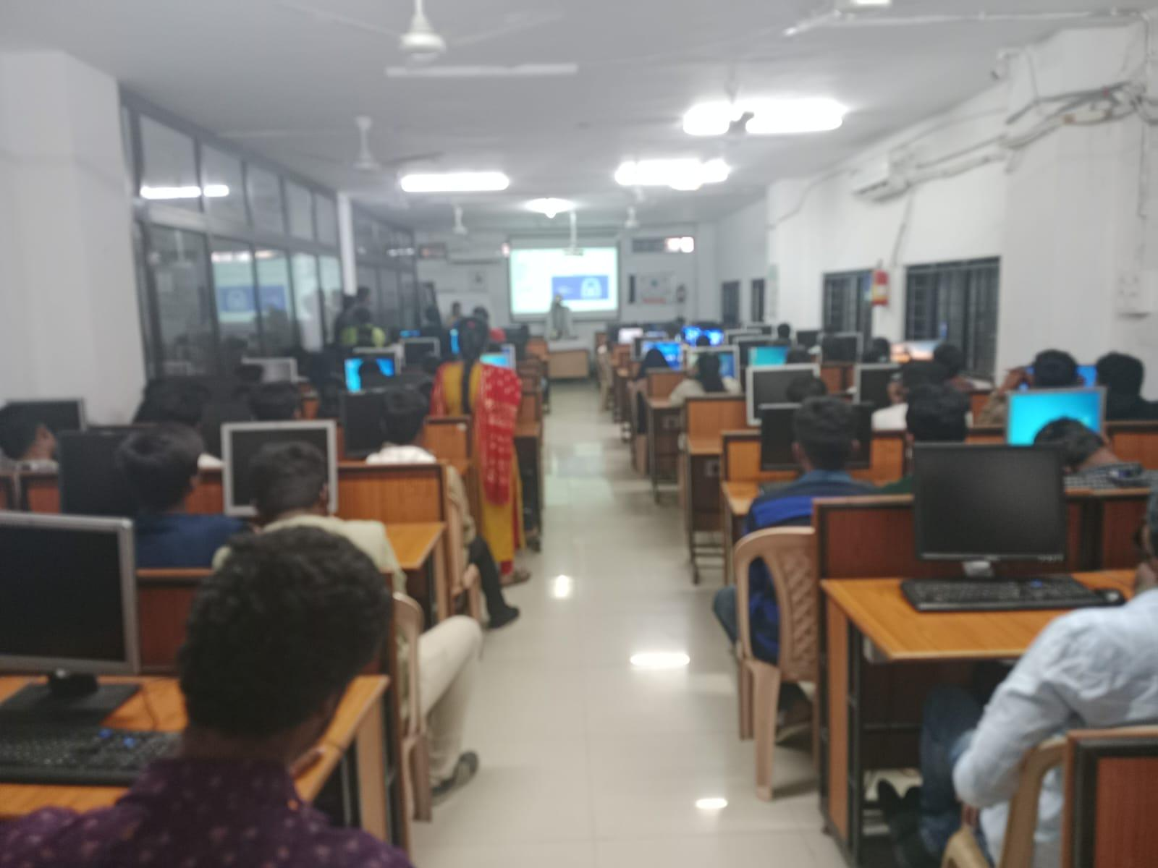

- GUEST PROFILE (IF ANY)-NA
- FEED BACK IF ANY-NA
- ATTACHMENTS:
EVENT/ACTIVITY PROPOSAL: Hardcopy
EVENT / ACTIVITY NOTICE: Hardcopy
RECEIPTS (IF ANY): NA
CERTIFICATES (IF ANY):NA
LETTERS OF COMMUNICATION (IF ANY):NA

