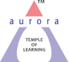
Aurora’s Degree & PG College
(Accredited by NAAC with 'B++' grade)
Chikkadpally, Hyderabad 500020

EVENT / ACTIVITY DETAILED REPORT

NAME OF THE EVENT / ACTIVITY | AZADI KA AMRIT MAHOTSAV
TYPE OR TITLE OF EVENT / ACTIVITY | COLLEGE EVENT
FACULTY INCHARGE | CULTURAL COMMITTEE MEMBERS
DEPARTMENT/CELL/COMMITTEE/CLUB | CULTURAL COMMITTEE
DATE | 15/08/2022
VENUE | AURORA’S DEGREE & PG COLLEGE
TARGET AUDIENCE | ALL STUDENTS & FACULTY OF ADC

1. PROGRAM SCHEDULE
Around 9:30 am to 11:00 am

2. LIST OF FACULTY COORDINATORS

FACULTY NAME | DEPARTMENT | POSITION
S Krishna Priya | Commerce | Convenor
Sandhya Rani A | Mathematics | Member
Sunanda G | Physical Science | Member
M Rama Lakshmi Anusuya | Languages | Member
Vineetha P | English | Member
Shiva Shanker G | Commerce | Member

3. LIST OF THE STUDENT COORDINATORS

NAME | ROLL NOS | STREAM
Rani Choudhary | 1051-21-405-063 | BCOM 2 APPLICATIONS
Usha | 1051-20-405-073 | BCOM 3 APPLICATIONS

4. LIST OF THE STUDENTS PARTICPATED

a) ROCK BAND BY TEAM AURA:

NAME | ROLL NOS | STREAM
Yakub | 1051-19-405-097 | BCOM 3 APPLICATIONS
Sunny Paul | 1051-19-405-273 | BCOM 3 APPLICATIONS
Geetha Sri | 1051-20-405-065 | BCOM 3 APPLICATIONS
P. Minith Kumar Naidu | 1051-20-401-064 | BCOM GENERALS
S. Sai Sweekruthi | 1051-20-684-138 | BBA3C
G.B Supraja | 1051-20-684-152 | BBA3C
E. Namami | 1051-21-459--010 | MIGC-2
Raghu Vamshi | 1051-21-471-013 | MIBIC-2
K. Chrislyn Evanle | 1051-21-684-064 | BBA2B
John Simon | 1051-21-459-027 | MIGC2
Gowtham | 1051-21-467-060 | BSC MSCS 2B

(b) LIST OF THE STUDENTS PARTICPATED IN DANCE:
ROLL NUMBER | NAME OF THE STUDENT | CLASS/SEC
1051-21-405-063 | Rani Choudhary | BCOM.COM.APPL.2CB
1051-21-467-051 | Dhanush Koti | BSC MSCS
1051-20-405-074 | Rithika Reddy | BCOM.COMP.APPL.2CB
1051-21-408-002 | Supriya | MCOM
1051-20-405-145 | Sanika Patil | BCOM.COMP.APPL.2CC
1051-20-459-015 | M Lokesh | MIGC
1051-20-459-027 | Arjun Sai Teja | MIGC
1051-20-401-121 | T Sunil Kumar | BCOM 3B
1051-20-474-067 | Naresh Kumar | BSC,MECS
1051-20-407-007 | Vrridhi Dugar | B.COM 3H
1051-20-407-009 | Vidhisha P Sanghvi | B.COM 3H

(c) LIST OF FACULTY PARTICPATED IN SINGING
FACULTY NAME | DEPARTMENT | CONTACT NUMBER
Madhavi Latha P | Commerce | 9100000580
Veena Malkhed | Commerce | 9100000508
Dr. Padmini S | Commerce | 9100000653
Aruna T | Commerce | 9100000581
Vineetha | Statistics | 9100000561
Parimala Sudhir | Statistics | 9100000578
Rajani B | Computer Science | 9100000505
Kavya B | Computer Science | 9100000549
Chandrakala | Mathematics | 9100000533
Latha Salomi | Mathematics | 9100000597
5. PARAGRAPH ABOUT THE PROCEEDINGS
75^{tth} anniversary of Indian Independence or Azadi ka Amrit Mahotsav event was celebrated with great excitement. This Mahotsav is dedicated to the people of India who have not only been instrumental in bringing Independent India thus far in it’s evolutionary journey but also hold within them the power and potential to enable Prime Minister Modi’s vision of activating India 2.0, fueled by the spirit of Aatmanirbhar Bharat. Azadi ka Amrit Mahotsav is an embodiment of all that is progressive about India’s socio-cultural, political and economic identity. The official journey of “Azadi ka Amrit Mahotsav” commences on 12th March, 2021 which starts a 75-week countdown to our 75th anniversary of Independence. In this regard, cultural committee coordinated few cultural activities to keep up the spirit of patriotism. The following events were organized:
After Flag hoisting – National Anthem, a set of Patriotic songs were presented by team “AURA” – Rock band for 15 minutes, followed by 10 min dance performance by group of students representing “Unity in Diversity” concept by dressing up in different regional attire to the song “Maa Tujhe Salam” sung by AR Rehman, the last presentation was by the faculty members group singing representing India is the best country in the whole world – “Saare Jahan se Acha” for around 6 min.
Everyone among the audience enjoyed and could connect to the performances presented by the cultural team.

6. INCOME AND EXPENDITURE
Nil

7. EVENT PHOTOS
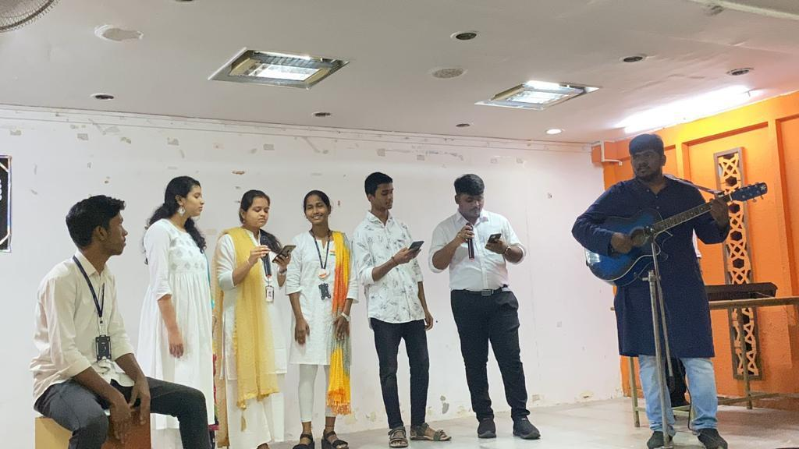

8. GUEST PROFILE
Nil
9. FEED BACK IF ANY
Nil
10. ATTACHMENTS
Nil

*** End of report ***

