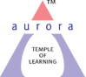
Aurora’s Degree & PG College
(ACCREDITED BY NAAC WITH 'B++' GRADE)
Chikkadpally, Hyderabad 500020

EVENT / ACTIVITY DETAILED REPORT

NAME OF THE EVENT / ACTIVITY | Telangana Basha Dinostavam
TYPE OR TITLE OF EVENT / ACTIVITY | Telangana Bhasha Dinosthavam - Varotsavam
FACULTY INCHARGE | Dr. Surya kanthi
DEPARTMENT/CELL/COMMITTEE/CLUB | Language
DATE | 01-09-2023 to 09-09-2023
VENUE | Aurora’s Degree and PG college (block-VI)
TARGET AUDIENCE | UG Students

- PROGRAM SCHEDULE: program started at 9:30 with welcoming the guest and Lighting of lamp. This was followed by Lecture from guest, Certificate distribution to winners from previously held competitions and Speech and songs by students.

2. LIST OF FACULTY COORDINATORS (DEPARTMENT)
S.no | Faculty Name | Role | Department
1 | Dr. N. Surya Kanti | Faculty Incharge | Associate Professor – Department of Second languages

3. LIST OF THE STUDENT COORDINATORS Name:
NAME | ROLL NO | CLASS & SECTION
S. Deekshitha | 1051-21-459-025 | MiGC-3
M. Bhargavi | 1051-21-459-032 | MiGC-3
John Simon | 1051-21-459-027 | MiGC-3
B. Pranith Raj | 1051-21-474-032 | BSc. MECs
Sanjan gadeela | 1051-22-371-007 | BBA business analytics

4. LIST OF THE PARTICIPANTS (NAME , ROLL NO, CLASS & SECTION, NO OF GIRLS, BOYS, CASTE )

Total Number of Participants | Number of Girls | Number of Boys
160 | 60 | 100

5. Paragraph about the Proceedings (Till the End of the Event)
On the occasion of Telangana Basha Dinostavam (9th September 2023), the program has started one week before 9th September 2023 that is called Varotsavam. As part of this Varotsavam, several competitions such as Elocution, JAM , Presentation on Kaloji Narayana Rao garu, etc., were conducted up to 7th September 2023.

On 8th September, 2023 a guest lecture was conducted by Dr. Kolakaluri Enoch. The day’s program started at 9:30 am in Aurora’s Degree and PG College in block -VI auditorium. The program started with welcoming of the guest, Lighting of the lamp, Lecture from guest, Certificate distribution to winners from previously held competitions and Speech and songs by students. The Certificate Distribution was done by Dr. Enoch sir and Dr.N. Surya kanthi

The lecture by guest Dr.Kolakaluri Enoch motivated the students and provided insights on Padmabhushan, Prajakavi, Kaloji Narayana Rao whose Jayanti on 9th September 2023 is celebrated as Telangana Basha Dinostavam.

At last, the program ended with Vote Of Thanks by Dr.N. Surya kanthi.

Also, an article on Kaloji Narayana Rao garu was distributed to all faculty of the college on 9th September 2023.

6. INCOME AND EXPENDITURE: 3000Rs/- ( Three thousand rupees only).
7 .EVENT PHOTOS ( MIN 2 MAX 4)
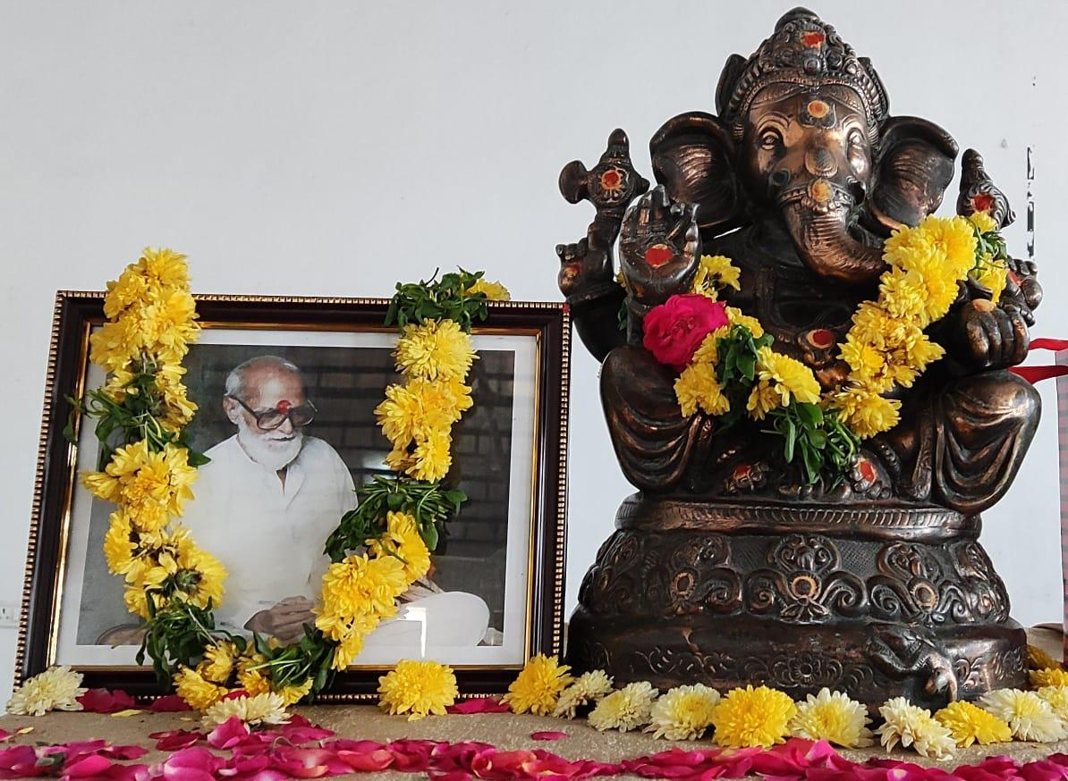
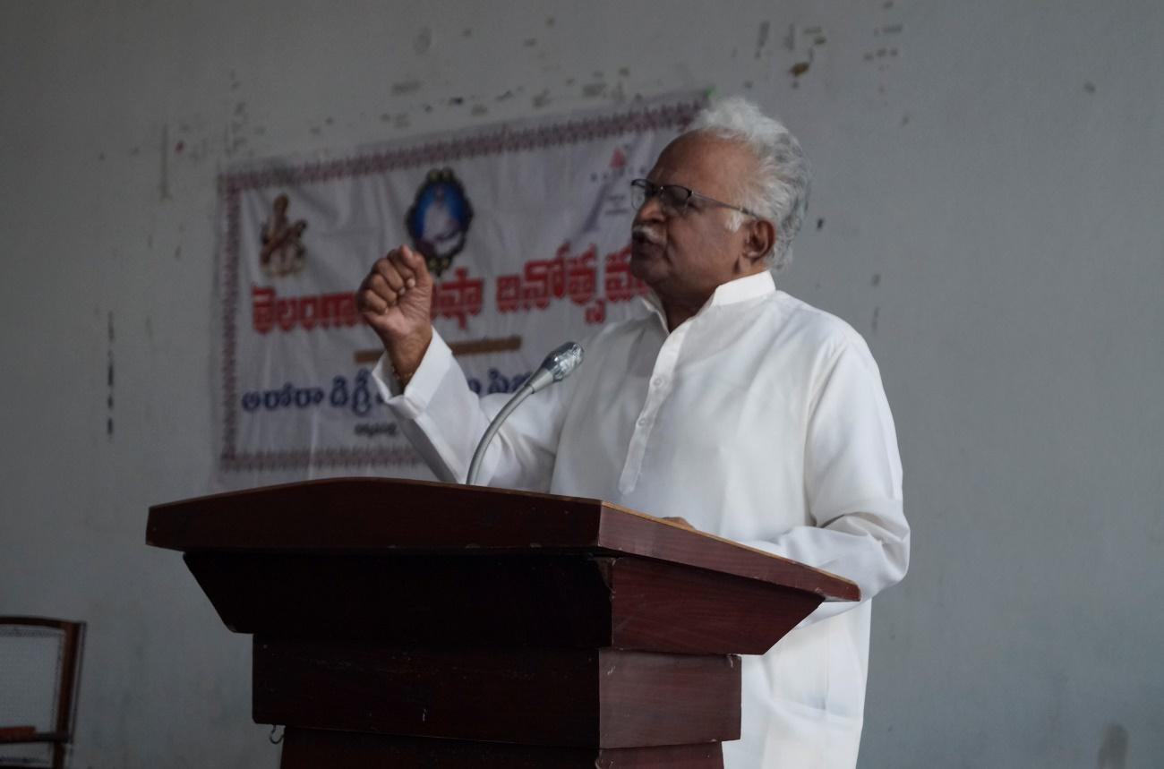
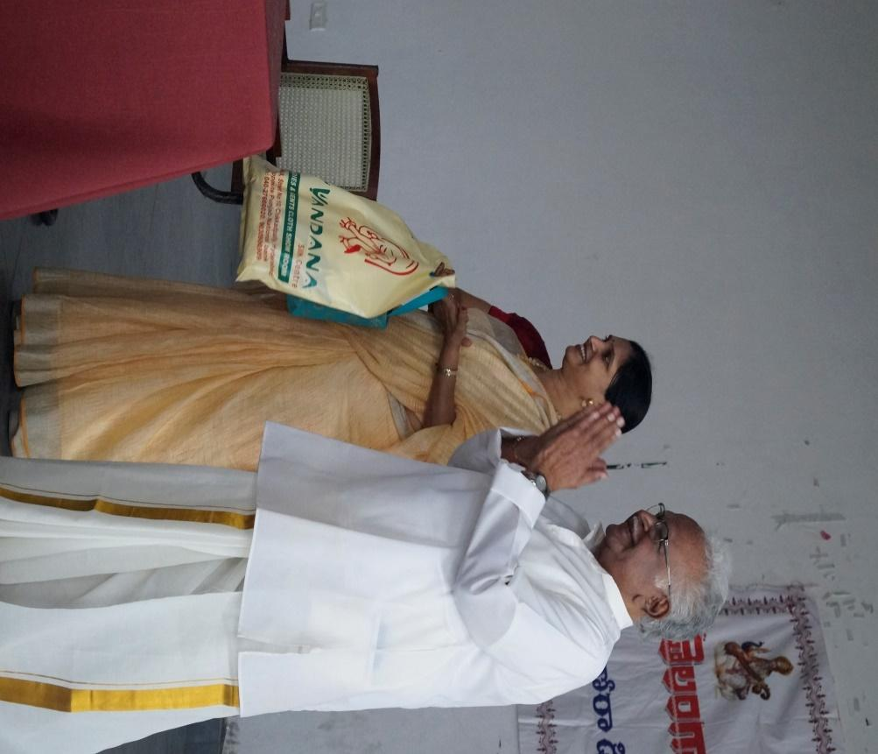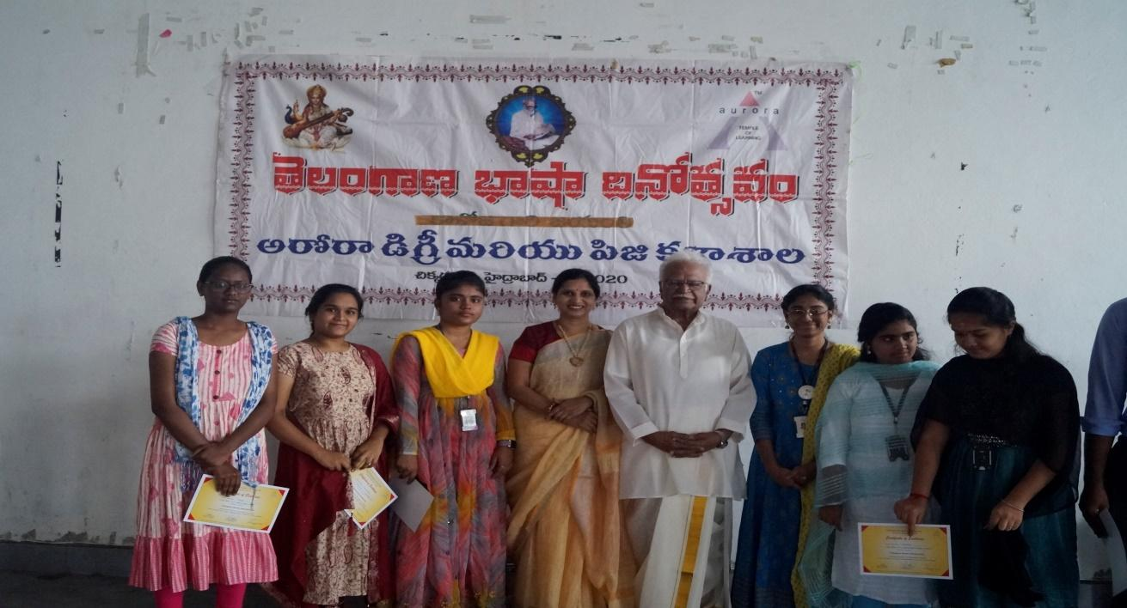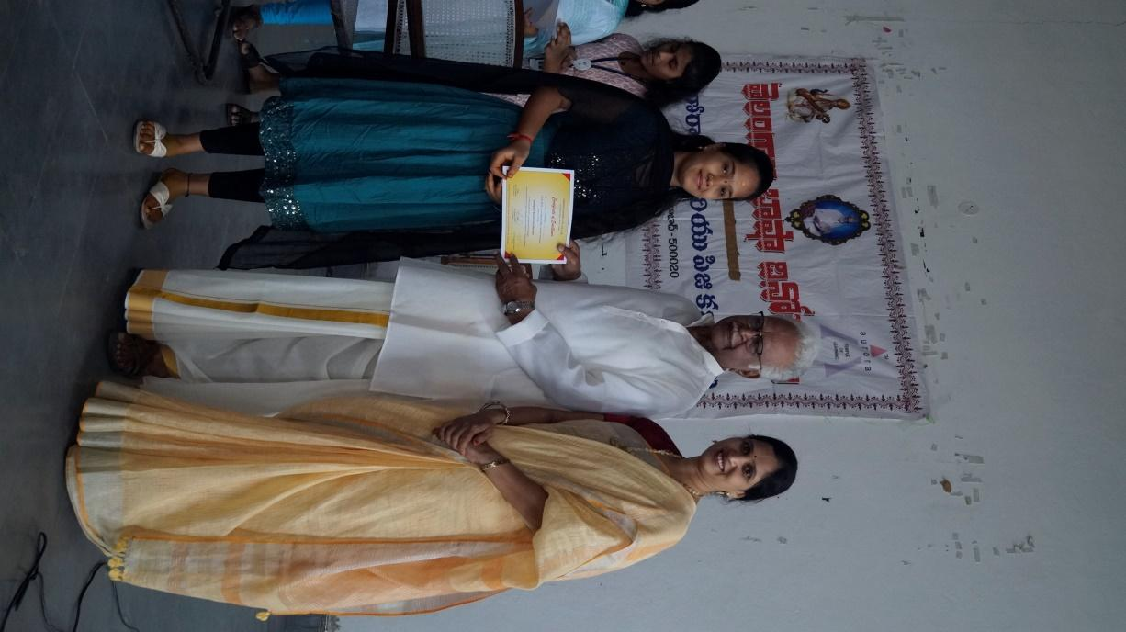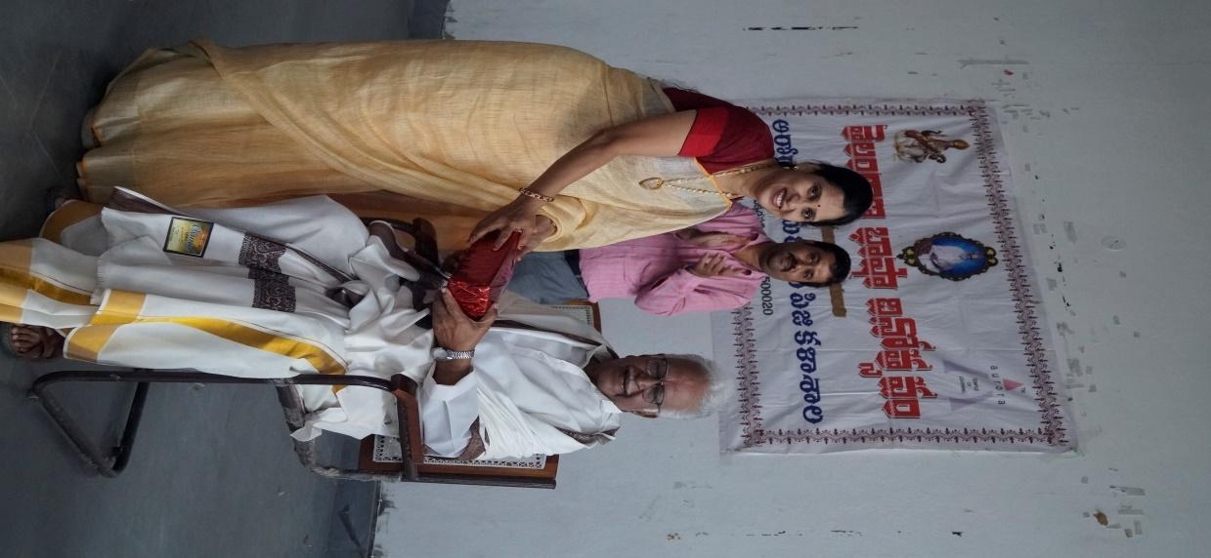
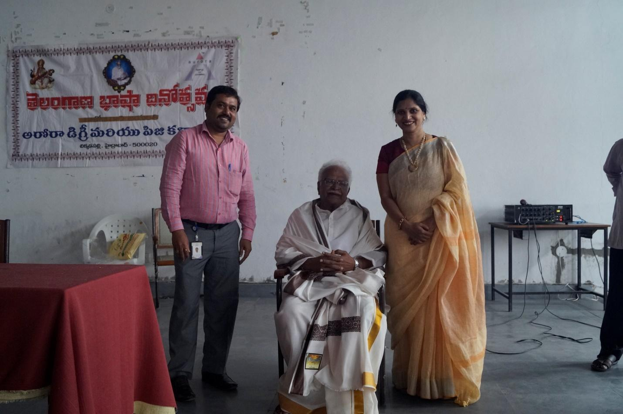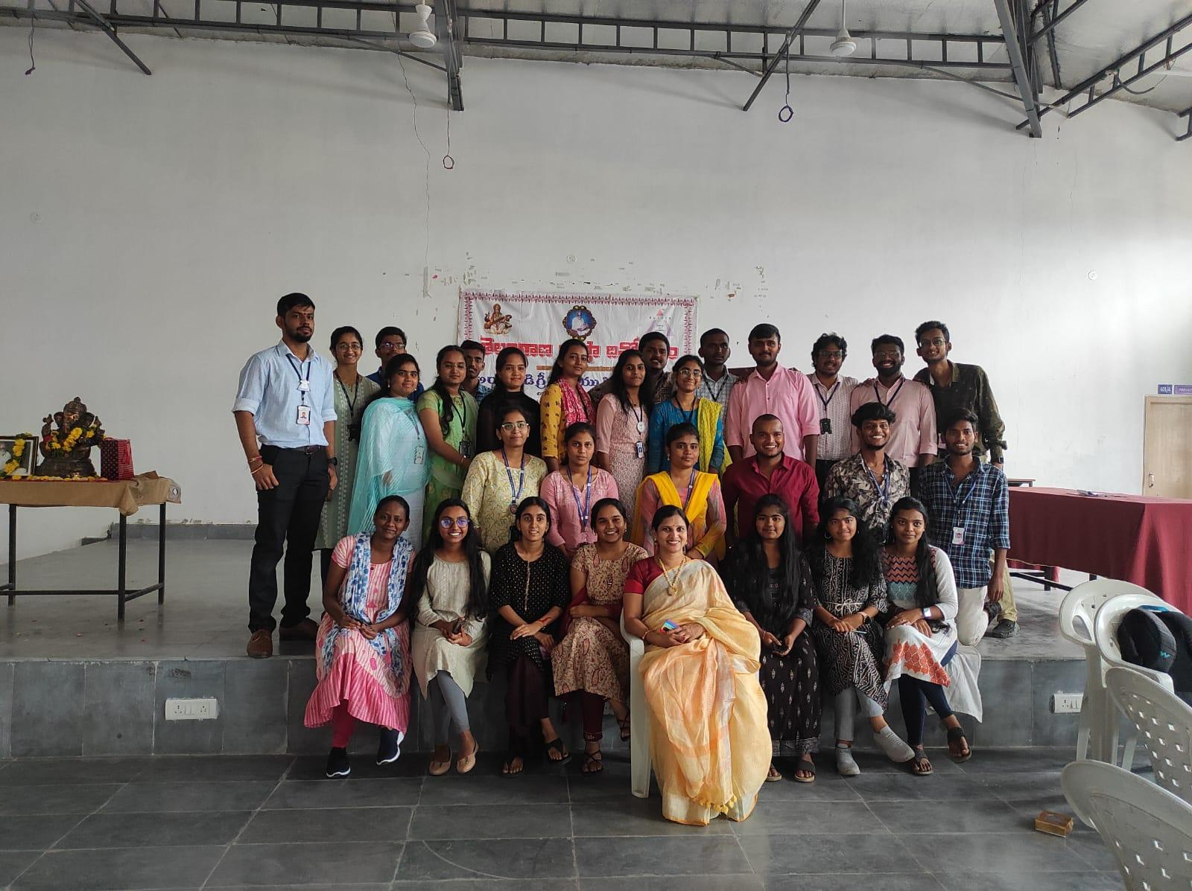
8. GUEST PROFILE (IF ANY): Dr.Kolakaluri Enock, is an Indian writer, teacher, and former Vice Chancellor of Sri Venkateswara University, Tirupati

FEED BACK IF ANY:
The Event was a learning experience for all the volunteers. The volunteers learnt many skills such as crowd management, communication skills and inspired a sense of responsibility towards the society. It was wonderful experience which they never had before, Students expressed their gratitude for this opportunity
9. EVENT / ACTIVITY NOTICE
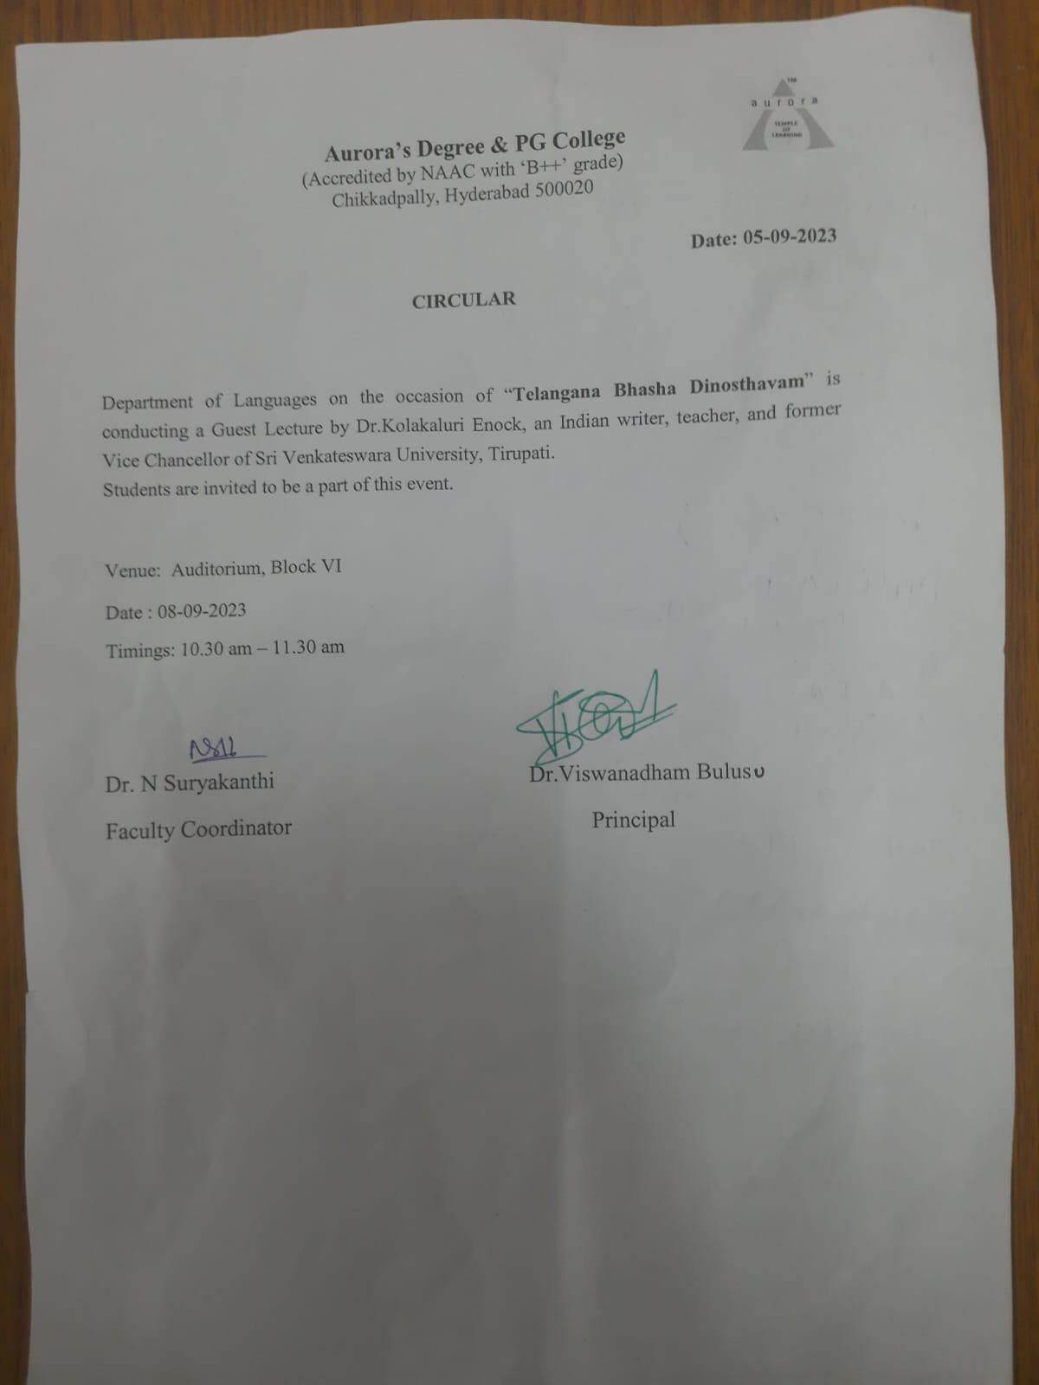
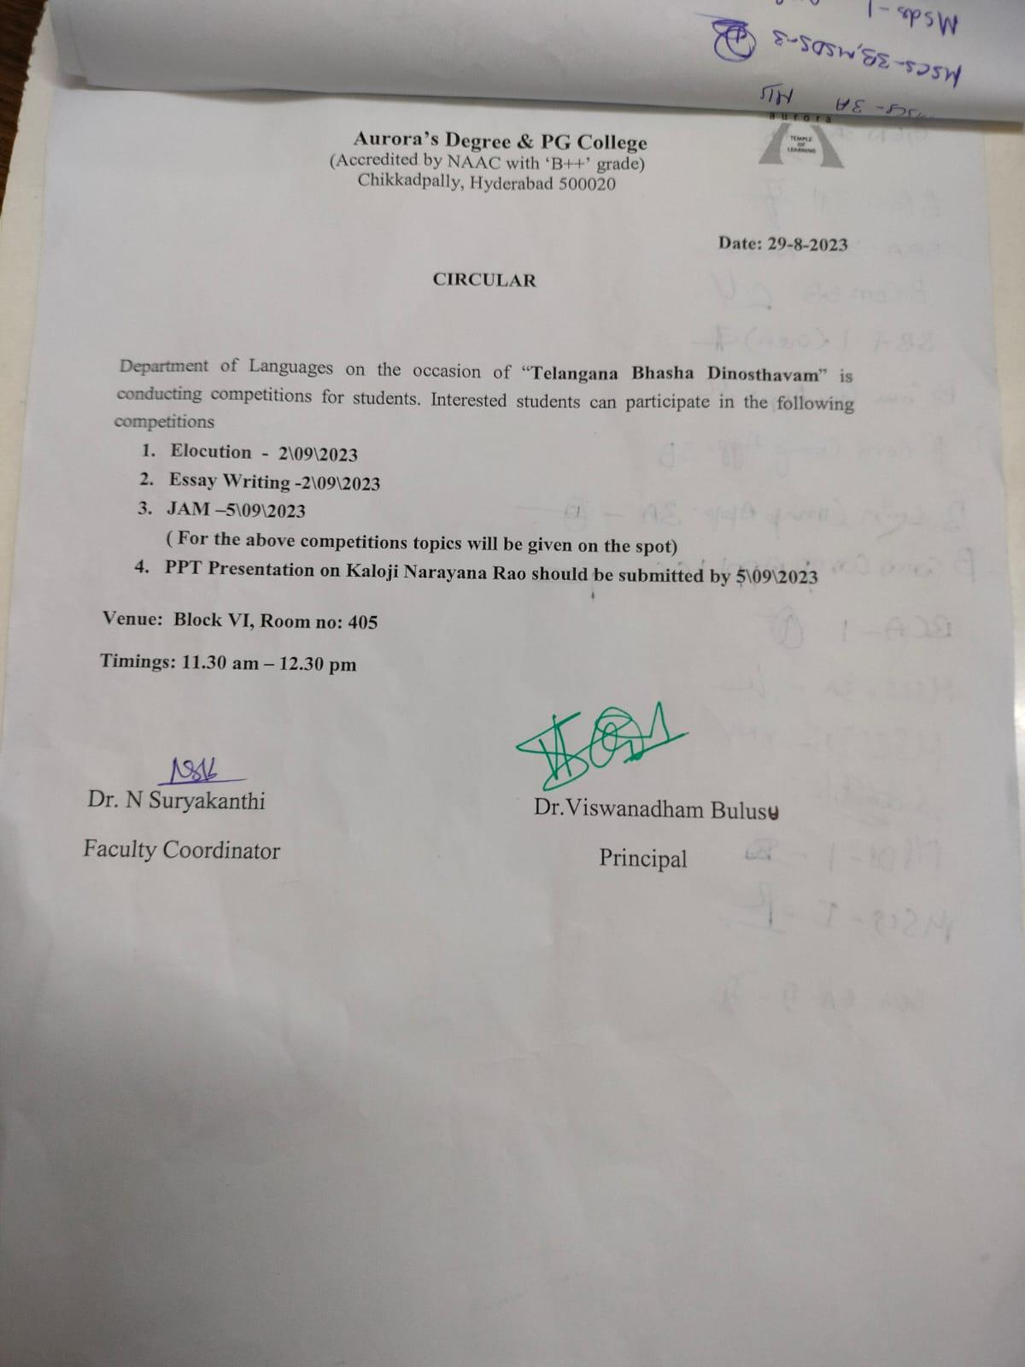

10.EVENT/ACTIVITY PROPOSAL
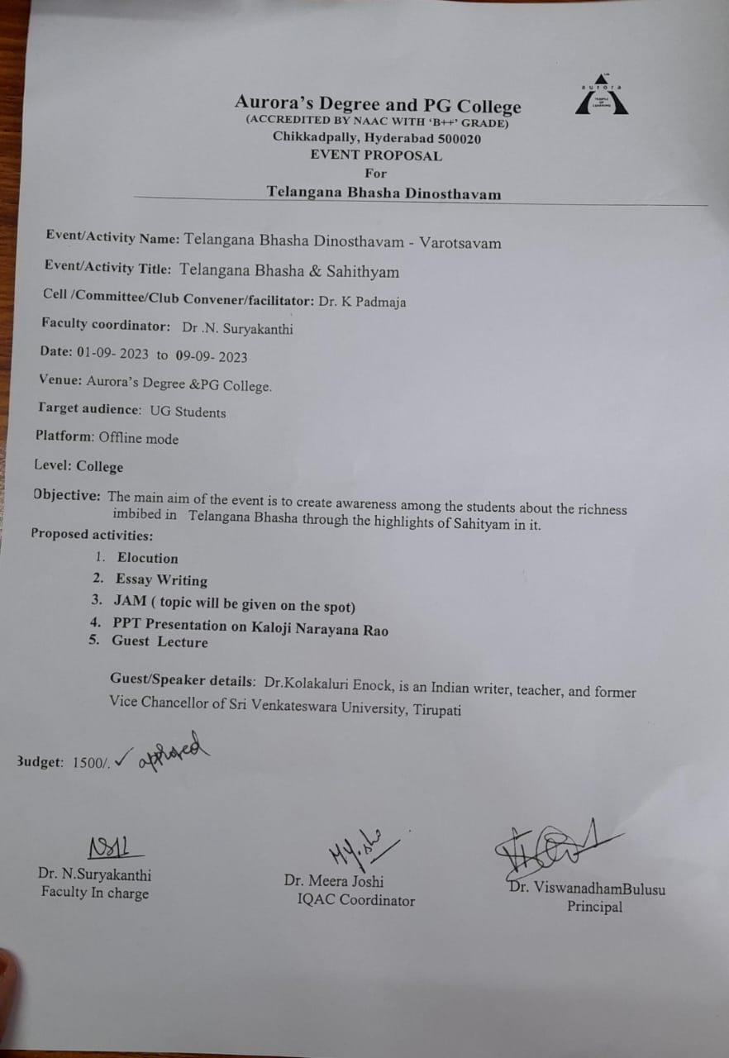

11. RECEIPTS (IF ANY) - NA
12. CERTIFICATES (IF ANY) - https://mail.google.com/mail/u/1?ui=2&ik=2c57021975&attid=0.1&permmsgid=msg-f:1776999749694817631&th=18a92bdb7e84855f&view=att&disp=inline&realattid=f_lm7k60nt0

13. LETTERS OF COMMUNICATION (IF ANY)-Yes

Invitation for Telangana Bhasha Dinosthavam as Chief Guest & Key note Speaker Reg .
Surya Kanthi <suryakanthin@adc.edu.in> | Tue, Sep 5, 12:37 AM (7 days ago)
to prof.kolakaluri.enoch

Good morning sir

PFA
One attachment • Scanned by Gmail
5 nh September 2023

To
Dr. Kolakaluri Enock,
Professor of Telugu

Respected Sir,

Sub: Invitation for Telangana Bhasha Dinosthavam as Chief Guest &amp; Key note Speaker
Reg .
We are glad to invite you for the Telangana Bhasha Dinosthavam to be held on 8th
September 2023 at our Aurora’s Degree and PG College, Chikkadpally, Hyderabad as a Guest
and Keynote Speaker. Your presence will be highly beneficial to our students .

Telugu Workshop: Telangana Bhasha Dinosthavam
Date &amp; Time : 08-09- 2023
Venue : Aurora’s Degree &amp; PG College,
Chikkadpally , Hyderabad.
Target audience : UG Students
PRINCIPAL
Dr. Viswanadham Bulusu
Aurora’s Degree and PG College

తెలంగాణ భాషా దినోత్సవం - 09-9-2023
Surya Kanthi <suryakanthin@adc.edu.in> | Sat, Sep 9, 12:26 AM (5 days ago)
to faculty

Good Morning Sir/Madam, PFA
One attachment • Scanned by Gmail -

