Aurora’s Degree & PG College
(ACCREDITED BY NAAC WITH 'B++' GRADE)
Chikkadpally, Hyderabad 500020

EVENT / ACTIVITY DETAILED REPORT

NAME OF THE EVENT / ACTIVITY | Alumni Lecture
TYPE OR TITLE OF EVENT / ACTIVITY | A Case study on Generative AI and Machine Learning in Banking
FACULTY INCHARGE | K. Parimala Diana Sudhir (Coordinator)  & Y.Aruna Rekha(Coordinator)
DEPARTMENT/CELL/COMMITTEE/CLUB | Statistics
DATE | 18-11-2023
VENUE | Aurora’s Auditorium
TARGET AUDIENCE | PG(Statistics, Applied Statistics) & MSDs/MSCs Final year students

- LIST OF FACULTY COORDINATORS (DEPARTMENT):
K. Parimala Diana Sudhir (Coordinator)
Y.Aruna Rekha (Coordinator)

- LIST OF THE STUDENT COORDINATORS (NAME, ROLL NO, CLASS & SECTION)
- Name: Chavi.B
Roll No: 1051-22-507-002
Class: PG Statistics 2nd year
- Name: Praveena Krishna
Roll No: 1051-22-508-005
Class: PG Applied Statistics 2nd year
- LIST OF THE PARTICIPANTS
All PG (Statistics, Applied Statistics) & MSCS/MSDS final year students
participated.

- PARAGRAPH ABOUT THE PROCEEDINGS (TILL THE END OF THE EVENT):
Day : 18-11-2023
Speaker: 1) Mohammed Azam Mohiuddin Manager/Consultant (Analytics & Insights) , TCS, Bangalore.
Th department of statistics organized an Alumni lecture related to a case study for PG (Statistics, Applied Statistics) & MSDs/MSCs final year students. Ms. Parimala Diana Sudhir, coordinator introduced the speaker Mr.Mohammed Azam Mohiuddin Manager/Consultant (Analytics & Insights, TCS, Bangalore, an Alumnus of BSC-MSCs 2009. Ms. Y. Aruna Rekha honored our guest with a bouquet. Mr.Mohammed Azam shared his personal and professional journey since graduating from Aurora. highlighted the steps, challenges, and pivotal moments that shaped his career in Analytics & Insights at TCS.
Presented a practical case study from his experience, from a project that he encountered during his work. Discussed on a detailed statistical approach on “Credit Card Analysis”. Also shared practical insights and tips for students entering the workforce, aiming for higher studies in statistics & related fields. Emphasized on networking, internship opportunities, & how to leverage academic knowledge in the industry. Advised students on the key skills, competencies, potential areas for growth and mindsets required to succeed in the analytics industry. Around 150 students participated.
The lecture was informative and relevant to Statistics students, providing valuable insights into the world of placements and career preparation.

- INCOME : Nil
EXPENDITURE : Rs 500
- EVENT PHOTOS (MIN 2 MAX 4):
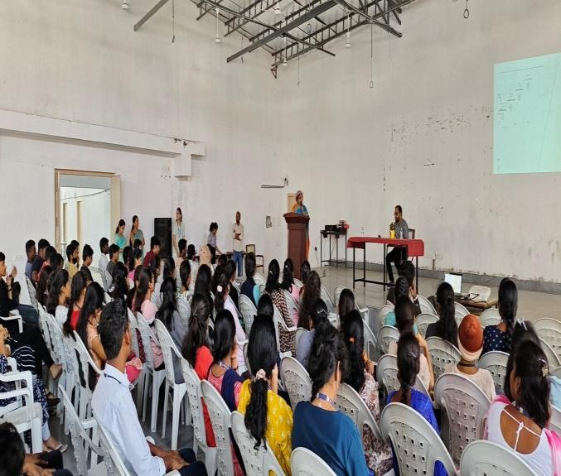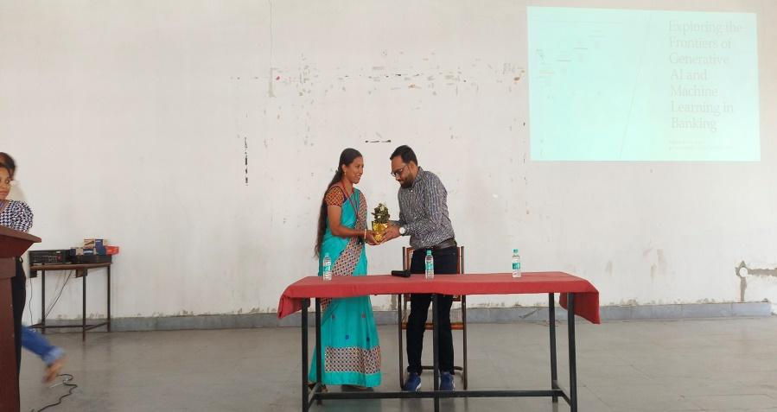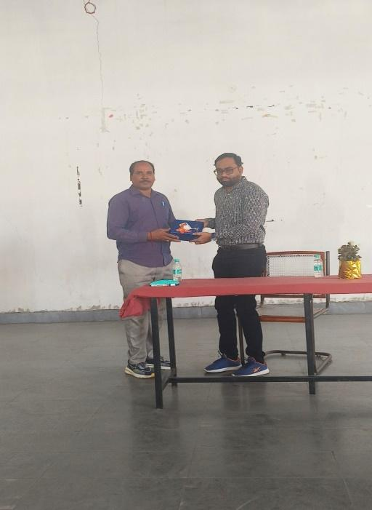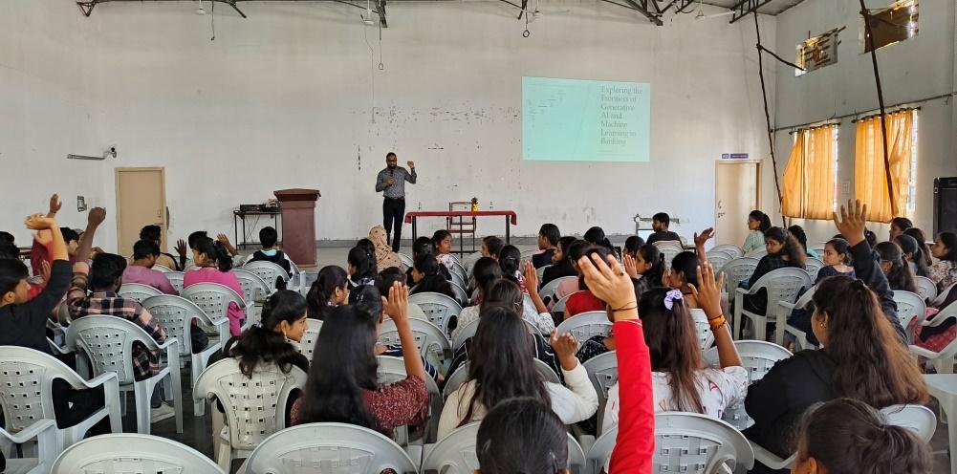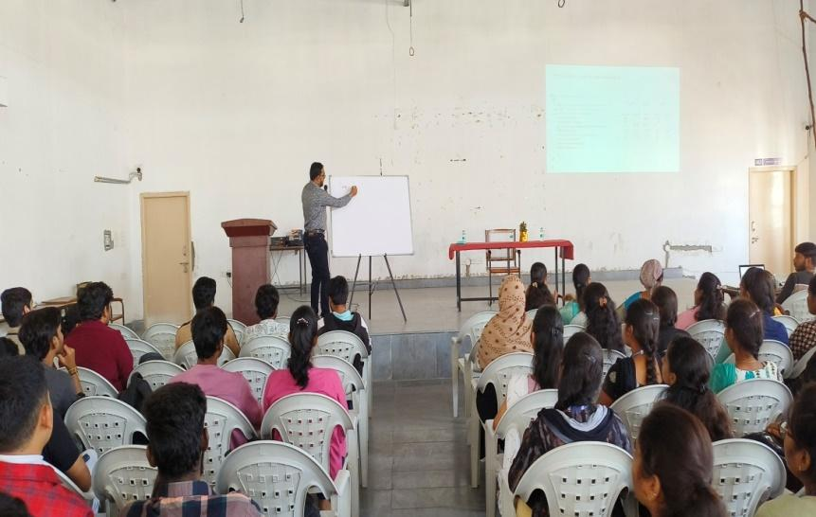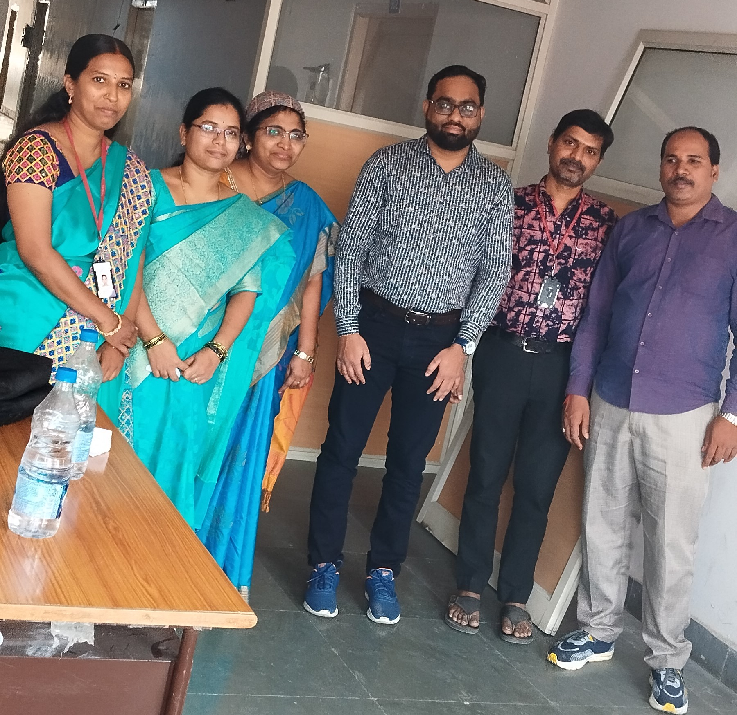

- ATTACHMENTS:
EVENT/ACTIVITY PROPOSAL

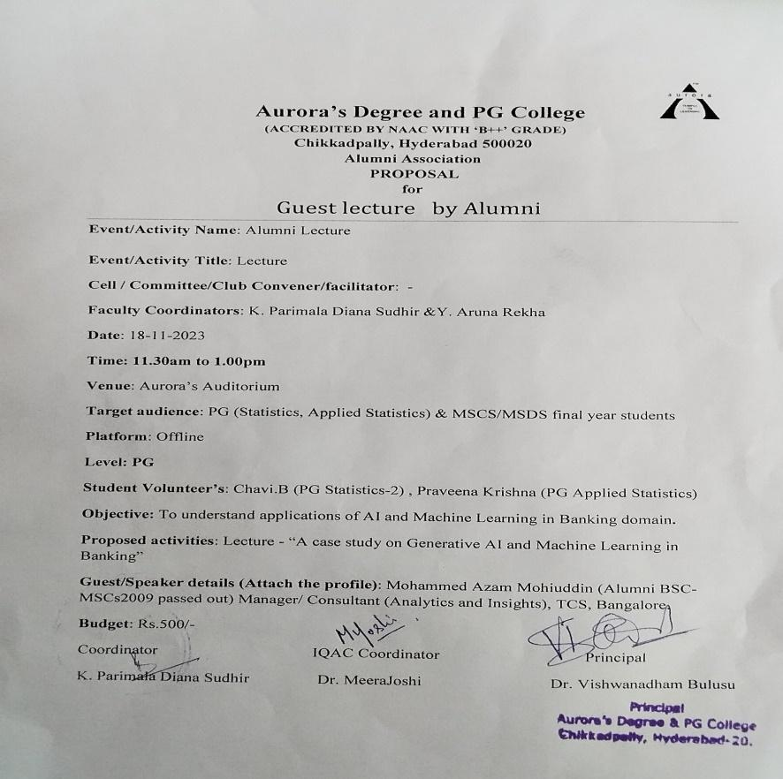

EVENT / ACTIVITY NOTICE
RECEIPTS (IF ANY): Nil
CERTIFICATES (IF ANY):Nil
LETTERS OF COMMUNICATION (IF ANY): (Communicated through WhatsApp.)
