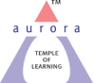
Aurora’s Degree & PG College
(ACCREDITED BY NAAC WITH 'B++' GRADE)
Chikkadpally, Hyderabad 500020

EVENT / ACTIVITY DETAILED REPORT

NAME OF THE EVENT / ACTIVITY | NATIONAL MATHEMATICS DAY
TYPE OR TITLE OF EVENT / ACTIVITY | DEPARTMENT EVENT
FACULTY INCHARGE | A SANDHYA RANI
DEPARTMENT/CELL/COMMITTEE/CLUB | MATHEMATICS
DATE | 21-12-2023 & 22-12-23
VENUE | DR. B R AMBEDKAR HIGH SCHOOL, BAGHLINGAMPALLY.
TARGET AUDIENCE | HIGHER CLASS STUDENTS

- PROGRAM SCHEDULE
S. No. | Scheduled Programme | Date & Time
1 | Essay writing and drawing competitions at Dr. BR Ambedkar High School | 1:30 Pm to 2:30 PM  on 21-12-2023
2 | Quiz Competition at Dr. BR Ambedkar High School | 2:30 Am to 3:15 PM  on 21-12-2023
3 | Displaying the charts | 22-12-2023

- LIST OF FACULTY COORDINATORS (DEPARTMENT)
FACULTY NAME | DEPARTMENT | POSITION
A Sandhya Rani | Mathematics | Coordinator

- LIST OF THE STUDENT COORDINATORS (NAME , ROLL NO, CLASS & SECTION)
S.NO | NAME OF THE COORDINATOR | CONTACT NUMBER | CLASS & SECTION
1 | G Sai Yashaswi Reddy | 9948876603 | MCA 1A
2 | K Pravalika | 9391198242 | MCA 1A
3 | K Gurumurthy | 9010963871 | MCA 1A
4 | T Dillep | 6300290684 | MCA 1A
5 | E Akhil | 9700235189 | MCA 1A

- LIST OF THE PARTICIPANTS (NAME , ROLL NO, CLASS & SECTION, NO OF GIRLS, BOYS, CASTE )
A) Drawing Competition participants from Dr. BR Ambedkar High School
S. No. | Name of the participant | Class | Roll No.
1 | S. Keertan Babu | IX | 28
2 | D Sai Teja | IX | 40
3 | D Sashi Kumar | VIII | 28
4 | T Harsha Vardhan | VIII | 19
5 | R Sai Rikshith | IX | 39
6 | K Nikhil Teja | IX | 32
7 | R Venkatesh | VIII | 34
8 | M Manoj | VIII | 22
9 | A Harish | IX | 24
10 | B Ravi Das | VIII | 37

B) Essay writing Competition participants from Dr. BR Ambedkar High School
S. No. | Name of the Participants | Class | Roll No.
1 | A Prasad Kumar | IX | 35
2 | H Srineethu | IX | 15
3 | M Supriya | IX | 15
4 | M Amreen Bhanu | IX | 2
5 | Y Akshaya | IX | 1
6 | S Rishika | IX | 9
7 | P Neha Bathul | IX | 8
8 | S Mamtha | IX | 6
9 | D Sujeeth Narayan | IX | 34
10 | K Charan | IX | 20
11 | S Sai Nikilesh | IX | 38
12 | S Krithika | IX | 4
- Quiz Competition participants from Dr. BR Ambedkar High School
S. No. | Name of the Participants | Class | Roll No.
1 | S. Keertan Babu | IX | 28
2 | D Sai Teja | IX | 40
3 | D Sashi Kumar | VIII | 28
4 | T Harsha Vardhan | VIII | 19
5 | R Sai Rikshith | IX | 39
6 | H Srineethu | IX | 15
7 | M Supriya | IX | 15
8 | M Amreen Bhanu | IX | 2
9 | Y Akshaya | IX | 1
10 | S Rishika | IX | 9
11 | P Neha Bathul | IX | 8

- PARAGRAPH ABOUT THE PROCEEDINGS (TILL THE END OF THE EVENT)

The Department of Mathematics upholds a tradition of celebrating the birthdays of eminent mathematicians to instill interest and a research-oriented approach to mathematics. On December 22, 2023, the department commemorated the 136th birthday of Srinivasa Ramanujan.
As part of the event, on December 21, a quiz competition, pencil sketching, and essay writing contest were organized for 8th and 9th-grade students from Dr. B R Ambedkar High School, Baghlingampally. Over 30 students enthusiastically participated, and winners received stationery items to aid them in their upcoming exams. It's noteworthy to mention that these competitions were originally scheduled for December 22, 2023. However, due to the alumni meet planned at the school on that day, we were requested to advance the competitions to December 21, 2023.

- INCOME AND EXPENDITURE:
S.No | Item | Expenditure
1 | Exam Pads | 200
2 | Chocolates | 200
3 | Pens & Pencils | 200
4 | Sketch pens | 100
5 | Drawing Books | 150
 | Total | 850 Rs

Note: The mentioned amount was spent from department budget.

- EVENT PHOTOS ( MIN 2 MAX 4)

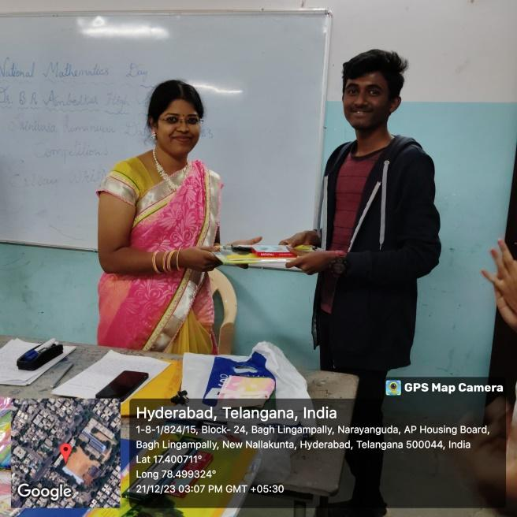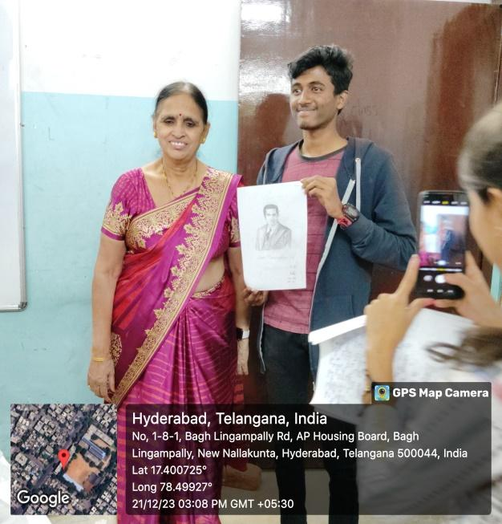
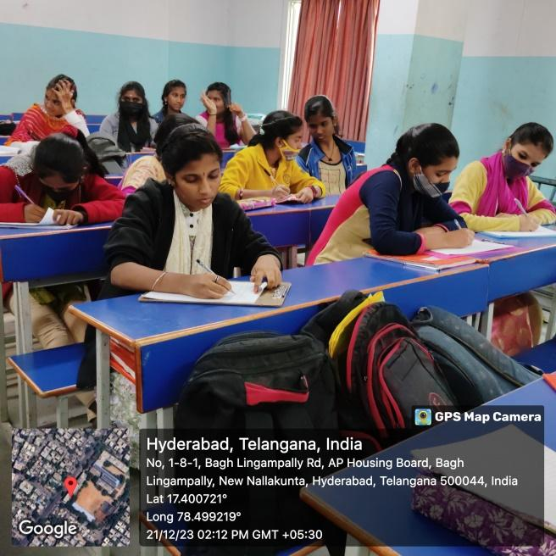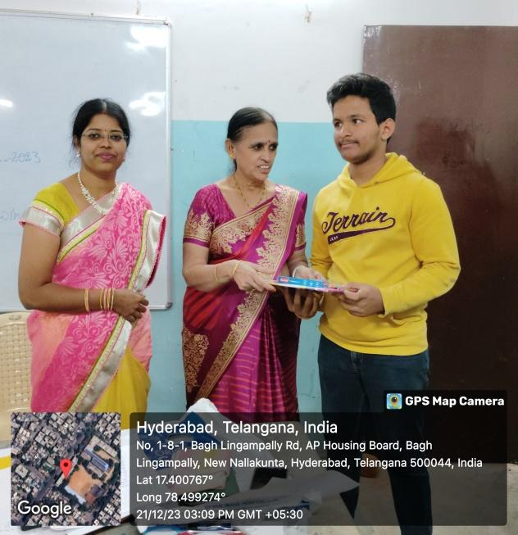

- ATTACHMENTS:
EVENT/ACTIVITY PROPOSAL
