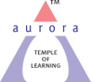
Aurora’s Degree & PG College
(ACCREDITED BY NAAC WITH 'B++' GRADE)
Chikkadpally, Hyderabad 500020

EVENT / ACTIVITY LONG REPORT

NAME OF THE EVENT / ACTIVITY | Guest Lecture on Agile Methodology
TYPE OR TITLE OF EVENT / ACTIVITY | Guest Lecture on Agile Methodology
FACULTY INCHARGE | N. Padmashri
DEPARTMENT/CELL/COMMITTEE/CLUB | Computer Science
DATE | 30-12-2023
VENUE | Aurora’s Degree & PG College, Block VI RTC X ROAD’S, Hyderabad
TARGET AUDIENCE | PG Students –MSc Computer Science.

OBJECTIVE:
The guest lecture on Agile Methodology aimed to enhance the understanding of postgraduate students about Agile principles and practices in project management.
BRIEF ABOUT THE EVENT
An event titled Agile Methodology for the students of M.Sc computers on 30th December,2023. Students were informed prior with the help of a circular. The Speaker of this event was
N. Praveen Raju, Project Manager in one of the top 5 MNC company. The session started at 10:00 am with a brief introduction of the speaker followed by the guest. A seasoned professional with extensive experience in Agile methodologies delivered an insightful lecture. Fundamental concepts of the lecture covered foundational Agile principles, emphasizing flexibility, collaboration, and iterative development. Practical examples and case studies were presented to illustrate successful Agile implementations in diverse industries. And also students actively engaged in a Q&A session, seeking clarification on Agile concepts and their application in different contexts.
OUTCOME
Clear understanding of Agile principles. Insight into real-world Agile applications and
Enhanced knowledge of iterative development and collaboration.
EVENT PHOTOS:(MIN 2 MAX 4): 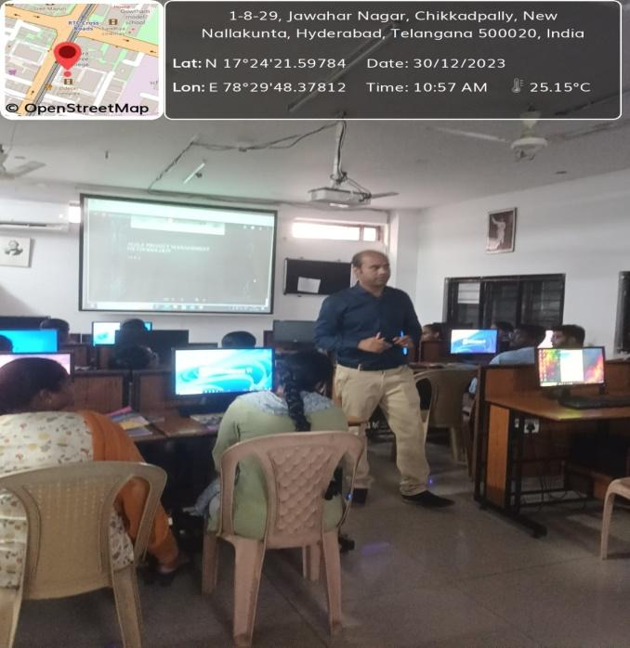

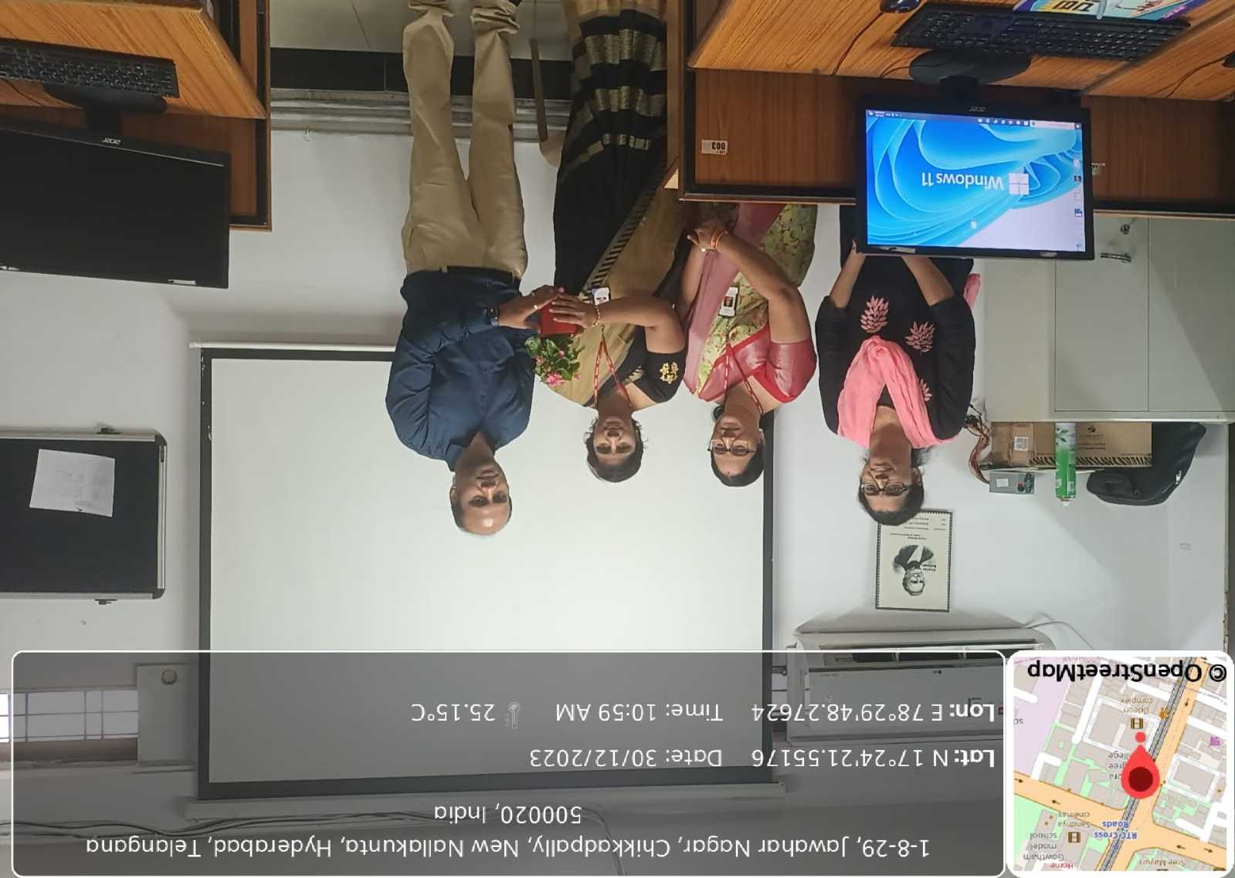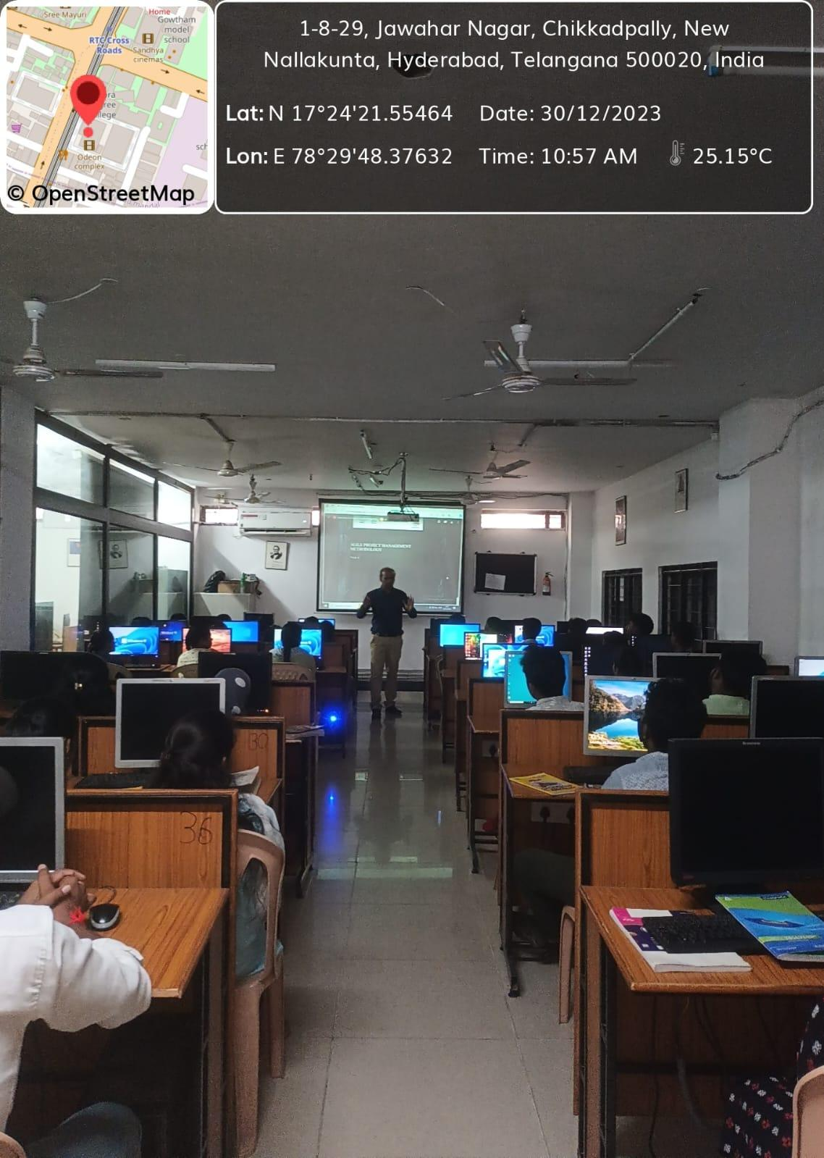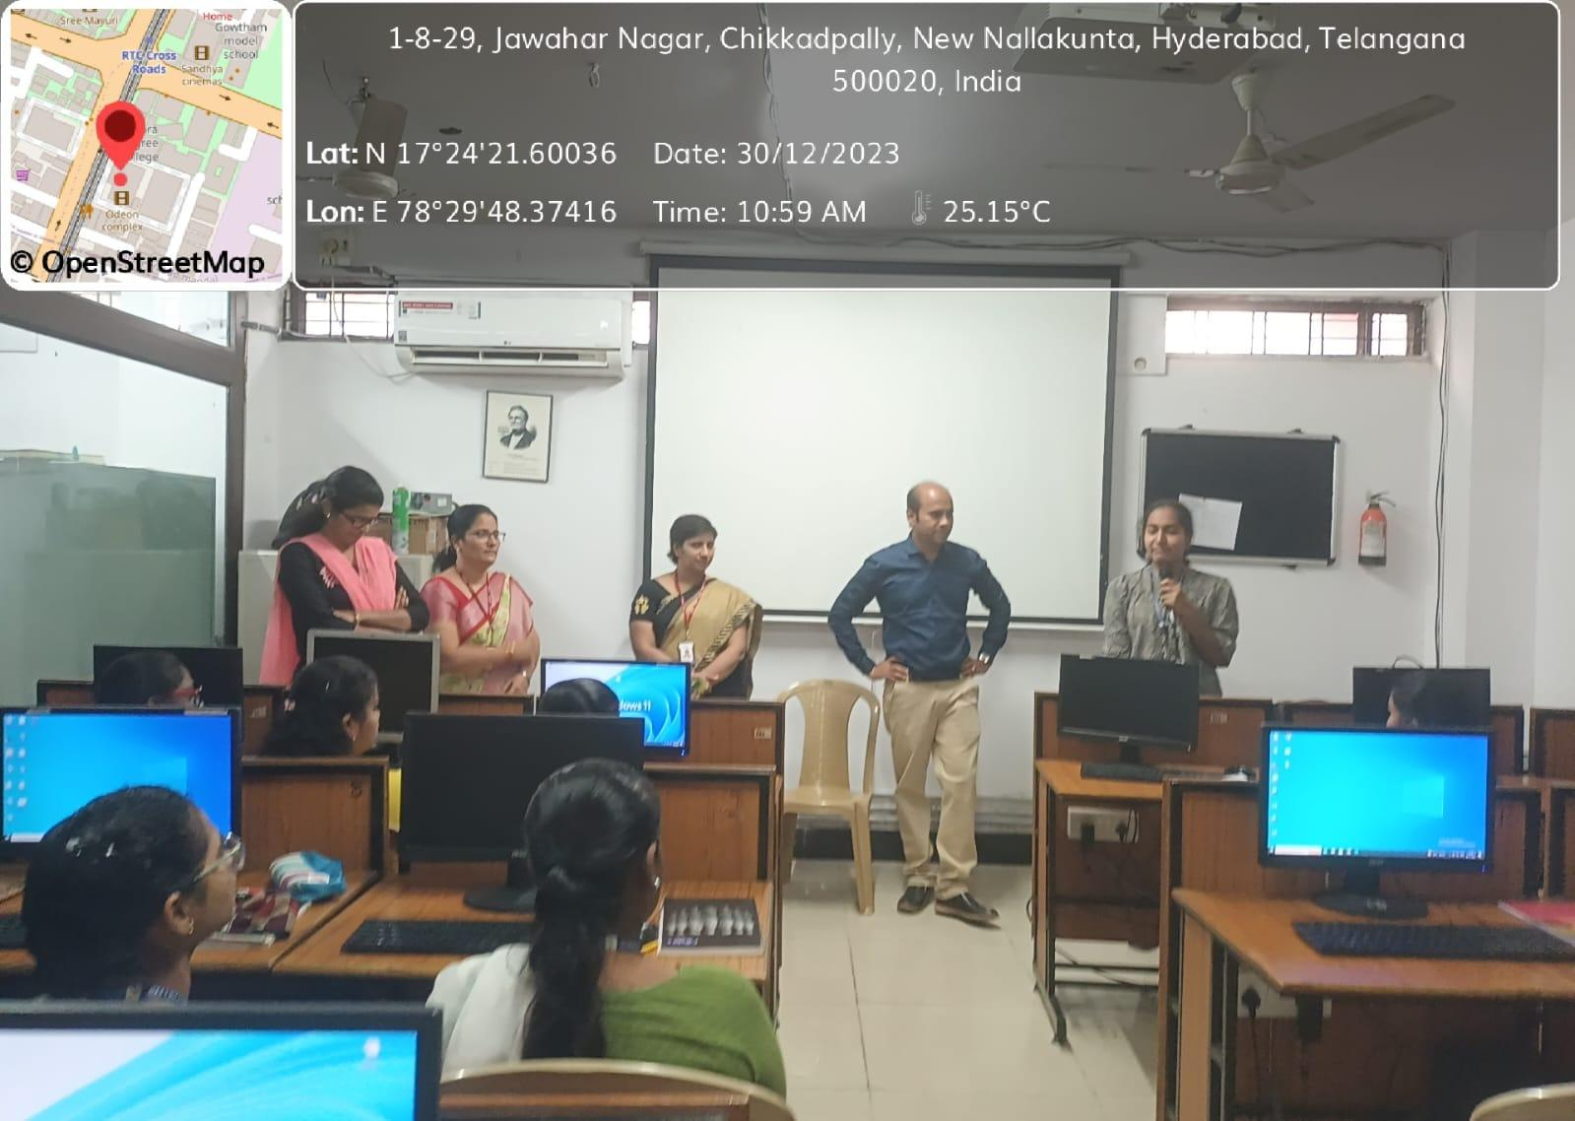

STUDENTS ATTENDED:
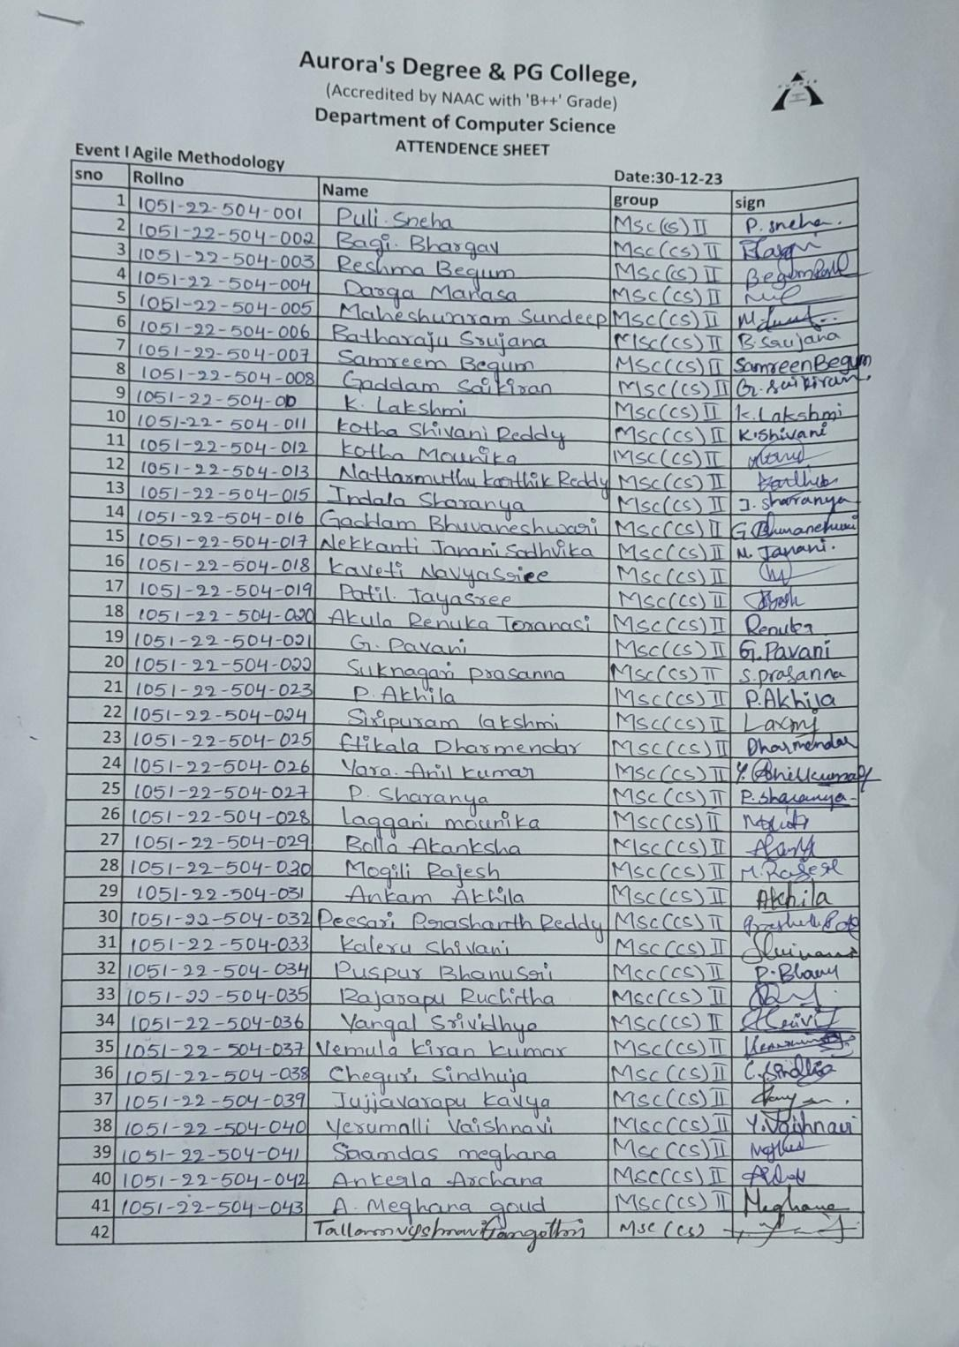
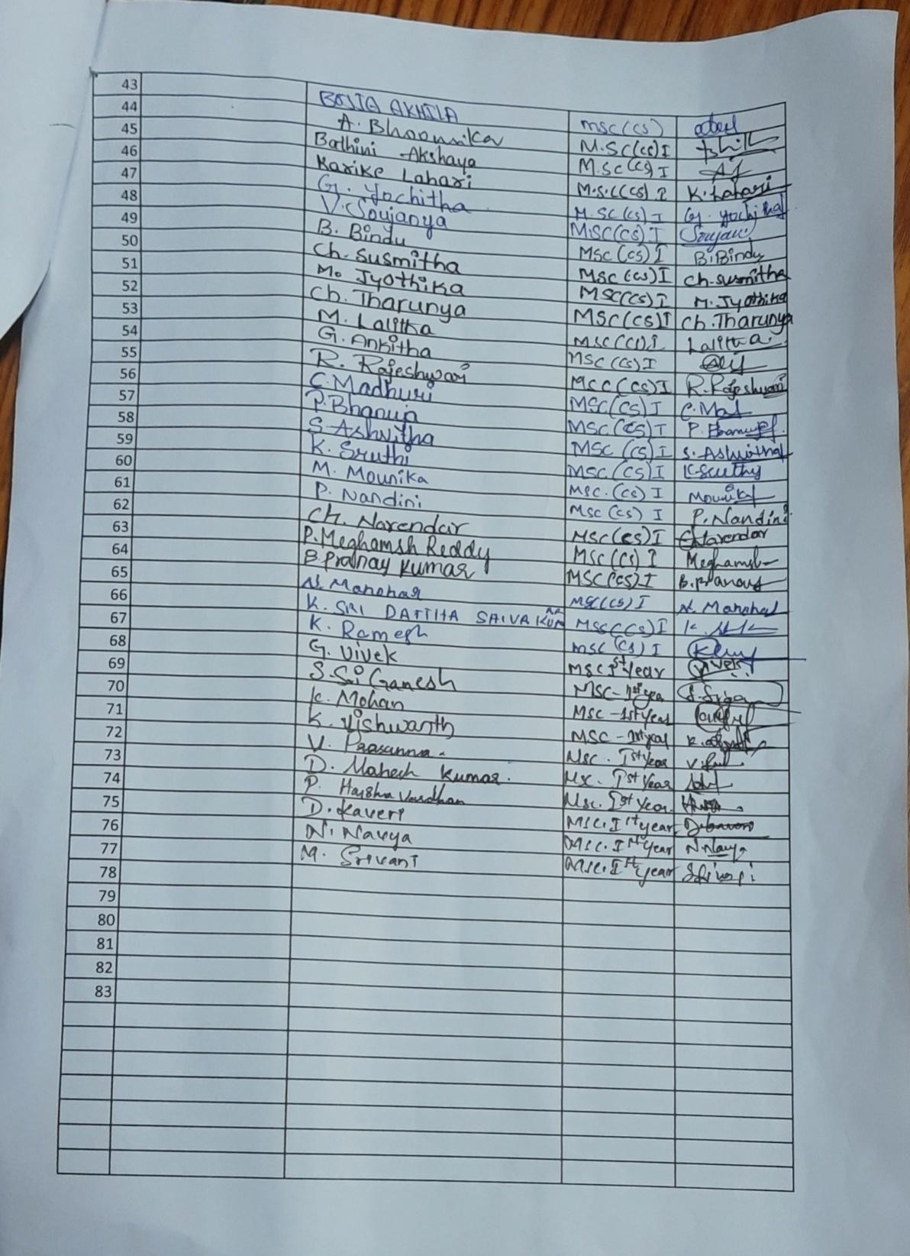

- GUEST PROFILE (IF ANY)-NA
- FEED BACK IF ANY-NA
- ATTACHMENTS:
EVENT/ACTIVITY PROPOSAL: Hardcopy
EVENT / ACTIVITY NOTICE:NA
RECEIPTS (IF ANY):NA
CERTIFICATES (IF ANY):NA
LETTERS OF COMMUNICATION (IF ANY):NA

