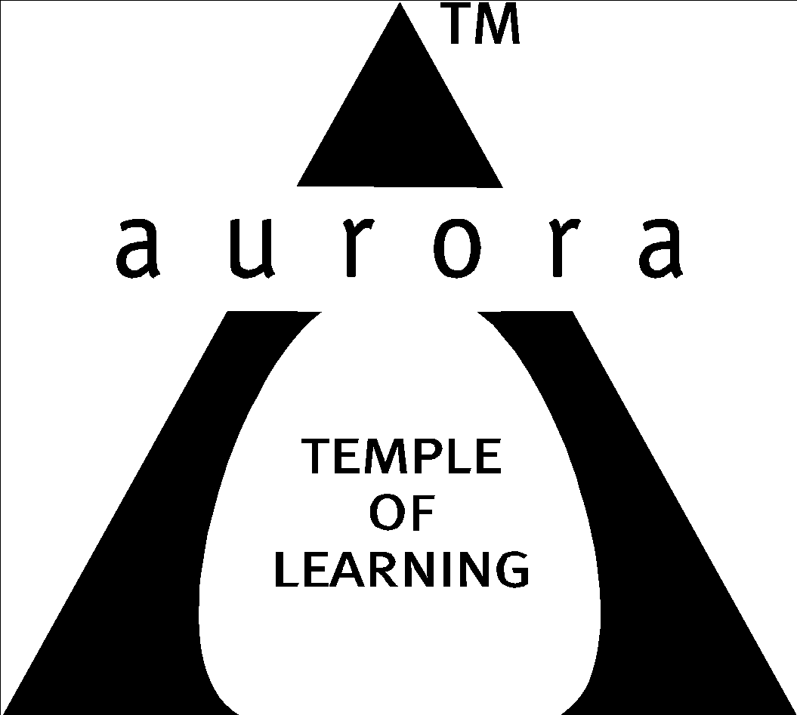
Aurora’s Degree & PG College
(ACCREDITED BY NAAC WITH 'B++' GRADE)
Chikkadpally, Hyderabad 500020

EVENT / ACTIVITY DETAILED REPORT
NAME OF THE EVENT / ACTIVITY | Visit to Dangoria Trust, Narsapur, Medak district
TYPE OR TITLE OF EVENT / ACTIVITY | Social Activity /Field trip
FACULTY INCHARGE | K. Parimala Diana Sudhir (Coordinator)  Anjaneyulu.P (Coordinator) & Saikishore. N (Coordinator)
DEPARTMENT/CELL/COMMITTEE/CLUB | Statistics
DATE | 15-7-2023
VENUE | Dangoria Trust, Narsapur, Medak
TARGET AUDIENCE | PG Statistics & Applied Statistics (Previous &final)

- LIST OF FACULTY COORDINATORS (DEPARTMENT): K. Parimala Diana Sudhir
Anjaneyulu. P & Saikishore. N
- LIST OF THE STUDENT COORDINATORS (NAME, ROLL NO, CLASS & SECTION)
- Name: Sai Vandana
Roll No: 1051-21-507-002
Class: PG 2nd Year (Statistics)
- Name: Niharika
Roll No: 1051-21-508-006
Class: Pg 2nd year (Applies statistics)
- Name: Praveena Krishna
Roll No: 1051-22-508-005
Class: Pg 1st year (Applies statistics)
- Name: Chavi Boob
Roll No: 1051-22-507-002
Class: Pg 1st year (Statistics)
- LIST OF THE PARTICIPANTS
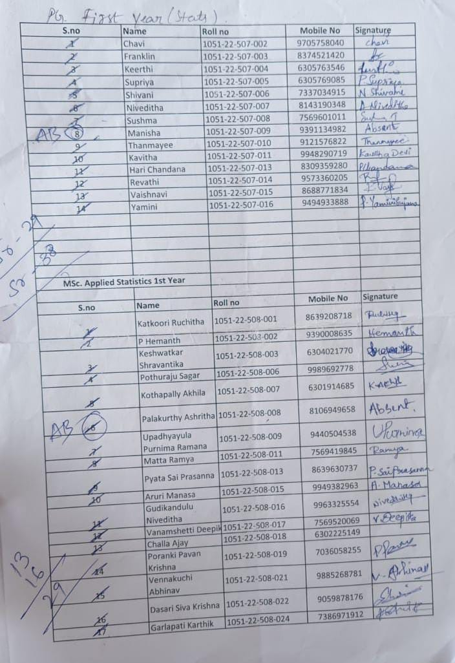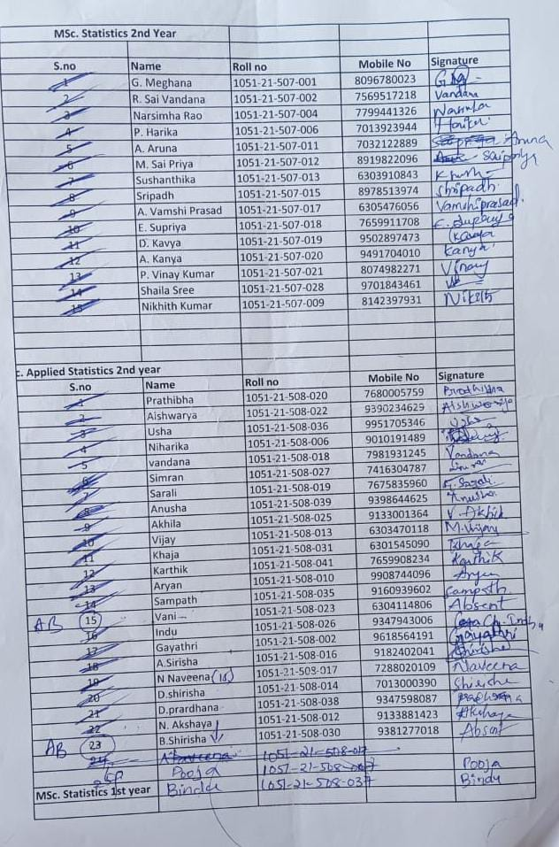

- PARAGRAPH ABOUT THE PROCEEDINGS (TILL THE END OF THE EVENT):
Day : July 15th 2023
Speaker: Dr. Mehtab Bamji, Emeritus Scientist (Retd from NIN),

The department of Statistics initiated to visit Dangoria trust, Narsapur village, Medak under the guidance of Dr. Mehtab Bamji, Emeritus Scientist for PG Statistics & Applied Statistics students. We got an opportunity to interact with the team of faculty of Dangoria trust and the programmes done by them. We have started at 9.30am along with Dr. Mehtab Bamji and reached the trust at Narsapur village by 11.40am. The Murthy sir and his team welcomed us and arranged a lecture in their seminar hall. Immediately all of us were given their special drink Millets ambali which were prepared by them. Dr. Mehtab Bamji mam gave a lecture on the activities and initiatives of the Dangoria trust and hospital. She explained the importance of nutrition of in our diet and their “Food Processing Unit.” Also explained the project on “Food and Nutrition Security of pregnant women in rural areas of Medak district. Later Mrs. Lakshmi gave a talk on the importance and their nutritional values of organic products and the various items prepared by the “Food Processing Unit”. After the lunch visited the field at Pedda Chinta Kunta village which is 5 km away from Narsapur. The farmer explained about vermicompost preparation and its importance to all. Then we reached back to Dangoria Trust Narsapur village and the students visited old-age home, interacted with them, performed dance activities for them, and 67 students along with 3 faculty visited the trust. We hired RTC bus with a 10hrs package. Special thanks to RTC driver.
Participants: PG Statistics & Applied Statistics students, Faculty, Dr. Mehtab Bamji (Emeritus Scientist), Murthy sir and his team, Mrs. Lakshmi, farmers, old-age home residents, RTC driver.
Timeline:
9:30 AM: Departure from the starting point with Dr. Mehtab Bamji and the students.
11:40 AM: Arrival at the Dangoria Trust in Narsapur village.
11:40 AM - 12:00 PM: Warm welcome by Murthy sir and his team, followed by a refreshing drink of Millets ambali.
12:00 PM - 1:00 PM: Lecture by Dr. Mehtab Bamji about the activities and initiatives of the Dangoria trust and hospital. Emphasis on nutrition and the "Food Processing Unit".
1:00 PM - 2:00 PM: Mrs. Lakshmi's talk on the nutritional values of organic products and various items prepared by the "Food Processing Unit".
2:00 PM - 3:00 PM: Lunch break.
3:00 PM: Visit to Pedda Chinta Kunta village (5 km away from Narsapur) to learn about vermicompost preparation and its importance from a farmer.
Late afternoon: Return to Dangoria Trust, Narsapur village.
Late afternoon - Evening: Visit to an old-age home, interaction with the residents, and dance performances by the students.
Total Participants: 67 students and 3 faculty members.
Transport: RTC bus with a 10-hour package.
Key Highlights:
Lecture on Trust Activities: Dr. Mehtab Bamji delivered a lecture on the Dangoria Trust's activities, focusing on nutrition and the "Food Processing Unit". She also discussed the project related to "Food and Nutrition Security of pregnant women in rural areas of Medak district".
Nutritional Values of Organic Products: Mrs. Lakshmi explained the importance and nutritional values of organic products while showcasing the various items produced by the "Food Processing Unit".
Field Visit: A visit to Pedda Chinta Kunta village allowed participants to learn about vermicompost preparation and its significance for farming.
Old-age Home Interaction: The students visited an old-age home, engaging with the residents through interactions and dance activities.
Appreciation for RTC Driver: Special thanks were given to the RTC driver for their service throughout the day.
Overall, our visit provided a comprehensive understanding of the Dangoria Trust's initiatives, nutrition-related projects, organic product processing, sustainable farming practices, and community engagement through the old-age home visit. It's clear that the visit was well-organized and offered valuable insights to the students.
- INCOME AND EXPENDITURE: Students collected- -Rs 22,080 (69* 320/ per head)
a) Transport (Bus Fair +toll + permit) - Rs. 2,830
b) Lunch - Rs.5,950
c) Donated Rice +Dal for the trust - Rs.2,400
d) Farmer in the field - Rs.200
e) Miscellaneous (transport charges to RTC office) - Rs100

Total Expenditure - Rs.22,080

- EVENT PHOTOS (MIN 2 MAX 4):
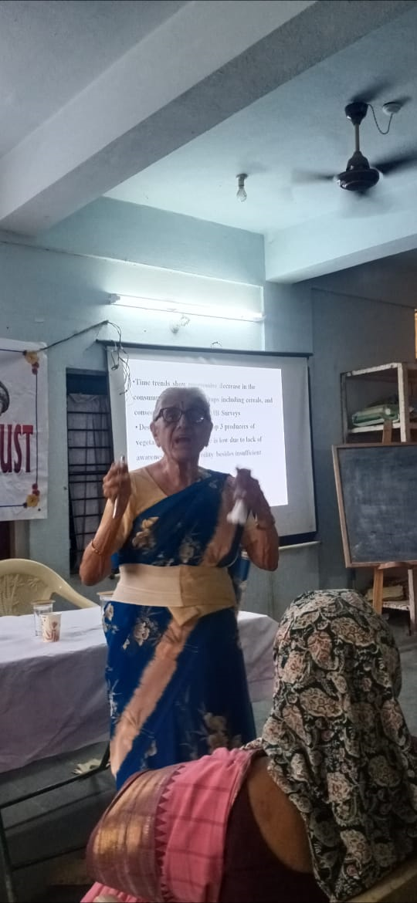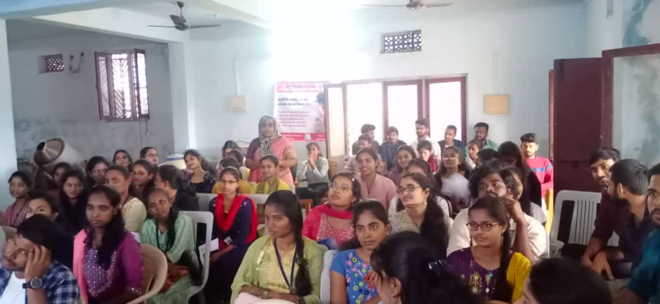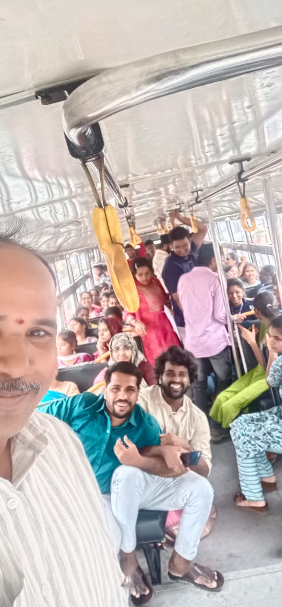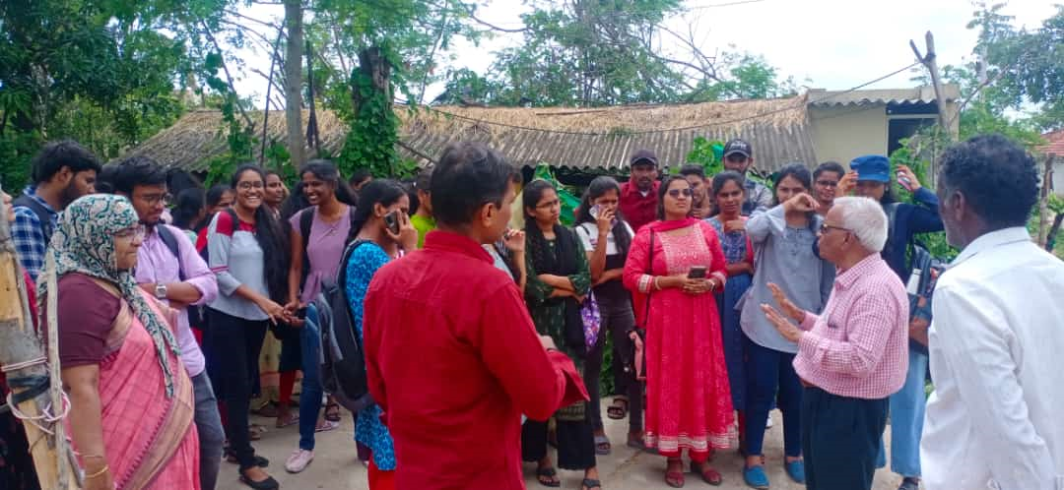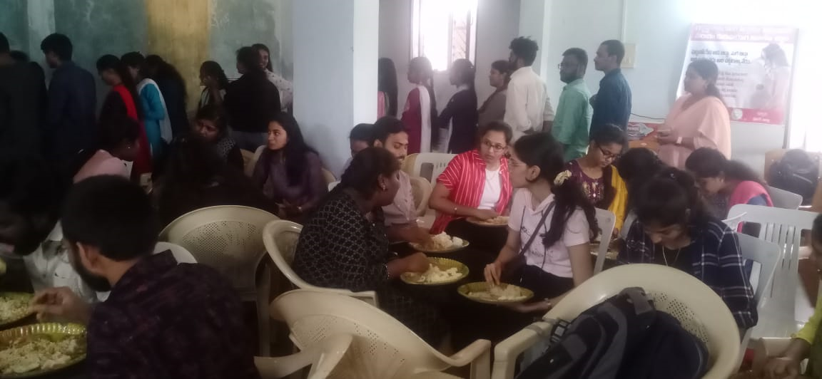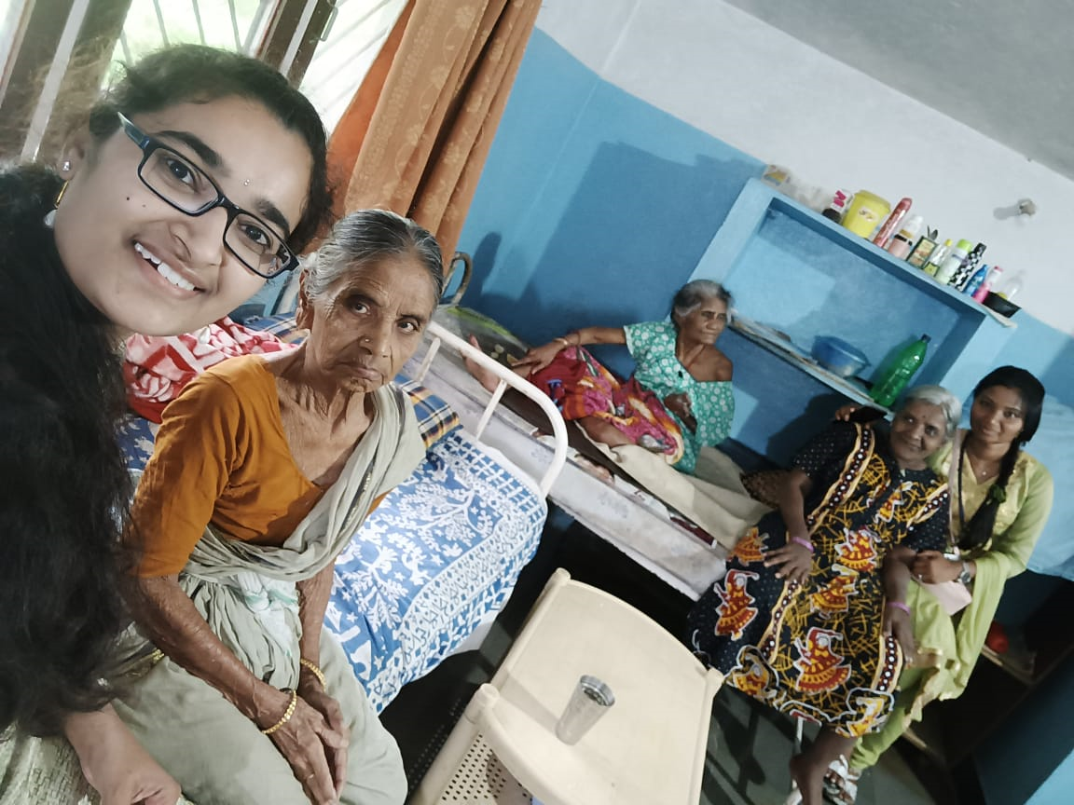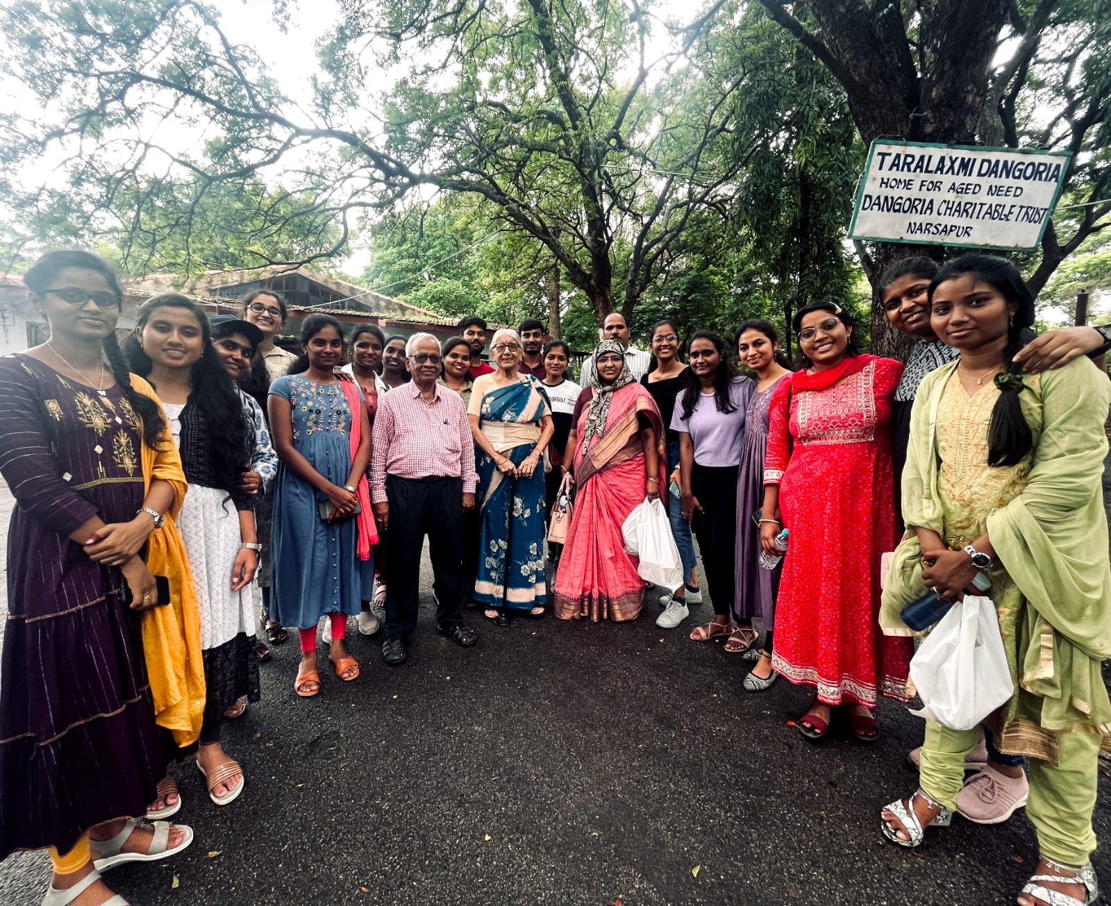

- GUEST PROFILE (IF ANY):

Mahtab Bamji —Multiple prestigious awards winning nutritionist who loves social work
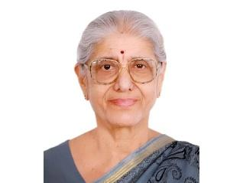

NIN, Bamji and their contributions
In the male dominated world of Indian Science, Dr Bamji, has carved a name for herself with outstanding contributions in nutrition and leadership. During the long innings at the NIN (1965-94), she rose to become Director Grade Scientist. She has been listed among the all time top women scientists of India by the Department of Biotechnology (DBT) recently.
Dr Bamji did her graduation in Chemistry, post-graduation in Biochemistry and PhD in biochemistry (1961) from the Bombay University. She moved to the Indian Institute of Science (IISc), Bangalore. During 1962-65, she was in the USA as post-doctoral Fellow/Research Associate at Tufts University Boston and Johns Hopkins University, Baltimore.
In a way Dr Bamji is one of the protégé’s of Dr C Gopalan, considered the doyen of Nutrition Science in India. Among others were Dr Vinodini Reddy, Dr Kamala Krishnaswamy (both became Directors of NIN) and Dr Prema Ramachandran.
A biochemist by training, Dr Bamji has made significant contributions in the field of nutritional biochemistry, particularly, towards the understanding of the aetiology of B vitamins deficiencies, development of tests for assessing vitamin nutrition status as well as for estimating the incidence of B-vitamins deficiency and its daily requirement in the community.
In addition, her work centred on interactions between nutrition and drugs such as contraceptive steroids, and identification of Carnitine as a vitamin. She has published 100 papers, written several book chapters, reviews, popular articles and reports and edited a very popular textbook on human nutrition.

Association with Dangoriya Charitable Trust
Post retirement in 1994 she has been associated with the Dangoriya Trust, a well known charitable organisation run by Dr Devyani. Dr Bamji holds the ICMR Emeritus Scientist position as well as the Honorary Scientist of the Indian National Science Academy (INSA).
She has been trying to evolve models for improving health, food, and nutrition and environment security in villages of Medak district, Telangana State, through scientific and technological interventions. With the Trust and support of scientific departments a food processing-cum-training centre has been established to prevent wastage of farm produce for nutrition security and women’s livelihood too.

Cause of women in science & science popularization
Dr Bamji has been a vocal proponent of greater involvement of women in the sciences. She chaired the DST and DBT committees on Science and Technology for Women; chaired the INSA Committee on Science Career for Indian Women and was the Chairperson of the National Task Force for Women in Science during 2006-2009.
At the same time, she was deeply involved in popularisation of science through an active role in organisations such as Indian Women Scientists Association and Jana Vignana Vedika.
She co-chaired the Health Panel for Vision 2020, one of the 17 areas identified by A P J Abdul Kalam, former India President in the Vision 2020 documents brought out by the TIFAC (Technology Information Forecasting and Assessment Council) un-1995. They were intended to transform India from a developing to a developed nation.
Dr Bamji was a Member of Planning Commission 10th and 11th plan working groups and Steering Committee for Science and Technology 11th plan; She also served on the INSA Council (1993-95) and Vice President during 2009-2011.
The tireless and effective interventions of the Trust that started transforming the quality of life of the villagers attracted the attention of the Department of Science and Technology (DST), which presented the national award for Development of women through science and technology.
“Our focus over the years has been on the different aspects of nutrition security — food (crop diversification using green methods of farming, backyard poultry, food processing), environment, health care, livelihood through a holistic approach,” says Dr Bamji with a sense of pride and confidence.

Awards and recognition
Dr Bamji received 21 awards and honours that include: Patwardhan Prize (1973); BC Guha Memorial Lecture Award (1987) and Jawaharlal Nehru Birth Centenary Lecture (1998) of INSA; Srikantia Memorial Oration Award (1999); National Award for Woman Scientist (2000) and; CV Raman Medal of INSA (2005).
Scientific research in the country even today does not attract many women. Exceptions like Dr Manju Sharma, who became Secretary of Dept of Biotechnology apart very few women, have reached the top echelons. The Indian Council of Medical Research was led by Dr Soumya Swaminathan, who now is the Chief Scientist at the WHO & the Secretary, DBT is Dr Renu Swarup.
Indian science requires more youngsters, especially women to power it into the future. At present information technology and computer sciences rule. The science, in general as a career comes a distant second. The contributions and zeal of Dr Bamji should be an inspiration.
- FEED BACK IF ANY:
Students enjoyed to the utmost.
- Vandana feedback:(PG Applied Statistics)
[6:12 pm, 17/07/2023] Vandana: Greetings to all The leaders...who initiated us to the event i.e. to the visit of Dangoria Trust. Firstly, it is a great experience to have a visit to the most valuable place ...it made us to learn some ethical values which these Generations may end up forgetting. Its and Educational cum resourcing tour...We helded our hearts while going but ended up filling them with lots of love and Forgiveness....We learned An edged moral “To do something, we don't need age, we need thought and heart" words can't even describe them ...but we have a peculiar respect for this thought of we knowing something....Thank you...we were blessed...
[6:14 pm, 17/07/2023] Vandana: Really I am very thankful for the trip ma'am....It really made us to understand the real life scenario...that we must at least learn and stop...Thank you ma'am
- Niharika Reddy :(PG Applied Statistics)
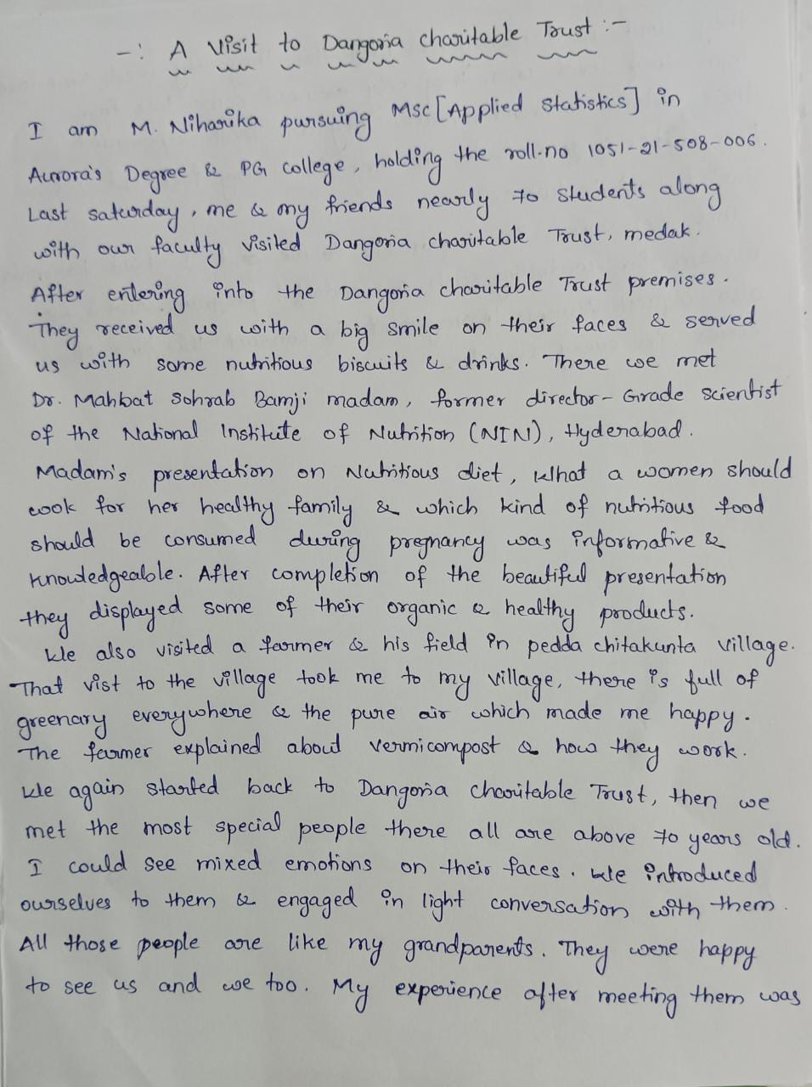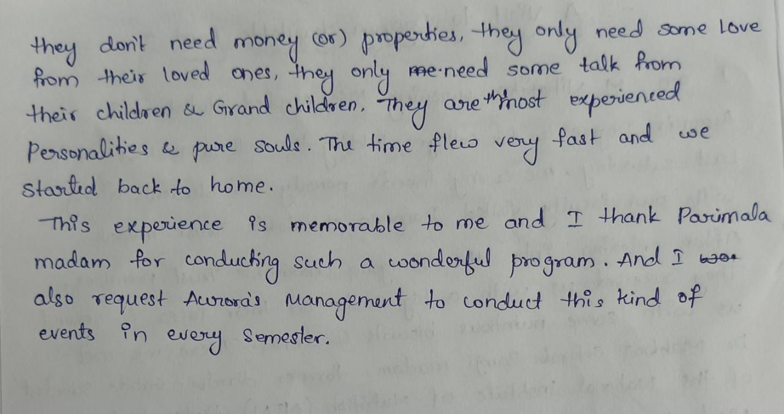
3) Vandana (PG-Statistics 2)
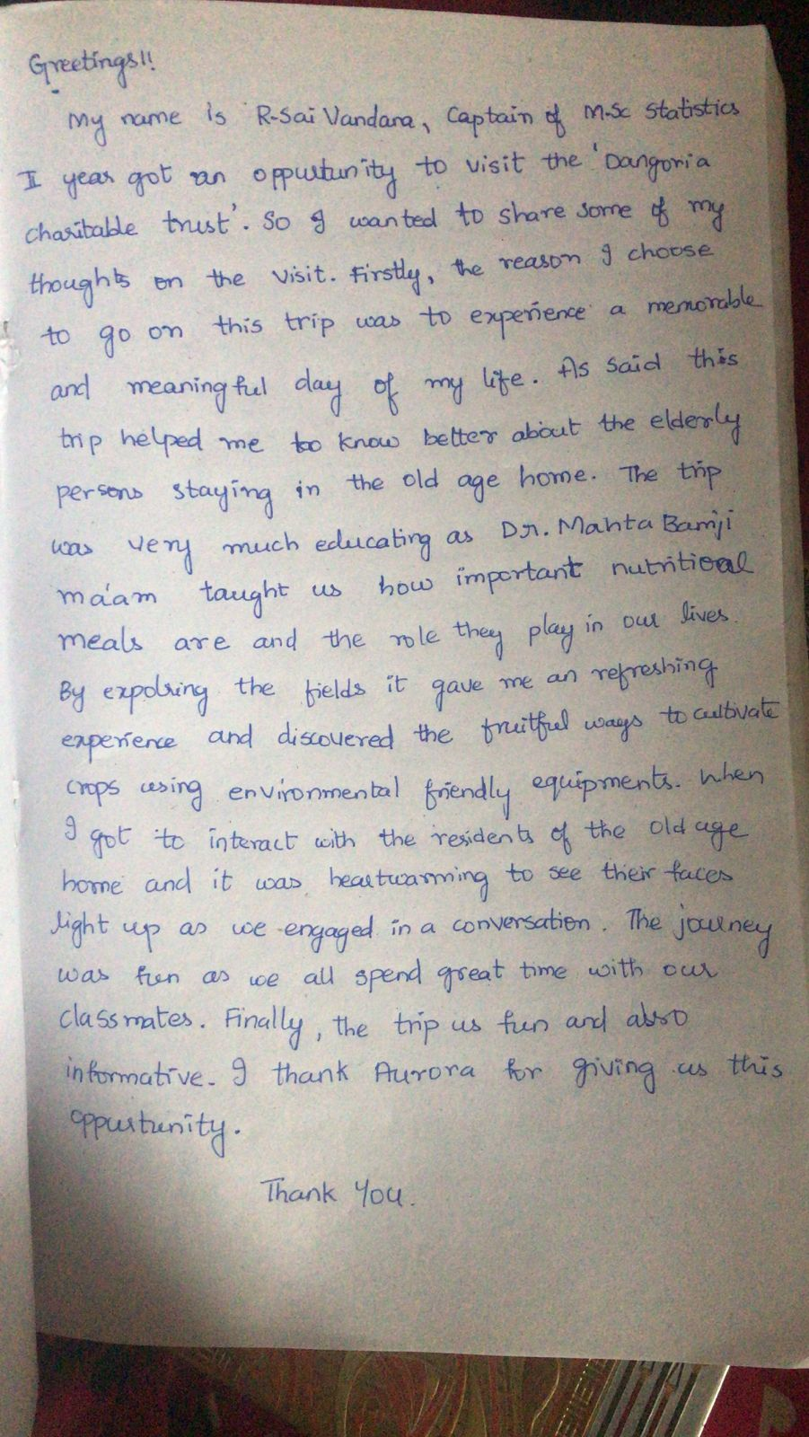

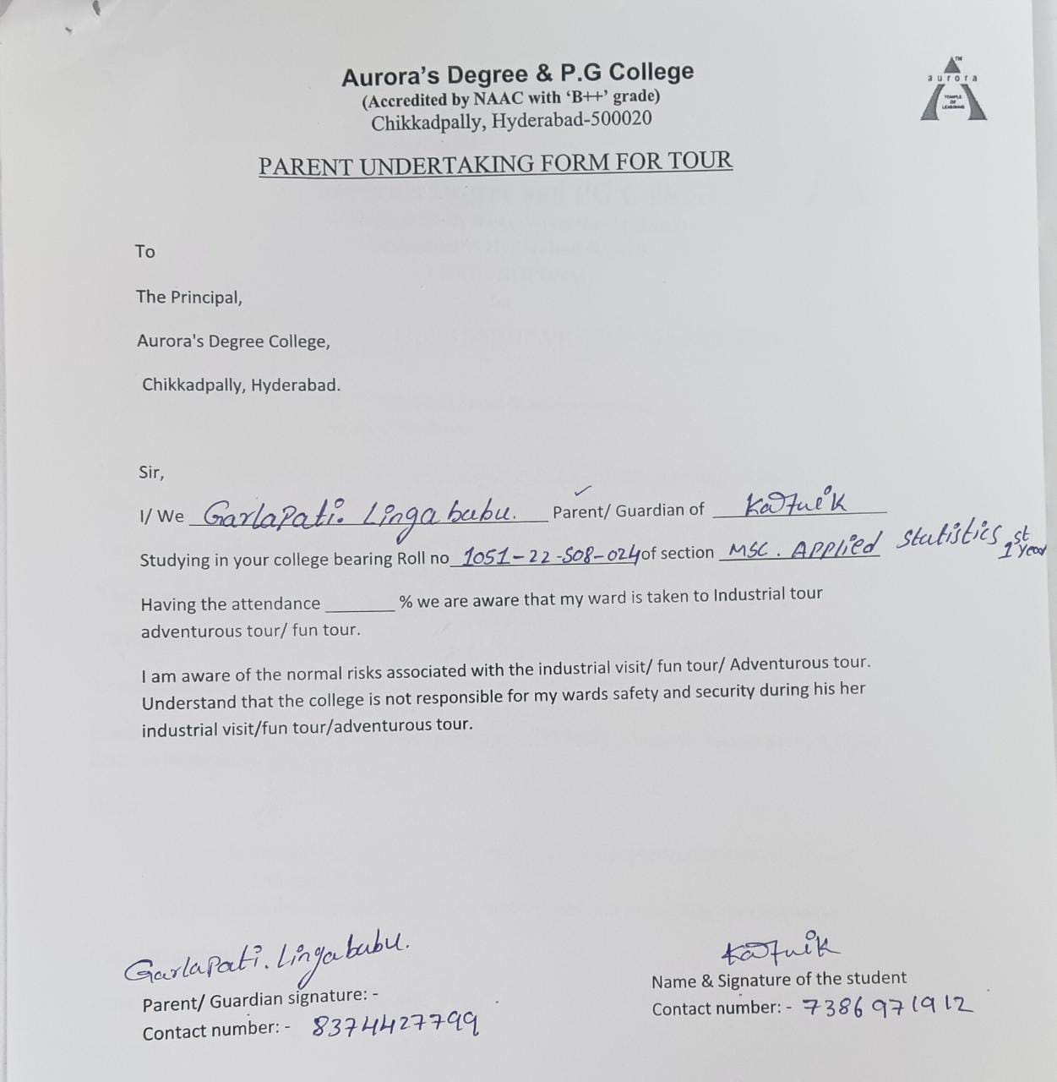
- ATTACHMENTS:
EVENT/ACTIVITY PROPOSAL
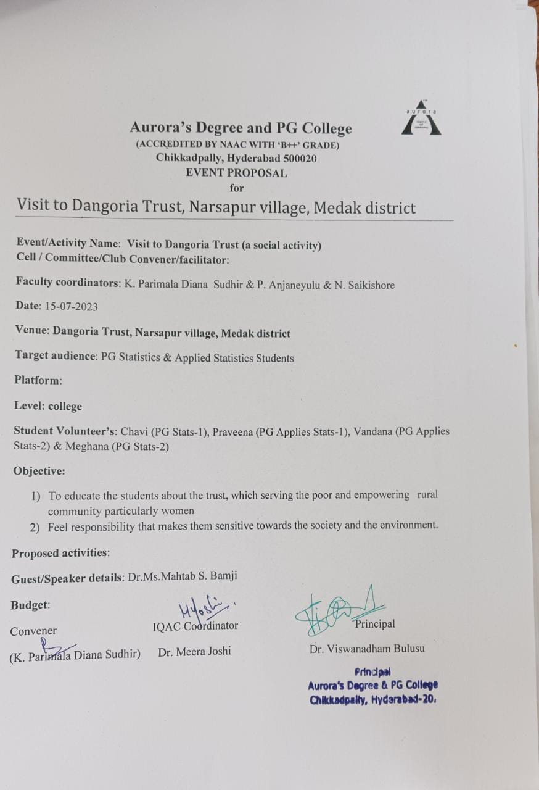

EVENT / ACTIVITY NOTICE

RECEIPTS (IF ANY):
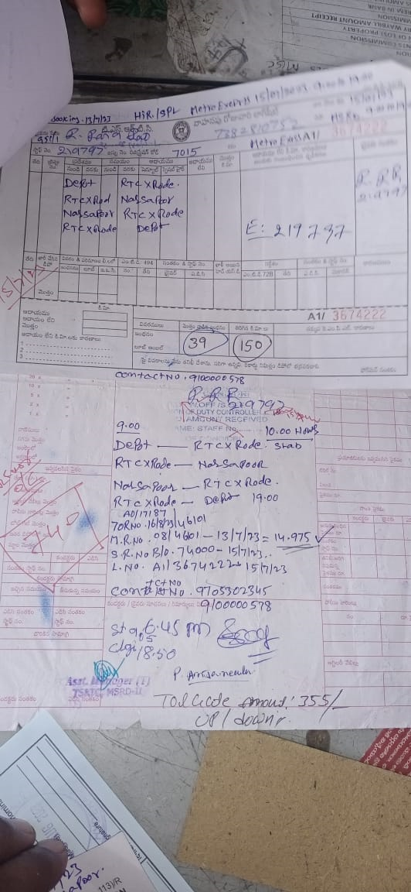

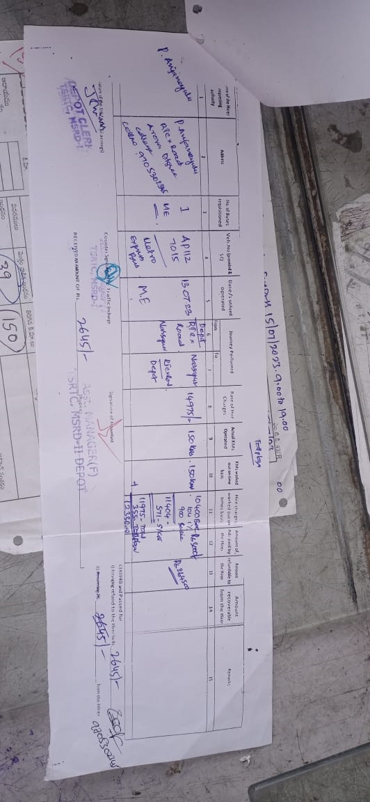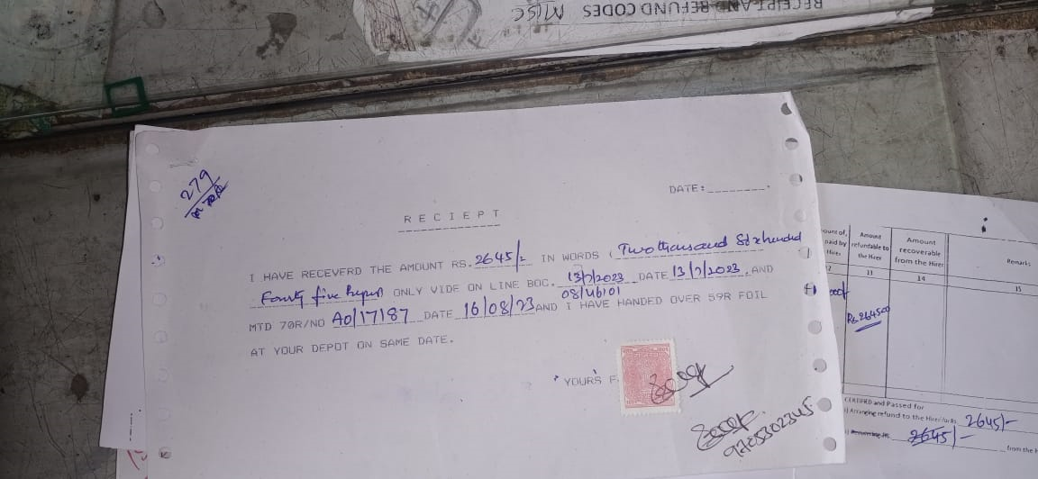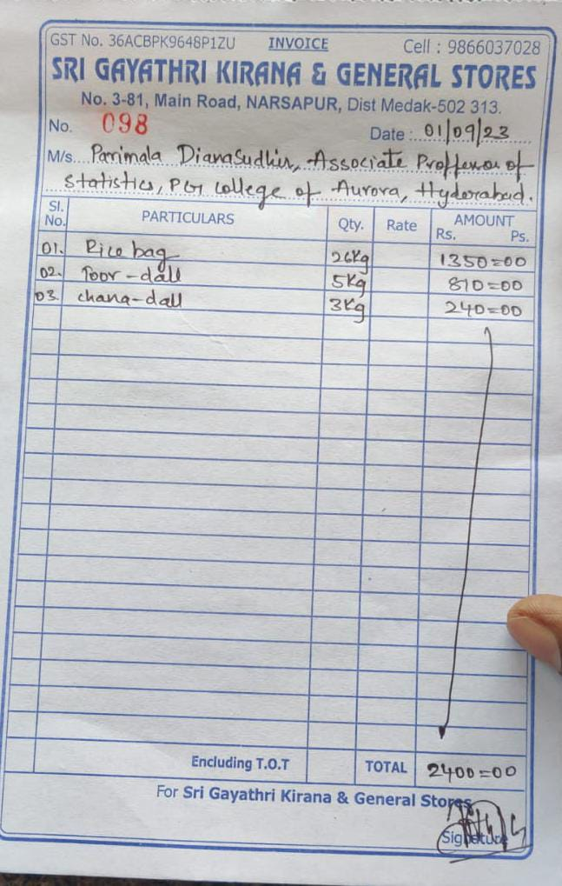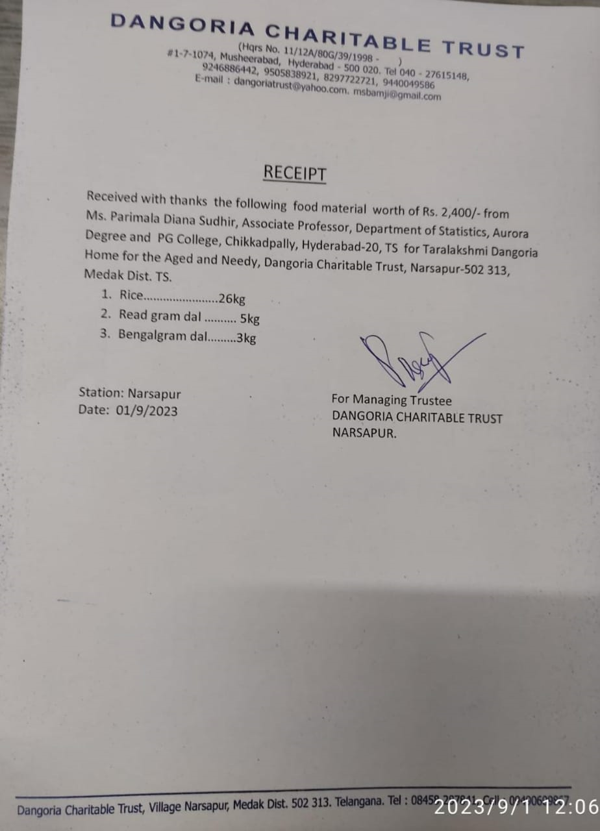

CERTIFICATES (IF ANY):
LETTERS OF COMMUNICATION (IF ANY):
Good morning mam,
We have planned to visit Dangoria Trust along with 60 PG Statistics students on 15th July 2023. Request you to give a talk and educate our students.
Thank you for the opportunity mam.
Parimala Diana Sudhir

